ATTN: BULLETIN EDITORS AND INTERCESSION WRITERS

ADDITIONAL BULLETIN BRIEFS AND FLYERS

Note: Suggested announcements, suitable for bulletins and social media, are also indicated in the full communiqué with red lines at top and bottom.

This attachment includes the following graphic files / flyers – see notes below on any text-only version in the Communique:

- Good Friday Collection for the Holy Land Parish Bulletin Announcements (Text)

- Vocation Bulletin Blurbs and Vocation General Intercessions (Text)

- Stewardship Thoughts for Parish Bulletins (Text)

- Background Check Requirements and Codes
- Care for Creation Coloring Page

- Kolbe Gathering (Flyer)
- Lutheran-Catholic Covenant Commission Lent Resources (Text)

- Lutheran-Catholic Covenant Commission – Evening Prayer (Flyer)

- Marriage Preparation Formation Opportunities and Engaged Couples Retreat Brochure

Diocese of Youngstown
Office of the Chancellor

GOOD FRIDAY COLLECTION FOR THE HOLY LAND
APRIL 15, 2022

SUGGESTED BULLETIN/PULPIT ANNOUNCEMENTS

PARISH BULLETIN ANNOUNCEMENT

Pope Francis has asked our parish to support the Pontifical Good Friday Collection, which helps Christians in the Holy Land. Your support helps the church minister in parishes, provide Catholic schools and offer religious education. The Pontifical Good Friday Collection also helps to preserve the sacred shrines.

The pandemic hit particularly hard on the Christians in the Holy Land. Most of them depend on pilgrimages to work. In these times of crisis, the Pontifical Good Friday Collection is also necessary to meet the basic needs of the People of God still living in this Land where the Church was born.

When you contribute to the Pontifical Good Friday Collection, you become an instrument of peace and join with Catholics around the world in solidarity with the Church in the Holy Land.

PLEASE BE GENEROUS!

For more information about Christians in the Holy Land, visit www.myfranciscan.org/good-friday.

PULPIT ANNOUNCEMENT

Pope Francis has asked our parish to support the Pontifical Good Friday Collection, which helps Christians in the Holy Land. Through the Pontifical Good Friday Collection, you stand in solidarity with the Church in the Holy Land as a witness of peace, supporting Catholics there in parishes and schools, maintaining Christian shrines and caring for refugees in the Holy Land.

PLEASE BE GENEROUS!
Please send to:
Diocese of Youngstown
c/o Msgr. John Zuraw
144 W. Wood Street, Youngstown, OH 44503

Vocation Bulletin Blurbs
April 2022/Cycle C

Fifth Sunday of Lent – April 3, 2022
“The Lord has done great things for us; we are filled with joy.” Are you called to bring the joy of Christ to His people? Call Father Scott Kopp at 330-744-8451 or email: skopp@youngstowndiocese.org.

Palm Sunday of the Lord's Passion – April 10, 2022
“He opens my ear that I may hear; and I have not rebelled.” Prayer and reflection are essential to discerning a vocation. Are you open to a vocation to the priesthood, diaconate or the consecrated life? Call Father Scott Kopp at 330-744-8451 or email: skopp@youngstowndiocese.org.

Easter Sunday -- April 17, 2022
“The Lord is truly risen!” Are you being called to proclaim the Lord’s resurrection as a priest, deacon, religious sister or brother? Call Father Scott Kopp at 330-744-8451 or email: skopp@youngstowndiocese.org.

Second Sunday of Easter -- April 24, 2022 - Divine Mercy Sunday
“As the Father has sent Me, so I send you.” Do you have an interest to share the Lord’s saving mission as a priest, deacon or in the consecrated life? Call Father Scott Kopp at 330-744-8451 or email: skopp@youngstowndiocese.org.

Third Sunday of Easter -- May 1, 2022
“Were not our hearts burning within us?” Do you feel a calling of the Holy Spirit to serve the Lord in the as a priest, deacon or in the consecrated life? Call Father Scott Kopp at 330-744-8451 or email: skopp@youngstowndiocese.org.

Vocation General Intercessions
April 2022/Cycle C

Fifth Sunday of Lent – April 3, 2022
That priests, deacons, sisters and brothers who, for the sake of Christ, have suffered the loss of all things, will be strengthened in their vocations to bring many souls to the knowledge of salvation, we pray to the Lord.

Palm Sunday of the Lord's Passion – April 10, 2022
For all those being called to share in the passion of Christ as priests, deacons and in the consecrated life, that they will echo His Eternal Word of mercy in their own faithfulness to the Father’s will, we pray to the Lord.

Easter Sunday -- April 17, 2022
That the Risen Lord, made known to us through apostolic witness, will bestow upon us more men and women who will answer the call to proclaim His life, death and resurrection as priests, deacons, sisters and brothers, we pray to the Lord.

Second Sunday of Easter -- April 24, 2022 - Divine Mercy Sunday
That we may be blessed with priests and consecrated religious to serve as messengers of God’s divine mercy, we pray to the Lord.

Third Sunday of Easter -- May 1, 2022
For prayerful openness in our young people, that they will see their vocation discernment as a call to love the Lord and respond generously to His choice of them, we pray to the Lord.

Stewardship Thoughts for Parish Bulletins
April 2022 | English

April 3, 2022
5th Sunday of Lent
“…For his sake I have accepted the loss of all things and I consider them so much rubbish, that I may gain Christ…“ (philippians 3:8)
The first commandment says that we should not put other gods before the Lord. Sharing all of our gifts - our time in prayer, our talent in charitable works and our treasure to support the Church helps us keep God first in everything. It helps us from putting other gods before God. It helps us from becoming a slave to our possessions. It helps us to use our gifts for the glory of God and not for the glory of ourselves.

April 10, 2022
Palm Sunday
“…I tell you, Peter, before the cock crows this day, you will deny three times that you know me. “ (Luke 22:34)
How many times have you heard someone make a disparaging comment about God or our Catholic faith? How did you react? Do you remain quiet not to cause a disturbance? Or, because you don’t want people to think negatively about you? Or, because you don’t think you know enough about the Catholic faith? Pray for the courage to speak up and enter into a respectful dialogue when the opportunity arises. Joyfully share your faith with others.

April 17, 2022
Easter Sunday
“…He went about doing good and healing all those oppressed by the devil, for God was with him.” (Acts 10:38)
We can’t give what we don’t have. Open your heart to receive God’s love, mercy and forgiveness. Then, show the same to others. As God’s adopted sons and daughters, we are made in His image and likeness. As Pope Benedict XVI says, “we are made for greatness.” Let our lives reflect His light to others. Pray to live a grateful and generous life. Strive for greatness! We are made for more! We are made for God!

April 24, 2022
Sunday of Divine Mercy
“Jesus said to them again, ‘Peace be with you. As the Father has sent me, so I send you.’” (John 20:21)
Peace – the first gift of the risen Lord. Just as Jesus sent the apostles out into the world, so too, He sends us. As disciples of Jesus, we are called to be compassionate and merciful; and not with just those who are our friends, but also with our “enemies.” Think of someone in your life who you need to reconcile with. Call them right now or better yet, go visit them.

May 1, 2022
3rd Sunday of Easter
“…Peter was distressed that Jesus had said to him a third time, ‘Do you love me?’ and he said to him, ‘Lord, you know everything; you know that I love you.’ Jesus said to him, ‘Feed my sheep.’” (John 21:17)
How often do you actually say the words “I love you” to Jesus, to family members, or to friends? We are made to be in relationship with God and each other. Sincerely telling someone that you love them is the best gift you can give them because it comes from your heart. You are giving them the gift of yourself. We all crave love. Tell someone you love them every day.

Stewardship Thoughts for Parish Bulletins
April 2022 | Spanish

3 de abril de 2022
Que mantengamos a Dios en primer lugar en todo y que no antepongamos otros dioses a Dios.
10 de abril de 2022 Que tengamos el coraje de defender nuestra fe Católica cuando se presente la ocasión.
17 de abril de 2022 Que permitamos que nuestras vidas reflejen el amor, la misericordia y el perdón de Dios.
24 de abril de 2022 Que mostremos misericordia a alguien con quien necesitamos reconciliarnos.
1 de mayo de 2022 Que demos el don de nosotros mismos diciéndole “te amo” a alguien todos los días.

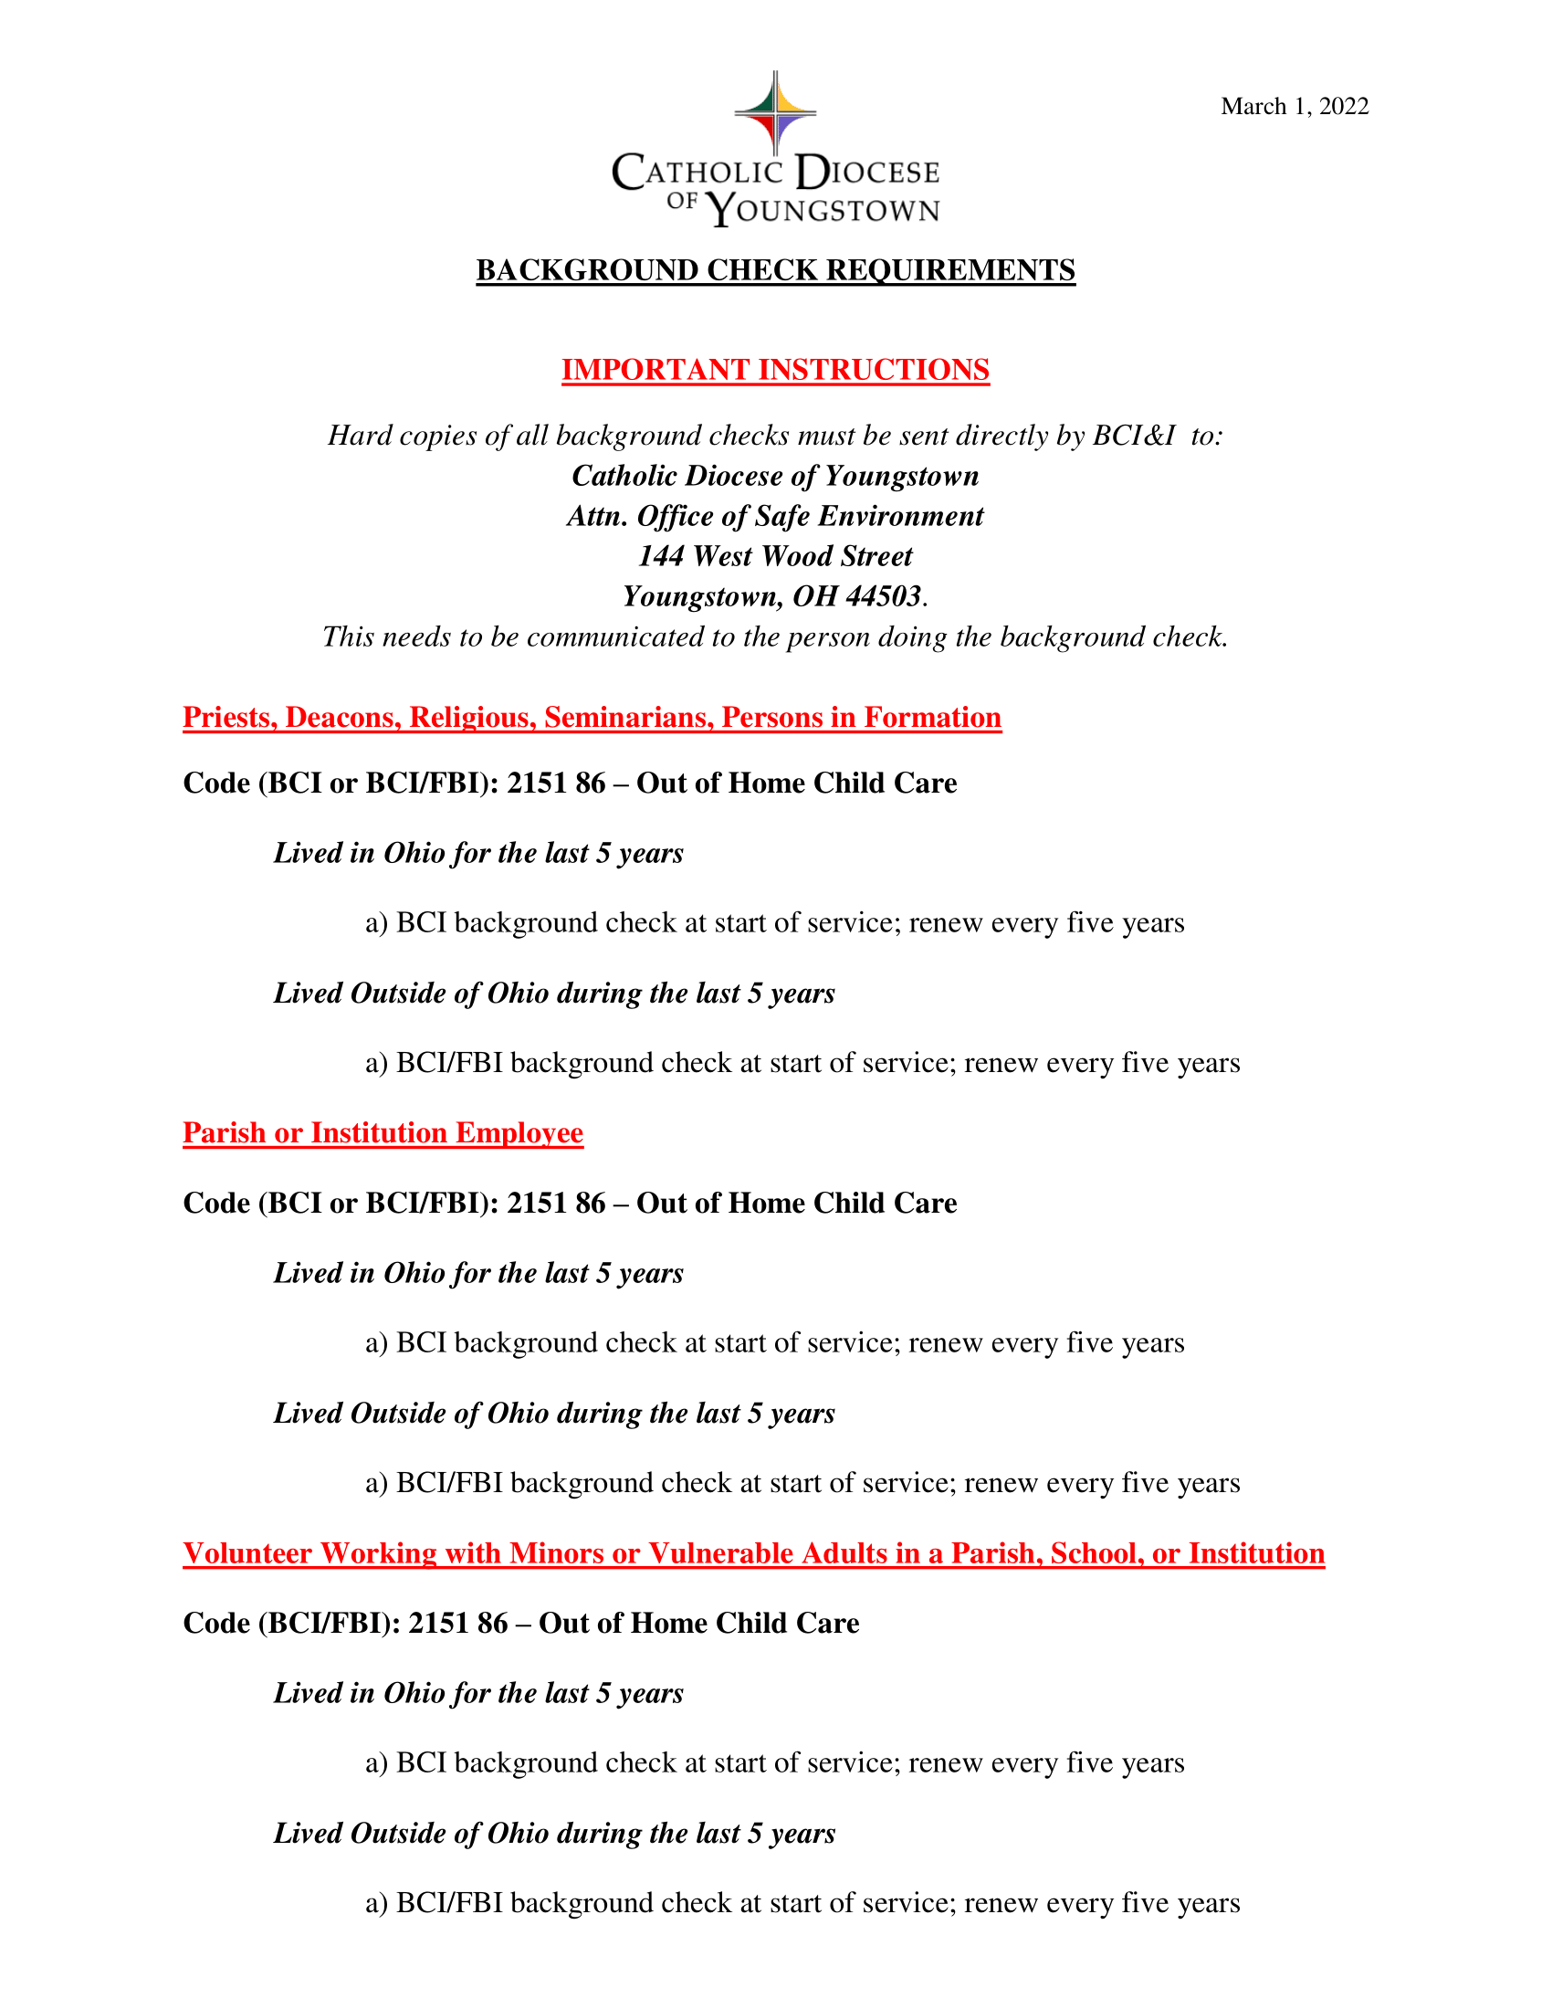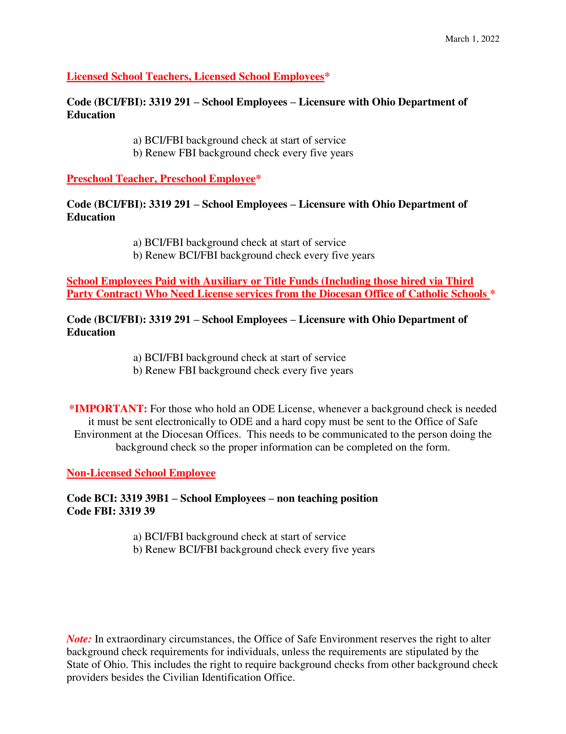
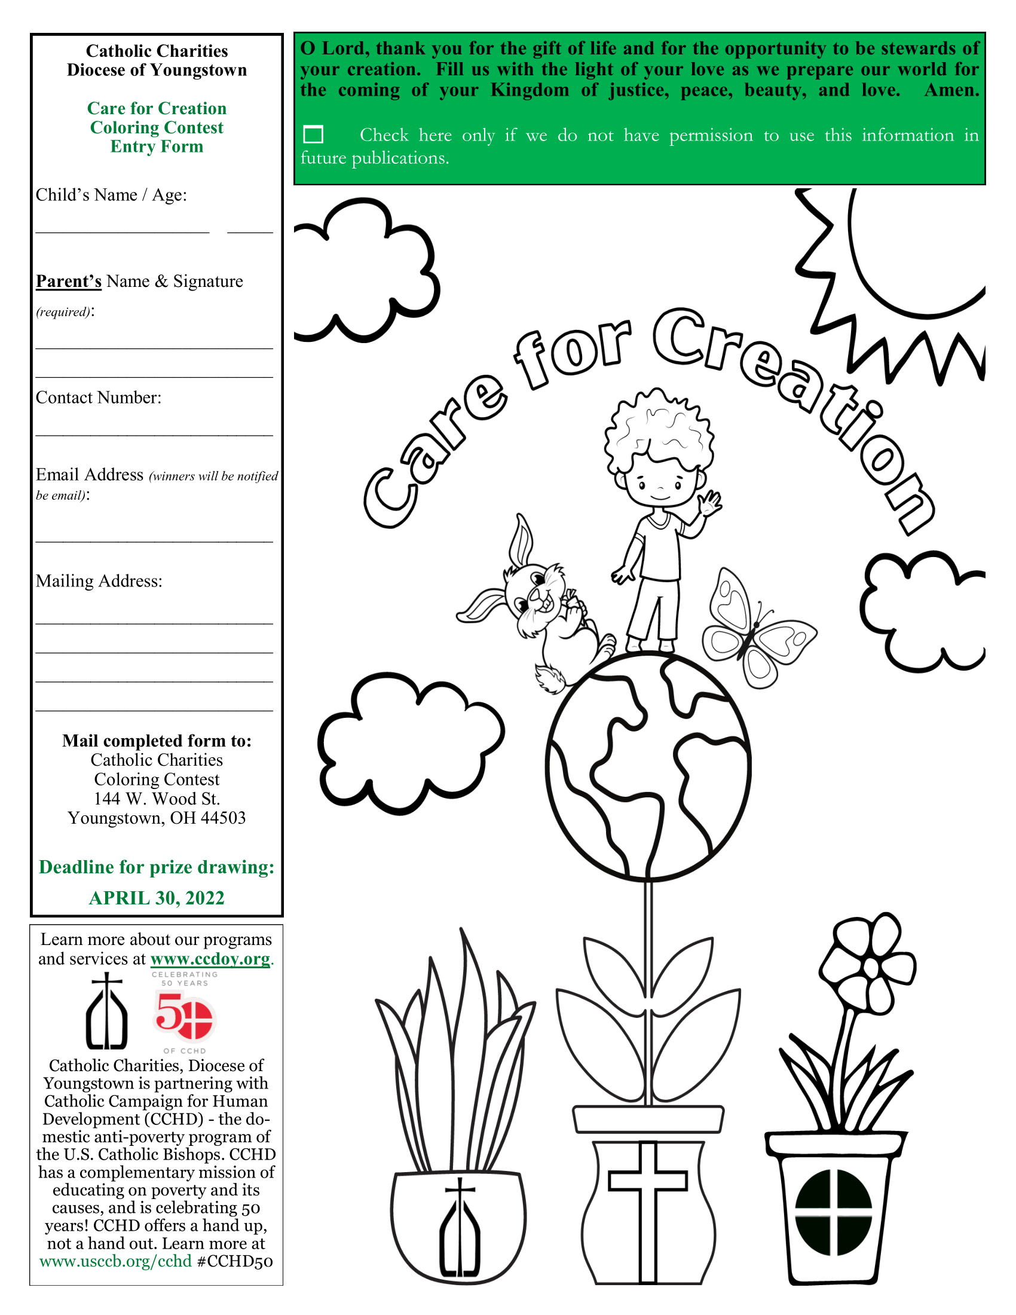

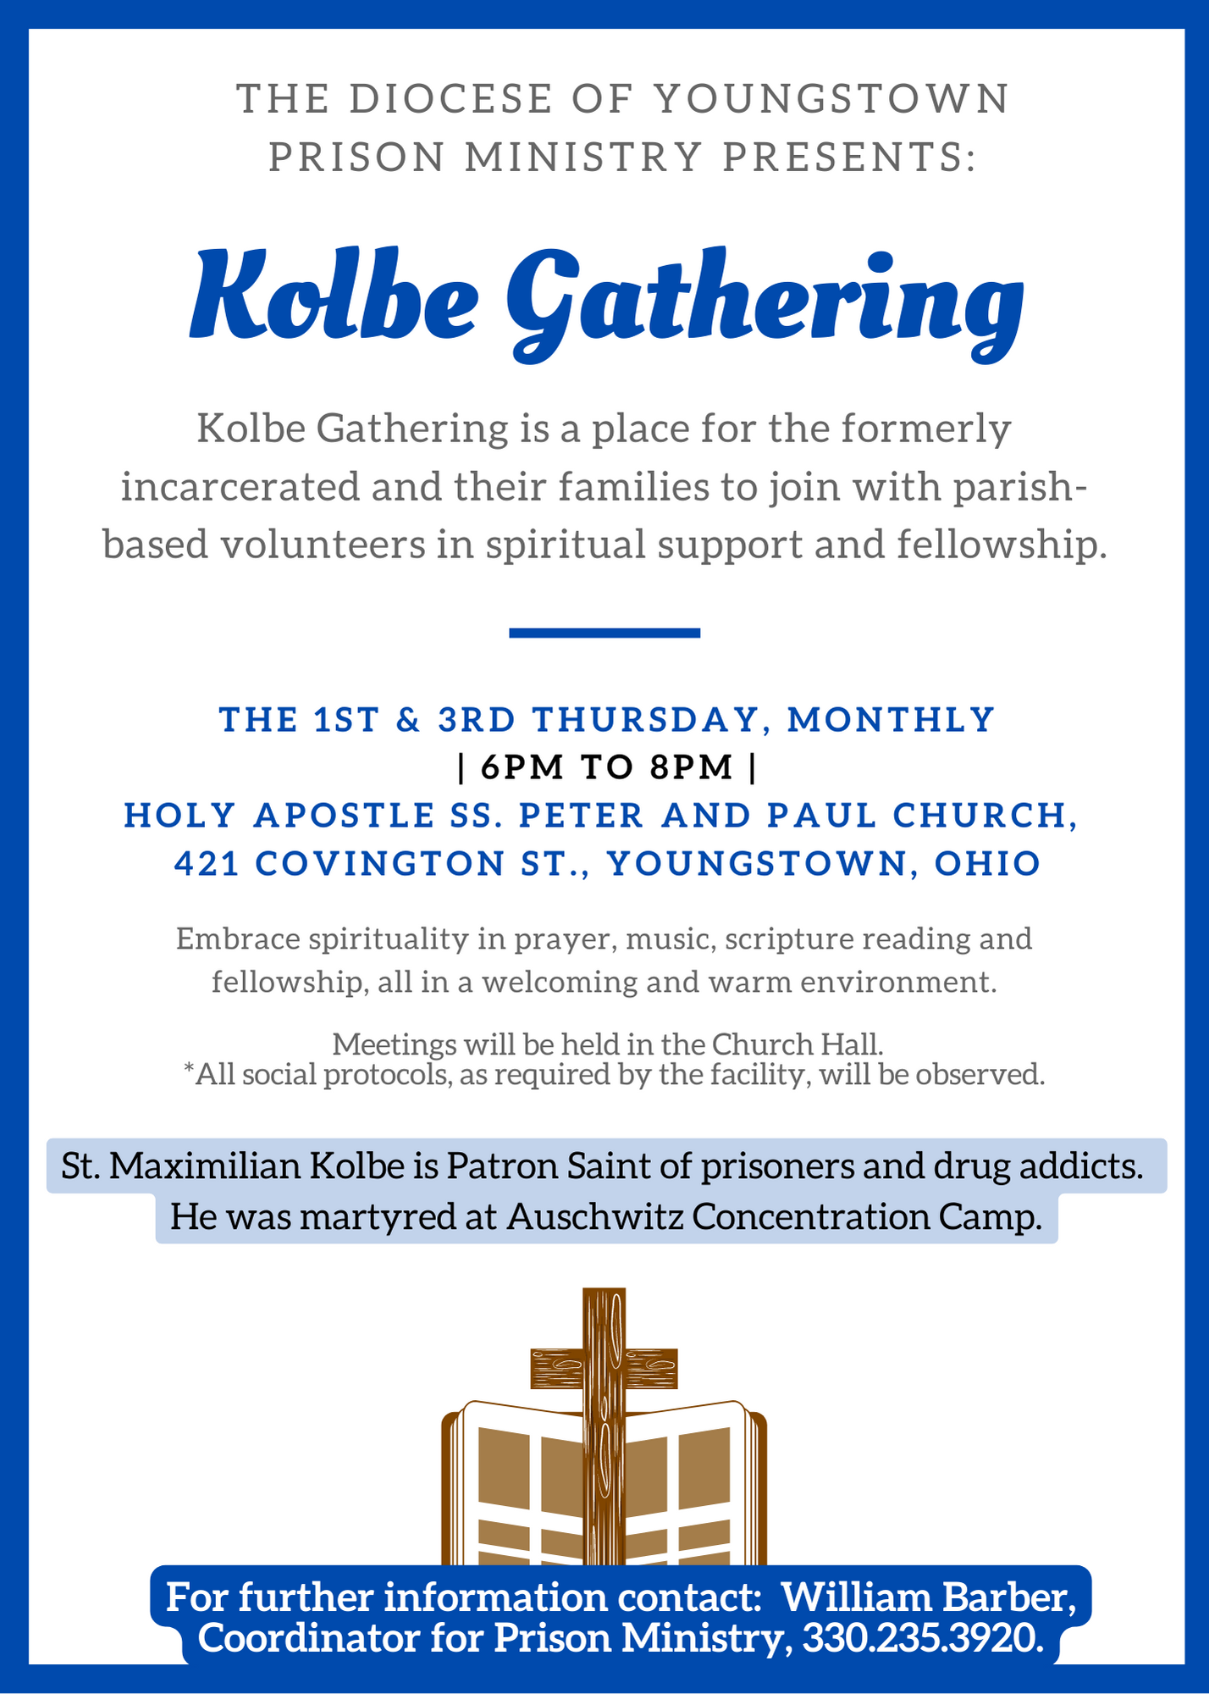
Lent 2022

Resources for Discussion and Reflection
Prepared by the Lutheran-Catholic Covenant Commission of the Northeastern Ohio Lutheran Synod of the Evangelical Lutheran Church in America & Catholic Diocese of Youngstown

Fifth Sunday of Lent, April 3
Isaiah 43:16-21 Philippians 3:4b-14 John 12:1-8

Our final reflection of this year’s Lenten journey finds us at the table of Lazarus, where Mary, his sister, acts as host. This is the story of the anointing of Jesus feet with perfume made of pure nard, an act of conscious loving. Judas could only see this act of love in terms of its value in money. Her devotion to Jesus becomes the basis of her service.

Have our Lenten disciplines helped transform us into faithful disciples who act with conscious loving? Or are we still living under the sway of our smaller selves like Judas whose self-interest is based on security and survival; power or control; or affection, esteem and approval? Do we create road blocks or are we generous and loving?

Did our Lenten journey this year make us ready to let go? Do we follow Jesus’ path of letting go described in the Palm Sunday text from Philippians 2?

Let the same mind be in you that was-in Christ Jesus, who, though he was in the form of God,
did not regard equality with God as something to be exploited, but emptied himself,
taking the form of a slave, being born in human likeness. And being found in human form,
he humbled himself
and became obedient to the point of death— even death on a cross.

Visit the website of the Northeastern Ohio Synod Evangelical Lutheran Church in America:

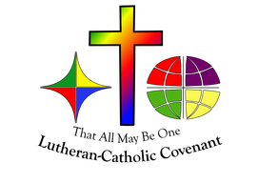
www.neos-elca.org
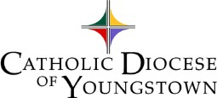
Visit the website for the Catholic Diocese of Youngstown:
www.doy.org

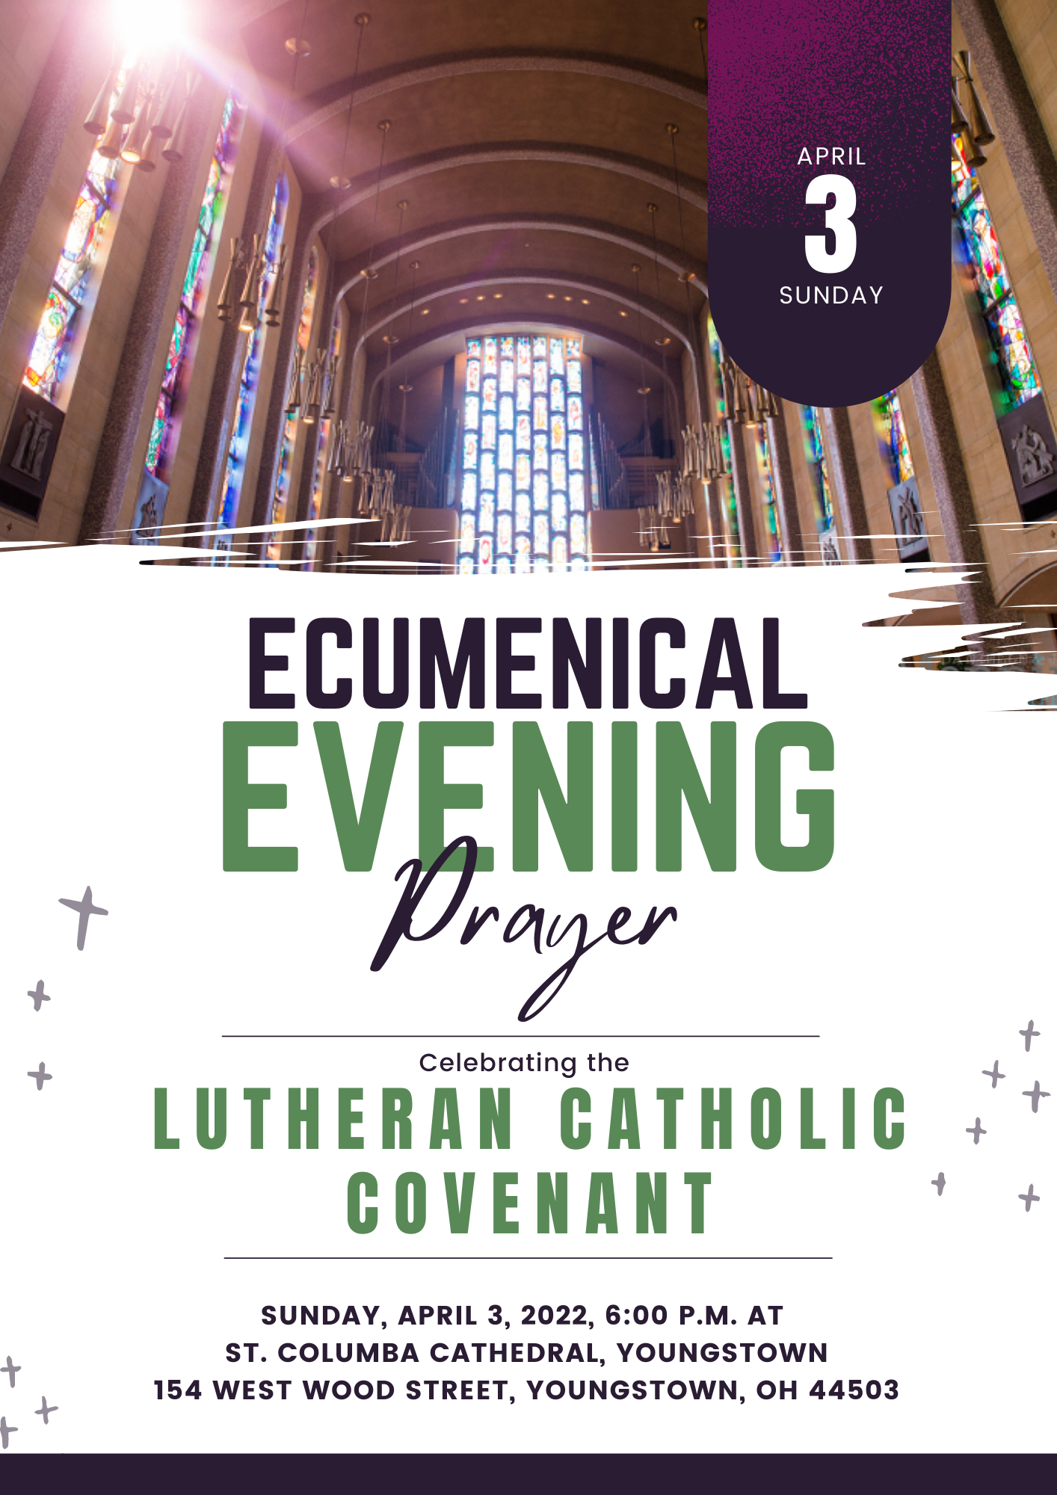
Marriage Preparation Formation Opportunities – 2022
(as of February 15, 2022)

Diocese of Youngstown

Marriage Preparation Engaged Couple Retreat, One-Day Retreat for Engaged Couples – On the following Saturdays, 9:00 to 4:00 p.m., $80 per couple:
- March 5, St. Columba Cathedral Hall, 144 W. Wood St., Youngstown
- April 9, St. Columba Cathedral Hall, 144 W. Wood St., Youngstown
- April 30, St. Columba Cathedral Hall, 144 W. Wood St., Youngstown
- June 4, Regina Coeli Parish, 663 Fernwood Blvd., Alliance
- August 20, St. Columba Cathedral Hall, 144 W. Wood St., Youngstown
- October 22, St. Columba Cathedral Hall, 144 W. Wood St., Youngstown
- November 19, St. Columba Cathedral Hall, 144 W. Wood St., Youngstown
Brochures or on-line registration may be found on the diocesan website: www.doy.org (click the “Ministries” tab and click on “Pro-Life, Marriage & Family Life”), or contact dschmidt@youngstowndiocese.org or 330-744-8451 ext. 272.

Diocese of Cleveland (https://www.dioceseofcleveland.org/offices/parish-life/marriage-and-family-ministry/marriage/overview)

Jesuit Retreat House, 5629 State Road, Parma, Ohio 44134 (Cuyahoga County) offers Pre-Cana days nearly every month on Sundays from 12:45 to 8:00 pm for $100.00 per couple. Call 440-884-9300 for details. https://www.jesuitretreatcenter.org/calendar/pre-cana
- February 20, 2022; March 20, 2022; April 3, 2022; May 1, 2022; June 12, 2022;

Loyola Retreat House, 700 Killinger Road, Clinton, Ohio 44216 (Summit County), offers Pre-Cana days on Sundays, 11:00 am to 7:00 pm for $90.00 per couple. Call 330-896-2315 for details. https://loyolaretreathouse.com/wp/precana/
- February 27, 2022; May 22, 2022; June 12, 2022; September 18, 2022

Diocese of Pittsburgh (https://diopitt.org/marriage-preparation)

Over

Diocese of Erie (https://www.eriercd.org/familylifeoffice/precana.html Phone 814-824-1265 or e-mail familylife@erieRCD.org)

Sunday, April 3rd | 9am - 5pm  Includes Mass | St. James, Erie | 814-899-6178
Sunday, July 10th | 8:30am - 6:00pm | St. Mark Catholic Center, Erie | 814-824-1210
Sunday, September 18th | 8am-5pm  Includes Mass | Our Lady of Mercy, Harborcreek | 814-699-5342
Sunday, November 6th | 8am-4:30pm  Includes Mass | St. George, Erie | 814-864-0622

Engaged Encounter weekends Held at St. Mark Catholic Center 429 E. Grandview Blvd., Erie, PA 16504. Start time: 7 p.m. on Friday; Ending time: 1 p.m. on Sunday; $200 per couple. For more information or to register go to https://www.eriercd.org/familylifeoffice/ee.html.
- October 14-16, 2022

