ATTN: BULLETIN EDITORS AND INTERCESSION WRITERS

ADDITIONAL BULLETIN BRIEFS AND FLYERS

Note: Suggested announcements, suitable for bulletins and social media, are also indicated in the full communiqué with red lines at top and bottom.

This attachment includes the following graphic files / flyers – see notes below on any text-only version in the Communique:

- Vocation Bulletin Blurbs and Vocation General Intercessions (Text)

- Stewardship Bulletin Reflections (English and Spanish)

- Background Check Requirements and Codes

- African American Sunday – Save the Date (Flyer)
- Kolbe Gathering (Flyer)

- Appeal Bulletin Pledge Card
- Marriage Preparation Formation Opportunities and Engaged Couples Retreat Brochure

- The Chaplet of Divine Mercy (Flyer)

- Walking Rosary (Flyer)

- Church at Home Bulletin Announcements (Text)

Please also see the separate attachments for the Eucharistic Revival and a flyer regarding responding with care to the Dobbs Decision.

Attn: Bulletin Editor and Intercessions Writers

Vocation Bulletin Blurbs
June 2022/Cycle C

Pentecost Sunday -- June 5, 2022
“To each individual the manifestation of the Spirit is given for some benefit.” Is your gift of the Holy Spirit the discernment of a vocation to the priesthood or consecrated life? Call Father Scott Kopp at 330-744-8451 or email: skopp@youngstowndiocese.org.

The Most Holy Trinity – June 12, 2022
How do you hope to share in God’s glory…as a priest, deacon or in the consecrated life? Call Father Scott Kopp at 330-744-8451 or email: skopp@youngstowndiocese.org.

The Most Holy Body and Blood of Christ -- June 19, 2022 [Corpus Christi]
“They all ate and were satisfied.” Are you called to feed his flock as a priest? Call Father Scott Kopp at 330-744-8451 or email: skopp@youngstowndiocese.org.

Thirteenth Sunday in Ordinary Time – June 26, 2022
“Serve one another through love.” Does a life of prayer and service as a priest, deacon or in the consecrated life attract you? Call Father Scott Kopp at 330-744-8451 or email: skopp@youngstowndiocese.org.

Fourteenth Sunday in Ordinary Time -- July 3, 2022
“The harvest is abundant but the laborers are few.” Are you called to be a laborer for Christ as a priest, deacon, brother or sister? Call Father Scott Kopp at 330-744-8451 or email: skopp@youngstowndiocese.org.

Vocation General Intercessions
June 2022/Cycle C

Pentecost Sunday -- June 5, 2022
That those now discerning their vocations will be guided by the Holy Spirit to respond to the Lord’s call with passion and enthusiasm, we pray to the Lord.

The Most Holy Trinity – June 12, 2022
That those chosen to share the mercy of God as priests, deacons, sisters and brothers will be faithful to the Spirit of Truth who has called them and guides them, we pray to the Lord.

The Most Holy Body and Blood of Christ -- June 19, 2022 [Corpus Christi]
That the Body and Blood of Christ will strengthen those being called to the priesthood, diaconate or consecrated life to persevere in their vocations and respond with confidence and joy, we pray to the Lord.

Thirteenth Sunday in Ordinary Time – June 26, 2022
That men and women called to proclaim the kingdom of God as priests, deacons and in the consecrated life, will be given the strength to overcome every obstacle to their response through prayer and the practice of virtue, we pray to the Lord.

Fourteenth Sunday in Ordinary Time -- July 3, 2022
For an increase in laborers to the Lord of the Harvest in response to our prayers for vocations to the priesthood, diaconate and the consecrated life, and for the holiness of all those now serving the people of our diocese in these vocations, we pray to the Lord.

STEWARDSHIP BULLETIN REFLECTIONS
June 2022

June 5, 2022
Pentecost Sunday
“The Advocate, the Holy Spirit whom the Father will send in my name, will teach you everything and remind you of all that I told you.” (John 14:26)
The materialism of our society lures us to concentrate more on what we want than on what God wants for us. The relativism of our world tells us that we should be tolerant of all things, that there is no absolute truth. Pray to the Holy Spirit to transform our lives and to guide our thoughts, words and actions. What you put in your head, heart and mind affects your actions. Put good things in and good things will come out.

June 12, 2022
The Most Holy Trinity Sunday
“But when he comes, the Spirit of truth, he will guide you to all truth...” (John 16:13)
It has been said that the best gift we can give someone is to teach them how to pray. If you don’t talk and more importantly, listen, to God every day, how else will you know what He is calling you to do? Just as you talk to family and friends every day, get in the habit of talking with God every day. Develop a daily prayer routine. Keep your prayers simple and sincere. This is best done in silence, when you can hear His response.

June 19, 2022
Feast of Corpus Christi
“They all ate and were satisfied. And when the leftover fragments were picked up, they filled twelve wicker baskets.” (Luke 9:17)
The story of the Loaves and Fishes shows us that when you share what you have, even if it doesn’t seem like that much, miracles can happen! Do not think that your gift is too small or insignificant! Each of us has a role in God’s plan; you just need to place your trust in the Lord. Nothing is impossible with God. You may be the answer to someone else’s prayer.

June 26, 2022
13th Sunday in Ordinary Time
“For you were called to freedom, brothers and sisters. But do not use this freedom as an opportunity for the flesh; rather serve one another through love.” (Galatians 5:13)
We like to celebrate that we are free to “live the good life.” We can do what we want, anytime we want, with no regard for laws. But, Jesus calls us to a different kind of freedom. St. Paul reminds us that by imitating Jesus we are freed from becoming a slave to our own self-interests and desires, so that we can serve one another. We are free to share our gifts and promote God’s work on earth to glorify His name and not honor ourselves.

REFLEXIONES DEL BOLETIN DE CORRESPONSABILIDAD
Junio 2022

5 de junio de 2022
Domingo de Pentecostés
El Defensor, el Espíritu Santo a quien el Padre enviará en mi nombre, les enseñará todo y les recordará todo lo que les he dicho.» (Juan 14:26)
El materialismo de nuestra sociedad nos atrae a concentrarnos más en lo que nosotros queremos que en lo que Dios quiere para nosotros, el relativismo de nuestro mundo nos dice que debemos ser tolerantes de todas las cosas, que no existe la verdad absoluta. Rece al Espíritu Santo para que transforme nuestras vidas y guíe nuestros pensamientos, palabras y acciones. Lo que ponemos en nuestra cabeza, corazón y mente afecta nuestras acciones. Si ponemos cosas buenas dentro saldrán cosas buenas.
12 de junio de 2022
Domingo de la Santísima Trinidad
“pero cuando él venga, el Espíritu de la verdad, él los guiara hacia la verdad...” ( Juan 16:13)
Se ha dicho que el mejor regalo que puede darle a alguien es enseñarlo a rezar. A menos que usted le hable y más importante, escuche a Dios cada día, ¿Como sabrá para que lo está llamando? Así como usted habla con su familia y sus amigos cada día, adopte el hábito de hablar con Dios cada día. Desarrolle una rutina diaria de oración. Mantenga sus oraciones sencillas y sinceras. Es mejor hacerlo en silencio, para que pueda escuchar Su respuesta.

19 de junio de 2022
Fiesta de Corpus Christi
“Todos comieron y quedaron satisfechos. Y cuando recogieron los pedazos que sobraron, llenaron doce cestos de mimbre” (Lucas 9:17)
La historia de los Panes y los Peces nos muestra que cuando usted comparte lo que tiene, aunque no parezca mucho, ¡suceden los milagros! ¡No piense que sus dones son demasiado pequeños o insignificantes! Cada uno de nosotros tiene un rol en el plan de Dios: solo necesita poner su confianza en el Señor. Con Dios nada es imposible. Usted puede ser la respuesta a la oración de alguien más.

26 de junio de 2022
13º Domingo del Tiempo Ordinario
Hermanos, Dios los ha llamado para ser libres, pero no permitan que la libertad sea una excusa para dar rienda suelta a sus pasiones. Mejor ayúdense por amor los unos a los otros. (Gálatas 5:13)
Queremos celebrar que somos libres para “vivir la buena vida”. Podemos hacer lo que queramos, en cualquier momento, sin respeto a las leyes. Mas bien, Jesús nos llama a una clase de libertad diferente. San Pablo nos recuerda que al imitar a Jesús nos liberamos de transformarnos en esclavos de nuestros propios intereses y deseos, de manera que podamos servirnos los unos a los otros. Somo libres de compartir nuestros dones y promover la obra de Dios en la tierra para glorificar Su nombre y no para honrarnos a nosotros mismos.

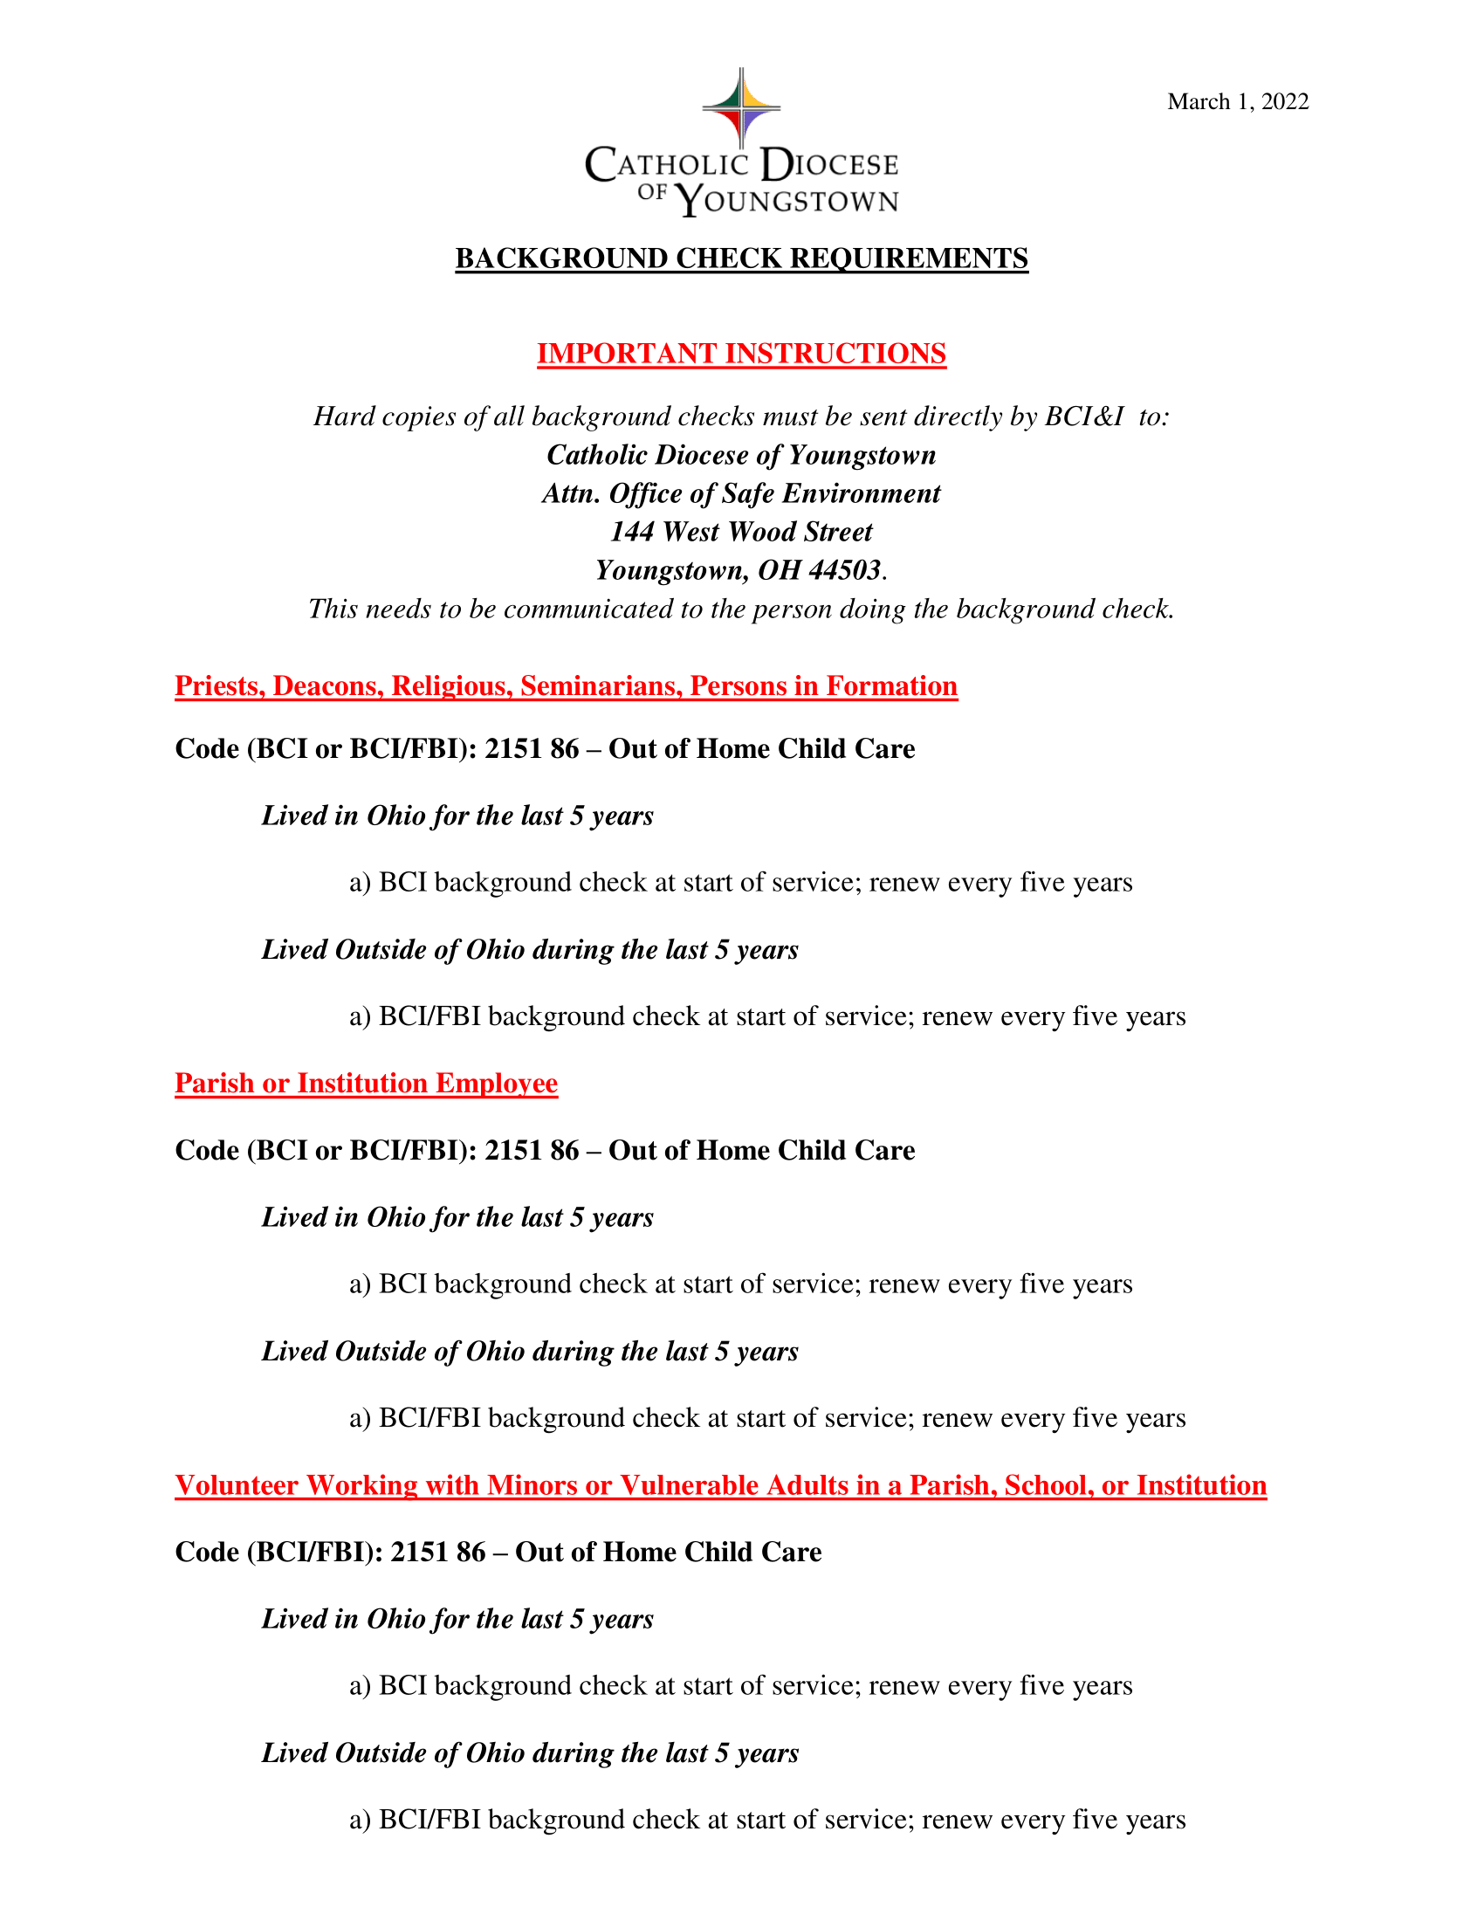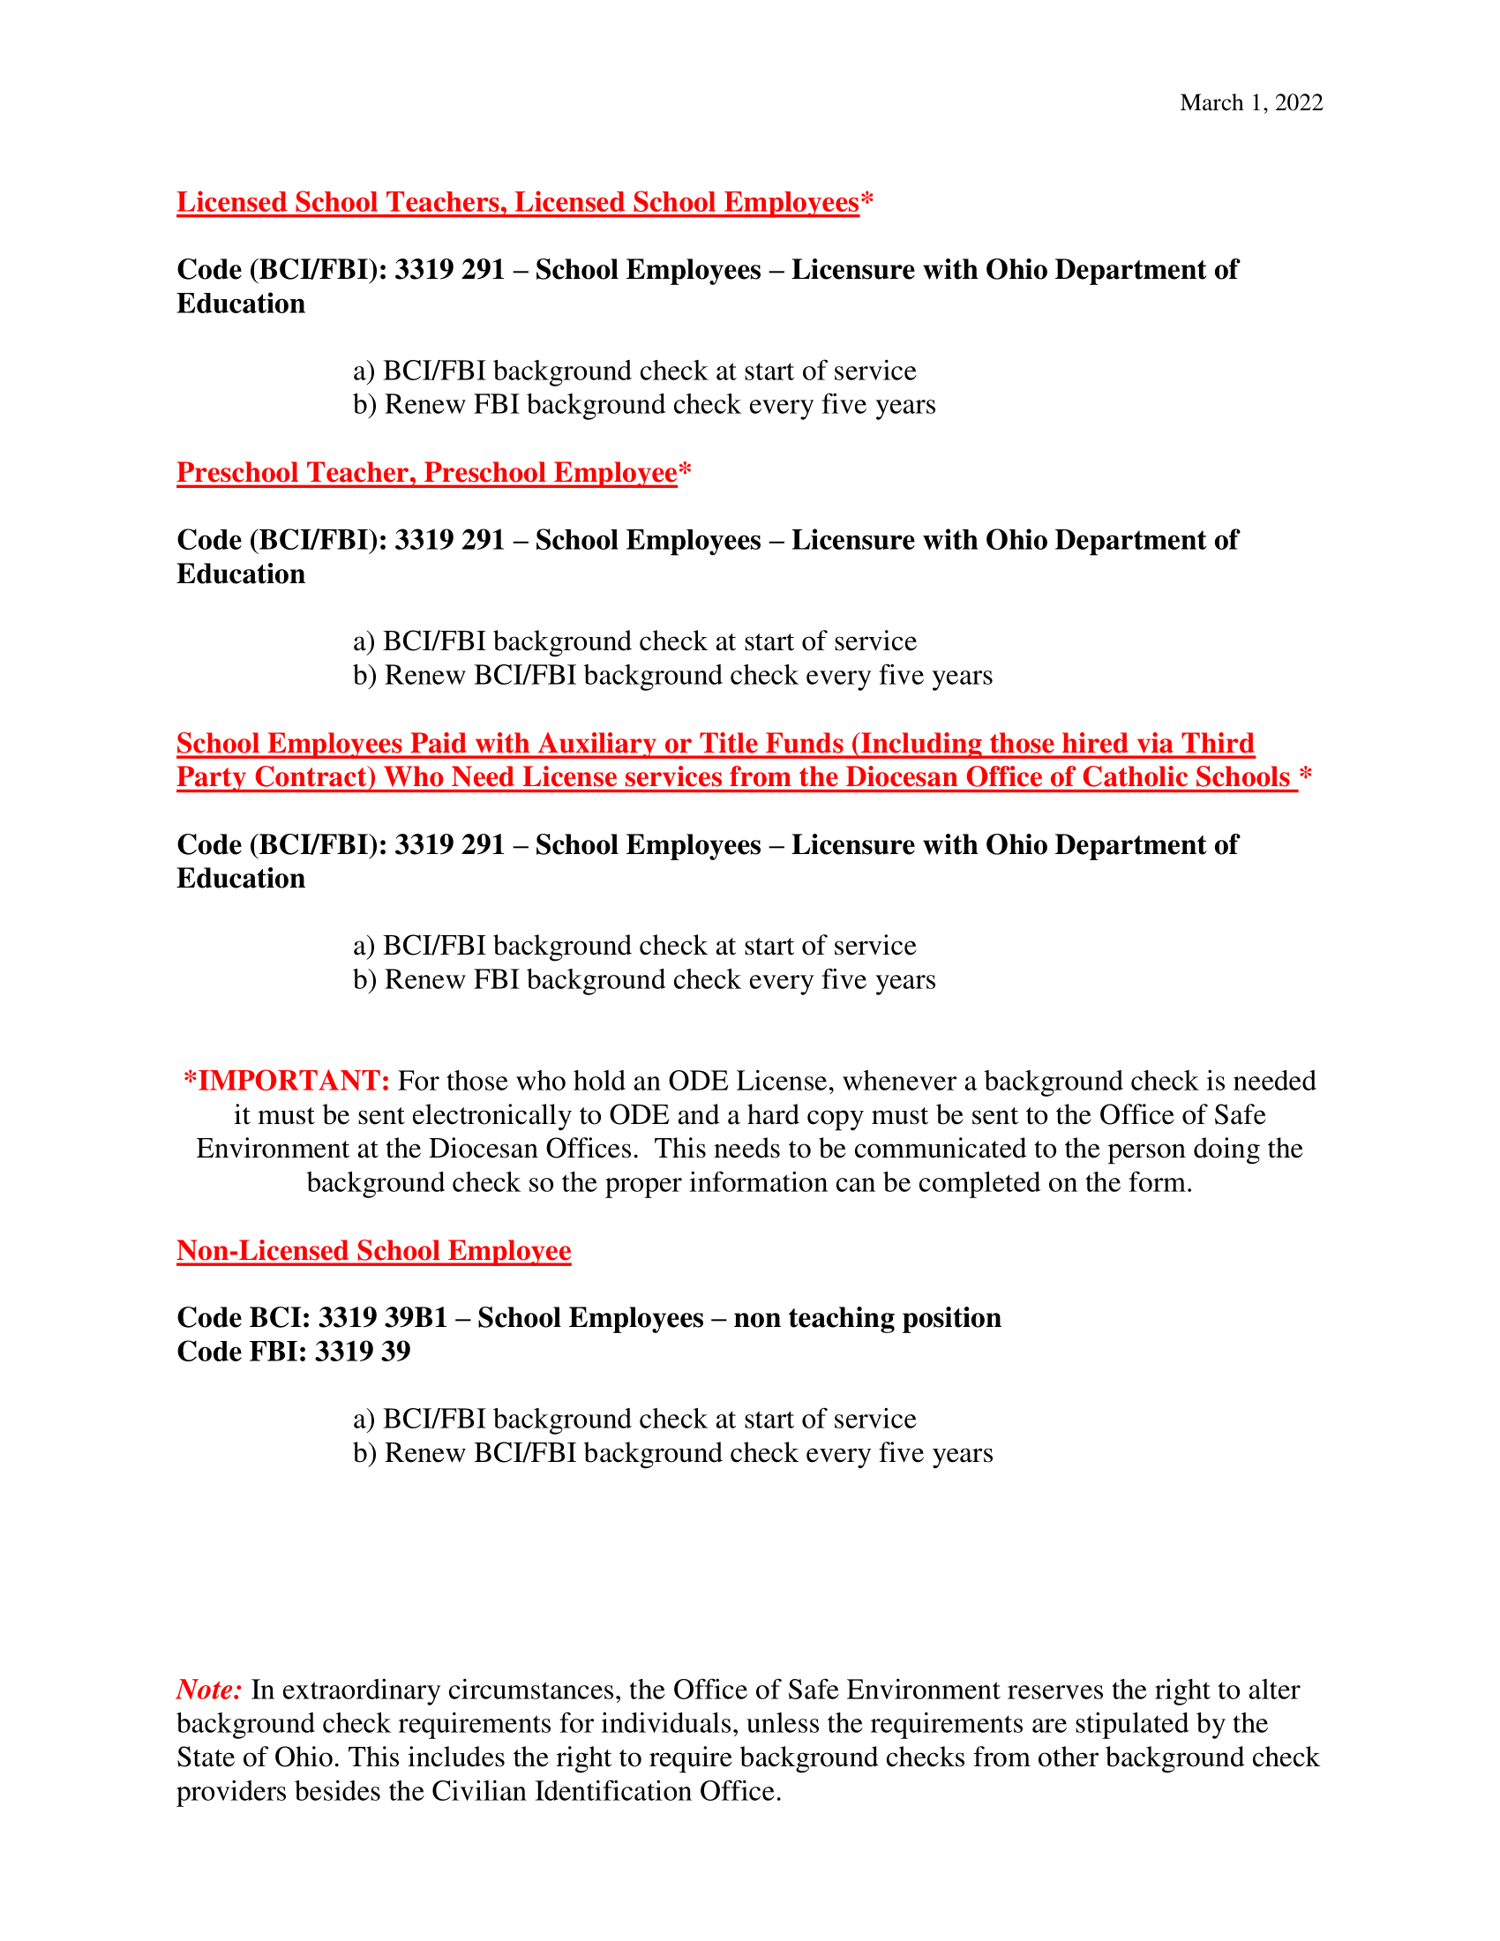
First Step for Change
Bulletin/Pulpit Announcements 2022

Announcement One
Catholic Charities will hold its annual First Step for Change campaign from Mother’s Day through Father’s Day, honoring the faith, humility and love it takes to raise a child, and recognizing that many parents lack adequate financial resources their children. Funds raised through this campaign assist low-income pregnant women and families with food, formula, clothing, diapers and other items essential to a child’s health, safety and well-being. Each family interested in participating in First Step for Change is asked to pick up a FIRST STEP after Mass. Take a FIRST STEP PACKET home, learn about the program, complete the participation card and return it to our parish by June 30. All money collected by our parish will help to meet local needs. Thank you.

Announcement Two
One way to support the Catholic Church’s pro-life, pro-family position is to participate in First Step for Change, a campaign sponsored by Catholic Charities to assist low-income pregnant women and families with food, formula, clothing, diapers and other items essential to a child’s health, safety and well-being. Pick up a FIRST STEP PACKET, learn about the program, complete the participation card and return it to our parish by June 30. Support the Gospel of Life by reaching out to women, children and families who need a helping hand.
Online giving is also available at www.ccdoy.org.

Announcement Three
Catholic Charities’ First Step program provides specific material assistance to pregnant women and families with children ages 0-3. Funds collected through First Step for Change are used to supplement case management services with material goods, such as food, formula, diapers and hygiene products. Please support this important pro-life, pro-family fundraiser that helps Catholic Charities provide help and create hope for people in need. For more information on Catholic Charities’ services, visit www.ccdoy.org.

The First Step for Change campaign will conclude at our parish on Father’s Day. Please remember to bring your completed FIRST STEP PACKET to Mass with you on Father’s Day, or return it to the parish no later than June 30.

Announcement Four
Thank you to all who have participated in Catholic Charities’ First Step for Change campaign at our parish

(DESCRIBE THE LOCATION OR METHOD FOR COLLECTING THE FIRST STEP PACKETS. MAKE SURE ALL PACKETS ARE RETURNED TO YOUR PARISH BY JUNE 30. ONCE ALL PACKETS ARE COLLECTED, SEND SEALED PACKETS IN ONE ENVELOPE TO CATHOLIC CHARITIES FOR PROCESSING).

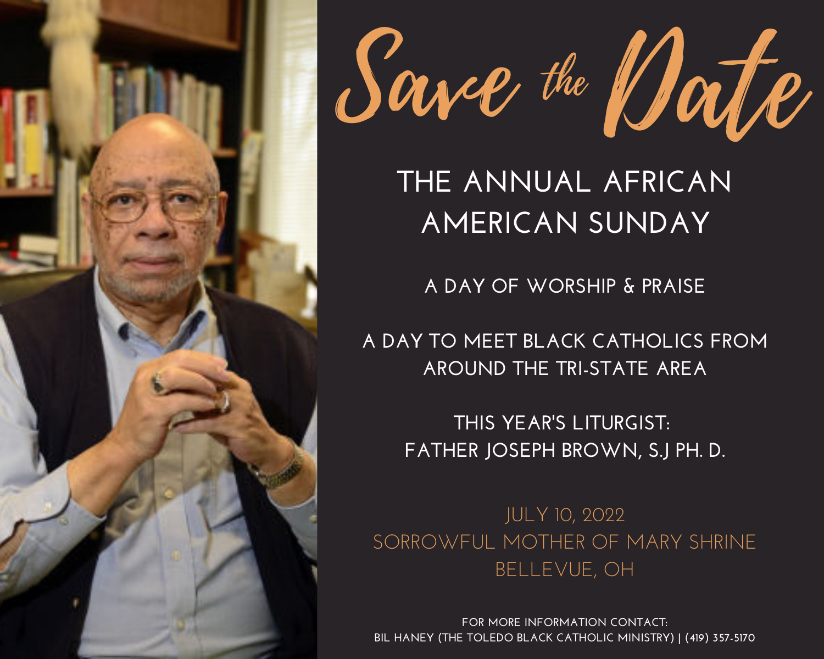

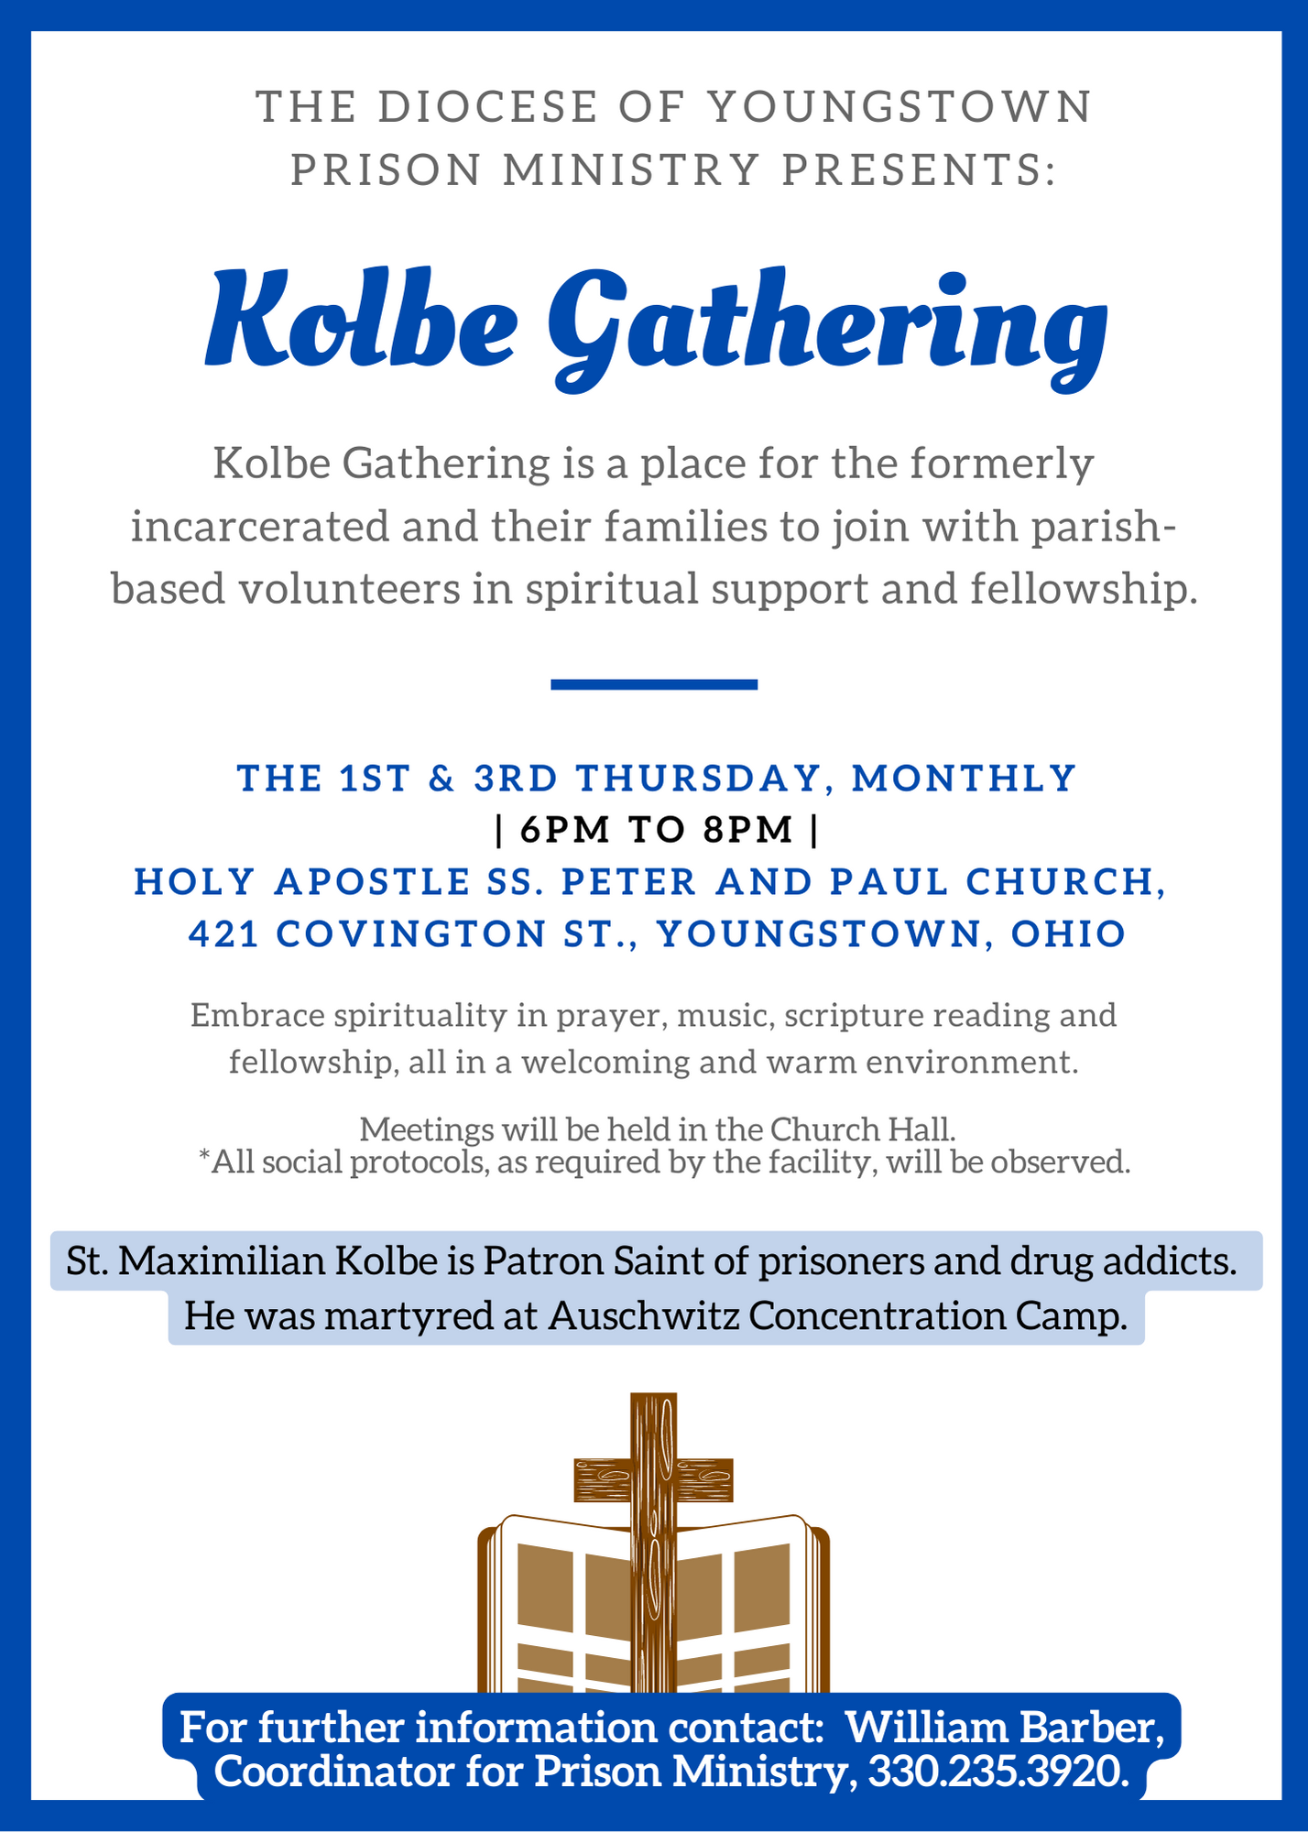

ANNUAL DIOCESAN APPEAL

Father John-Michael Lavelle continues to send regular progress updates by email, along with suggested announcements and bulletin blurbs.

These announcements can also be found in the “Parish Toolkit” at the bottom of the www.doy.org/appeal/ page.

The pledge care below may also be include in parish bulletins, to accompany regular announcements.

PLEDGE CARD TO BE INCLUDED IN BULLETIN
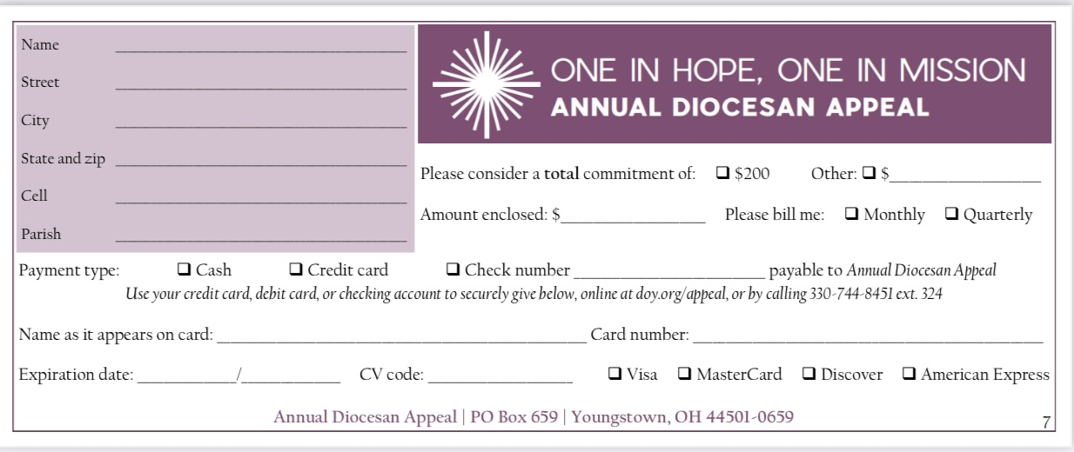

Marriage Preparation Formation Opportunities – 2022

Diocese of Youngstown

Marriage Preparation Engaged Couple Retreat, One-Day Retreat for Engaged Couples – On the following Saturdays, 9:00 to 4:00 p.m., $80 per couple:
- June 4, Regina Coeli Parish, 663 Fernwood Blvd., Alliance
- August 20, St. Columba Cathedral Hall, 144 W. Wood St., Youngstown
- October 22, St. Columba Cathedral Hall, 144 W. Wood St., Youngstown
- November 19, St. Columba Cathedral Hall, 144 W. Wood St., Youngstown
Brochures or on-line registration may be found on the diocesan website: www.doy.org (click the “Ministries” tab and click on “Pro-Life, Marriage & Family Life”), or contact dschmidt@youngstowndiocese.org or 330-744-8451 ext. 272.

Diocese of Cleveland (https://www.dioceseofcleveland.org/offices/parish-life/marriage-and-family-ministry/marriage/overview)

Jesuit Retreat House, 5629 State Road, Parma, Ohio 44134 (Cuyahoga County) offers Pre-Cana days nearly every month on Sundays from 12:45 to 8:00 pm for $100.00 per couple. Call 440-884-9300 for details. https://www.jesuitretreatcenter.org/calendar/pre-cana
- June 12, 2022;

Loyola Retreat House, 700 Killinger Road, Clinton, Ohio 44216 (Summit County), offers Pre-Cana days on Sundays, 11:00 am to 7:00 pm for $90.00 per couple. Call 330-896-2315 for details. https://loyolaretreathouse.com/wp/precana/
- June 12, 2022; September 18, 2022

Diocese of Pittsburgh (https://diopitt.org/marriage-preparation)

Diocese of Erie (https://www.eriercd.org/familylifeoffice/precana.html Phone 814-824-1265 or e-mail familylife@erieRCD.org)

Sunday, July 10th | 8:30am - 6:00pm | St. Mark Catholic Center, Erie | 814-824-1210
Sunday, September 18th | 8am-5pm  Includes Mass | Our Lady of Mercy, Harborcreek | 814-699-5342
Sunday, November 6th | 8am-4:30pm  Includes Mass | St. George, Erie | 814-864-0622

Engaged Encounter weekends Held at St. Mark Catholic Center 429 E. Grandview Blvd., Erie, PA 16504. Start time: 7 p.m. on Friday; Ending time: 1 p.m. on Sunday; $200 per couple. For more information or to register go to https://www.eriercd.org/familylifeoffice/ee.html.
- October 14-16, 2022
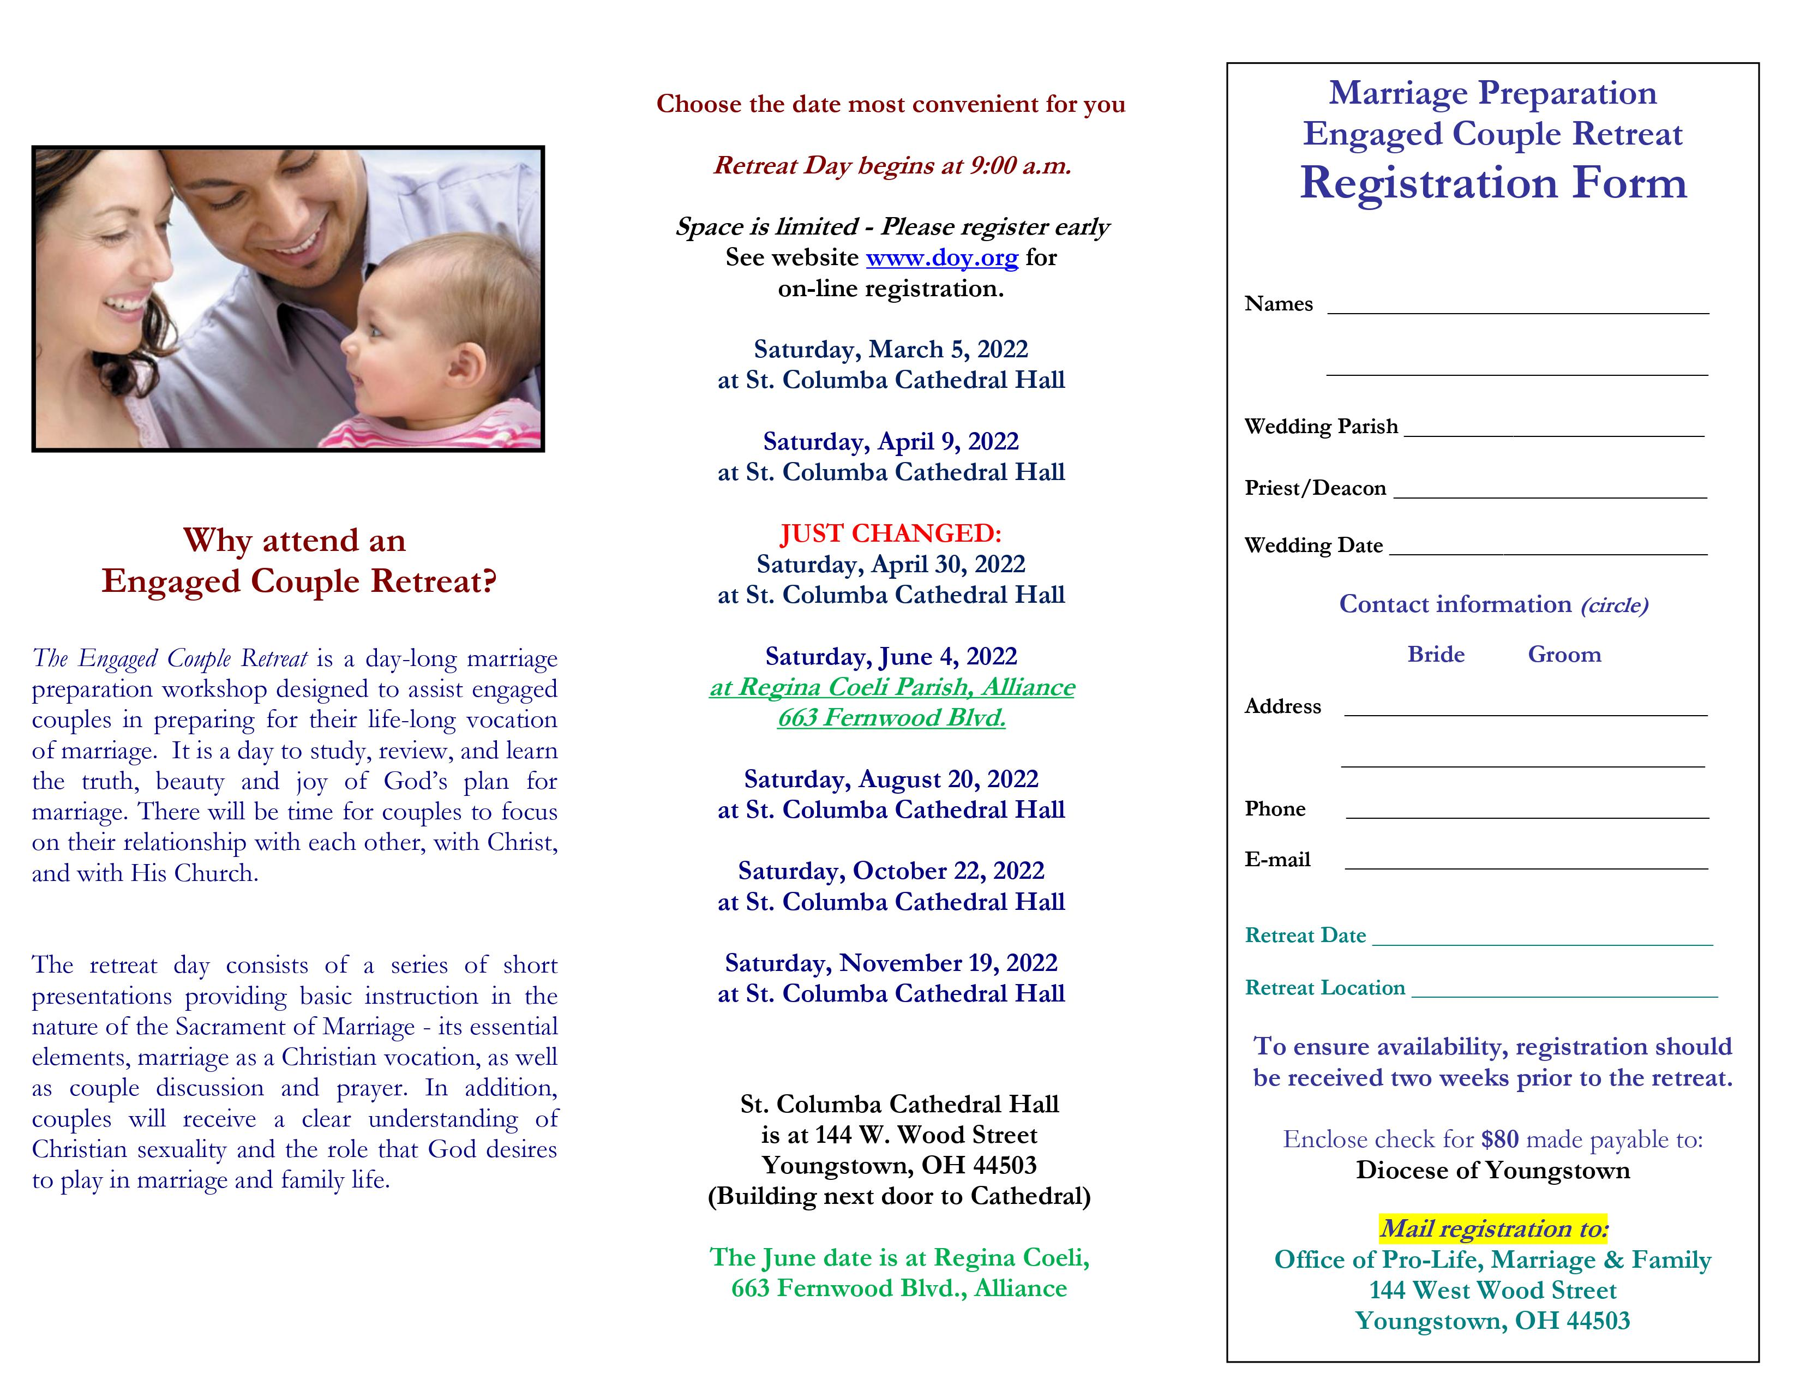
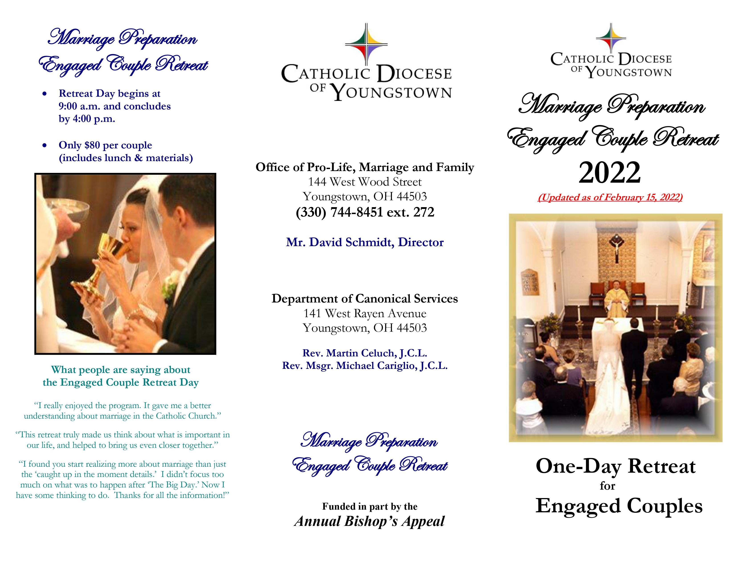

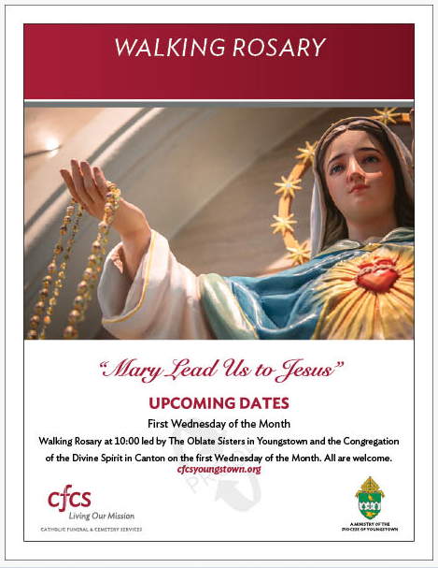
CHURCH AT HOME COMBINED COLLECTION

JUNE 5, 2022

BULLETIN/PULPIT ANNOUNCEMENTS

Weekend of May 28-29, 2022

Next weekend parishes in the Diocese of Youngstown will hold the annual CHURCH AT
HOME combined collection. This three-in-one collection supports the national and local
work of the Catholic Campaign for Human Development, the Catholic Communications
Campaign, and the Catholic University of America/Newman Campus Ministries collection
next weekend for the ministries of the CHURCH AT HOME.

Weekend of June 4-5, 2022

This weekend parishes in our diocese will participate in the combined collection for three
major CHURCH AT HOME ministries. The Catholic Campaign for Human Development
provides local diocesan and national support for groups of low-income persons to change
their lives. The Catholic Communication Campaign supports the efforts of the Catholic
Television Network of Youngstown (CTNY) and other national telecommunications
services to help spread the Word of God. The Catholic University of America and Newman
Campus Ministries continue the educational programs at the national university of our
Catholic Church. Your generous support is greatly appreciated.

Weekend of June 11-12, 2022

Thank you for your generous support last weekend of the Diocese of Youngstown CHURCH
AT HOME combined collection which supports the Catholic Campaign for Human
Development, the Catholic Communication Campaign and the educational ministries of the
Catholic University of America and Newman Campus Ministries. If you were unable to give
last weekend, please consider giving at your parish today for this important collection.

