ATTN: BULLETIN EDITORS AND INTERCESSION WRITERS

COMMUNIQUÉ JULY 2022
ADDITIONAL BULLETIN BRIEFS AND FLYERS

Note: Suggested announcements, suitable for bulletins and social media, are also indicated in the full communiqué with red lines at top and bottom.

This attachment includes the following graphic files / flyers – see notes below on any text-only version in the Communique (links to PDF included):

TABLE OF CONTENTS
- Safe Environment: Background Check Requirements
- Eucharistic Revival: Full Page Flyer
- Catholic Charities: Community Cupboard Bulletin Announcements 2022
- Catholic Charities: Community Cupboard Flyer/Bulletin
- Catholic Charities: African American Sunday – Save the Date Flyer
- Prison Ministry: Kolbe Gathering Flyer
- Catholic Exponent
- CTNY: Wineskins
- Office of Vocations: Vocations Bulletin Briefs
- Office of Vocations: Vocations Intercessions
- Office of Development and Stewardship: Stewardship Bulletin Thoughts (English)
- Office of Development and Stewardship: REFLEXIONES DEL BOLETIN DE CORRESPONSABILIDAD (en Español)
- Office of Faith Formation and Lay Ecclesial Ministry: Catechetical Sunday Flyer
- Catholic Diocese Library
- Office of Pro-Life, Marriage, and Family Life: World Day of Grandparents and the Elderly Flyer
- Office of Pro-Life, Marriage, and Family Life: NFP Week 2022 Flyer
- Office of Pro-Life, Marriage, and Family Life: Bulletin Blurbs
- Office of Worship: Bulletin Insert - Reception of Communion at Mass (Part 1)
- Office of Worship: Bulletin Insert – The Gesture of Reverence for Receiving Communion and Giving Thanks (Part 2)
- Office of Worship: Bulletin Insert – We Dare to Say “Amen” (Part 3)
- Diocesan Cemeteries: The Chaplet of Divine Mercy Flyer
- Diocesan Cemeteries: Walking Rosary Flyer
- St Joseph’s of Mantua: 58th Ox Roast Fair
- Diocese of Youngstown 35th Annual Pilgrimage: Basilica/Shrine in Carey, Ohio

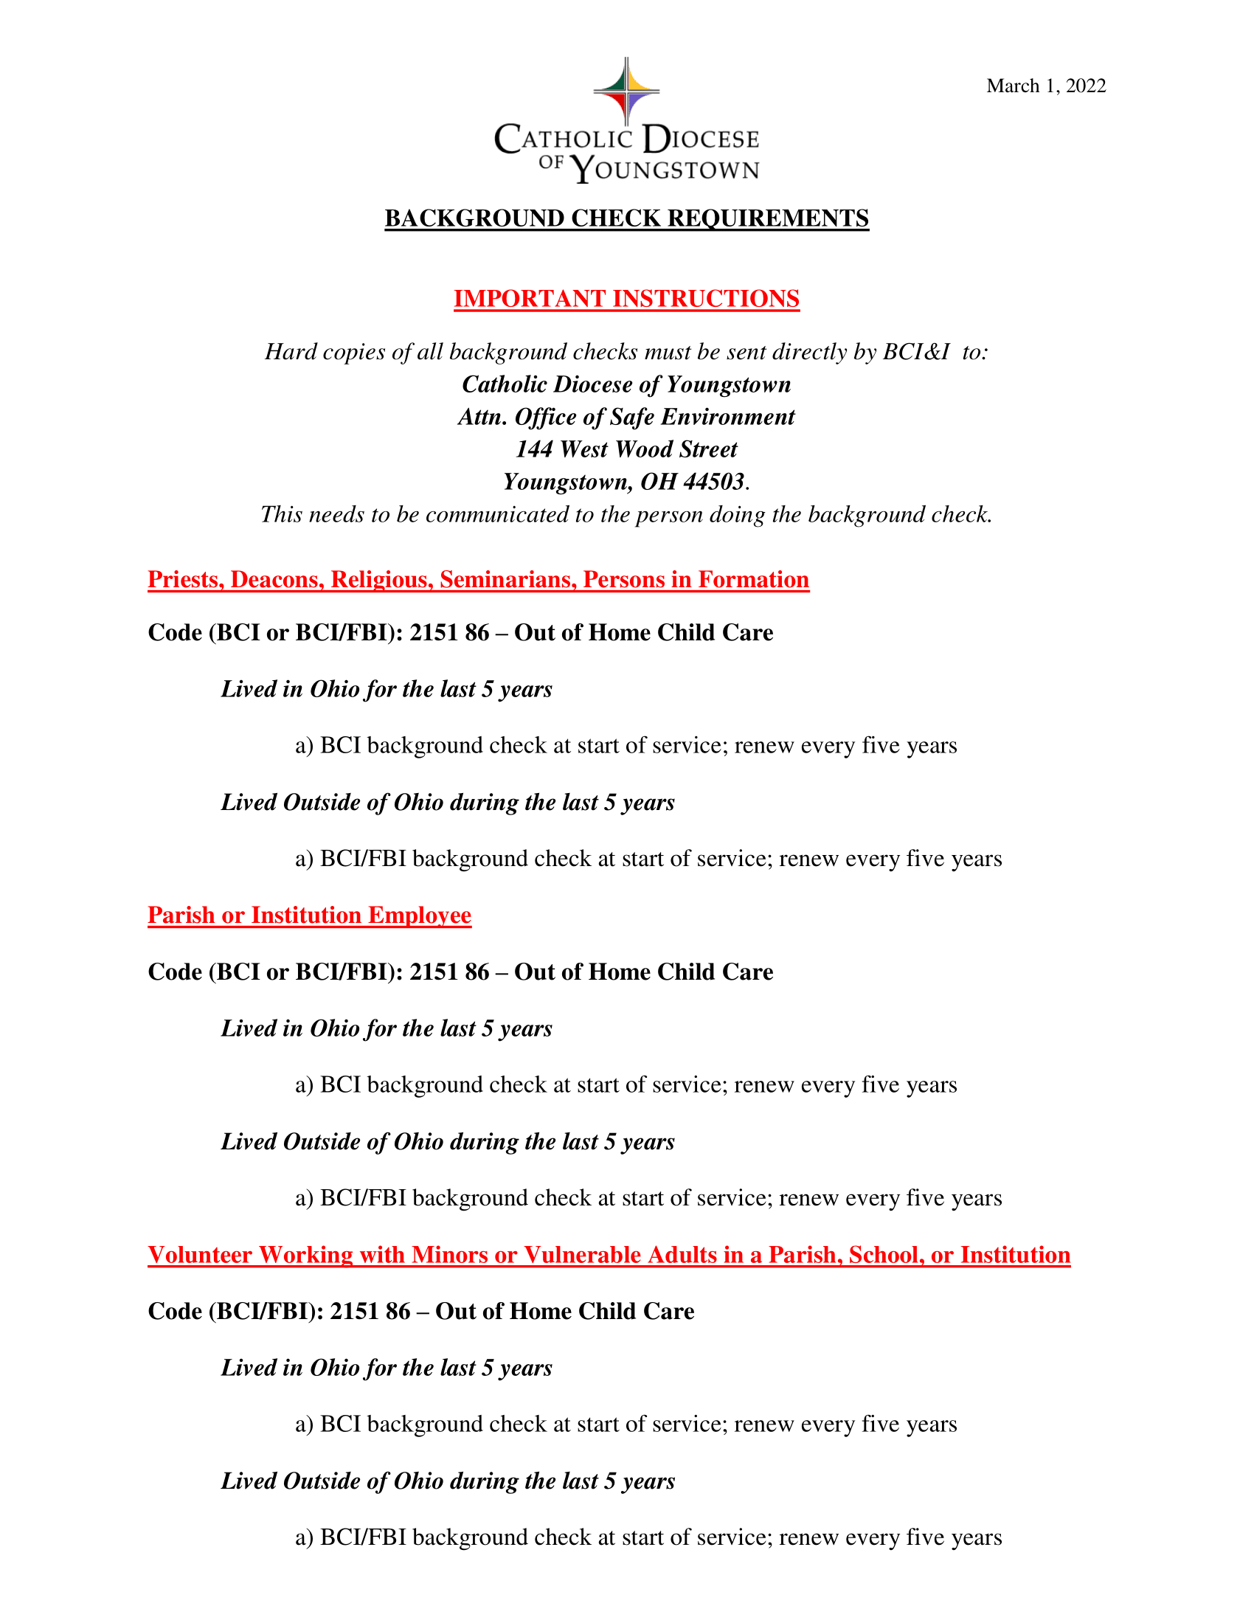

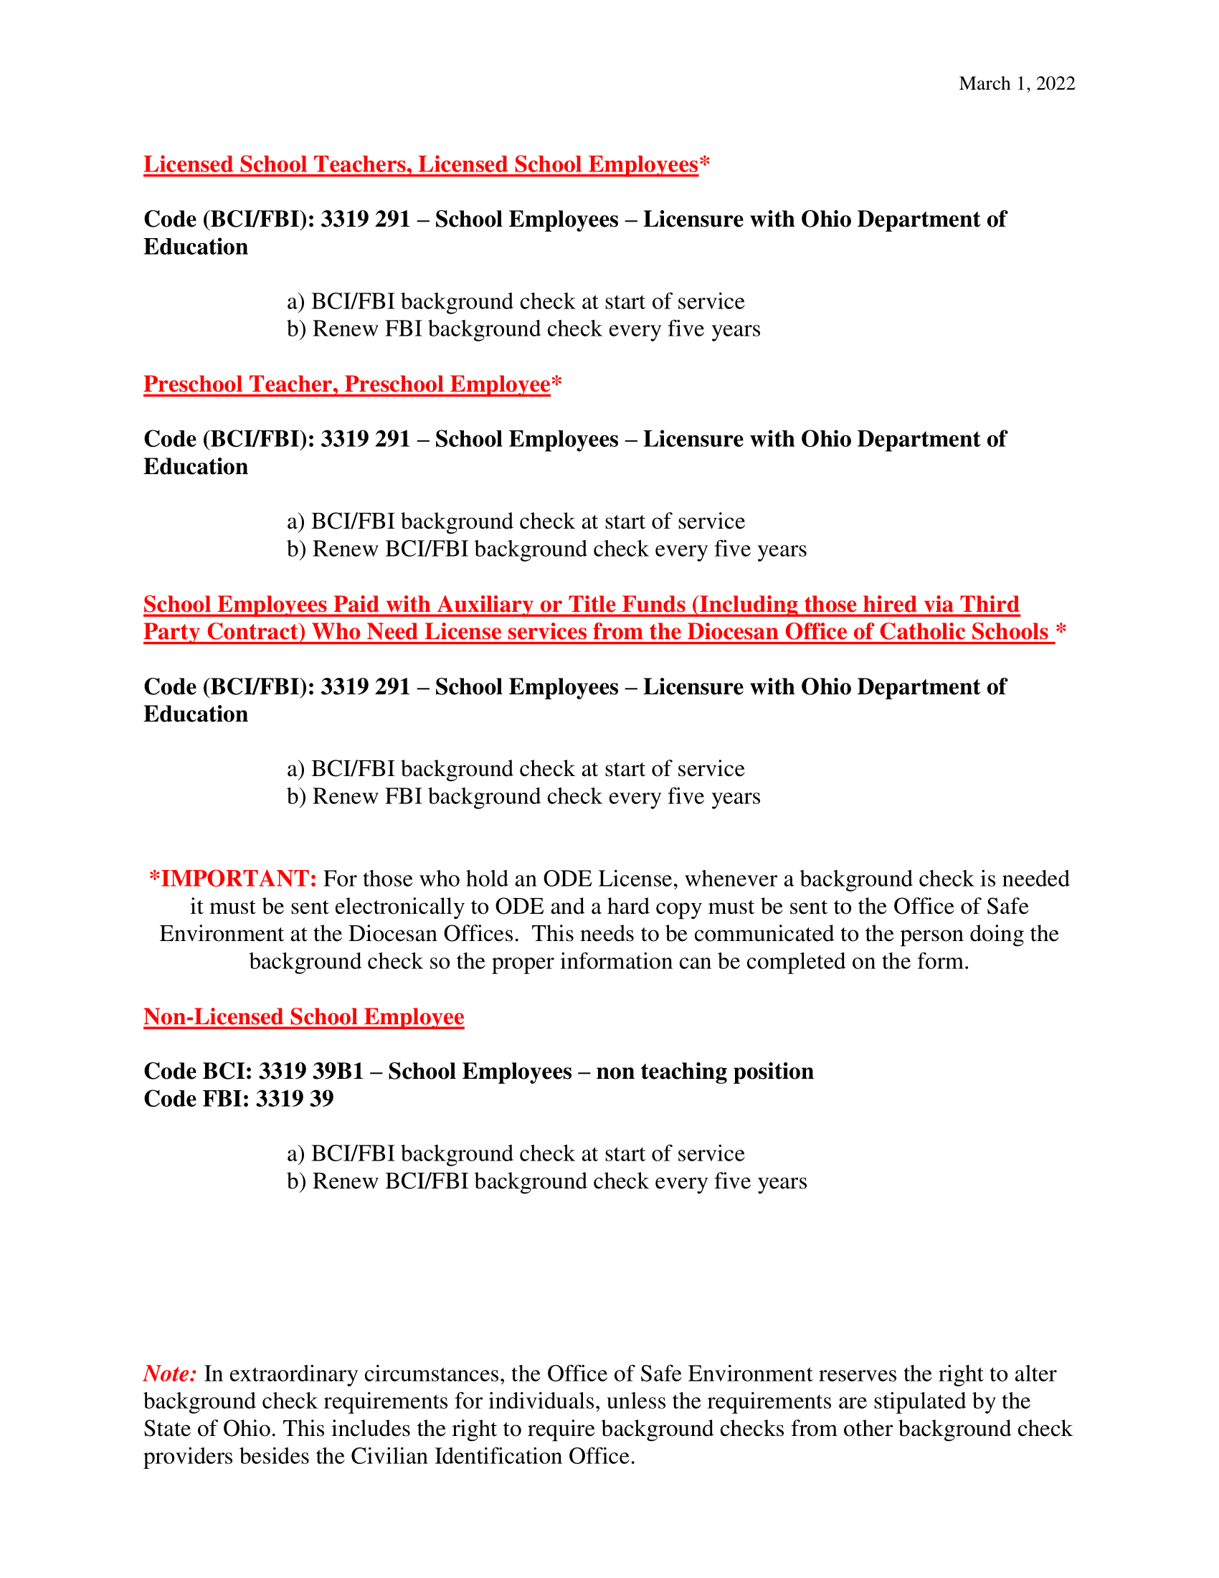

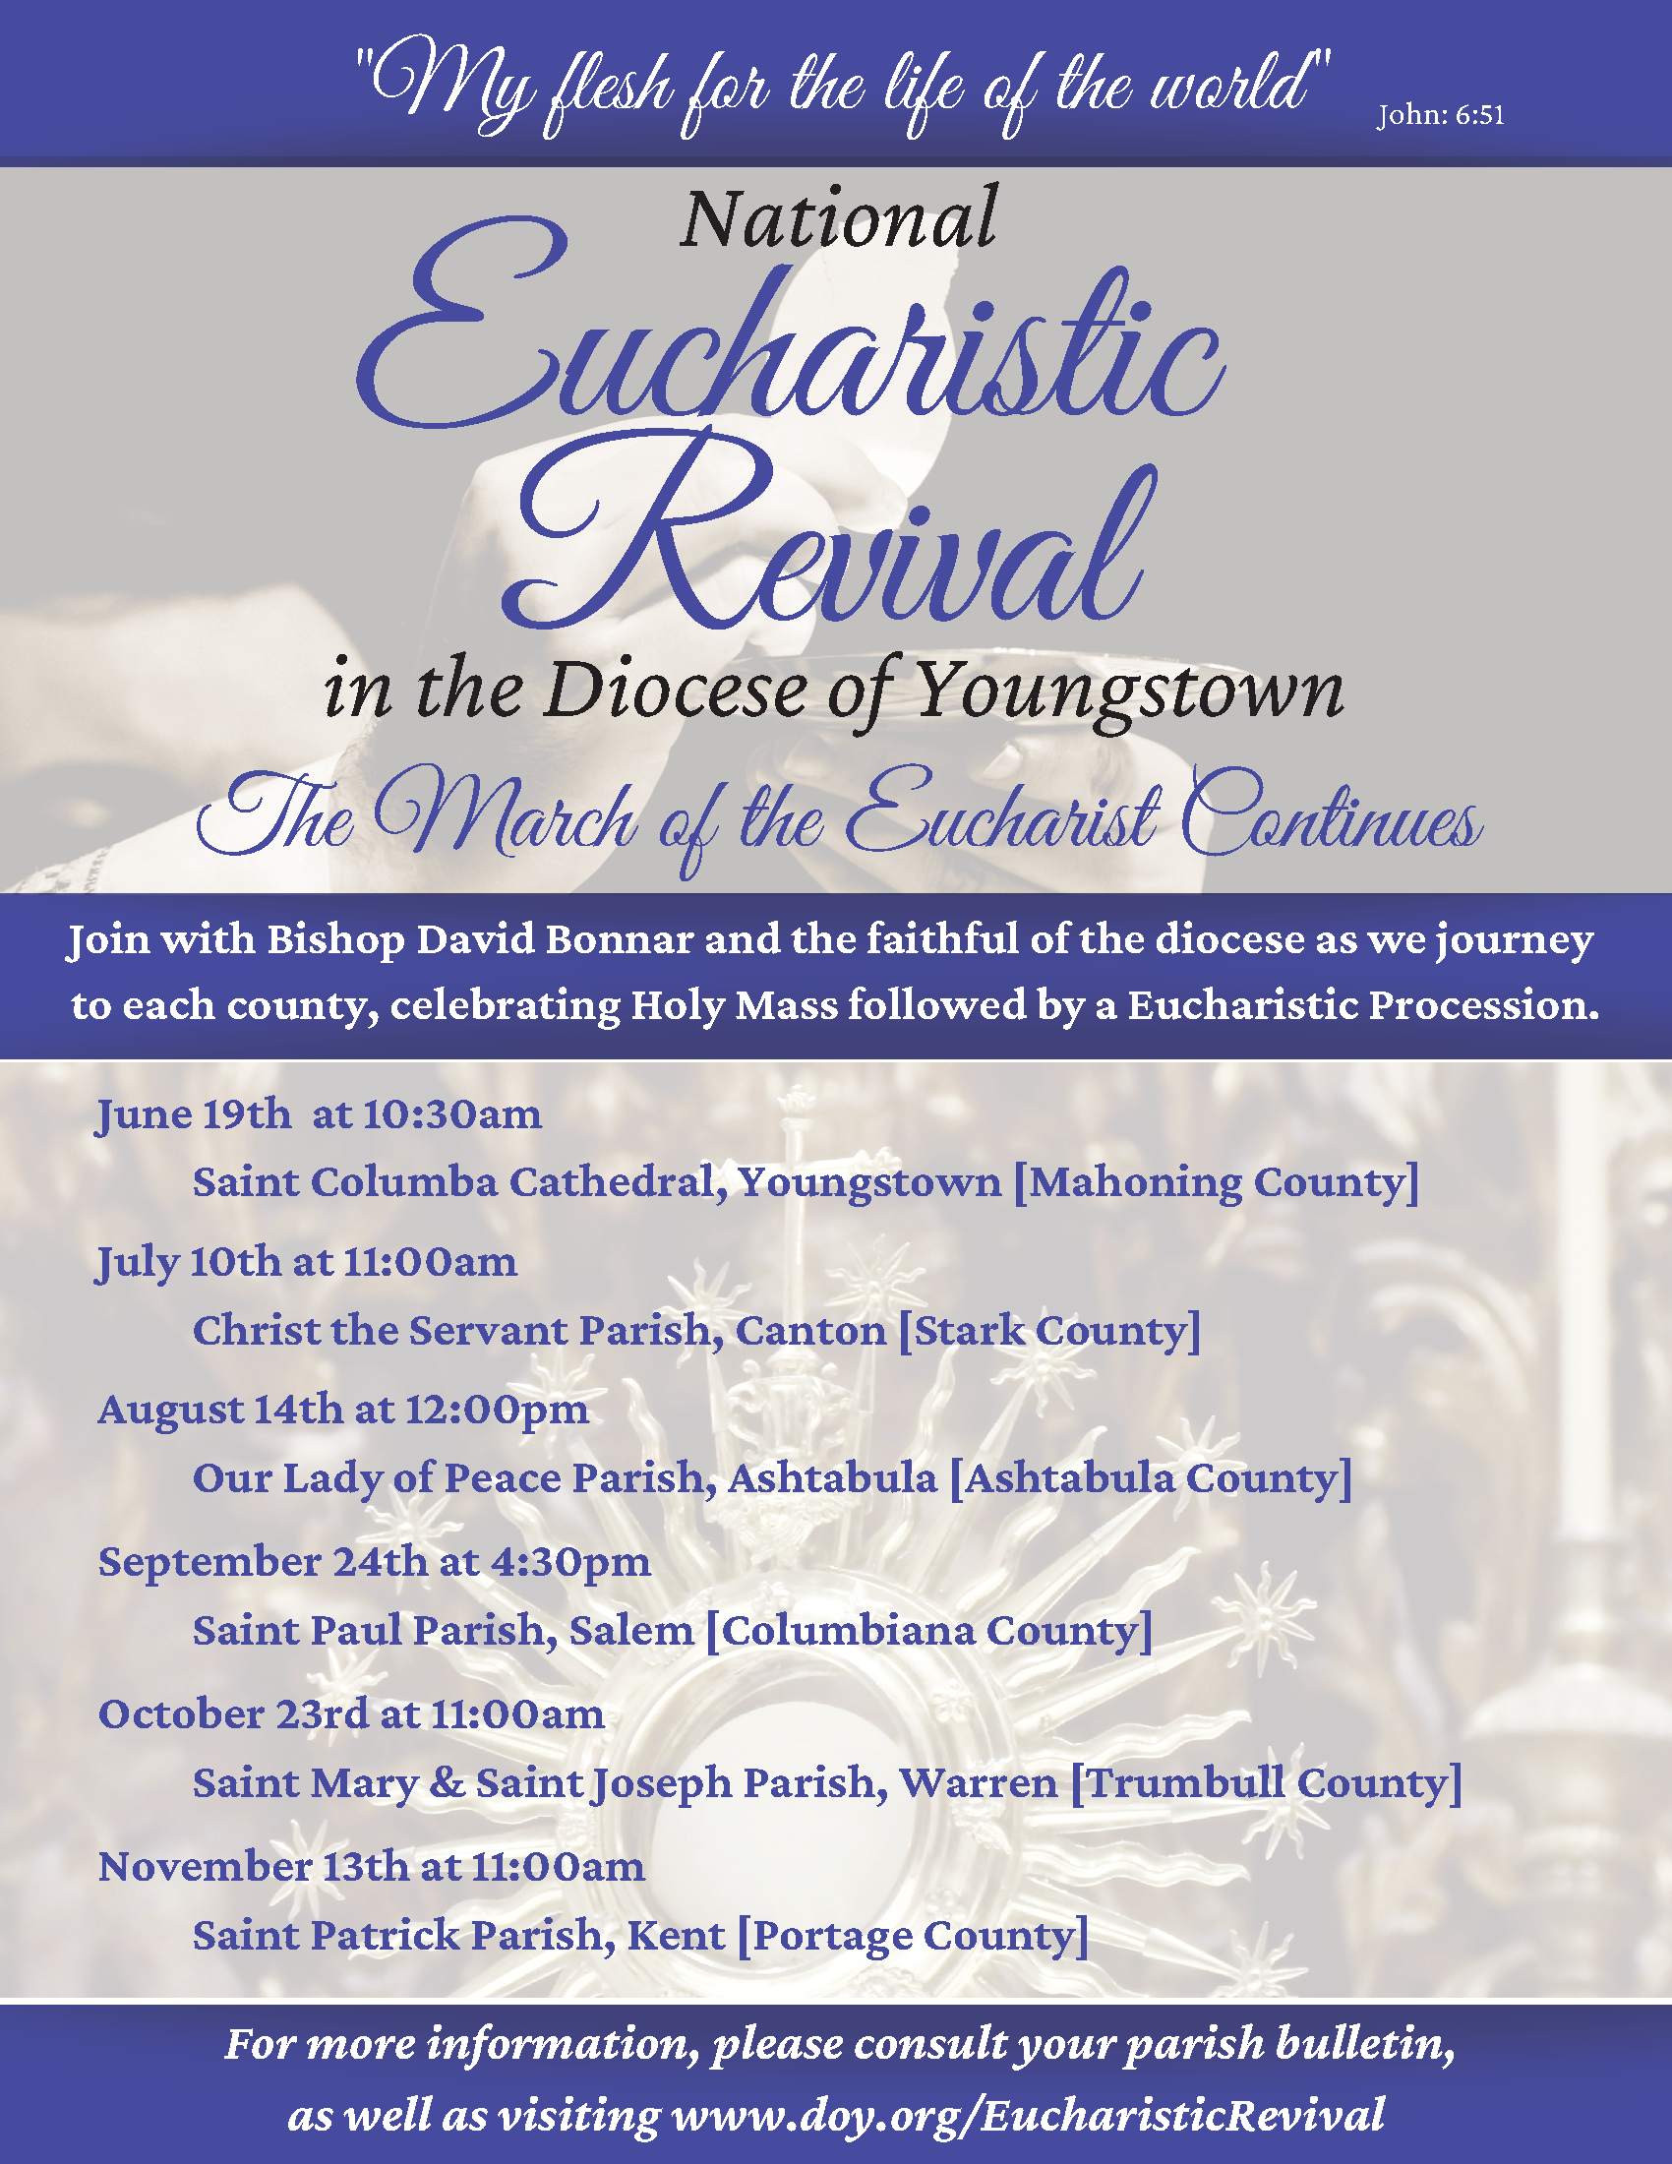

Community Cupboard

Bulletin Announcements 2022

Announcement # 1

Catholic Charities will launch its annual Community Cupboard campaign on Monday, July 18, 2022. This campaign responds to the economic hardships impacting many local families who struggle to keep food on their tables, purchase taxable goods, and pay their utility bills. These same families may already receive SNAP (food stamps) benefits to purchase food, but those benefits cannot be used to purchase personal care items or household products. The personal hygiene, paper, and cleaning products collected during the Community Cupboard campaign are distributed by our Catholic Charities agency sites to help restore clients’ dignity and self-esteem. Please visit www.ccdoy.org to learn more or make a donation at a Catholic Charities agency site near you. Donors are strongly encouraged to call the site first to confirm delivery details, such as office hours.

For a list of all area locations, visit www.ccdoy.org/locations.

Announcement # 2

Our faith reminds us to love God and to serve others. Many of the families who come to Catholic Charities for assistance could use our help keeping their families fed, clean and safe. Catholic Charities’ Community Cupboard campaign provides hygiene items, cleaning products and peace of mind to families in need. This campaign is a great service project for parish groups, youth groups, or local families to participate in. Please visit www.ccdoy.org to learn more about this important effort.

For a list of all area locations, visit www.ccdoy.org/locations.

Announcement # 3

When poor and working poor families face a set-back, such as an unexpected medical expense, missing work due to a sick child, or vehicle repairs, the consequences can lead to a serious and immediate financial crisis. Sometimes there is not enough money left to cover all of the monthly expenses, especially hygiene items, cleaning and laundry supplies. Catholic Charities’ annual Community Cupboard campaign aims to provide families these much needed items during times of crisis. Please support our Community Cupboard campaign by visiting our website to learn more (www.ccdoy.org), praying for those impacted by poverty, and by making a donation to an agency site nearest you. Donors are strongly encouraged to call the site first to confirm delivery details, such as office hours. Thank you! For a list of all area locations, visit www.ccdoy.org/locations.
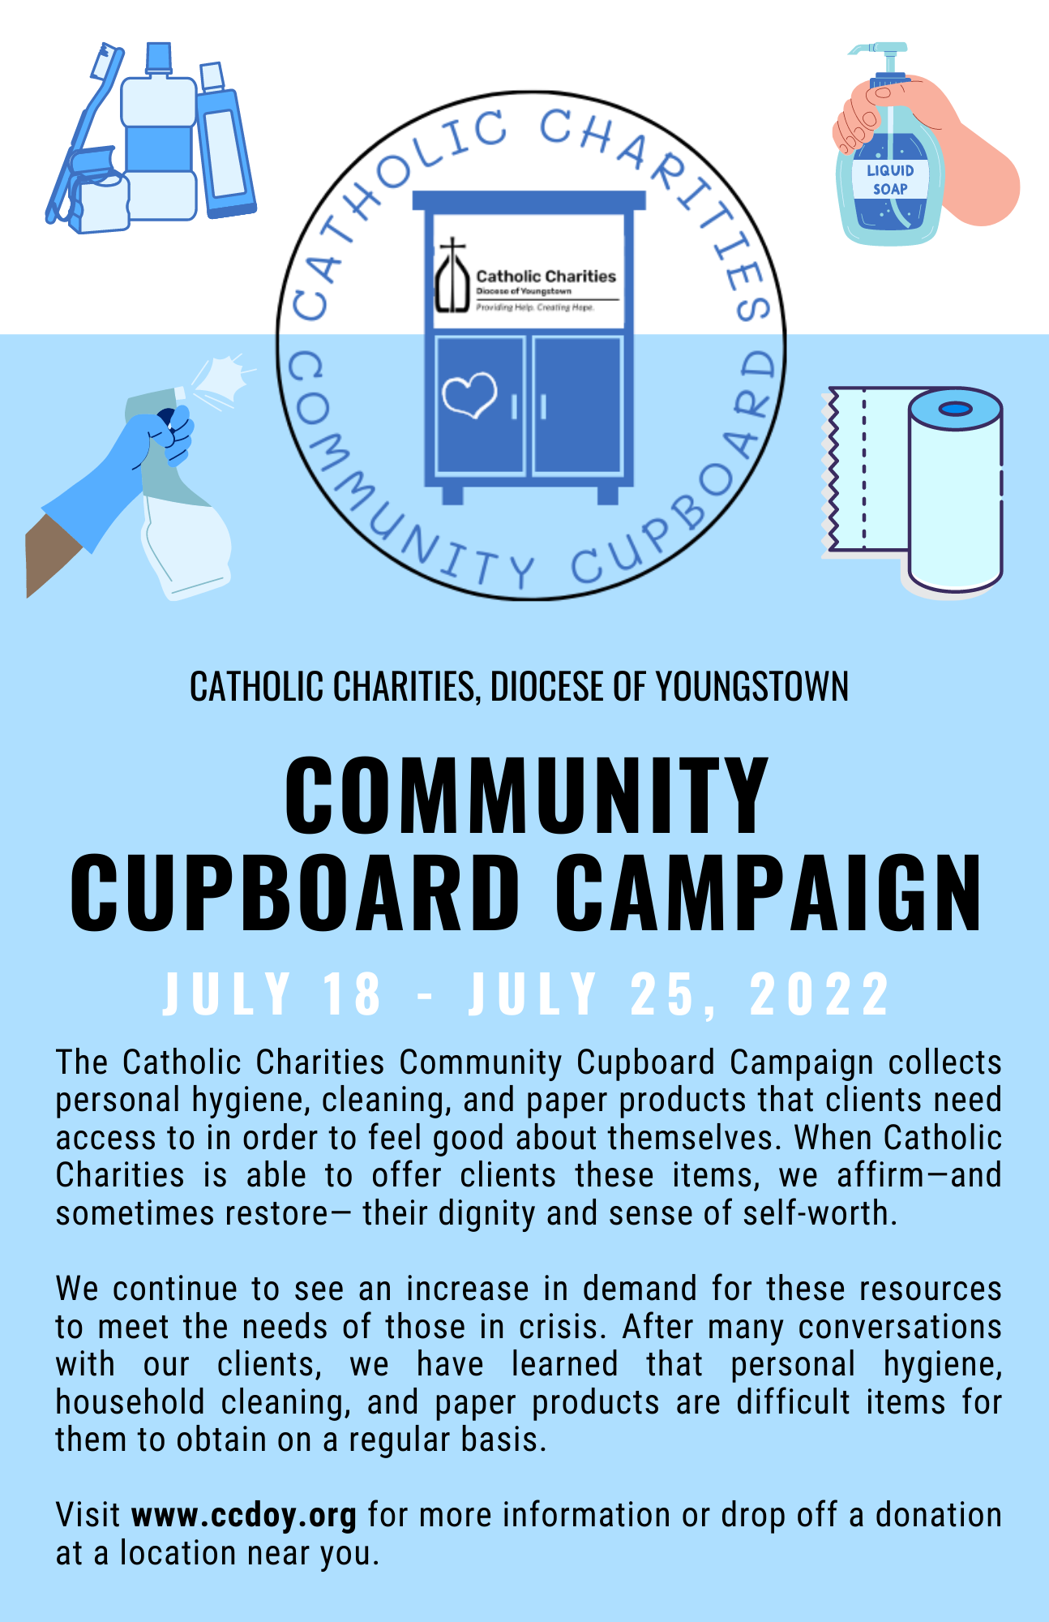
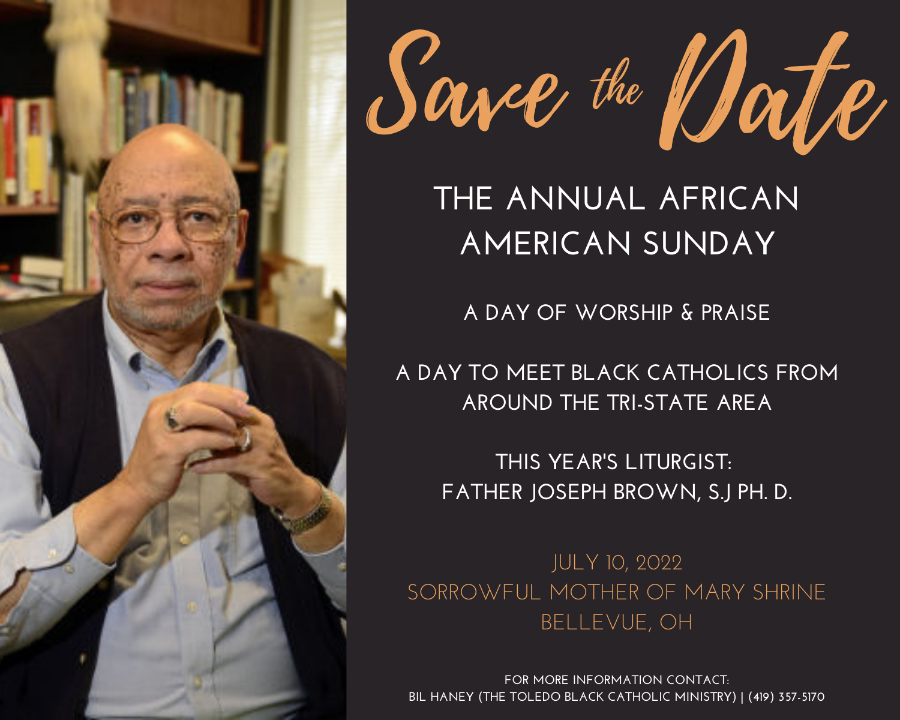
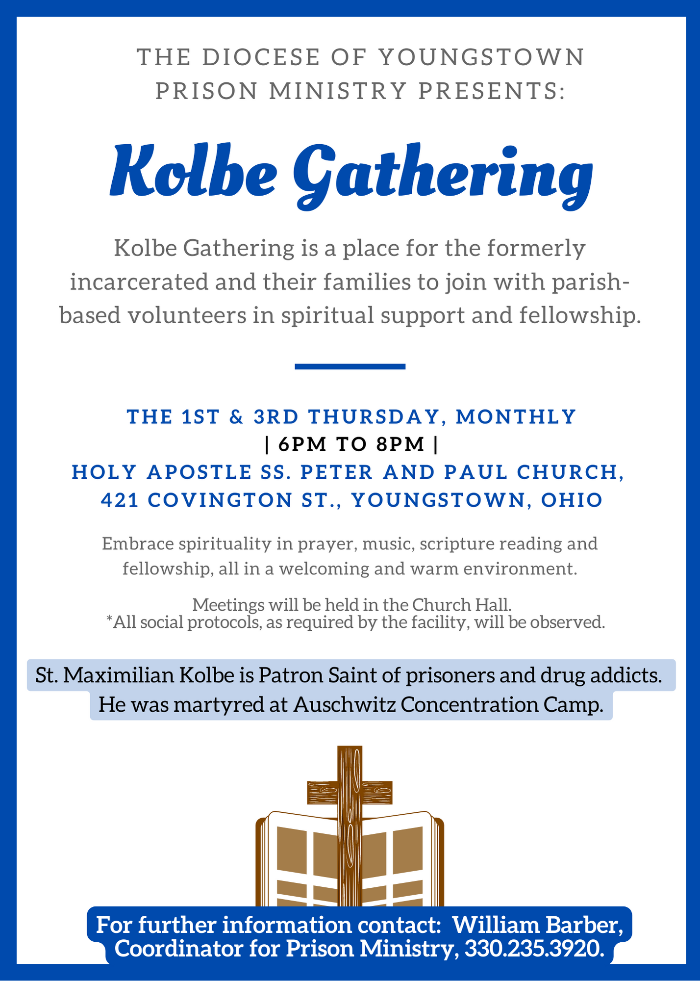

Subscribe to The Catholic Exponent

The Catholic Exponent is your source for informative, reliable, and doctrinally sound news stories, features, and commentary – keeping you up to date on local events such as Catholic school Advent programs and parish events, as well as the news of the Church across the country and around the globe.

To subscribe, call 330-744-5251 or email exposubscriptions@youngstowndiocese.org to request subscription information. Thank you for supporting your diocesan newspaper.

Wineskins airs every Sunday at 7:30 a.m. on WKBN 570 AM in Youngstown, WRQX 600 AM in Salem at 7:30 a.m., WILB AM Canton 1060/WILB FM 89.5 Youngstown/WILB FM 94.5 Canton at 9:30 a.m. and 9:00 p.m. Listen to Wineskins on the diocesan website by going to www.doy.org/live/ and clicking on the Wineskins button.

The Current Issue Segment will feature: July 3: Fr. Jim Korda speaks with Sheila Tripett; July 10: Fr. Jack Lavelle talks about the Media on Life Issues; July 17: Fr Jim Korda speaks with Nancy Voitus on Catholic Charities; July 24: Fr. Jim Korda speaks with Mary Beth Garvin from Peter’s Shadow; and, July 31: Fr. Jim Korda speaks with Fr David Misbrener on Patrimony.

Martha Coulter, from St. Jude Church in Columbiana, will tell us about the Saints celebrated this month: July 3: Venerable Martyr Febronia; July 10: St. Kateri Tekakwitha; July 17: St. Mary Magdalene; July 24: Saints Martha, Mary and Lazarus; and, July 31: St. John Vianney.

The Interview Segment will include: July 3: Fr. Jim Korda speaks with Sr. Mary McCormick, OSU, Part II; July 10: Fr. Jim Korda interviews Sr. Mary McCormick, OSU, Part III; July 17: Fr. Jim Korda speaks with Deacon Brook Benedict; July 24: Fr. Jim Korda speaks with Deacon Fred Schlueter; and, July 31: Fr. Jim Korda interviews Deacon John Rovnak.

This month’s Music Segment is from the CD “Love Songs Inspired from Above,” by the Kellenberg Memorial High School Choir.

Sr. Regina Rogers, OSU, Pastoral Assistant at St. Edward Church in Youngtown, will give her reflections on the Sunday Scripture Readings: July 3: Fourteenth Sunday in Ordinary Time; July 10: Fifteenth Sunday in Ordinary Time; July 17: Sixteenth Sunday in Ordinary Time; July 24: Seventeenth Sunday in Ordinary Time; and, July 31: Eighteenth Sunday in Ordinary Time.

Attn: Bulletin Editor and Intercessions Writers

Vocation Bulletin Briefs
July 2022/Cycle C
(Intercessions follow)

Thirteenth Sunday in Ordinary Time – June 26, 2022
“Serve one another through love.” Does a life of prayer and service as a priest, deacon or in the consecrated life attract you? Call Father Chad Johnson at 330-744-8451 or email: cjohnson@youngstowndiocese.org.

Fourteenth Sunday in Ordinary Time -- July 3, 2022
“The harvest is abundant but the laborers are few.” Are you called to be a laborer for Christ as a priest, deacon, brother or sister? Call Father Chad Johnson at 330-744-8451 or email: cjohnson@youngstowndiocese.org.

Fifteenth Sunday in Ordinary Time -- July 10, 2022
“What must I do to inherit eternal life?” Faithfulness to one’s vocation is essential to holiness. Is yours to be a priest, deacon, sister or brother? Call Father Chad Johnson at 330-744-8451 or email: cjohnson@youngstowndiocese.org.

Sixteenth Sunday in Ordinary Time -- July 17, 2022
“It is He whom we proclaim.” Are you being called to proclaim Christ and the word of God? Call Father Chad Johnson at 330-744-8451 or email: cjohnson@youngstowndiocese.org.

Seventeenth Sunday in Ordinary Time -- July 24, 2022
“Give us this day our daily bread.” Are you being called to help feed the people of God as a priest, deacon or in the consecrated life? Call Father Chad Johnson at 330-744-8451 or email: cjohnson@youngstowndiocese.org.

Eighteenth Sunday in Ordinary Time -- July 31, 2022
If simplicity of life and the evangelical counsels of poverty, chastity and obedience especially attract you, discover that life as a priest, deacon, sister or brother. Call Father Chad Johnson at 330-744-8451 or email: cjohnson@youngstowndiocese.org.

Nineteenth Sunday in Ordinary Time -- August 7, 2022
“ … for he has prepared a city for them.” Are you called to lead the Lord’s people to the eternal city that he has prepared for them as a priest, deacon or in the consecrated life? Call Father Chad Johnson at 330-744-8451 or email: cjohnson@youngstowndiocese.org.

Vocation General Intercessions
July 2022/Cycle C

The Ascension of the Lord -- May 29, 2022
That Christ, from his seat in heaven, will bless and guide all those called to serve Him as priests, deacons, sisters and brothers, we pray to the Lord.

Pentecost Sunday -- June 5, 2022
That those now discerning their vocations will be guided by the Holy Spirit to respond to the Lord’s call with passion and enthusiasm, we pray to the Lord.

The Most Holy Trinity – June 12, 2022
That those chosen to share the mercy of God as priests, deacons, sisters and brothers will be faithful to the Spirit of Truth who has called them and guides them, we pray to the Lord.

The Most Holy Body and Blood of Christ -- June 19, 2022 [Corpus Christi]
That the Body and Blood of Christ will strengthen those being called to the priesthood, diaconate or consecrated life to persevere in their vocations and respond with confidence and joy, we pray to the Lord.

Thirteenth Sunday in Ordinary Time – June 26, 2022
That men and women called to proclaim the kingdom of God as priests, deacons and in the consecrated life, will be given the strength to overcome every obstacle to their response through prayer and the practice of virtue, we pray to the Lord.

Fourteenth Sunday in Ordinary Time -- July 3, 2022
For an increase in laborers to the Lord of the Harvest in response to our prayers for vocations to the priesthood, diaconate and the consecrated life, and for the holiness of all those now serving the people of our diocese in these vocations, we pray to the Lord.

Fifteenth Sunday in Ordinary Time -- July 10, 2022
That all those now discerning their vocation will be attentive in prayer and active in their response to Jesus the Eternal Word who calls them, we pray to the Lord.

Sixteenth Sunday in Ordinary Time -- July 17, 2022
That like Mary of Bethany, all priests, deacons and brothers and sisters will listen to the Lord in prayer, faithful to their choice of vocation, we pray to the Lord.

Seventeenth Sunday in Ordinary Time -- July 24, 2022
That the Holy Spirit will give inspiration and guidance to all those discerning their vocation in Christ, we pray to the Lord.

Eighteenth Sunday in Ordinary Time -- July 31, 2022
That those who desire to be “rich in what matters to God” and are discerning a vocation to the consecrated life will be enriched by the Holy Spirit, we pray to the Lord.

Nineteenth Sunday in Ordinary Time -- August 7, 2022
That those who have been given their vocations as priests, deacons and consecrated men and women will be guided to imitate the Lord’s generosity as they live that gift, we pray to the Lord.

Stewardship Bulletin Thoughts
July - September 2022

July 3, 2022
14th Sunday in Ordinary Time
“He said to them, ‘The harvest is abundant, but the laborers are few…’” Luke 10:2
As Catholics we are all called to serve. Each of us has been given “charisms” otherwise known as gifts from the Holy Spirit to help build God’s Church. Our charisms can only be used for good. We know that we are using them in the right ministry when we are filled with joy and we want to share stories about our charitable works. Discern how God is calling you to use your charisms. Say “yes” to what God is calling you to do and then do it! Share your joy and invite others to do the same.

July 10, 2022
15th Sunday in Ordinary Time
“Jesus said to him, ‘Go and do likewise.’” Luke 10:37
This was Jesus’ command at the end of the Good Samaritan story. Did you know that the Samaritans and Jews despised each other? The moral of the story is to love our neighbor. That means loving someone you may not know, or someone that looks different than you, or someone that has different beliefs than you, or someone that you don’t like. All without expecting anything in return.

July 17, 2022
16th Sunday in Ordinary Time
“…I am a minister in accordance with God’s stewardship given to me to bring to completion for you the word of God.” Colossians 1:25
We are all called to evangelize – to convert individuals and society by the divine power of the Gospel. Our faith is more attractive to others by our actions than by our words alone. We may not be called to evangelize like St. Paul, but we should look for opportunities to share our faith through our actions and words, especially with those closest to us, like our family, friends and neighbors. Pray for the courage to joyfully express your faith the next time the opportunity arises.

July 24, 2022
17th Sunday in Ordinary Time
“Ask and you will receive; seek and you will find; knock and the door will be opened to you.”
Luke 11:9
Jesus assures us that if we ask, God will take care of what we need. The problem is that our culture often confuses what we really need with what we simply want. The truth is that many of us need very little. However, we usually want so much more! Stewardship is simply being grateful for all that we are and all that we have been given, and generously sharing all of our God-given gifts with others. Generosity is a gift that opens doors to new relationships with others and with God.

July 31, 2022
18th Sunday in Ordinary Time
“Take care to guard against all greed, for though one may be rich, one’s life does not consist of possessions.” Luke 12:15
The Gospel message is contrary to modern culture that continually tries to convince us that our joy comes from the material things we possess. That the more we acquire, the happier we will be. Jesus shows us that our true joy comes from our “invisible” gifts like love, mercy and forgiveness. True joy comes from “emptying” ourselves, giving of ourselves rather than always taking. We are called not to hoard but to share. True joy comes from living a grateful and generous lifestyle; become more “God-centered” and less “self-centered.”

August 7, 2022
19th Sunday in Ordinary Time
“For where your treasure is, there also will your heart be.” Luke 12:34
Jesus encourages us to build up our treasure in heaven. The world encourages us to build up our treasure in real estate, investments, and material goods. How much time are you investing in building up a worldly treasure? How much time are you investing in building up a heavenly treasure? To invest more in the things of heaven, you must let go of some of the things of this world.

August 14, 2022
20th Sunday in Ordinary Time
“Do you think I have come to give you peace on Earth? No, I tell you, but rather division.”
Luke 12:51
Many of us like to play it safe, not cause waves with our family and friends, especially when it comes to politics and religion. We don’t want to cause any turmoil. However, many times this is at the expense of the truth. The truth being Jesus Christ. Too many people are misguided because they rely on their own limited human ability to reason and are not allowing faith in God to guide them. Form your conscience; take a stance for life, marriage and religious liberty.

August 21, 2022
21st Sunday in Ordinary Time
“For behold, some are last who will be first and some are first who will be last.” Luke 13:30
Our cultural standards are different from God’s standards. We often rank people by what they have, how powerful they are, or how successful they are. Jesus reminds us that God will not judge us by the same earthly standards. When God asks you, “What have you done with the gifts I have given you?” How will you respond?

August 28, 2022
22nd Sunday in Ordinary Time
“Rather, when you hold a banquet, invite the poor, the crippled, the lame, the blind; blessed indeed will you be because of their inability to repay you." Luke 14:13-14
One of the main principles of living a stewardship lifestyle is to give without expecting anything in return. This is difficult for some to comprehend in our “consumerist” culture that we live in. This is even difficult for many parish communities that have become heavily dependent on parish fundraising events to support the mission and ministry of their local parish. Generally speaking, at a parish fundraiser, you pay money and receive something in return, it’s just a financial transaction. This is opposed to our parish offertory at Holy Mass, where you unite your sacrifice with Jesus’, renewing our covenant relationship with Him.

September 4, 2022
23rd Sunday in Ordinary Time
“Everyone of you who does not renounce all his possessions cannot be my disciple.” Luke 14:33
When we first hear this statement, it seems that Jesus is making an unrealistic demand upon us. How can we renounce all of our possessions? We need them to live. However, what we must renounce is the belief that they belong to us. Everything that we have belongs to God alone. All of our resources are entrusted to us not only for our own use, but also so that we can help others. Once we renounce the idea that we possess or are entitled to anything, it is much easier to share the many gifts that God has given us. Then we truly are His Disciples.

September 11, 2022
24th Sunday in Ordinary Time
“Everything I have is yours.” Luke 15:31
Our Heavenly Father gives us everything, including the chance to share in His eternal kingdom. Yet, like the Prodigal Son, we are often lured away by the materialism of our society. Do you really want to turn your back on all that God offers in exchange for material wealth that has no lasting value? God wants us to be happy on earth as well. But, that requires us to freely accept His gift of faith; putting Him first in all things and detaching from our own self-sufficiency.

September 18, 2022
25th Sunday in Ordinary Time
“No servant can serve two masters. He will hate one and love the other, or be devoted to one and despise the other. You cannot serve God and mammon (wealth).” Luke 16:13
Jesus knows that for many of us, God and money run “neck and neck” as top priority. Is money a “god” that you put before God? Giving money to support the Church and other charity is a pillar of our faith, just like attending Mass every Sunday and participating in parish ministry. Giving money frees us from becoming a slave to money. It increases our dependence on God and our trust that God will provide all that we need.

September 25, 2022
26th Sunday in Ordinary Time
“My child, remember that you received what was good during your lifetime while Lazarus likewise received what was bad; but now he is comforted here, whereas you are tormented. Moreover, between us and you a great chasm is established…” Luke 16:25-26
When God created the world He declared that it was good and He gave it to all mankind for us to enjoy. However, over the years we have created a chasm between those who have great gifts and those who do not. In today’s Gospel we see that with our own generosity we must bridge that gap between those who have much and those who have little or we may find ourselves on the wrong side of the chasm in the next life.

REFLEXIONES DEL BOLETIN DE CORRESPONSABILIDAD
Julio - Septiembre 2022

3 de Julio de 2022
Domingo 14º del Tiempo Ordinario
Él les dijo, “La cosecha es abundante, pero los trabajadores son pocos...” Lucas 10:2
Como Católicos todos estamos llamados a servir. A cada uno de nosotros se nos han otorgado “carismas”, también conocidos como dones del Espíritu Santo, para ayudarnos a construir la Iglesia de Dios. Nuestros carismas solamente pueden utilizarse para bien. Sabemos que los estamos utilizando en el ministerio correcto cuando nos sentimos llenos de alegría y queremos compartir las historias acerca de nuestras obras de caridad. Descifre como Dios lo llama a utilizar sus carismas. ¡Dígale “sí” al llamado de Dios y luego póngalo en práctica! Comparta su alegría e invite a los demás a hacer lo mismo.

10 de Julio de 2022
Domingo 15º del Tiempo Ordinario
“Jesus le dijo, ‘Ve y haz lo mismo’” Lucas 10:37
Este fue el mandato de Jesus al final de la historia del Buen Samaritano. ¿Sabía usted que los Samaritanos y los Judíos se despreciaban los unos a los otros? La moraleja de la historia es amar a nuestros vecinos. Eso quiere decir amar a alguien que usted quizás no conoce, que luce diferente a usted, que tiene creencias diferentes a las suyas, o que a usted no le gusta. Todo sin esperar nada a cambio.

17 de julio de 2022
Domingo 16º del Tiempo Ordinario
“...Soy ministro de acuerdo con el plan que Dios me ha dado: dar cumplimiento a la palabra de Dios.” Colosenses 1:25
Todos somos llamados a evangelizar - a convertir a los individuos y a la sociedad por el poder divino del Evangelio. Nuestra fe es más atractiva a los demás por nuestras obras que solo por nuestras palabras. Puede que no seamos llamados para evangelizar como San Pablo, pero debemos buscar oportunidades para compartir nuestra fe a través de nuestras acciones y palabras, especialmente con aquellos que están más cerca de nosotros, como nuestra familia, amigos y vecinos. Rece para tener el valor de expresar alegremente su fe la próxima vez que se presente la oportunidad.

24 de julio de 2022
Domingo 17º del Tiempo Ordinario
“Pidan, y se les dará; busquen, y encontrarán; llamen, y se les abrirá la puerta” Lucas 11: 9
Jesús nos asegura que, si le pedimos, Dios se ocupará de nuestras necesidades. El problema es que nuestra cultura a menudo confunde lo que realmente necesitamos y lo que simplemente queremos. La verdad es que muchos de nosotros necesitamos muy poco. Sin embargo, ¡usualmente queremos mucho más! Corresponsabilidad es simplemente estar agradecido por todo lo que somos y por todo lo que se nos ha dado, y compartir generosamente con los demás todos los dones que Dios nos ha otorgado. La generosidad es un don que abre puertas a nuevas relaciones con los demás y con Dios.

31 de julio de 2022
Domingo 18º del Tiempo Ordinario
“Estén atentos y cuídense de toda forma de avaricia; porque aun cuando alguien tenga abundancia, su vida no consiste en tener bienes” Lucas 12:15
El mensaje del Evangelio es contrario a la cultura moderna que continuamente trata de convencernos de que nuestra alegría viene de los bienes materiales que poseemos. Que mientras más cosas adquirimos, más felices seremos. Jesús nos muestra que nuestra verdadera alegría viene de nuestros dones “invisibles” como el amor, la misericordia y el perdón. La verdadera alegría viene de “vaciarnos” nosotros mismos, dando de nosotros en lugar de tomar. No somos llamados a atesorar sino a compartir. La verdadera alegría viene de tener un estilo de vida agradecido y generoso; de transformarnos para estar más “centrados en Dios” y ser menos “egocéntricos”.

7 de agosto de 2022
Domingo 19º del Tiempo Ordinario
“Porque donde estén sus tesoros, allí estará su corazón» Lucas 12:34
Jesús nos anima a construir nuestros tesoros en el cielo. El mundo nos anima a construir nuestros tesoros en bienes raíces, inversiones y bienes materiales. ¿Cuánto tiempo invierte en construir su tesoro terrenal? ¿Cuánto tiempo invierte en construir su tesoro celestial? Para invertir más en las cosas del cielo, debe dejar ir algunas de las cosas de este mundo.

14 de agosto de 2022
Domingo 20º del Tiempo Ordinario
“¿Creen ustedes que vine a traer paz a la tierra? ¡No! Más bien vine a traer división”
Lucas 12:51
A muchos de nosotros nos gusta ir a lo seguro, no causar problemas con nuestra familia y amigos, especialmente cuando se trata de política y religión.
No queremos causar ningún revuelo. Sin embargo, muchas veces lo hacemos a expensas de la verdad. Jesucristo es la verdad. Demasiadas personas están equivocadas porque confían en su propia capacidad humana limitada para razonar y no permiten que la fe en Dios los guíe.
Forma tu conciencia; toma una postura a favor de la vida, el matrimonio y la libertad religiosa.

21 de agosto de 2022
Domingo 21º del Tiempo Ordinario
“Entonces verán que los últimos serán los primeros, y los primeros serán los últimos”
Lucas 13:30
Nuestros estándares culturales son diferentes de los estándares de Dios. A menudo clasificamos a las personas por lo que tienen, por cuán poderosas o exitosas son. Jesús nos recuerda que Dios no nos juzgará por los mismos estándares terrenales. Cuándo Dios te pregunte, “¿Qué has hecho con los dones que yo te he dado?” ¿Cómo le responderás?

28 de agosto de 2022
Domingo 22º del Tiempo Ordinario
“Lo mejor es que cuando des un banquete, invites a los pobres, a los inválidos, a los cojos y a los ciegos. Así serás dichoso, pues ellos no tienen con qué recompensarte” Lucas 14:13-14
Uno de los principios más importantes de vivir un estilo de vida de corresponsabilidad es dar sin esperar nada a cambio. Para algunos es difícil comprender la cultura de “consumismo” en la que vivimos. Esto es aún más difícil para muchas comunidades parroquiales que se han vuelto en gran manera dependientes de los eventos de recaudación de fondos para apoyar las misiones y ministerios de su parroquia local. En términos generales, en una recaudación de fondos parroquiales, se paga dinero y se recibe algo a cambio, es solo una transacción financiera. Esto se opone a nuestro ofertorio parroquial en la Santa Misa, donde unimos nuestro sacrificio con el de Jesús, renovando nuestra relación de alianza con Él.

4 de septiembre de 2022
Domingo 23º del Tiempo Ordinario
“Cualquiera de ustedes que no renuncie a todas sus posesiones no puede ser mi discípulo” Lucas 14:33
Cuando oímos esta afirmación por primera vez, parece que Jesús nos está haciendo una demanda poco realista. ¿Cómo podemos renunciar a todas nuestras posesiones? Las necesitamos para vivir. Sin embargo, a lo que debemos renunciar es a la creencia de que nos pertenecen. Todo lo que tenemos le pertenece únicamente a Dios. Todos esos recursos se nos confiaron no sólo para nuestro propio uso, sino también para que pudiéramos ayudar a los demás. Al renunciar a la idea de que poseemos esos recursos o que tenemos derecho a algo, es mucho más fácil compartir los muchos dones que Dios nos ha dado. Entonces, seremos realmente Sus Discípulos.

11 de septiembre de 2022
Domingo 24º del Tiempo Ordinario
“Todo lo que tengo es de ustedes” Lucas 15:31
Nuestro Padre Celestial nos da todo, incluyendo el chance de compartir Su reino eterno. Sin embargo, como el Hijo Pródigo, a menudo somos tentados a alejarnos por el materialismo de nuestra sociedad. ¿Realmente queremos volverle la espalda a todo lo que Dios nos ofrece a cambio de riquezas materiales que no tienen un valor perdurable? Dios también quiere que seamos felices en la tierra, pero eso requiere que aceptemos libremente Su don de fe; poniéndolo a Él primero en todas las cosas y liberándonos de nuestra propia autosuficiencia.

18 de septiembre de 2022
Domingo 25º del Tiempo Ordinario
“Ningún siervo puede servir a dos señores. Odiaría a uno y amaría al otro, o será devoto de uno y menospreciará al otro. Usted no puede servir a Dios y a la riqueza” Lucas 16:13
Jesús sabe que, para muchos de nosotros, Dios y el dinero corren “cabeza a cabeza” por la máxima prioridad. ¿Es el dinero un “dios” que anteponemos a Dios? Dar dinero para apoyar a la Iglesia y otras obras de caridad es un pilar de nuestra fe, tal como lo es asistir a la Misa todos los domingos y participar en los ministerios de la parroquia. Donar dinero nos libera de convertirnos en esclavos del dinero. Aumenta nuestra dependencia de Dios y nuestra confianza en que Dios proveerá todo lo que necesitamos.

25 de septiembre de 2022
Domingo 26º del Tiempo Ordinario
“Amigo, recuerda que durante tu vida terrena recibiste muchos bienes, y que Lázaro, en cambio, solamente recibió males. Pues bien, ahora él goza aquí de consuelo y a ti te toca sufrir. Más aun, entre nosotros y ustedes hay un abismo infranqueable ...”. Lucas 16:25-26
Cuando Dios creo el universo declaró lo que era bueno y se lo dio a la humanidad para que lo disfrutara. Sin embargo, a lo largo de los años hemos creado un abismo entre los que recibieron grandes dones y los que no. En el Evangelio de hoy vemos que con nuestra propia generosidad debemos cerrar la brecha que permita unir a aquellos que tienen mucho con los que tienen poco, o nos podremos encontrar en el lado equivocado del abismo en la próxima vida.

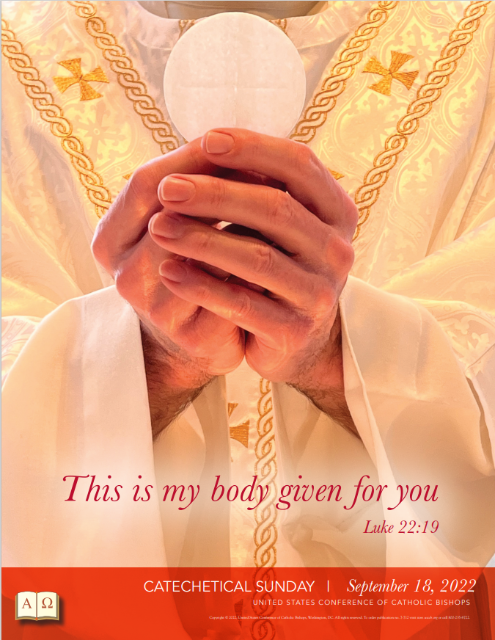

Catholic Diocese Library

You are welcome to visit the library at the diocesan offices located at 225 Elm St., Youngstown. We have a large collection of books that cover a wide variety of topics, including: bereavement support, catholic social teaching, liturgy and worship, prayer, and saints just to name a few. If you need a book on grandparenting, seasonal devotions, bible study, or Church documents, we have what you need. We also have a collection of children’s books, DVDs, and audio books.

The visitor parking lot is at the corner of Elm Street and Rayen Avenue.
The Library is open 8:00 am – 4:00 pm, Monday - Friday. You are always welcome to stop by and look around or you can view our collection online at https://doylib.follettdestiny.com. Contact Margie Hynes (330) 744-8451, mhynes@youngstowndiocese.org for more information.

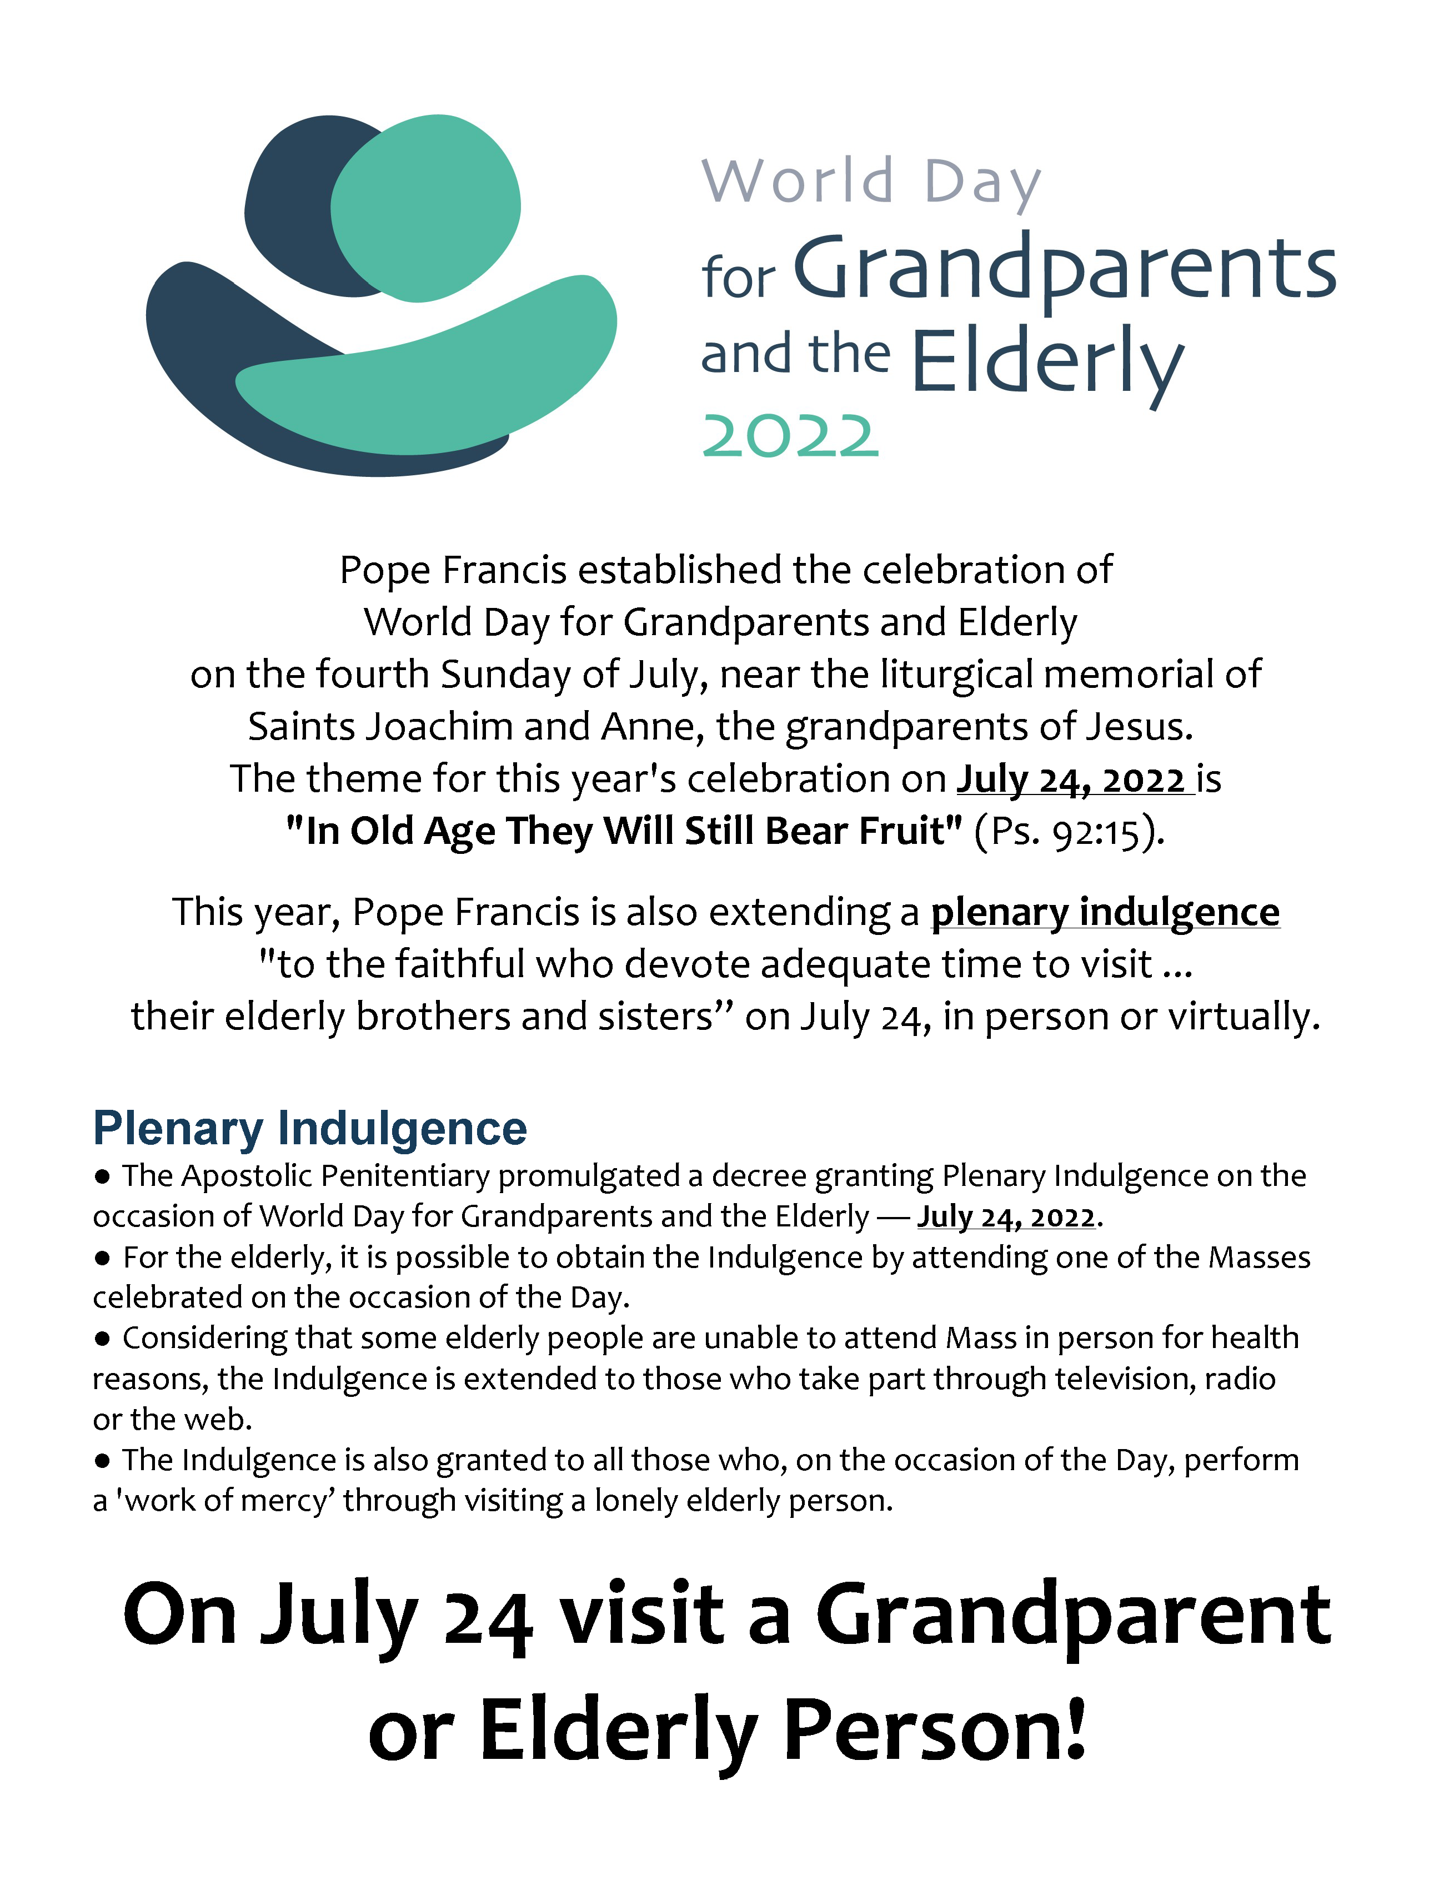

Office of Pro-Life, Marriage and Family

World Day of Grandparents and the Elderly – July 24
On Sunday, July 24, 2022, the Second World Day for Grandparents and the Elderly will be celebrated throughout the universal Church. The theme chosen by the Holy Father is "In old age they will still bear fruit" (Psalm 92:15) and emphasizes how grandparents and the elderly are a gift both to society and the Church. This year, Pope Francis is also extending the opportunity for a plenary indulgence to the faithful who devote adequate time to visit, in person or virtually, their elderly brothers and sisters on July 24. For more information go to www.doy.org/family/ or https://www.usccb.org/topics/marriage-and-family-life-ministries/grandparents-elderly

Flyer: World Day for Grandparents and the Elderly

Natural Family Planning: Called to the Joy of Love!

July 24 – 30 is Natural Family Planning Awareness week and this year’s theme is “Called to the Joy of Love!” Modern methods of Natural Family Planning are scientifically researched and based on the observation of naturally occurring signs and symptoms of fertility during a woman’s menstrual cycle. NFP reflects the God-given dignity of the human person within the context of marriage and family life, promotes openness to life, and recognizes the value of the child. To learn more, go to www.doy.org/family/ or contact dschmidt@youngstowndiocese.org or 330-744-8451 ext. 272.

Flyer: NFP Week 2022

Eleventh Annual Faith & Family Festival – Save the Date: September 25

A day of fun and fulfillment for families, students and friends will be held on Sunday, September 25, 2022, on the West Quad of the campus of Walsh University at 2020 E. Maple St., North Canton. The day will begin at 11:00 a.m. with Mass with Bishop Bonnar. Our featured presenter is Fr. Leo Patalinghug “the cooking priest” from Plating Grace. The day will also include musical acts, activities for kids and young people, vendors and exhibitors, and food. For more information contact dschmidt@youngstowndiocese.org or 330-744-8451 ext. 272.

Project Rachel Outreach – July Message for Bulletin/Newsletter:
Do you need freedom from the heartache of an abortion? God’s mercy offers release from the bonds of regret. There is Hope and Healing available. For CONFIDENTIAL help text or call Project Rachel of Northeast Ohio at 330-360-0430 or go to https://hopeafterabortionneo.weebly.com/

Intercessions for Life and Pro-Life Bulletin Briefs
Recommended intercessions and bulletin briefs for July, prepared by the U.S. Conference of Catholic Bishops Secretariat for Pro-Life Activities, may be found at https://www.respectlife.org/word-of-life

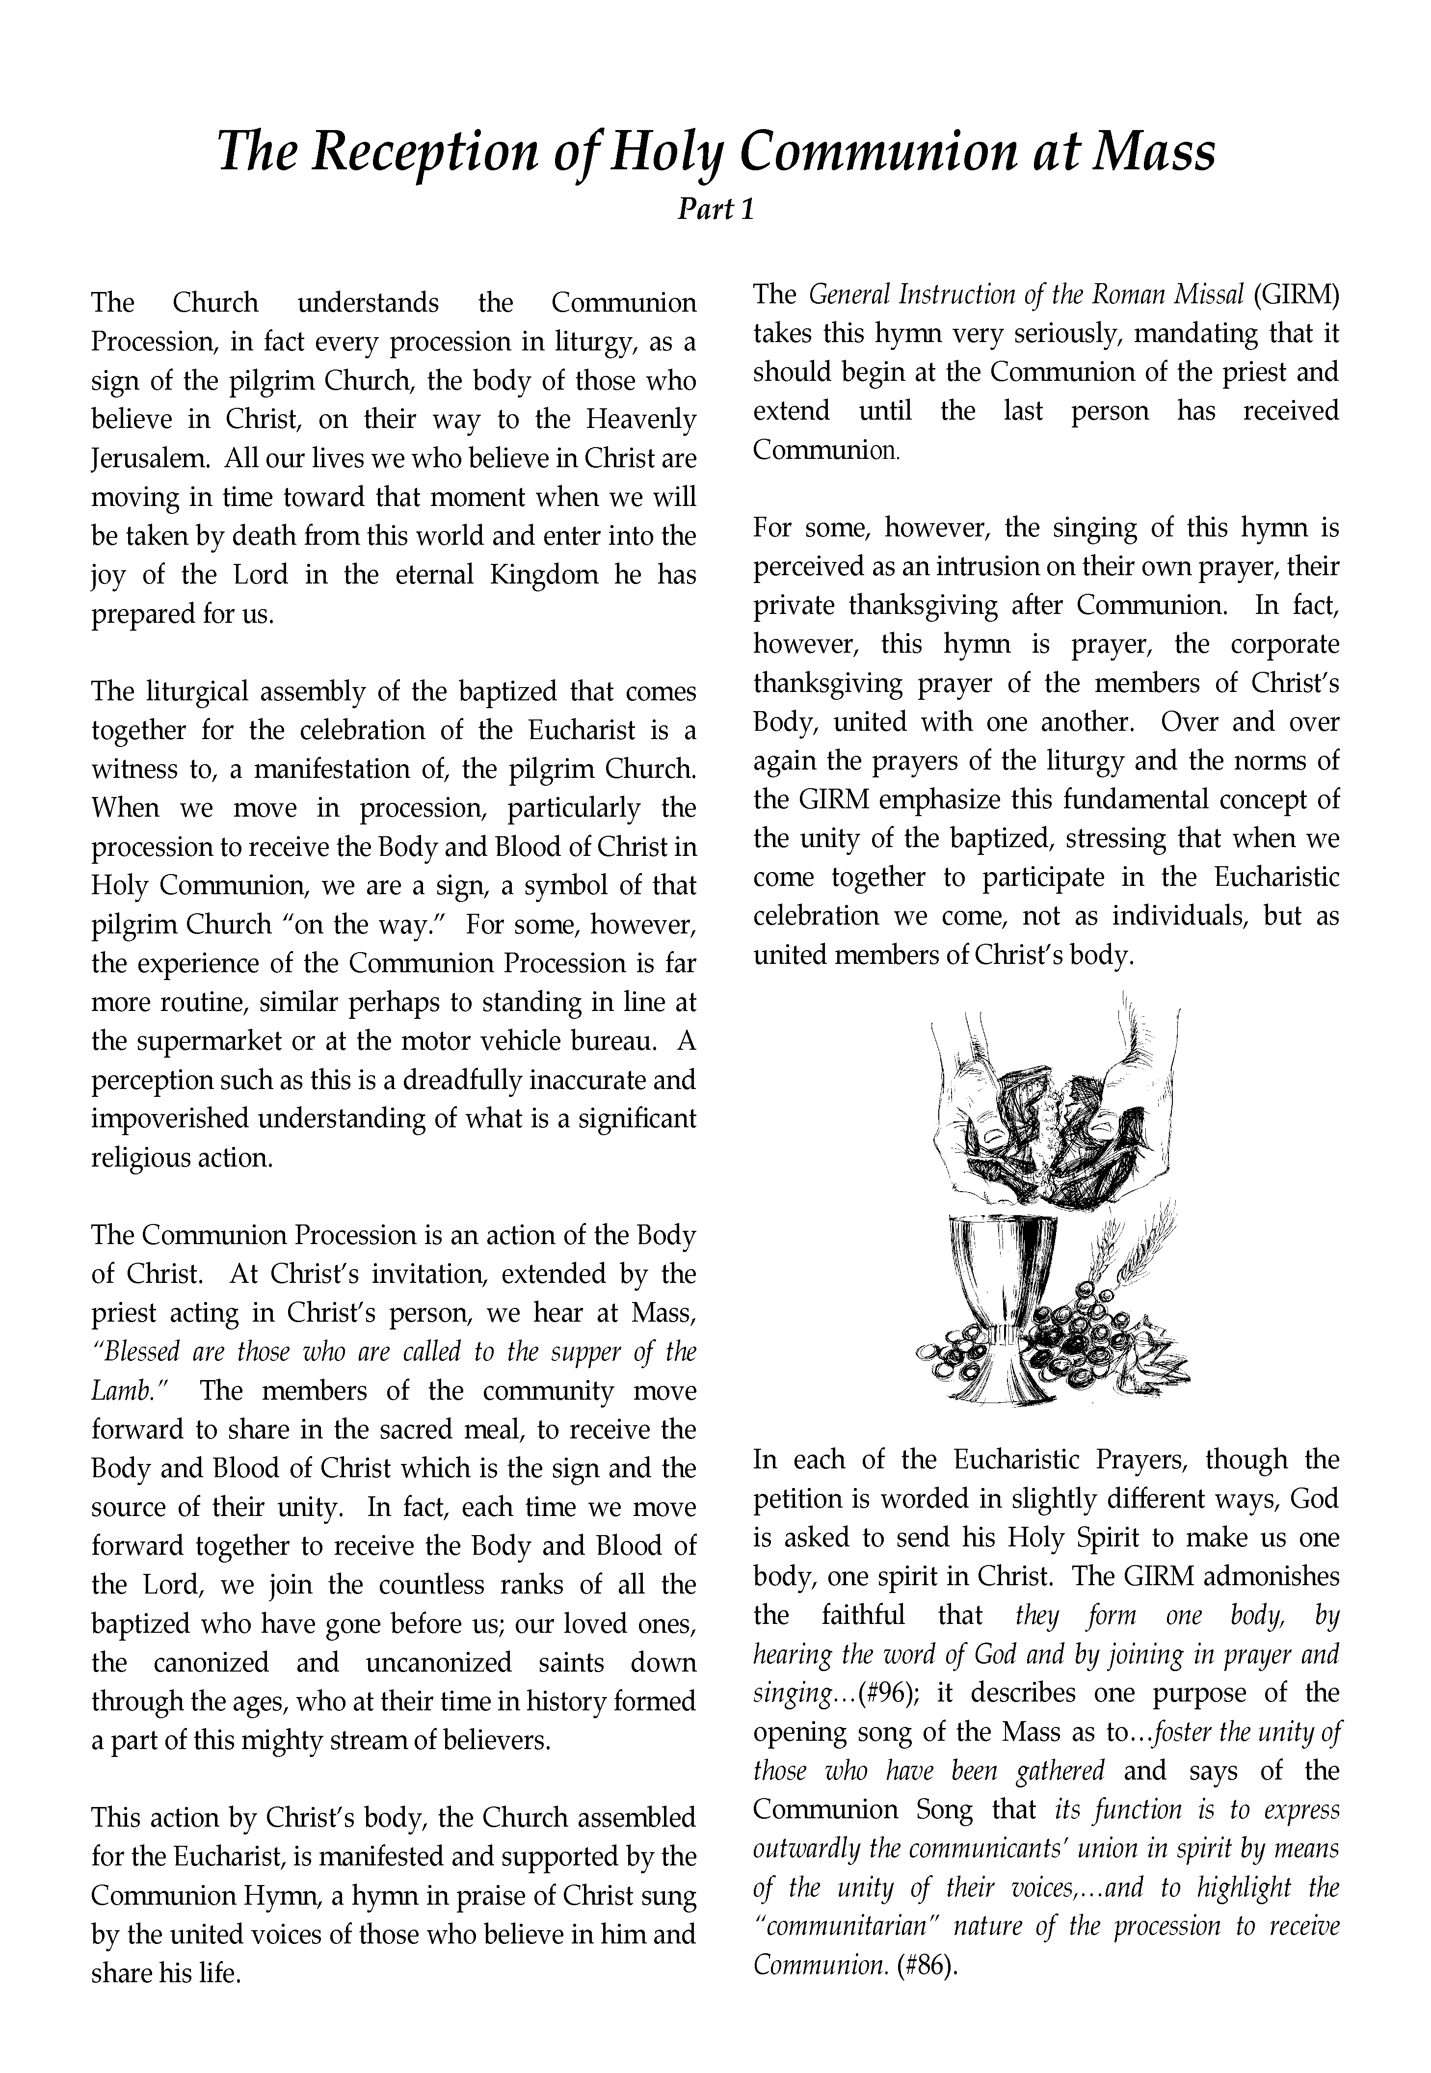

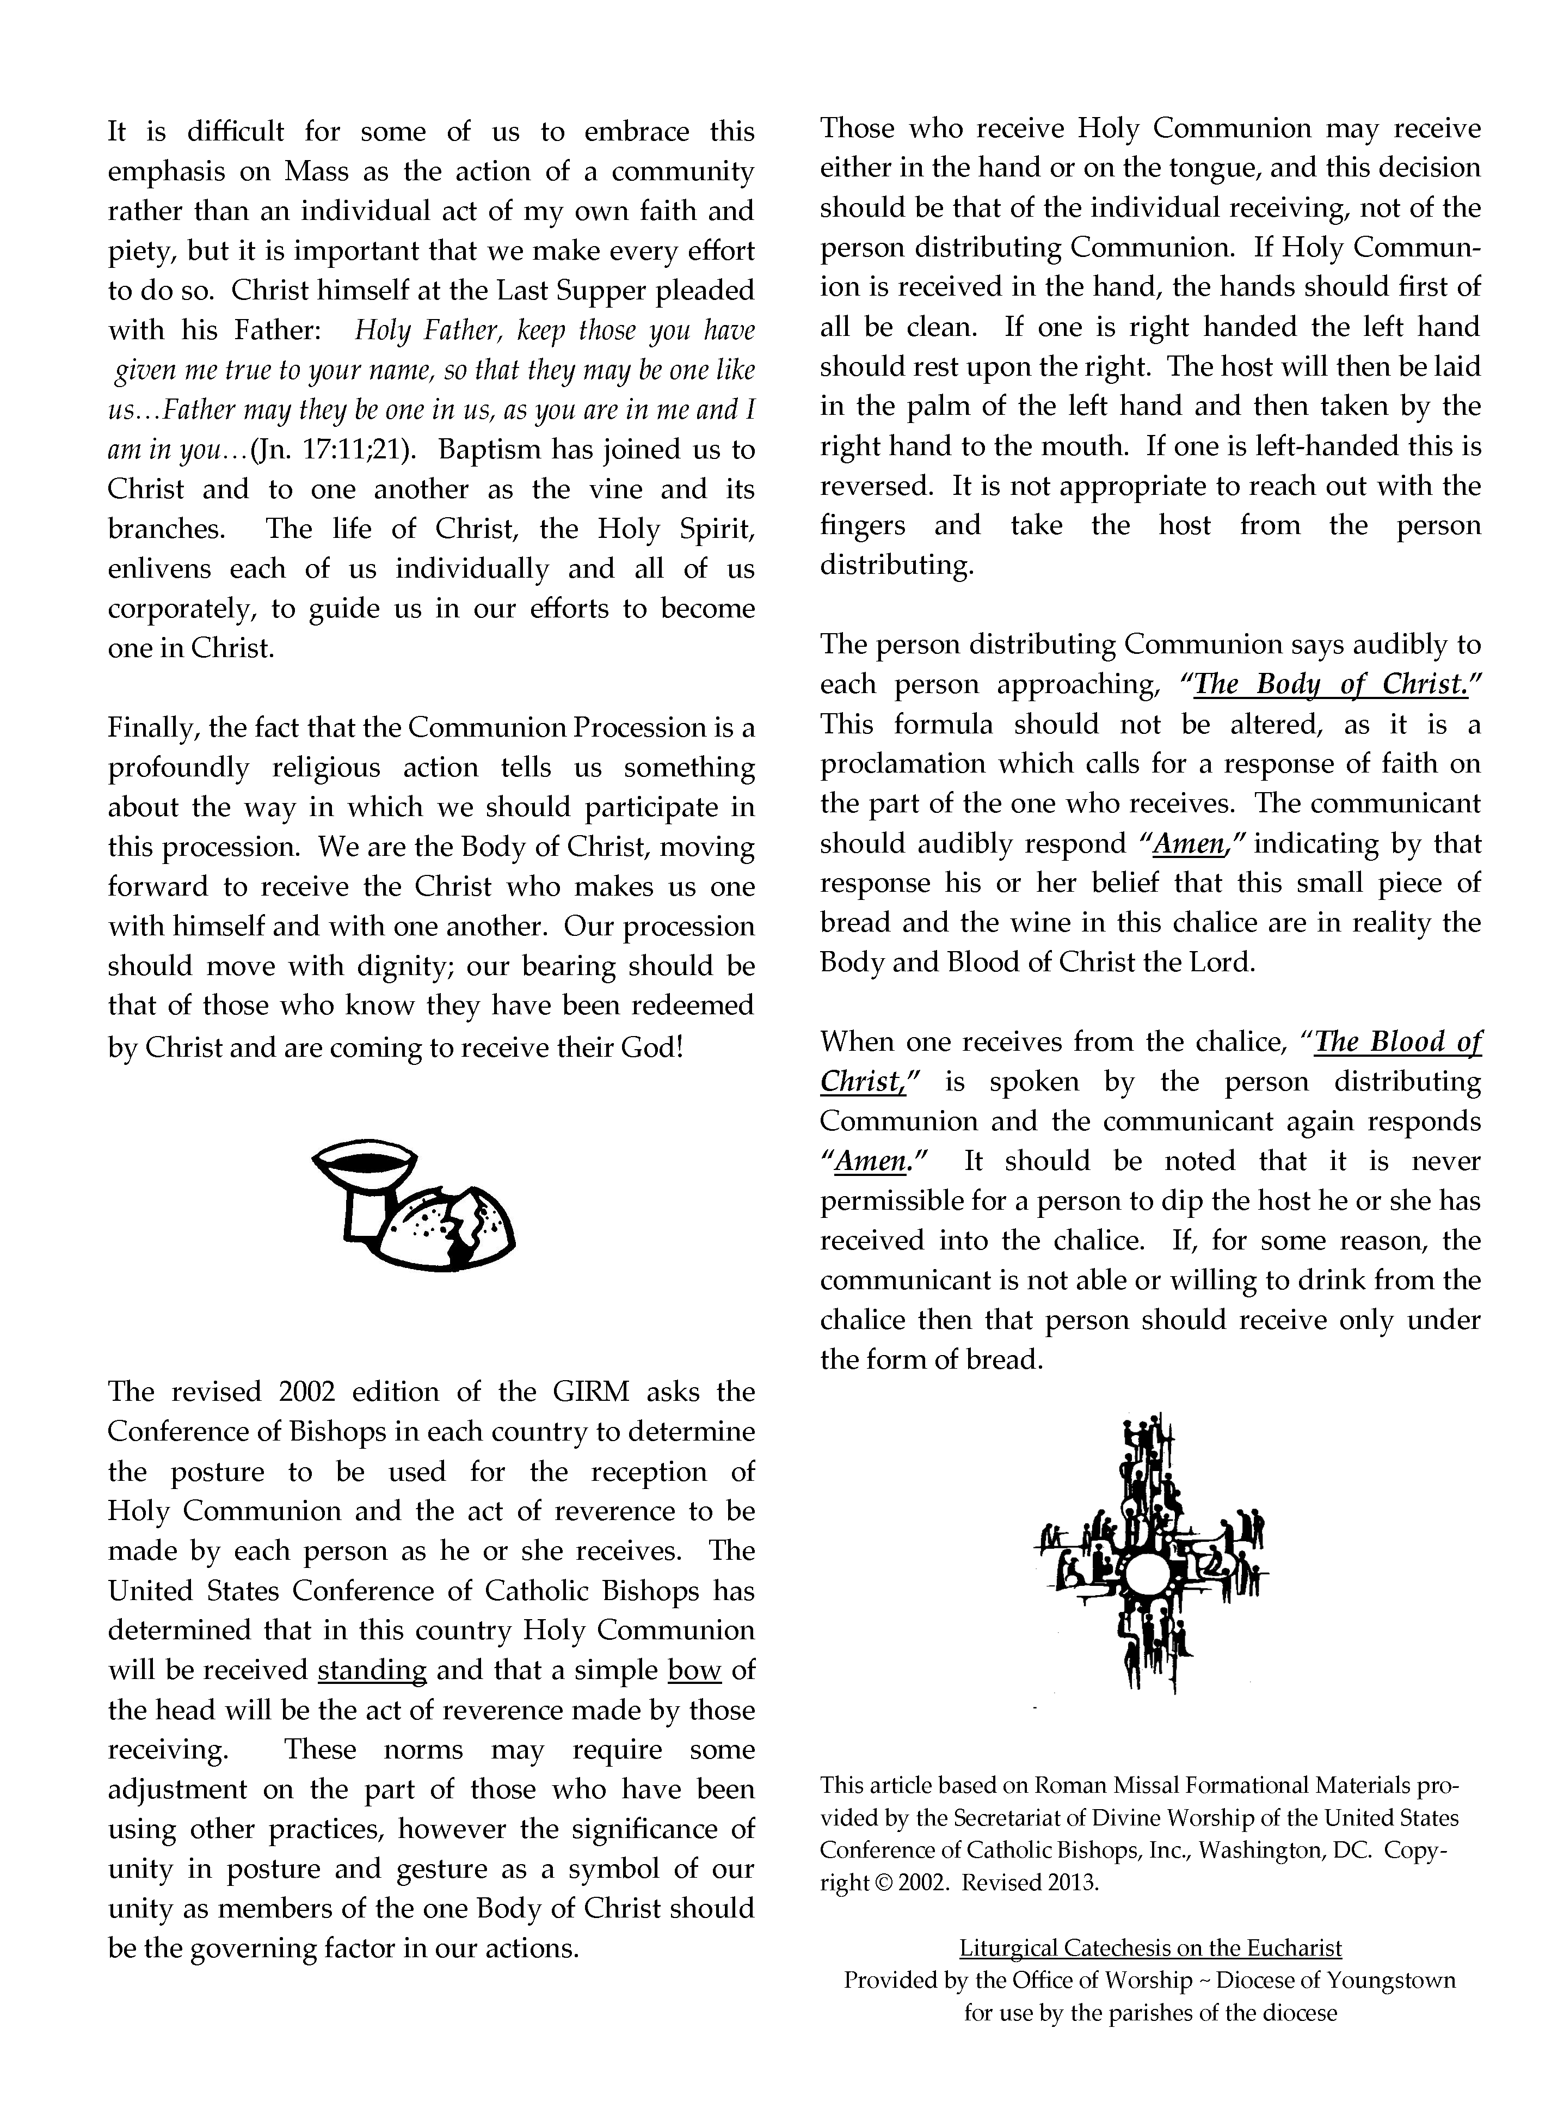

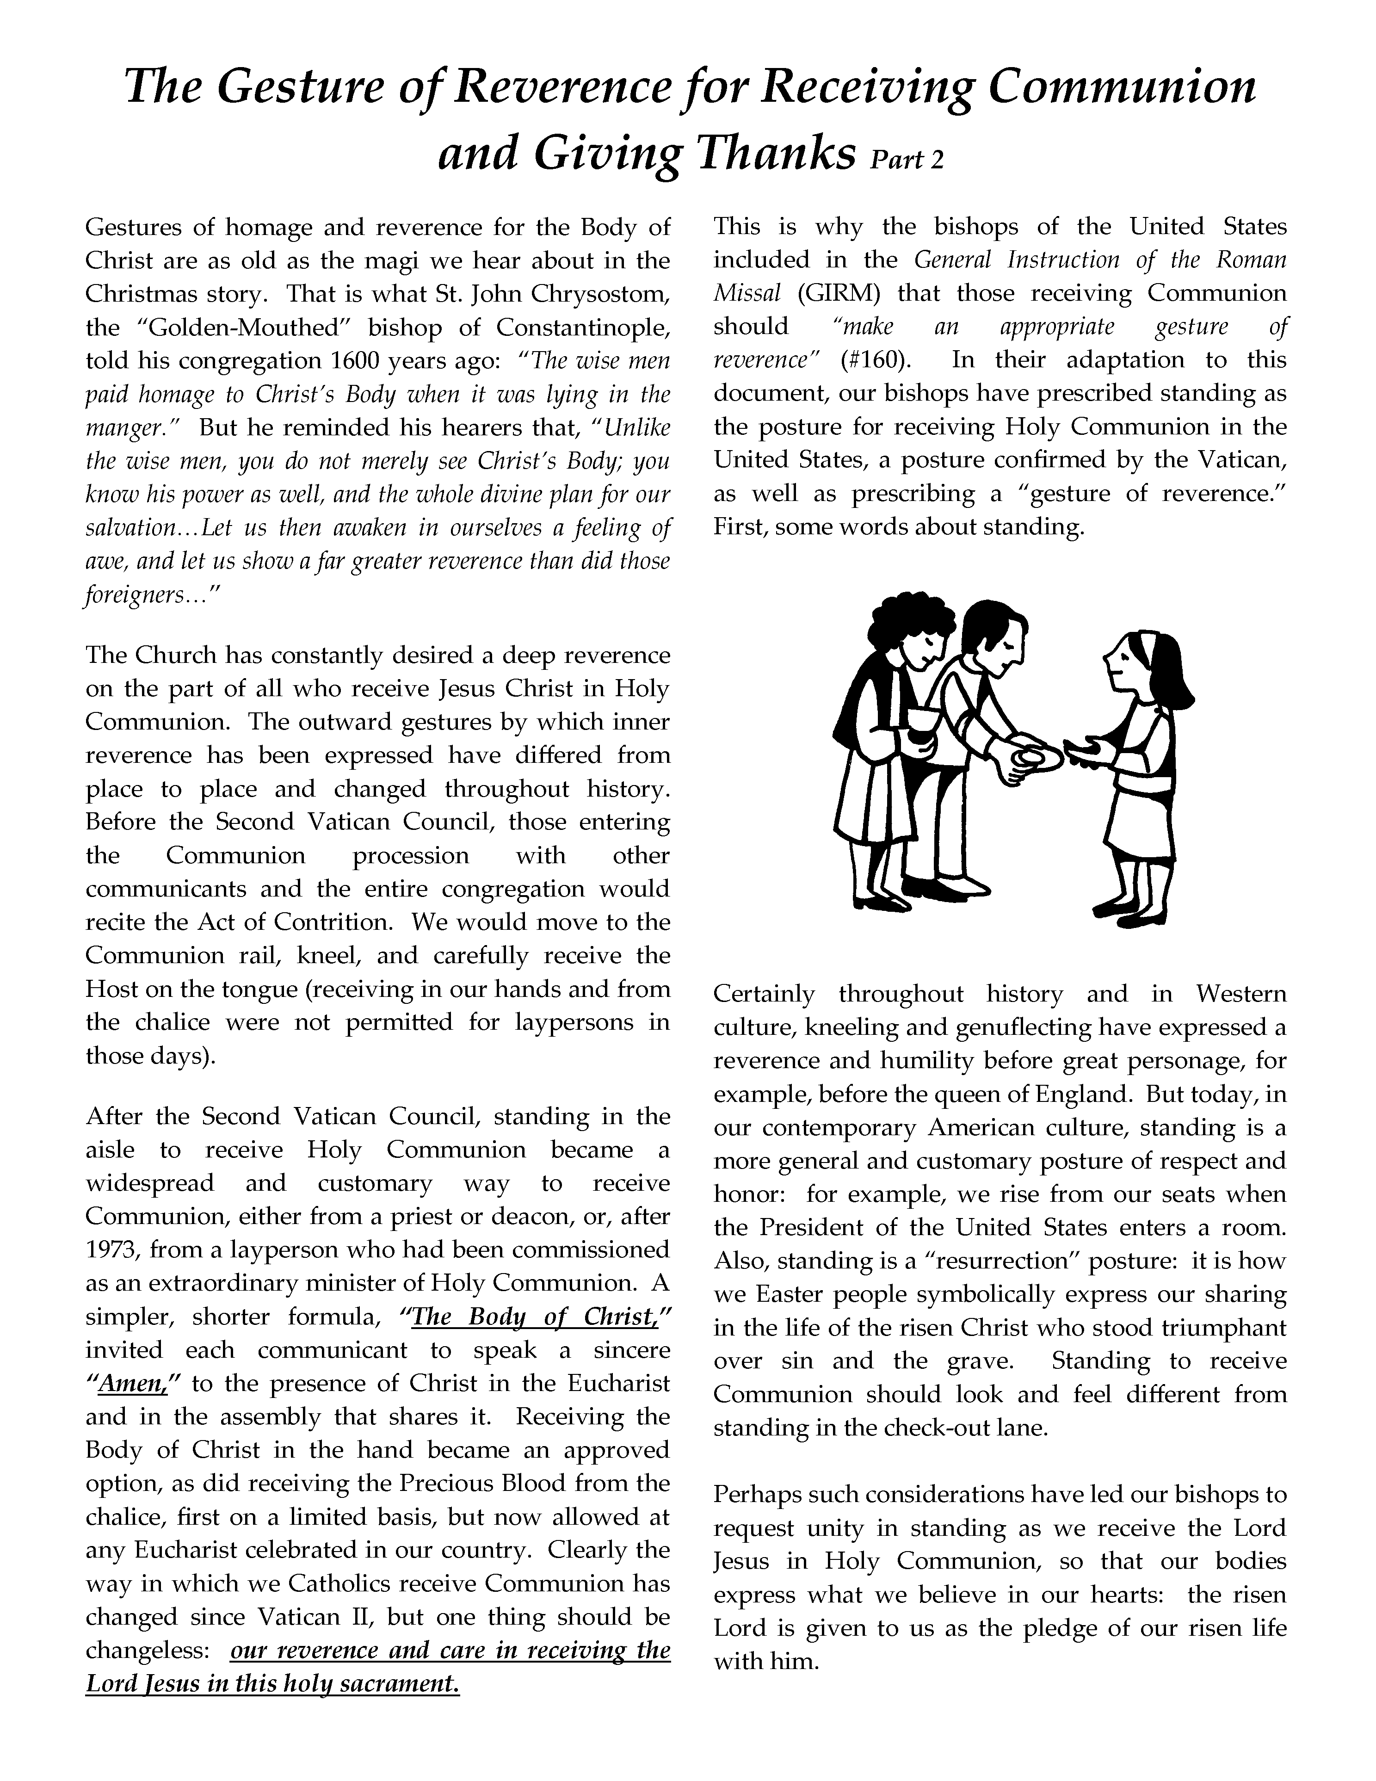

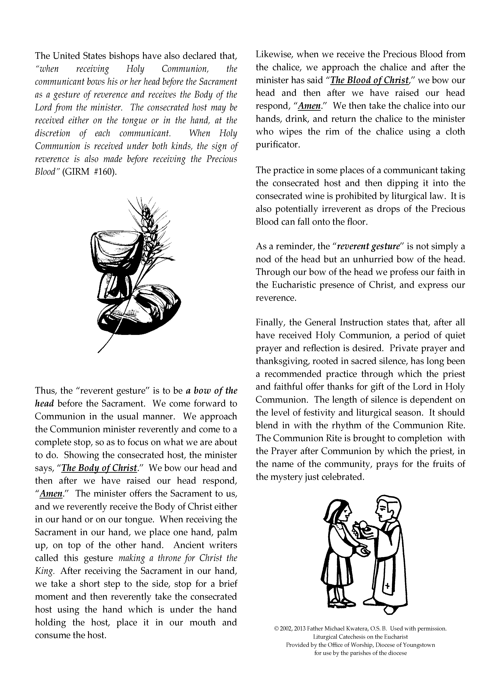
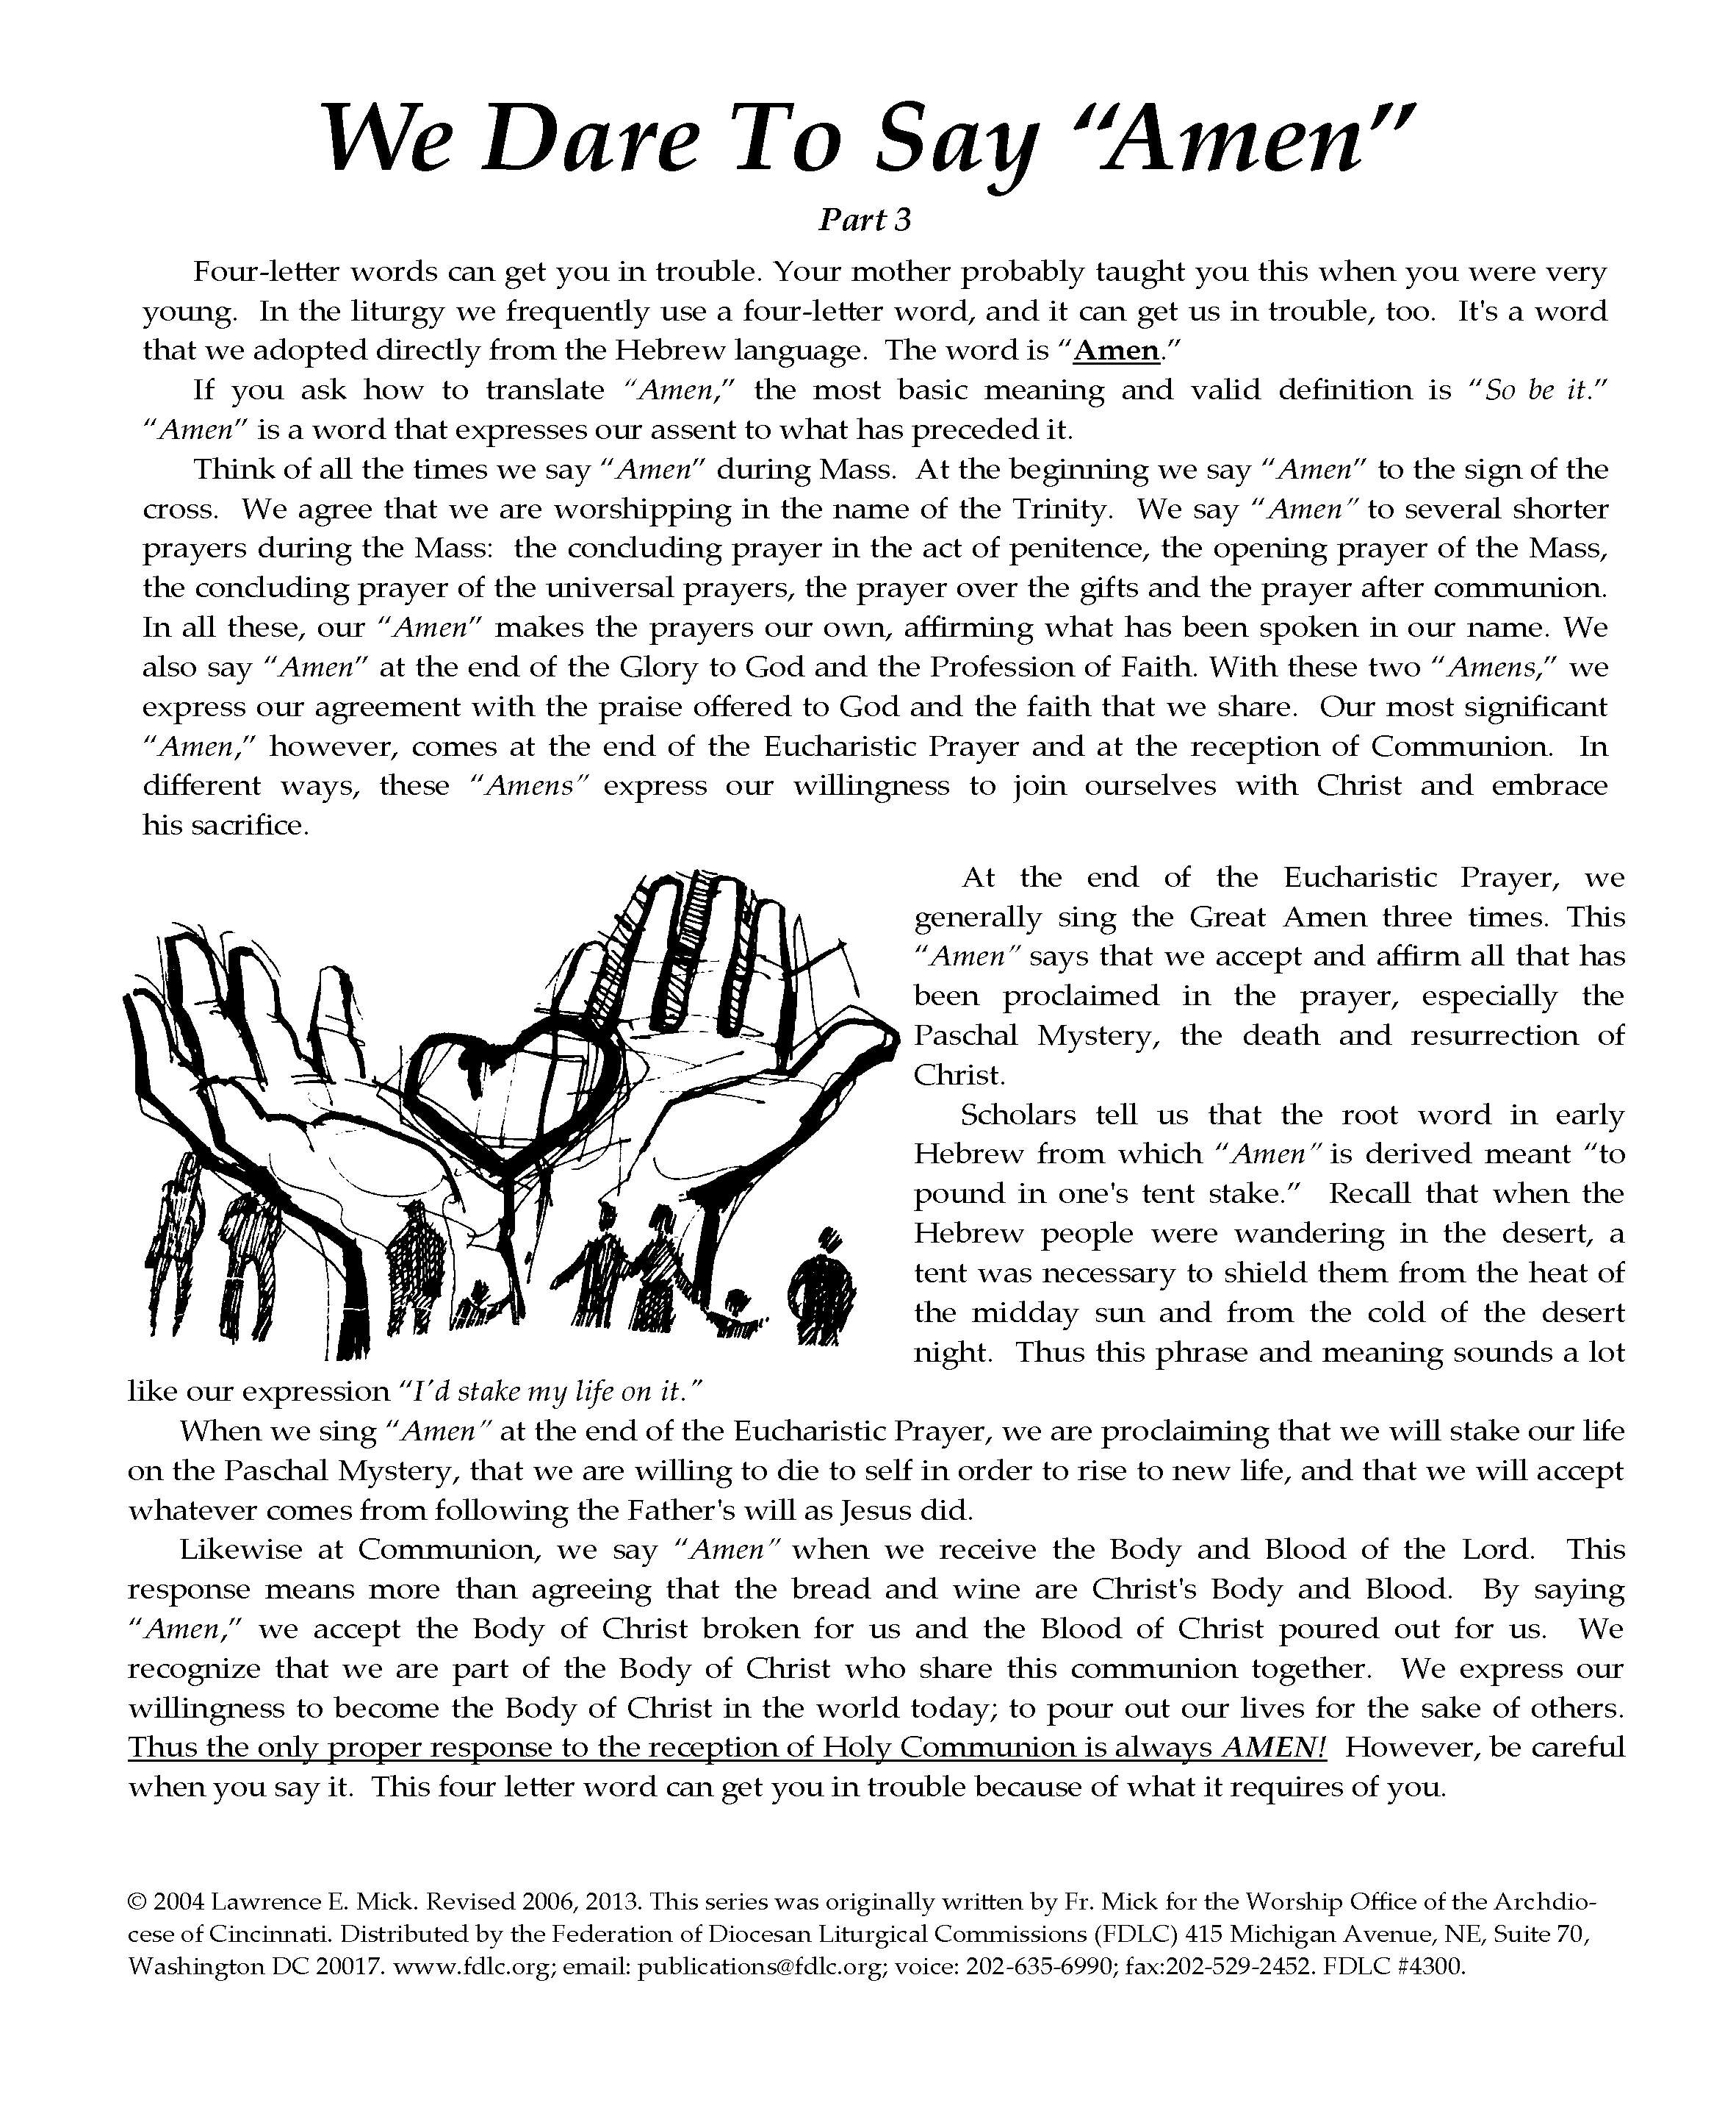

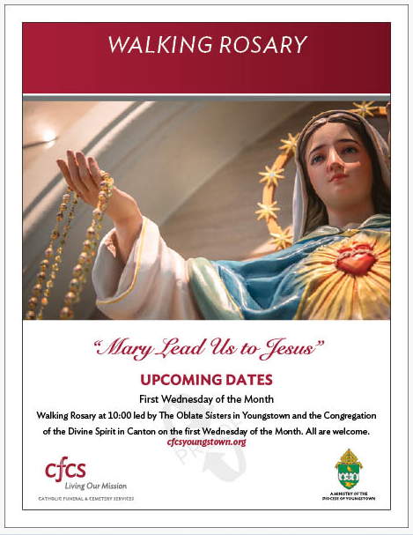
ST. JOSEPH'S OF MANTUA
58th OX ROAST FAIR

July 15th - 6 p.m. to 11:30 p.m.
July 16th 1 p.m. to 11:30 p.m.
July 17th - Noon to 10 p.m.
WE’RE LOOKING FORWARD TO 2022!
Largest 3-day Fair in Northern Portage County
Family Fun • Delicious Food • Beer Garden
Friday Fireworks • Saturday 5K Walk/Run
Rides • Games • Contests • Cash Prizes • Giveaways
Sunday Blessing of Bikes • Karaoke Sunday Night
Live Bands at Main Stage, Beer Garden & Talent Stage
Ox Roast Sandwiches & Sundaes • Casino & Instant Bingo Games
Semi Truck, 4WD Pick-Up & Tractor Pulls
Not Your Typical Church Festival!!!

Located on St. Joseph Blvd. off Pioneer Trail, West of S.R. 44
South of S.R. 82 just North of Mantua Village
Accessible from Alt. 422 or Ohio Turnpike Exit 193

For More Info: call 330-274-2253
visit https://stjosephmantua.com/ox-roast-fair
or Find Us on Facebook!

Diocese of Youngstown 35th Annual Pilgrimage
The Basilica and National Shrine of Our Lady of Consolation
Carey, Ohio

Day of Prayer for Vocations & Religious Life
Reverend Msgr. Michael Cariglio, Spiritual Director
Wednesday, August 10, 2022
Cost: $35 per person
Lunch Options: Bring Your Own Brown Bag Lunch or
Pre-Order SUBWAY BOXED LUNCH

Please call 330-744-8451 ext. 252 for more information
Departing from Our Lady of Mount Carmel Basilica, Youngstown at 6:00 A.M.
~ RESERVATIONS REQUIRED ~

