ATTN: BULLETIN EDITORS AND INTERCESSION WRITERS

COMMUNIQUÉ SEPTEMBER 2022
ADDITIONAL BULLETIN BRIEFS AND FLYERS

Note: Suggested announcements, suitable for bulletins and social media, are also indicated in the full communiqué with red lines at top and bottom.

This attachment includes the following graphic files / flyers – see notes below on any text-only version in the Communique (links to PDF included):

TABLE OF CONTENTS
- Quote of the Month: Pope Francis on Finding New Roads
- Safe Environment: Text for English & Spanish Bulletin Inserts
- Safe Environment: English Bulletin Insert
- Safe Environment: Spanish Bulletin Insert
- Eucharistic Revival: Full Page Flyer
- Bishop Bonnar’s 2023 Pilgrimage: Full Page Flyer
- Catholic Charities: Catholic Charities Regional Agency
- Catholic Charities: Support for Ukraine
- Office of Peace & Justice: Civilize It Flyer
- Prison Ministry: Kolbe Gathering Flyer
- Multimedia (CTNY): Wineskins for September
- Multimedia (CTNY): How to Watch the Mass for Shut-Ins
- Office of Vocations: Vocations Bulletin Briefs
- Office of Vocations: Vocations Intercessions
- Office of Development and Stewardship: Stewardship Bulletin Thoughts (English)
- Office of Development and Stewardship: REFLEXIONES DEL BOLETIN DE CORRESPONSABILIDAD (en Español)
- Office of Faith Formation and Lay Ecclesial Ministry: Catechetical Sunday Bilingual Flyer
- Office of Faith Formation and Lay Ecclesial Ministry: September Bulletin Announcements
- Office of Faith Formation and Lay Ecclesial Ministry: Ministry Day Banner
- Office of Pro-Life, Marriage, and Family Life: Bulletin Blurbs
- Office of Pro-Life, Marriage, and Family Life: Faith and Family Festival Flyer 2022
- Office of Pro-Life, Marriage, and Family Life: Mass for Life October 2022
- Office of Pro-Life, Marriage, and Family Life: Ohio March for Life October 2022
- Office of Pro-Life, Marriage, and Family Life: Into Life September 2022
- Diocesan Cemeteries: The Chaplet of Divine Mercy Flyer
- Diocesan Cemeteries: Walking Rosary Flyer
- Mahoning County: First Friday Club Poster
- Portage County: Rocktember Flyer
- Stark County: Catholic in Recovery Weekly Meetings Flyer
- Parish Events: Bulletin Blurbs
Quote of the Month:

"Instead of being just a church that welcomes and receives by keeping the doors open, let us try also to be a church that finds new roads, that is able to step outside itself and go to those who do not attend Mass, to those who have quit or are indifferent. The ones who quit sometimes do it for reason that, if properly understood and assessed, can lead to a return. But that takes audacity and courage." -Pope Francis

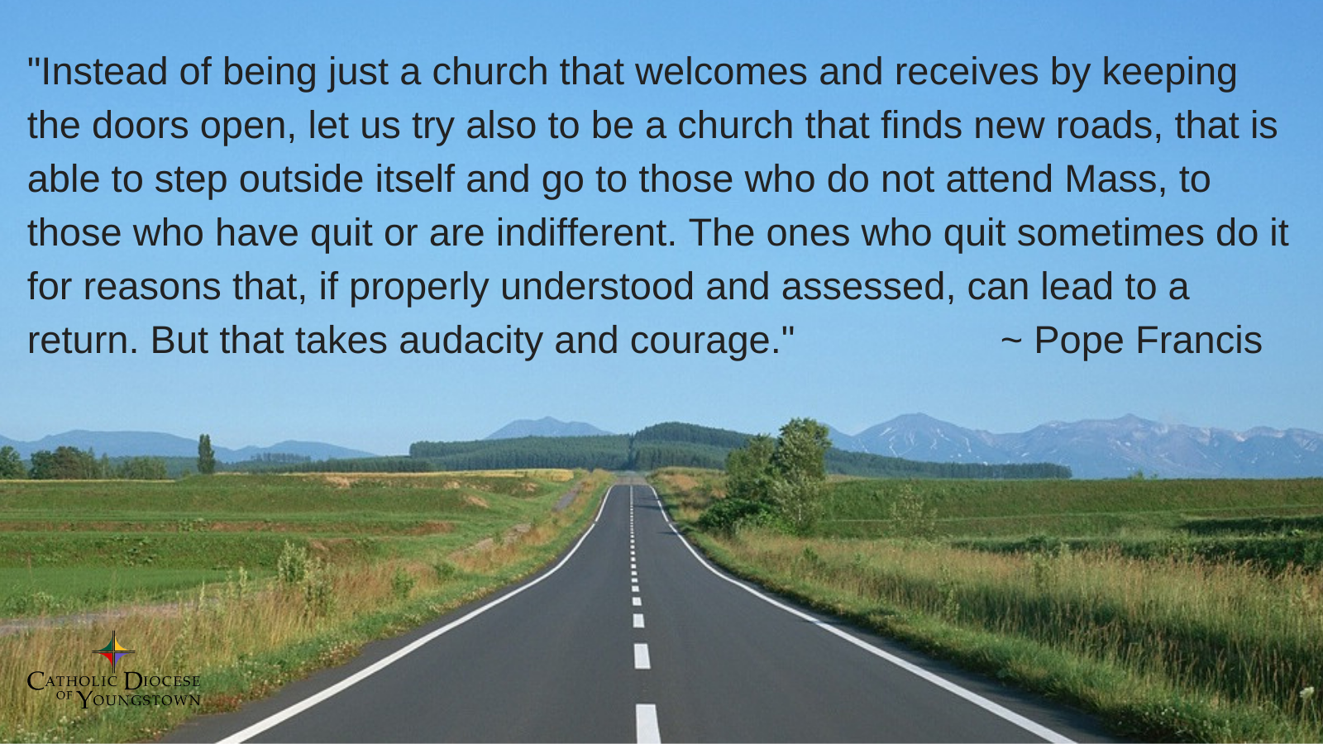

CATHOLIC DIOCESE OF YOUNGSTOWN
SAFE ENVIRONMENT POLICY
FOR THE PROTECTION OF CHILDREN AND VULNERABLE ADULTS

EDUCATION & SCREENING
All clergy, religious, seminarians/persons in formation, and employees, as well as any volunteers who work with children, young people, or vulnerable adults, are required to complete a background check and safe environment training. For more information about our safe environment compliance requirements visit: doy.org/safe-environment/.

REPORTING & VICTIM ASSISTANCE
If you or someone you know has been abused or victimized by someone representing the Catholic Church, the Diocese encourages you to come forward and speak out by contacting Civil Authorities and Mr. Dominic Colucy, Victim Assistance Coordinator. Mr. Colucy is available to help. He will listen to your needs and support you. He will help you make a formal complaint.

Contact Information
Confidential Response Line: 330-718-1388
Email: dcolucy@youngstowndiocese.org
By Mail: Catholic Diocese of Youngstown, Attn: Dominic Colucy
144 W. Wood St., Youngstown, OH 44503

Contact information for Civil Authorities can be found at: doy.org/safe-environment/.

DIÓCESIS CATÓLICA DE YOUNGSTOWN
POLÍTICA DE AMBIENTE SEGURO
PARA LA PROTECCIÓN DE NIÑOS Y ADULTOS VULNERABLES

EDUCACIÓN Y DETECCIÓN
Los clérigos, religiosos, seminaristas/personas en formación, y empleados, así como cualquier voluntario que trabaja con niños, jóvenes o adultos vulnerables, están obligados a completar una verificación de antecedentes y capacitación en la política de ambiente seguro. Para más información sobre nuestros requisitos de cumplimiento de ambiente seguro visite doy.org/safe-environment/.

DENUNCIA Y ASISTENCIA LAS VICTIMAS
La Diócesis lo alienta a presentarse y denunciar el caso contactando a las autoridades civiles y/o al Sr. Dominic Colucy, Coordinador de Asistencia a las Víctimas. El Sr. Colucy está disponible para ayudarlo a usted o cualquier otra persona que haya sido abusada o víctima de alguien que representa a la Iglesia Católica. Él lo escuchará y lo apoyará en lo que necesite. Él lo ayudará a redactar una denuncia formal.

Información del contacto
Línea confidencial: 330-718-1388
Email: dcolucy@youngstowndiocese.org
Por correo: Catholic Diocese of Youngstown, Attn: Dominic Colucy
144 W. Wood St., Youngstown, OH 44503
La información para contactar a las Autoridades Civiles puede ser encontrada en: doy.org/safe-environment/.

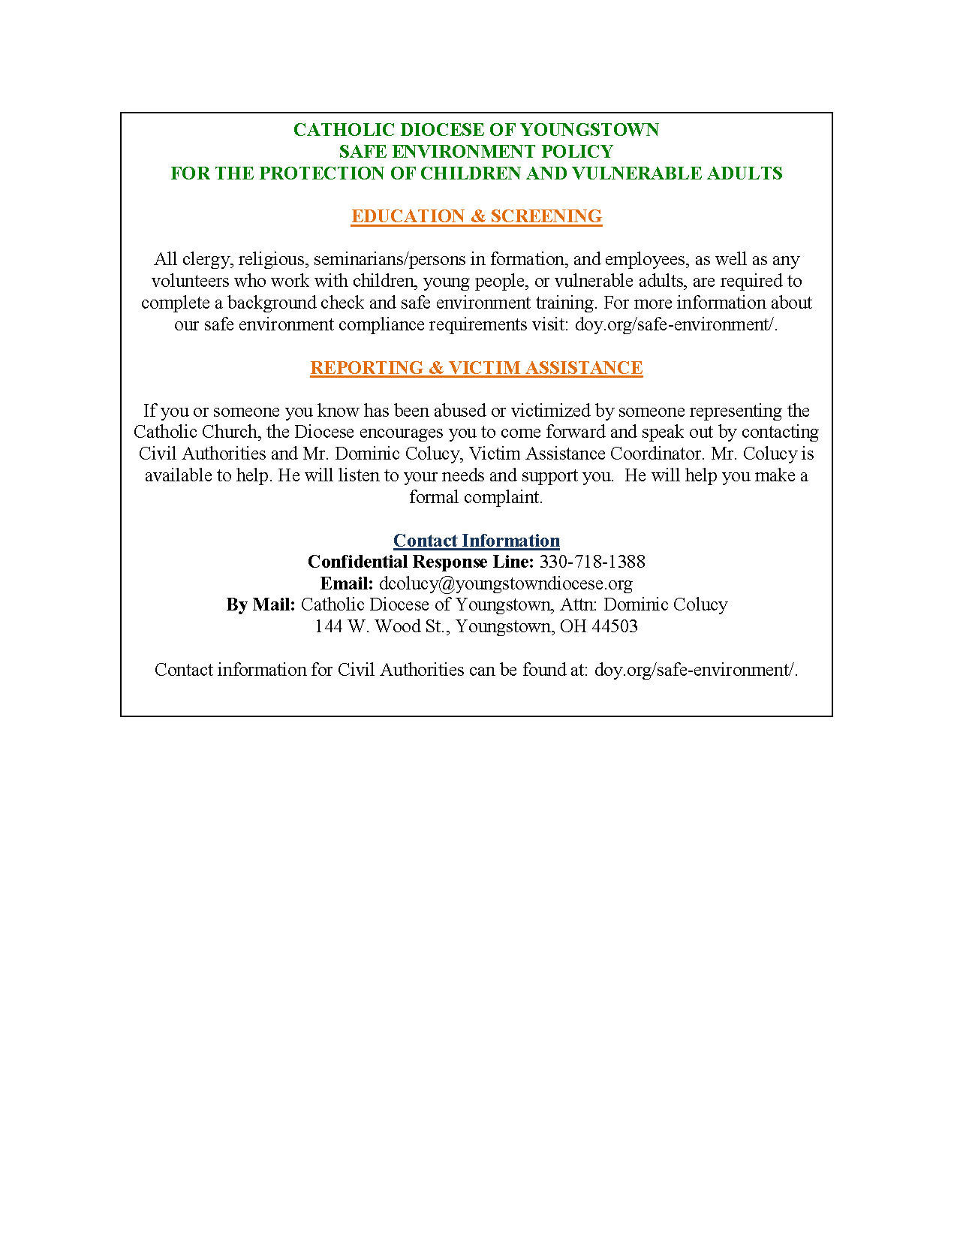

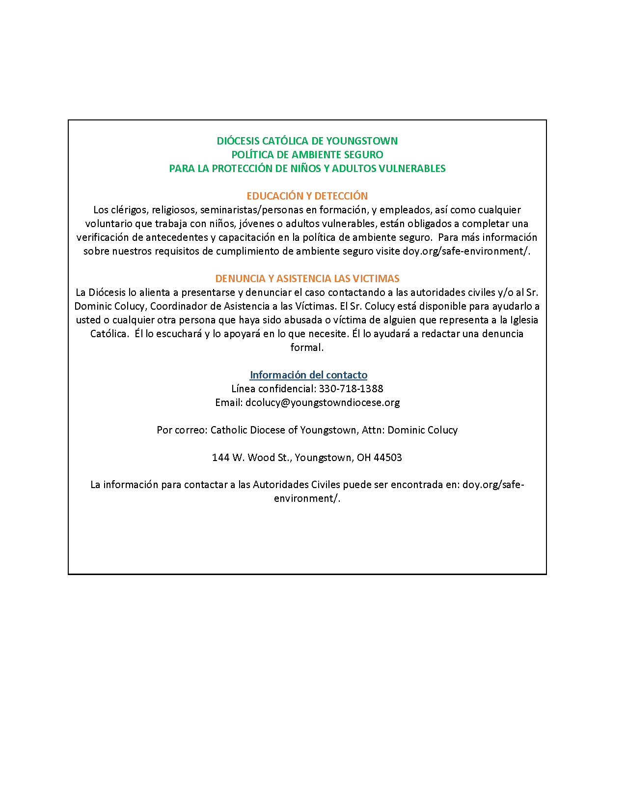

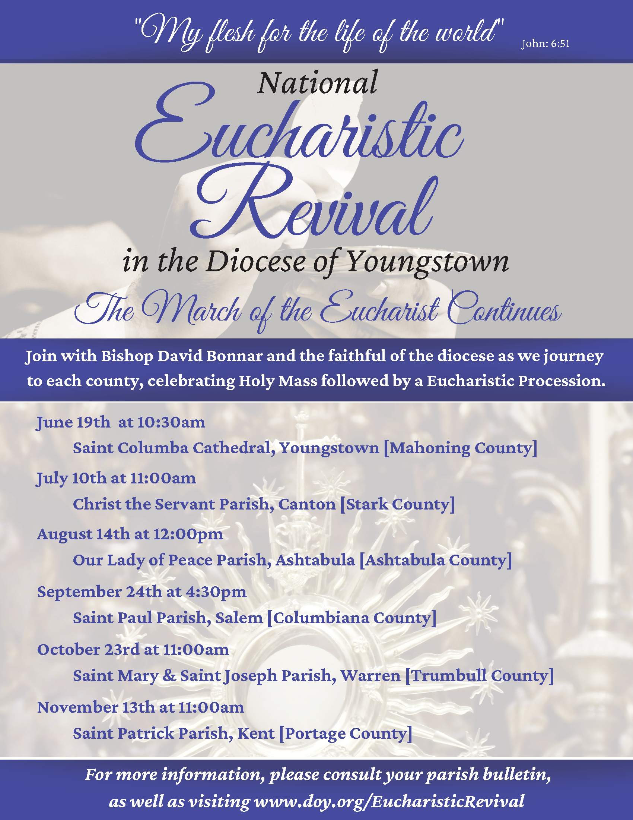

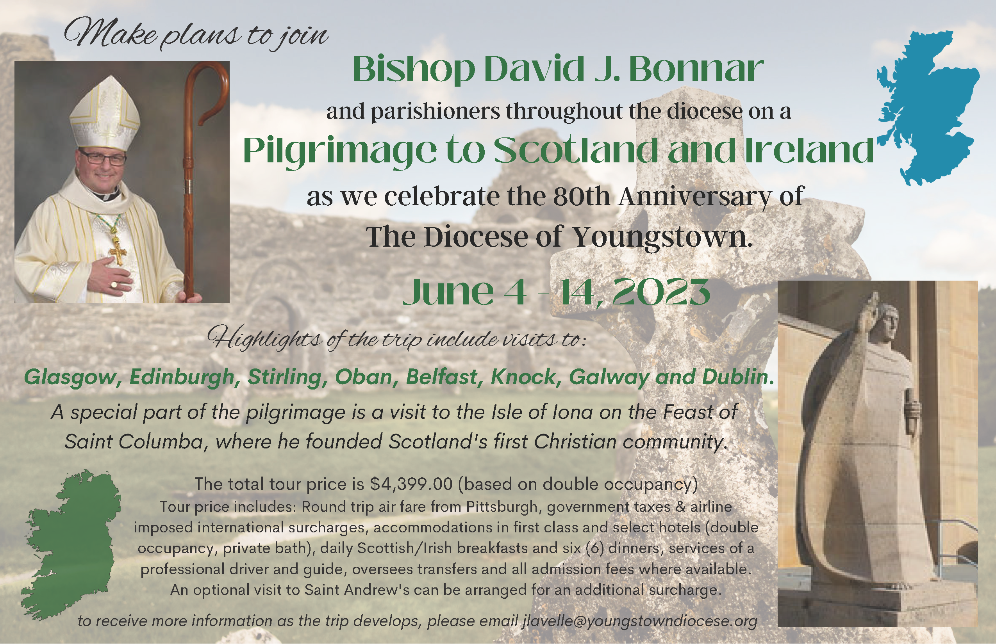

Catholic Charities Regional Agency

Catholic Charities Regional Agency serving Columbiana, Mahoning, and Trumbull counties is seeking donations for the following programs: The Voice of Hope Shelter, Youngstown; Christina House, Lisbon.
- The Voice of Hope Shelter – in need of Twin Size bed sets (including sheets, pillow cases, comforters)
- Christina House Domestic Violence Shelter – in need of Chest of Drawers/Dressers
For more information, drop off locations, or phone numbers, please visit the locations page of our website at https://www.ccdoy.org/locations/.
As an alternative, items can also be purchased using the Catholic Charities Amazon Wish list: https://tinyurl.com/amzshelter.

Catholic Charities Support for Ukraine

Financial Support

Catholic Charities of the Diocese of Youngstown continues to accept financial contributions to assist the people of Ukraine. 100% of the funds we receive in the Diocese of Youngtown for Ukraine will be divided between the United State Conference of Catholic Bishops’ (USCCB) Subcommittee on Aid to the Church in Eastern Europe and Catholic Relief Services, unless otherwise specified by the donor. Both of these organizations are uniquely suited to help, since they and their partners have been “on the ground” for years doing critical work. Both are intently focused right now on supporting the emergency needs of Ukraine and Ukrainian refugees, with any additional funds (if applicable) supporting ongoing needs in Eastern Europe and globally. Please note that Catholic Charities in the Diocese of Youngstown does not process or keep any of these disaster donations for Ukraine for our local efforts in the collection process. All of the money goes to the people who desperately need it.

Sponsor Support

Uniting for Ukraine is a streamlined process that allows for Ukrainian citizens who have been displaced by Russia’s aggression to apply for humanitarian parole in the United States.
Under Uniting for Ukraine, the U.S. government allows people fleeing the war in Ukraine to seek refuge in the United States on a temporary basis known as humanitarian parole, with the support of a sponsor in the United States. The sponsor will provide financial support to meet the basic needs of someone fleeing Ukraine. They may also provide additional support, such as assistance enrolling in educational or training programs or securing employment.
Sponsors can be U.S. citizens, permanent residents or other lawfully present individuals. This includes individuals on Temporary Protected Status (TPS) and refugees. Groups of sponsors, nonprofits, educational institutions, and employers can also help sponsor people fleeing Ukraine.
So far this year, more than 70,000 Americans have applied to become a sponsor. If you are already connected to a Ukrainian individual or family, please use this link for information on becoming a sponsor.
SPONSORS: https://ukraine.welcome.us/resources
According to the USCCB, this program will need an additional 30,000 to 40,000 American households to register as sponsors in the months to come. If you are interested in becoming a sponsor, but are not currently connected to a Ukrainian individual or family, learn more about how may be able to connect with someone in need in order to become their sponsor by viewing the link below. *The responsibility for making a “connection” will fall upon the Ukrainian beneficiary. It must be their final decision to connect.
CONNECTIONS: https://ukraine.welcome.us/connect

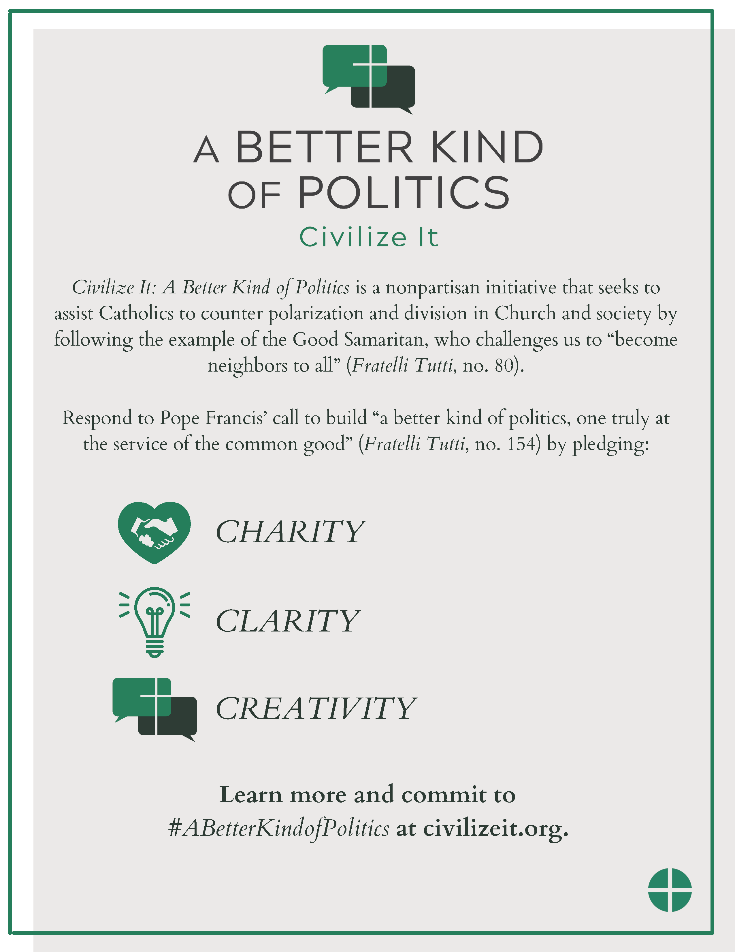
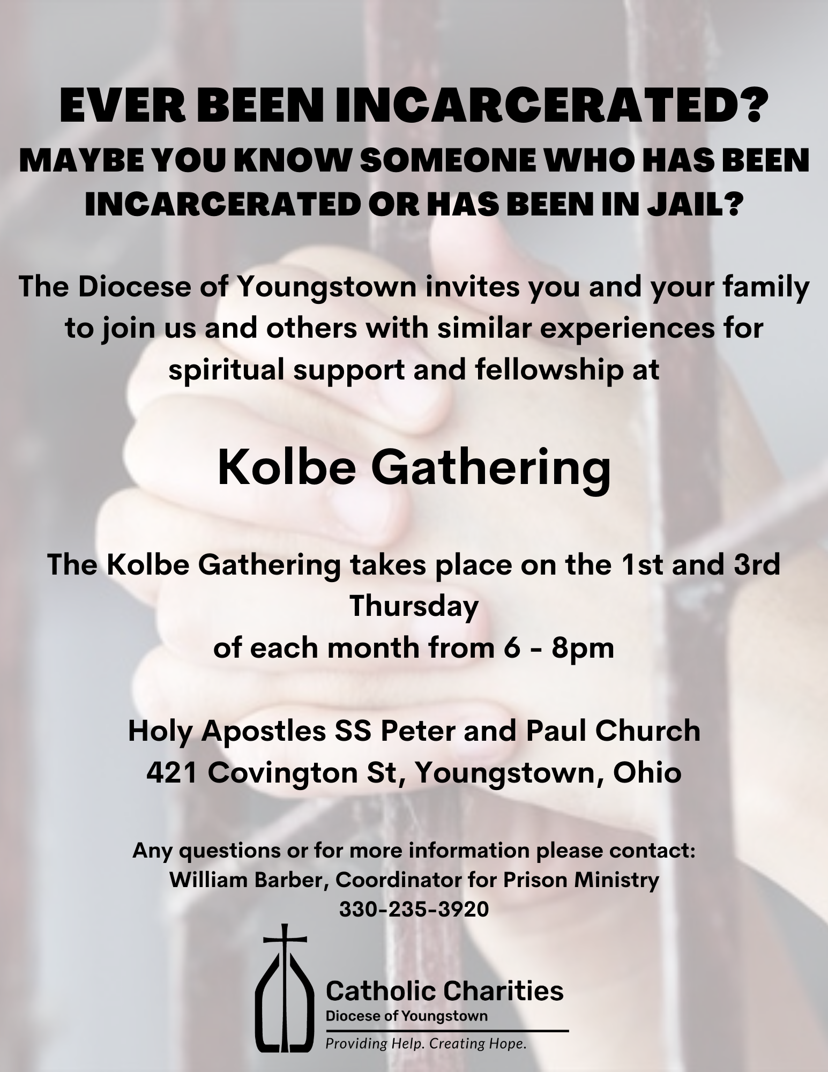

Wineskins airs every Sunday:
- 7:30 a.m. on WKBN 570 AM in Youngstown
- 7:30 a.m. on WRQX 600 AM in Salem
- 9:30 a.m. and 9:00 p.m. on WILB AM Canton 1060, WILB FM 89.5 Youngstown, WILB FM 94.5 Canton
Listen to Wineskins on the diocesan website at www.doy.org/live/ and click the Wineskins button. Subscribe to our YouTube channel for updates when we post a new episode: https://www.youtube.com/CTNYDOY
September 4:
- Current Issue: Jim Korda speaks with Fr. Norbert Keliher O.P. on Vocations.
- Saint Celebrated This Month (Diane Hancharenko from St. Angela Merici Parish): Mother Teresa.
- Interview Segment: Jim Korda speaks with Margaret Hynes Part I.
- Music Segment: from the CD “Songs of Praise,” by Salvatore Tassone.
- Sunday Scripture Reflection (Deacon Paul Lisko from St. Charles Borromeo Parish, Boardman): Twenty-Third Sunday in Ordinary Time.
September 11:
- Current Issue: Jack Lavelle talks about Adoption.
- Saint Celebrated This Month (Diane Hancharenko from St. Angela Merici Parish): John Chrysostom.
- Interview Segment: Jim Korda speaks with Margaret Hynes Part II.
- Music Segment: from the CD “Songs of Praise,” by Salvatore Tassone.
- Sunday Scripture Reflection (Deacon Paul Lisko from St. Charles Borromeo Parish, Boardman): Twenty-Fourth Sunday in Ordinary Time.

September 18:
- Current Issue: Rachel Hrbolich gives us an update on Catholic Charities.
- Saint Celebrated This Month (Diane Hancharenko from St. Angela Merici Parish): Padre Pio.
- Interview Segment: Jim Korda speaks with Margaret Hynes Part III.
- Music Segment: from the CD “Songs of Praise,” by Salvatore Tassone.
- Sunday Scripture Reflection (Deacon Paul Lisko from St. Charles Borromeo Parish, Boardman): Twenty-Fifth Sunday in Ordinary Time.

September 25:
- Current Issue: Jim Korda speaks with Nancy Bird, a recent guest speaker at The Frist Friday Club.
- Saint Celebrated This Month (Diane Hancharenko from St. Angela Merici Parish): Jerome.
- Interview Segment: Jim Korda speaks with Fr. Matthew Roehrig, SSP from the Society of St. Paul Part I.
- Music Segment: from the CD “Songs of Praise,” by Salvatore Tassone.
- Sunday Scripture Reflection (Deacon Paul Lisko from St. Charles Borromeo Parish, Boardman): Twenty-Sixth Sunday in Ordinary Time.

How to Watch the Mass for Shut-Ins

The diocese continues to produce the Mass for Shut-Ins. The Mass may be viewed the following ways:
Online:
- On doy.org/live/ and on Facebook.com/DOYoungstown/

In Youngstown, Warren, Mahoning Valley:
- On WFMJ TV-21: Sundays at 6 a.m.
- On Armstrong Cable Channel 45: Sundays at 8 a.m., noon, 7 p.m., for the time being.

Currently, a technical difficulty was making it unavailable on Spectrum Cable Channel 9, 13, or 14 in the Youngstown-Warren area.

In Stark County:
- On Spectrum Cable in Canton – Channel 989: Sundays at 9:30 a.m.
- On Massillon Cable Channel 128: Sundays at 9:30 a.m.
- On WIVM TV-39: Sundays at 9:30 a.m.

In nursing homes and prisons:
- The diocese continues to make its televised Mass available in 10 nursing homes and 3 prisons. For more information, contact Bob Gavalier at 330-533-2243.

Any further updates to diocesan cable TV programming will be noted at www.doy.org/live/

Attn: Bulletin Editor and Intercessions Writers
Vocation Bulletin Inserts
September 2022/Cycle C
The following parish bulletin blurbs are provided for your use to support the development of vocations to the priesthood and consecrated life in our diocese. They are keyed to the liturgical calendar for placement in your weekly bulletin. Your support is most appreciated.
Twenty-Third Sunday in Ordinary Time -- September 4, 2022
“Anyone of you who does not renounce all his possessions cannot be my disciple.” Are you being called to discipleship as a priest, deacon or in the consecrated life? Call Father Chad Johnson at 330-744-8451 or email: cjohnson@youngstowndiocese.org.
Twenty-Fourth Sunday in Ordinary Time -- September 11, 2022
“He was lost and has been found.” Do you want to bring others to life in Christ as a priest, deacon, religious sister or brother?
Contact Fr. Chad Johnson at (330) 744-8451 or cjohnson@youngstowndiocese.org.

Twenty-Fifth Sunday in Ordinary Time -- September 18, 2022
“No servant can serve two masters.” Are you discerning a vocation to serve the Lord as a priest, deacon, sister or brother?
Contact Fr. Chad Johnson at (330) 744-8451 or cjohnson@youngstowndiocese.org.

Twenty-Sixth Sunday in Ordinary Time -- September 25, 2022
“But you, man of God, pursue righteousness, devotion, faith, love, patience, and gentleness.” Is your faith in Christ leading you to grow in holiness as a priest, deacon or in the consecrated life?
Contact Fr. Chad Johnson at (330) 744-8451 or cjohnson@youngstowndiocese.org.

Twenty-Seventh Sunday in Ordinary Time -- October 2, 2022
“If today you hear his voice, harden not your hearts.” Will you let the Holy Spirit guide you beyond your hesitation and follow Christ as a priest, deacon or in the consecrated life?
Contact Fr. Chad Johnson at (330) 744-8451 or cjohnson@youngstowndiocese.org.

Vocation General Intercessions
August 2022/Cycle C
The following intercessions are provided for your use to support the development of vocations to the priesthood and consecrated life in our diocese. They are keyed to the liturgical calendar. Please consider including them in your mass intentions.

Twenty-Third Sunday in Ordinary Time -- September 4, 2022
For the faithful response of all those being called by Christ to take up their crosses and follow Him as a priest, deacon, sister or brother, we pray to the Lord.
Twenty-Fourth Sunday in Ordinary Time -- September 11, 2022
That the Lord, who rejoices over one sinner who repents, will bless us with vocations to the priesthood and consecrated life to call sinners to repentance, we prayy to the Lord.

Twenty-Fifth Sunday in Ordinary Time -- September 18, 2022
For all those dedicated to following the one true Master, that they will be strengthened in their vocations as priests, deacons and in the consecrated life, we pray to the Lord.

Twenty-Sixth Sunday in Ordinary Time -- September 25, 2022
That the pursuit of righteousness, godliness, faith, love, endurance and gentleness will mark the lives of all those discerning our Heavenly Father’s will, especially those considering a vocation to the priesthood or consecrated life, we pray to the Lord.

Twenty-Seventh Sunday in Ordinary Time -- October 2, 2022
That by the power of the Holy Spirit, every Catholic called to the priesthood and consecrated life will guard the treasure of their unique vocation in Christ and fan it into a flame of their love for Him, we pray to the Lord.

Stewardship Bulletin Thoughts
September 2022

September 4, 2022
23rd Sunday in Ordinary Time
“Everyone of you who does not renounce all his possessions cannot be my disciple.” Luke 14:33
When we first hear this statement, it seems that Jesus is making an unrealistic demand upon us. How can we renounce all of our possessions? We need them to live. However, what we must renounce is the belief that they belong to us. Everything that we have belongs to God alone. All of our resources are entrusted to us not only for our own use, but also so that we can help others. Once we renounce the idea that we possess or are entitled to anything, it is much easier to share the many gifts that God has given us. Then we truly are His Disciples.

September 11, 2022
24th Sunday in Ordinary Time
“Everything I have is yours.” Luke 15:31
Our Heavenly Father gives us everything, including the chance to share in His eternal kingdom. Yet, like the Prodigal Son, we are often lured away by the materialism of our society. Do you really want to turn your back on all that God offers in exchange for material wealth that has no lasting value? God wants us to be happy on earth as well. But, that requires us to freely accept His gift of faith; putting Him first in all things and detaching from our own self-sufficiency.

September 18, 2022
25th Sunday in Ordinary Time
“No servant can serve two masters. He will hate one and love the other, or be devoted to one and despise the other. You cannot serve God and mammon (wealth).” Luke 16:13
Jesus knows that for many of us, God and money run “neck and neck” as top priority. Is money a “god” that you put before God? Giving money to support the Church and other charity is a pillar of our faith, just like attending Mass every Sunday and participating in parish ministry. Giving money frees us from becoming a slave to money. It increases our dependence on God and our trust that God will provide all that we need.

September 25, 2022
26th Sunday in Ordinary Time
“My child, remember that you received what was good during your lifetime while Lazarus likewise received what was bad; but now he is comforted here, whereas you are tormented. Moreover, between us and you a great chasm is established…” Luke 16:25-26
When God created the world He declared that it was good and He gave it to all mankind for us to enjoy. However, over the years we have created a chasm between those who have great gifts and those who do not. In today’s Gospel we see that with our own generosity we must bridge that gap between those who have much and those who have little or we may find ourselves on the wrong side of the chasm in the next life.

REFLEXIONES DEL BOLETIN DE CORRESPONSABILIDAD
Septiembre 2022

4 de septiembre de 2022
Domingo 23º del Tiempo Ordinario
“Cualquiera de ustedes que no renuncie a todas sus posesiones no puede ser mi discípulo” Lucas 14:33
Cuando oímos esta afirmación por primera vez, parece que Jesús nos está haciendo una demanda poco realista. ¿Cómo podemos renunciar a todas nuestras posesiones? Las necesitamos para vivir. Sin embargo, a lo que debemos renunciar es a la creencia de que nos pertenecen. Todo lo que tenemos le pertenece únicamente a Dios. Todos esos recursos se nos confiaron no sólo para nuestro propio uso, sino también para que pudiéramos ayudar a los demás. Al renunciar a la idea de que poseemos esos recursos o que tenemos derecho a algo, es mucho más fácil compartir los muchos dones que Dios nos ha dado. Entonces, seremos realmente Sus Discípulos.

11 de septiembre de 2022
Domingo 24º del Tiempo Ordinario
“Todo lo que tengo es de ustedes” Lucas 15:31
Nuestro Padre Celestial nos da todo, incluyendo el chance de compartir Su reino eterno. Sin embargo, como el Hijo Pródigo, a menudo somos tentados a alejarnos por el materialismo de nuestra sociedad. ¿Realmente queremos volverle la espalda a todo lo que Dios nos ofrece a cambio de riquezas materiales que no tienen un valor perdurable? Dios también quiere que seamos felices en la tierra, pero eso requiere que aceptemos libremente Su don de fe; poniéndolo a Él primero en todas las cosas y liberándonos de nuestra propia autosuficiencia.

18 de septiembre de 2022
Domingo 25º del Tiempo Ordinario
“Ningún siervo puede servir a dos señores. Odiaría a uno y amaría al otro, o será devoto de uno y menospreciará al otro. Usted no puede servir a Dios y a la riqueza” Lucas 16:13
Jesús sabe que, para muchos de nosotros, Dios y el dinero corren “cabeza a cabeza” por la máxima prioridad. ¿Es el dinero un “dios” que anteponemos a Dios? Dar dinero para apoyar a la Iglesia y otras obras de caridad es un pilar de nuestra fe, tal como lo es asistir a la Misa todos los domingos y participar en los ministerios de la parroquia. Donar dinero nos libera de convertirnos en esclavos del dinero. Aumenta nuestra dependencia de Dios y nuestra confianza en que Dios proveerá todo lo que necesitamos.

25 de septiembre de 2022
Domingo 26º del Tiempo Ordinario
“Amigo, recuerda que durante tu vida terrena recibiste muchos bienes, y que Lázaro, en cambio, solamente recibió males. Pues bien, ahora él goza aquí de consuelo y a ti te toca sufrir. Más aun, entre nosotros y ustedes hay un abismo infranqueable ...”. Lucas 16:25-26
Cuando Dios creo el universo declaró lo que era bueno y se lo dio a la humanidad para que lo disfrutara. Sin embargo, a lo largo de los años hemos creado un abismo entre los que recibieron grandes dones y los que no. En el Evangelio de hoy vemos que con nuestra propia generosidad debemos cerrar la brecha que permita unir a aquellos que tienen mucho con los que tienen poco, o nos podremos encontrar en el lado equivocado del abismo en la próxima vida.

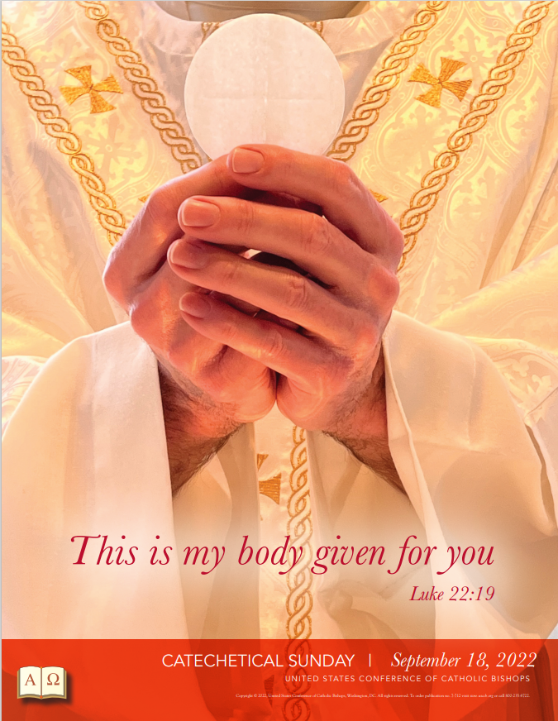

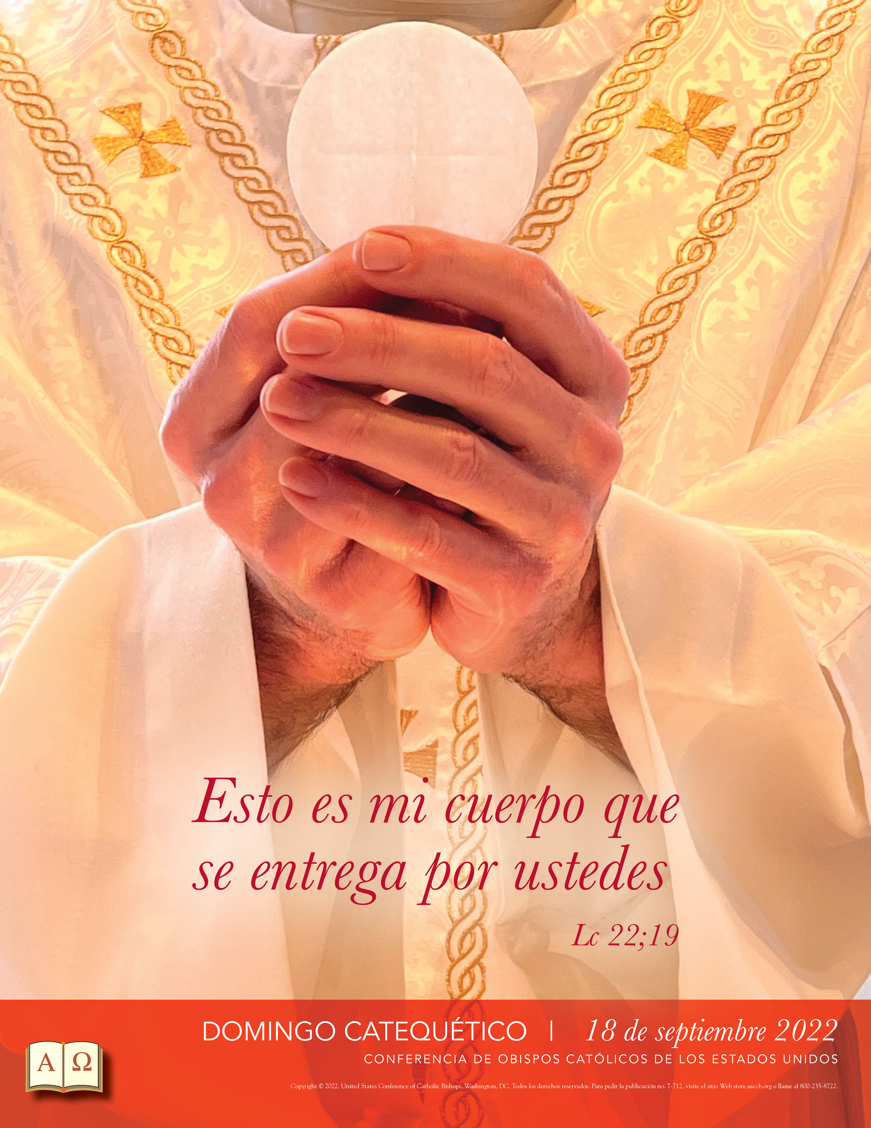

SEPTEMBER BULLETIN ANNOUNCEMENTS
OFFICE OF FAITH FORMATION AND LAY ECCLESIAL MINISTRY

CELEBRATE FAITH FORMATION September 4, 2022
Those who Labor in the Vineyard of the Lord serve with a joyful enthusiasm to spread the Good News of Jesus Christ at all times in all ways, often with little or no compensation for their generosity of time and talent. Perhaps today we can seek a catechist, youth minister, adult faith formation minister, or RCIA team member to express our appreciation for their willingness to share their faith with our parishioners and our community.

CELEBRATE THOSE WHO SHARE FAITH: September 11, 2022
The Ministry of the Word includes the mission of Faith Formation, Catechesis, and teaching. Catechesis means “to echo.” Believers who embrace the Gospel of Jesus Christ as the best news ever proclaimed are eager to “echo” the Good News everywhere. Have you shared your enthusiasm for the Catholic Church with someone recently?
HONOR OUR CATECHISTS AND TEACHERS: September 18, 2022
Today the Catholic Church of the United States observes “Catechetical Sunday” to recognize the importance of the ministry of catechesis. We honor those persons who share faith with other adults, youth and children through their service as catechists and facilitators in all of our parish ministries. Please commit yourself to pray for those who are helping faith to grow in you, and your family.

COMMIT TO LIFELONG LEARNING: September 25, 2022
Faith formation requires a commitment to lifelong learning and openness to grow in Discipleship. Many opportunities designed to assist adults to nurture their spirituality and acquire enhanced knowledge of the faith are presented during the fall and Advent season. Should you be open to expanding your understanding of the teaching of the Catholic Church, please contact the Diocesan Office of Faith Formation and Lay Ecclesial Ministry at 330 744-8451, visit https:catechistcafe.weebly.com/catechist-courses.html or speak with your Parish Director of Religious Education for more information.

LIMEX INFORMATION SESSIONS

Are you interested in a part-time, graduate-level program in theology and spirituality from a Catholic university? Information sessions concerning the Loyola Institute for Ministry Extension Program of Loyola University New Orleans are scheduled October 13, 2022 at 10:00 am at the Diocesan Conference Room and at 6:30 pm via Zoom. Please contact Margie Hynes, liaison for LIMEX, at 330 744-8451 ext. 296 or mhynes@youngstowndiocese.org with any questions and which information session you plan to attend.

CATHOLIC DIOCESE LIBRARY
What's the best kept secret in the Youngstown diocese? Our expansive library of materials to enrich your faith. We have books, DVDs and audio books about bereavement support, bible study, devotionals and prayer. Explore our collection online at https://doylib.follettdestiny.com or visit us in person, 225 Elm St., Youngstown, Monday-Friday 8am-4pm. Contact Margie Hynes for more information 330-744-8451, mhynes@youngstowndiocese.org.

MINISTRY DAY 2022
A day for everyone! Please register for the Diocesan Ministry Day at John F. Kennedy High School on Saturday, October 8, 2022. The day is a collaborative effort of the Central Offices serving multiple ministries and will include Welcome by Bishop Bonnar, Prayer, Keynote by Father Ricky Manalo, CSP, many breakout sessions on a variety of topics, exhibits, and more!
Find more information at DOY.org.

Office of Pro-Life, Marriage and Family

National Day of Remembrance for Aborted Children: September 10
September 10 is the National Day of Remembrance for Aborted Children. Local observances are being held at:
– 10:00 a.m. at St. Joseph Parish in Maximo, 12055 Easton St NE, Alliance
– 1:00 p.m., the Shrine of Our Lady Comforter of the Afflicted, 517 S. Bella Vista, Youngstown
More information may be found at www.nationaldayofremembrance.org or contacting 330-744-8451 ext.272 or dschmidt@youngstowndiocese.org. There are 20 memorials to the unborn located at parishes and other intuitions throughout the Diocese of Youngstown.

Eleventh Annual Faith & Family Festival: September 25

A day of fun and fulfillment for families, students and friends will be held on Sunday, September 25, 2022, on the West Quad of the campus of Walsh University at 2020 E. Maple St., North Canton. The day will begin at 11:00 a.m. with Mass with Bishop Bonnar. Our featured presenter is Fr. Leo Patalinghug “the cooking priest” from Plating Grace. The day will also include musical acts, activities for kids and young people, vendors and exhibitors, and food. For more information contact dschmidt@youngstowndiocese.org or 330-744-8451 ext. 272.

Volunteer at the Faith & Family Festival: September 25

The eleventh annual Faith and Family Festival of the Diocese of Youngstown will take place on Sunday, September 25, 2022 from 11:00 am to 5:00 pm on the Walsh University campus in North Canton. The day is designed to be one of faith, fun, and fellowship for families, students, and all members of the community. Please help us make it happen! We can use help with Set-Up, Taking Pictures, Parking Cars, Activities, Manning a Booth, Trash Collection, Clean-Up, etc. To help out contact 330-272-3758 or dscopacasa@youngstowndiocese.org or go to www.faithfamilyfest.org.
Vendor & Exhibitor Opportunities at the Faith & Family Festival

The eleventh annual Faith and Family Festival of the Diocese of Youngstown will take place on Sunday, September 25, 2022 from 11:00 am to 5:00 pm on the Walsh University campus in North Canton. The day is designed to be one of faith, fun, and fellowship for families, students, and all members of the community.
Vendor and exhibitor opportunities are available at very affordable rates. There are a limited number of spaces available. If you would like more information about how you or your organization can participate in this year’s Faith and Family Festival, please contact the vendor area coordinator, Kevin Krabill at kevinkrabill@gmail.com or 330-428-3333.
Project Rachel Outreach – September Message for Bulletin/Newsletter

“My daughter had an abortion…I don’t know what to do.” There is Hope and Healing available. For CONFIDENTIAL help text or call Project Rachel of Northeast Ohio at 330-360-0430 or go to https://hopeafterabortionneo.weebly.com/.

Into Life
Consider signing up for the INTO LIFE: Love Changes Everything program being hosted by the Diocese of Youngstown’s Office of Pro-Life, Marriage & Family Life on Wednesdays, beginning September 28, from 7:00 to 8:15 pm in the Regina Coeli Parish Rectory Meeting Room (663 Fernwood Blvd., Alliance).
Into Life is an opportunity to pray and reflect on what it means to deeply listen and understand the heart of another and accompany someone into God’s life and freedom. The program is a 12-part series created by the Sisters of Life and the McGrath Institute for Church Life at the University of Notre Dame. Journey with the Sisters of Life as they explain what it means to walk with a woman who is pregnant and vulnerable.
Into Life can be instrumental in establishing Walking with Moms in Need throughout the Diocese of Youngstown (see above) by training those who seek to assist moms in need make life-affirming decisions. For more information contact Dave Schmidt at 330-744-8451 ext. 272 or dschmidt@youngstowndiocese.org.
Flyer: Into Life September 2022

40 Days for Life in Canton and Warren

40 Days for Life is an internationally coordinated 40-day campaign that aims to end abortion locally through prayer and fasting, community outreach, and a peaceful all-day vigil in front of abortion businesses. Go to www.40daysforlife.com. The Fall 2022 campaign takes place September 28 through November 6. There are two 40 Days for Life campaigns in the Diocese of Youngstown:
– Canton, at 2663 Cleveland Ave. NW, in front of the Planned Parenthood. Contact Linda at 330-826-1885 or fortydayscanton@gmail.com.
– Warren at 375 North Park Ave., in front of the Planned Parenthood. Contact Mary at 330-372-6147 or mgoffos@hotmail.com.

Mass for Life with Bishop Bonnar – Saturday, October 1

Bishop Bonnar will preside at a Mass for Life on Saturday, October 1, at 5:00 p.m. at Walsh University’s Our Lady of Perpetual Help Chapel, to mark the beginning of October Respect Life Month and to pray for the success of the First Annual Ohio March for Life in Columbus. Bishop Bonnar will offer a special Blessing of Children in the Womb. A reception will follow. All are welcome – no reservations needed. For more information contact 330-744-8451 ext.272 or dschmidt@youngstowndiocese.org.

First Annual Ohio March for Life – Ohio Statehouse, Columbus

When: Wednesday, October 5, 2022
10:00 a.m. Pre-Rally Concert; 11:00 a.m. Rally; Noon Ohio March for Life begins
Where: West side for the Ohio State Capital Square, facing South High Street, Columbus
Who: Bishop Bonnar, Pastor David Forbes, Dr. Alveda King, Aaron Baer, Peter Range, Jeanne Mancini
An incredible opportunity for pro-life Ohioans to come together to be a voice for the voiceless at the state legislature. To learn more and to register go to: https://marchforlife.org/ohio-march-for-life/ or contact 330-744-8451 ext. 272 or dschmidt@youngstowndiocese.org.

25th, 40th, 50th and over Wedding Anniversary Celebration

The Diocese of Youngstown is sponsoring a Wedding Anniversary Celebration on Sunday, October 16th, 2:00 p.m. at the Basilica of St. John the Baptist in Canton, honoring couples observing their 25th, 40th, 50th, and over wedding anniversaries in 2022.
The Wedding Anniversary Celebration will include Mass with the Most Reverend David J. Bonnar, Bishop of Youngstown, renewal of marriage vows and a personalized certificate for each couple. Following the Mass, there will be a reception for the couples and their families in the parish hall. You must make advanced reservations for this event by contacting your parish office and obtaining your pastor’s signature before September 16th.

Intercessions for Life and Pro-Life Bulletin Briefs
Recommended intercessions and bulletin briefs for July, prepared by the U.S. Conference of Catholic Bishops Secretariat for Pro-Life Activities, may be found at https://www.respectlife.org/word-of-life

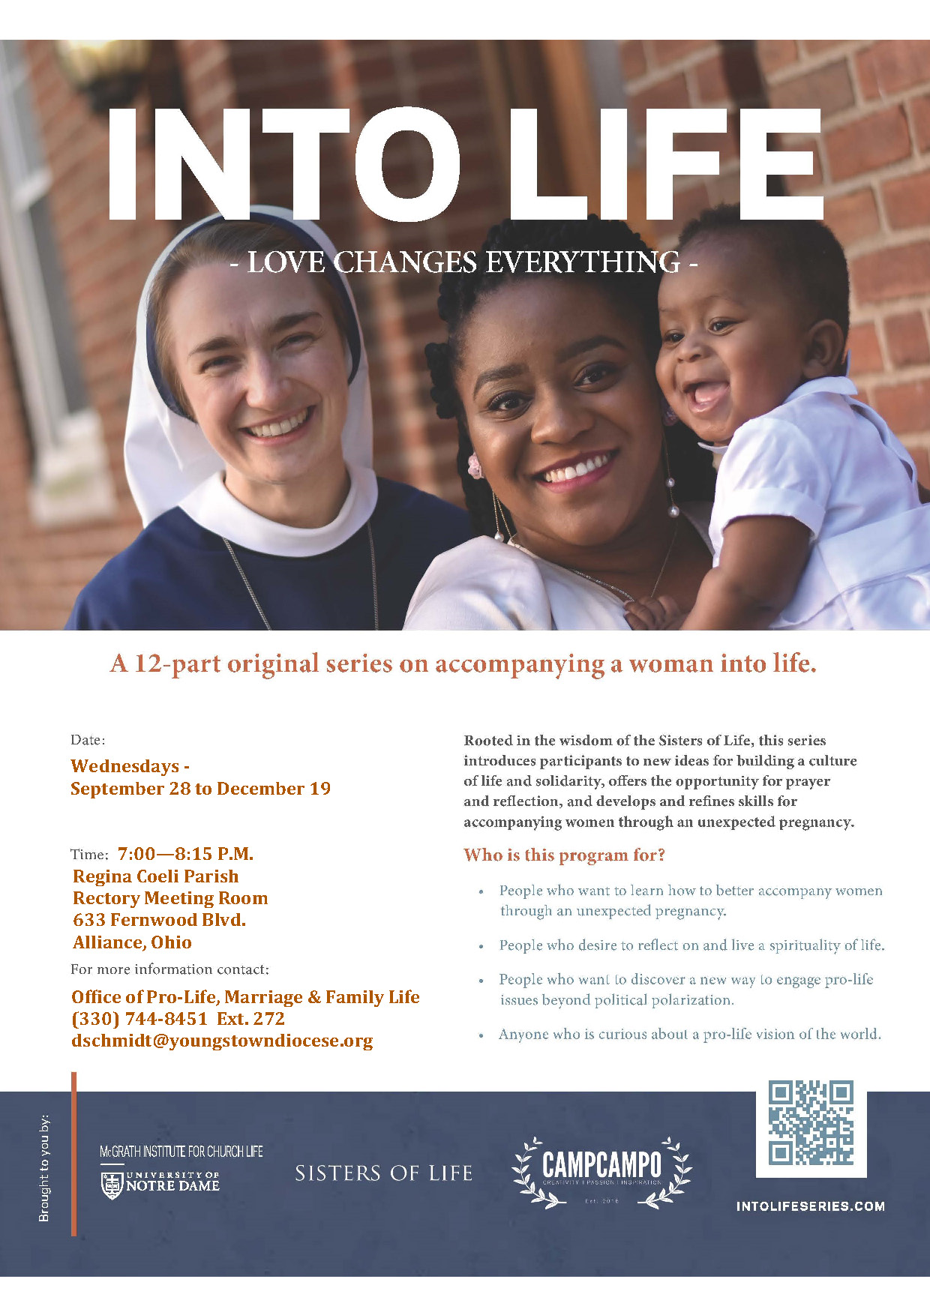
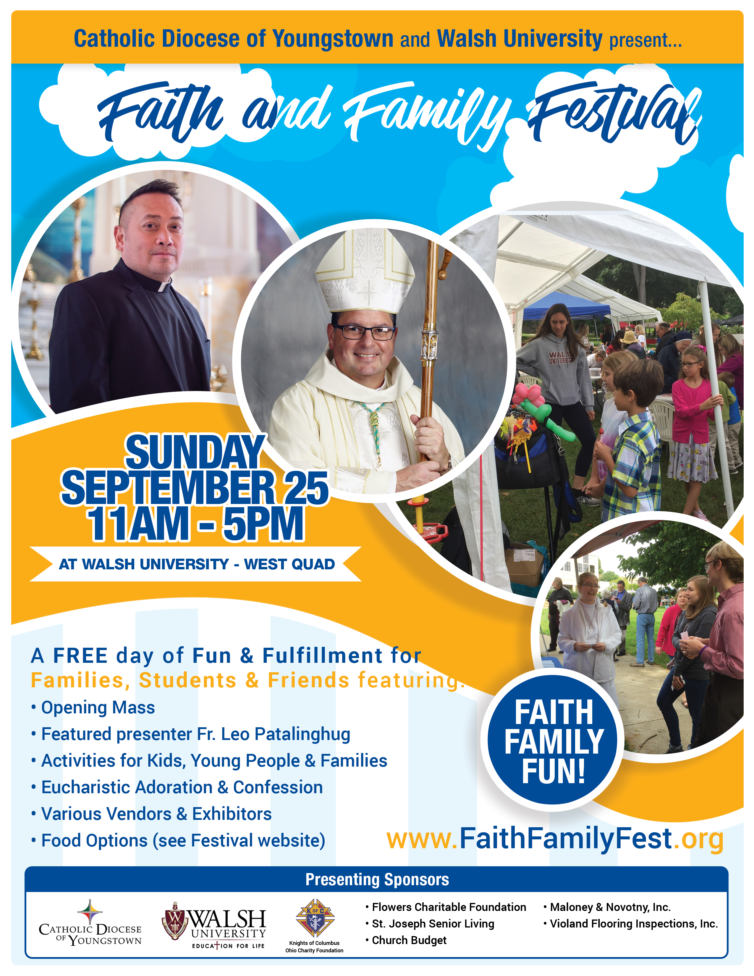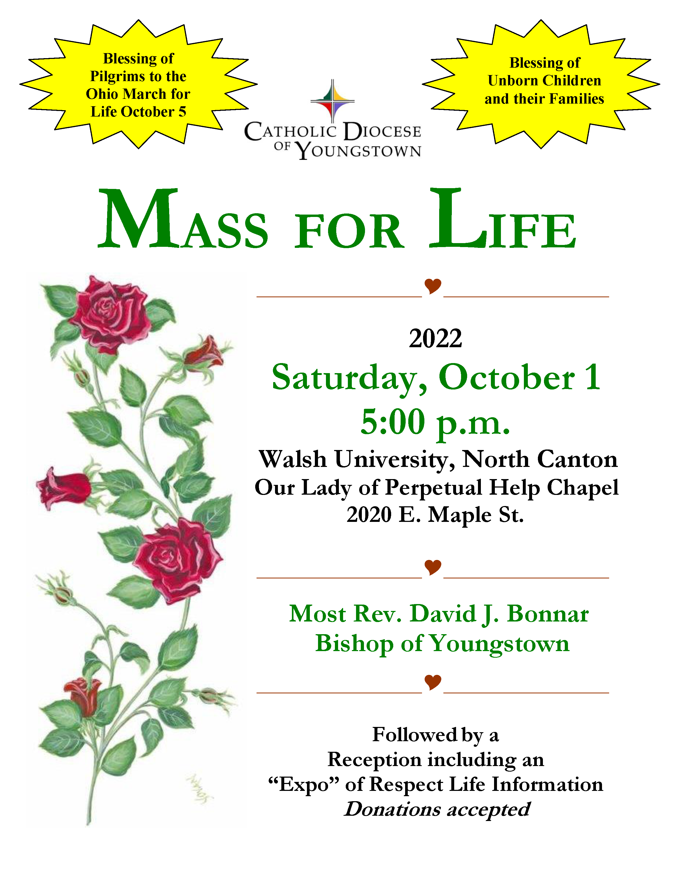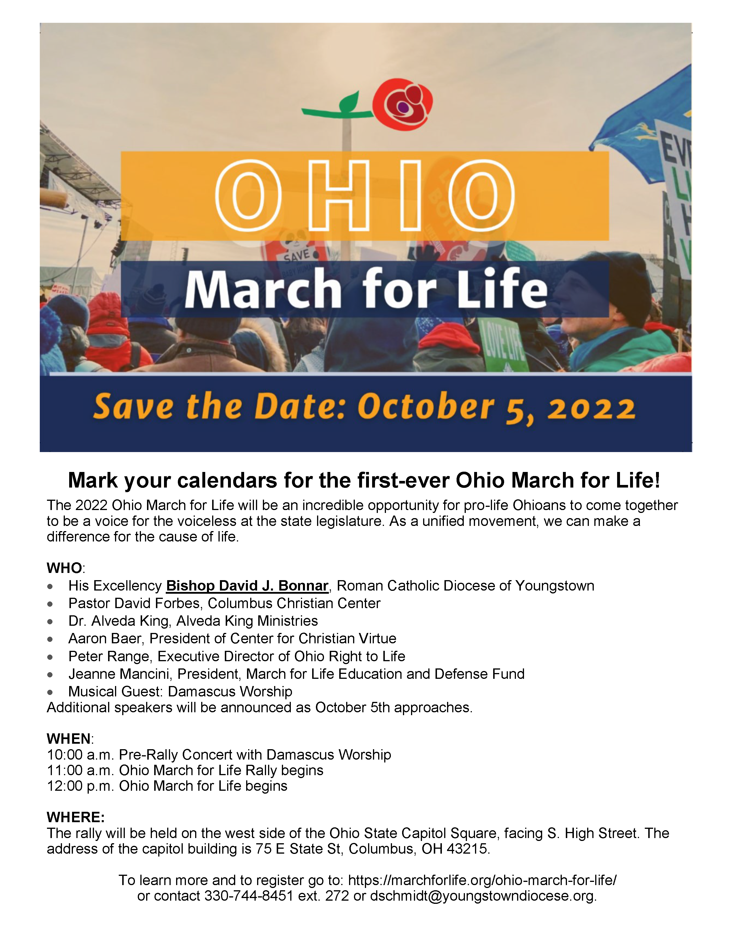

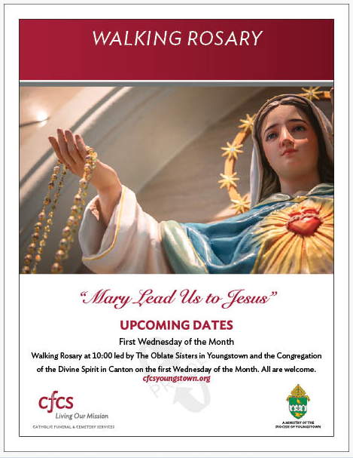

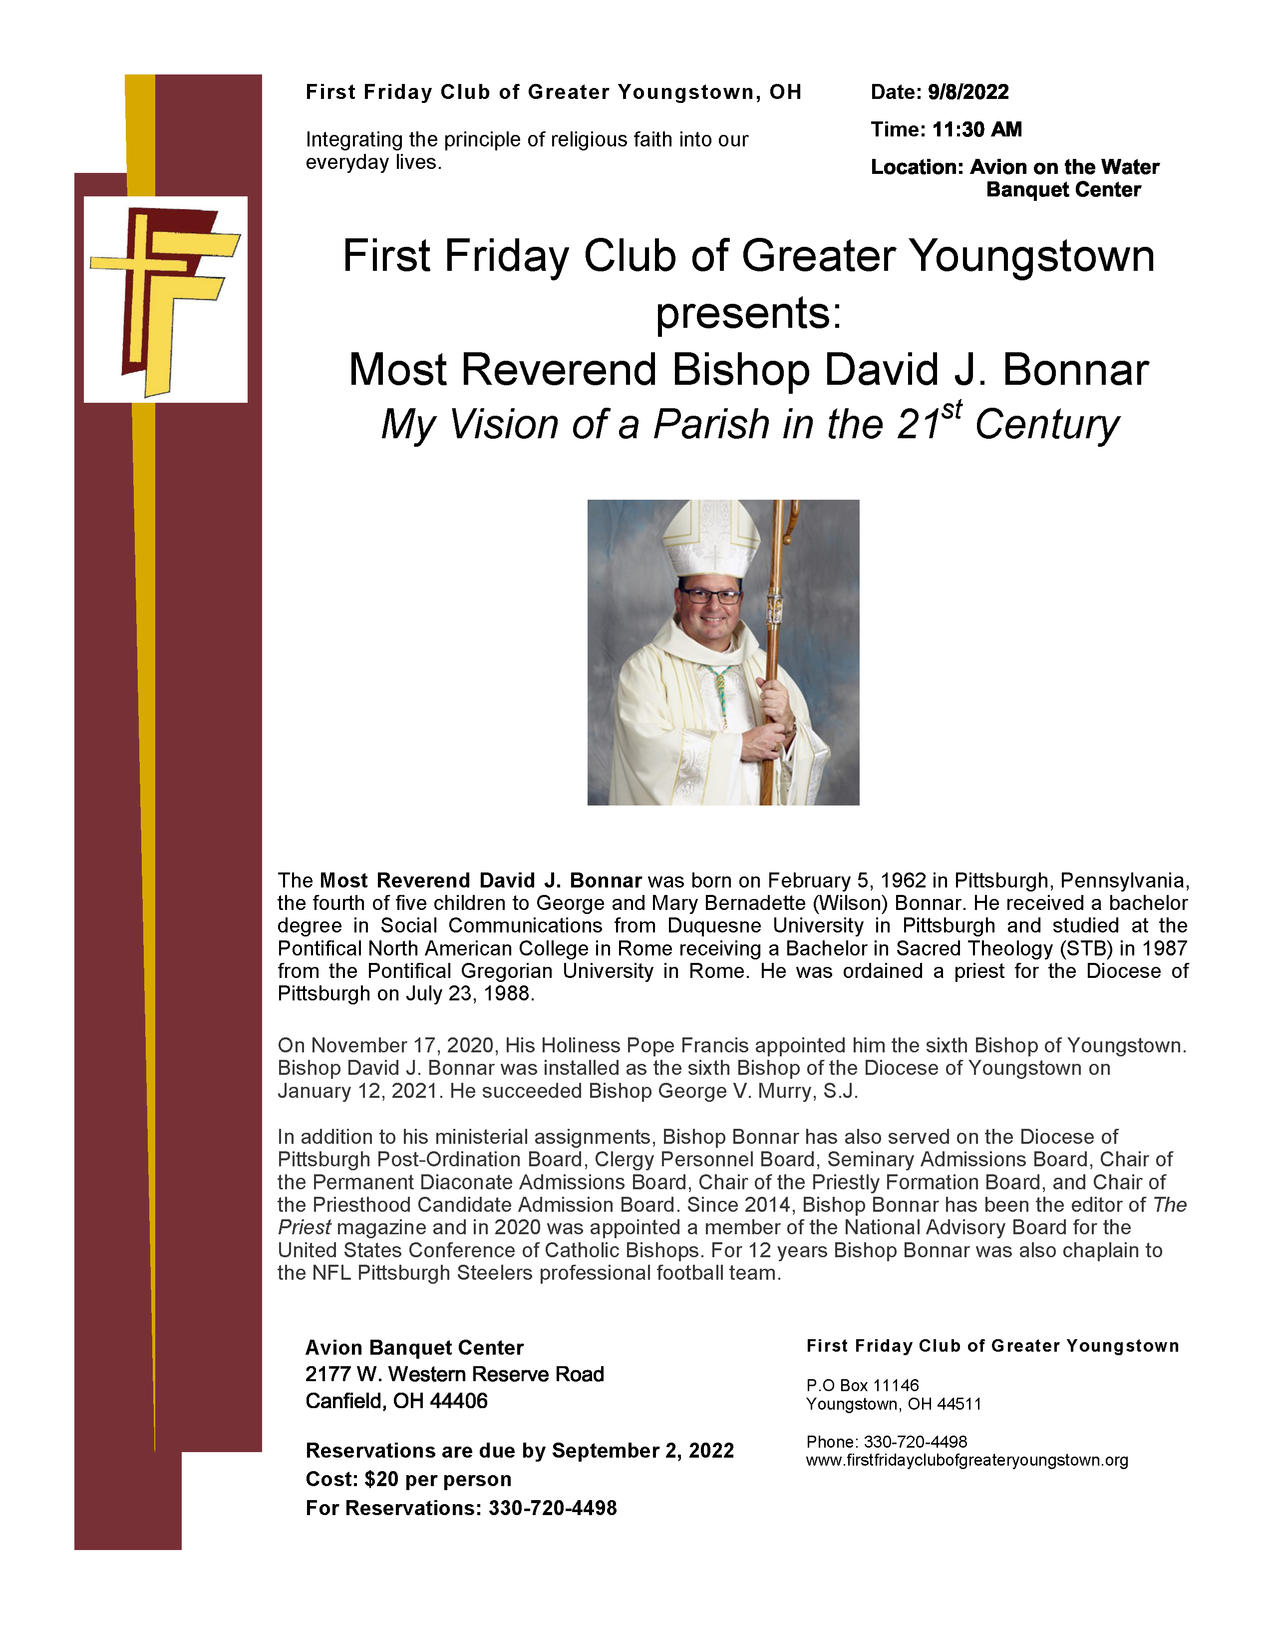

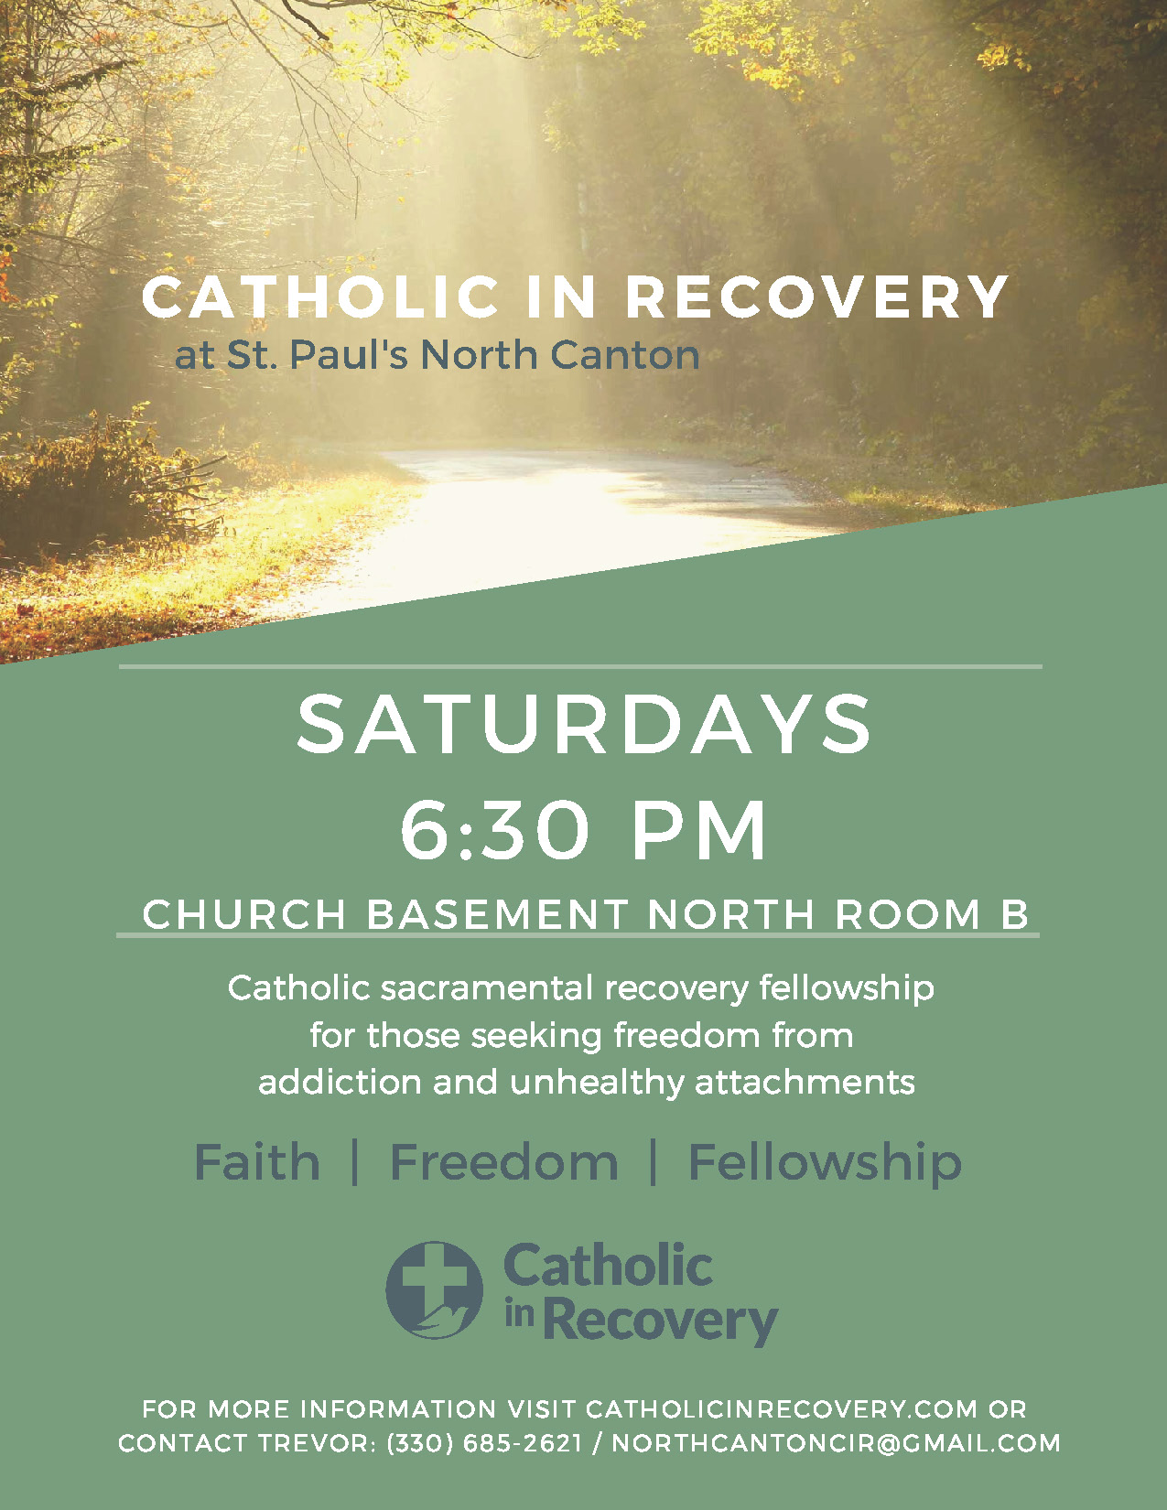

Parish Events: Bulletin Blurbs

Ashtabula County: Grape Jamboree in Geneva Sept 23-25
Assumption Parish will again have their famous Grape Pies at the Grape Jamboree Sept. 23rd - 25th, in Geneva, Ohio. You can pre-order your pies by calling 440-466-3427, or by visiting our website www.assumptionchurchoh.org

Mahoning County: First Friday Club with Bishop Bonnar 9/8 at 11:30am**
“My Vision of a Parish in the 21st Century”
First Friday Club
September 8th Speaker: Bishop David Bonnar

The First Friday Club of Greater Youngstown begins their 16th season on Thursday September 8, 2022. We invite you to attend as we welcome Most Rev. David J. Bonnar, Bishop of the Diocese of Youngstown. Bishop Bonnar will present, “My Vision of a Parish in the 21st Century” at Avion on the Water Banquet Center, 2177 W. Western Reserve Road in Canfield.

There will be an opportunity for participants’ questions to follow. Luncheon will be served at 11:30 a.m. with the presentation beginning at noon. The cost is $20.00. Call by September 2, 2022, 330-720-4498. Reservations are limited!
Visit our website www.firstfridayclubofgreateryoungstown.org

Stark County: Catholic in Recovery Weekly Meetings

We welcome all Catholics who are interested in recovery from addiction and unhealthy attachments. This Catholic sacramental fellowship focuses on deepening our relationship with Jesus Christ and the Catholic Church. A Catholic in Recovery group meets weekly on Saturdays, 6:30pm St Paul's Parish (North Canton), Church Basement North Room B.
For more information, visit CatholicinRecovery.com or contact Trevor: (330) 685-2621 | northcantoncir@gmail.com
Virtual meetings available at CatholicinRecovery.com
St Paul Parish (North Canton)
241 S Main St, North Canton, OH 44720

Stark County: St. Benedict School Reunion
The former St. Benedict School in Canton will hold a reunion the weekend of September 17 and 18. We are looking for classmates and photos. Please contact David Bernardo at 330-936-6645 or dbernardo@sssnet.com for further information.

Trumbull County: New Praesidium of the Legion of Mary
Queen of the Holy Rosary Church in Vienna has a newly formed praesidium of the Legion of Mary. Anyone in the diocese may join, but we would especially like to inform former members of the Legion who no longer have a praesidium that we are here. We meet at 9:15 am on Saturdays in our large CCD classroom (first classroom on the left as you enter the school wing).
For more information, contact Mary Elizabeth Tinnirello at the parish office:
qhrvienna@gmail.com or 330-856-4204
Queen of the Holy Rosary Parish
291 Scoville Dr., Vienna, OH 44473

