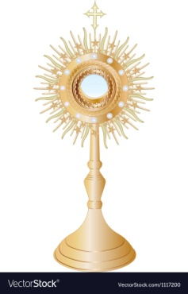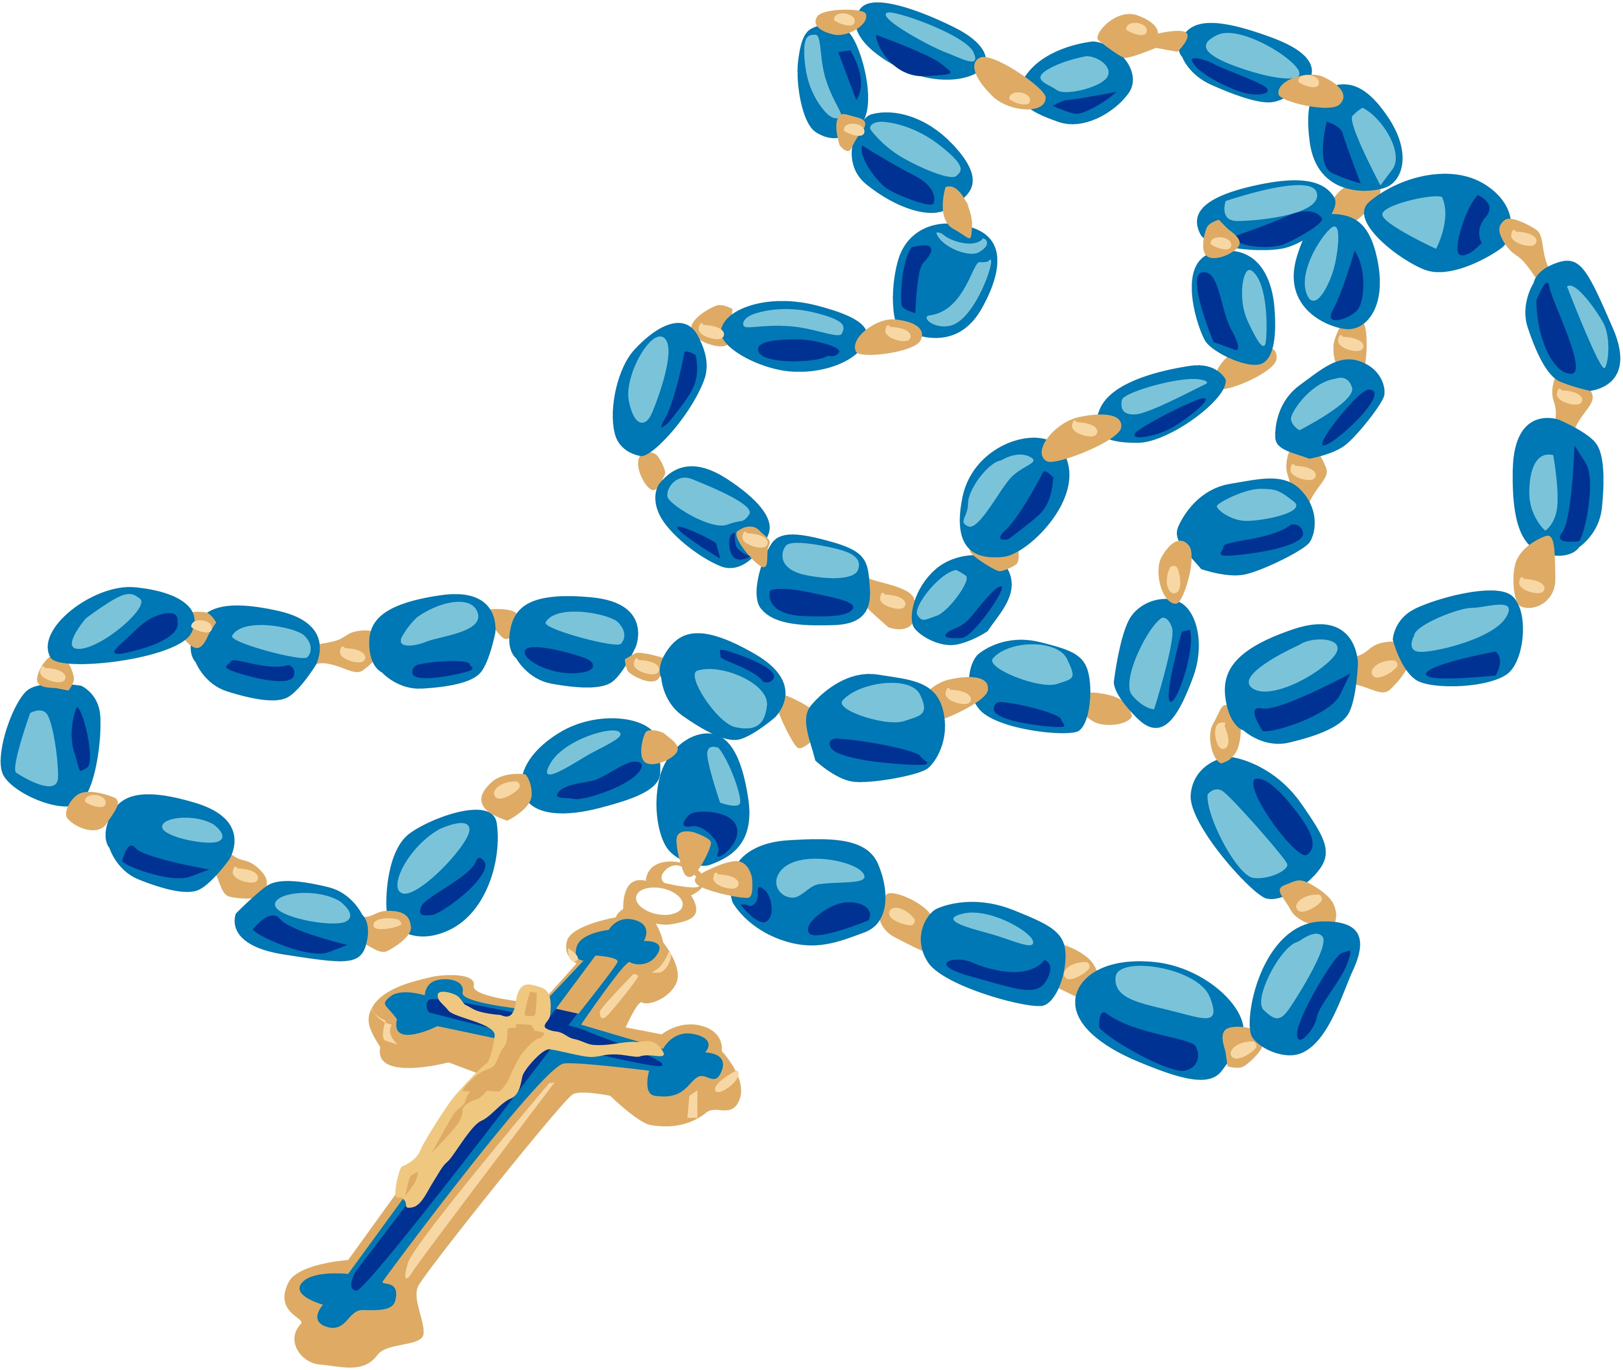

**Please Join Us in Prayer**

**At the 7th Annual**

**Greater Youngstown Area**

**OUR LADY OF FATIMA**

**Public Square Rosary Rally**

**Saturday, October 15, 2022**

**10:30 AM Mass at St. Columba Cathedral**

**11:20 AM Eucharistic Procession**

****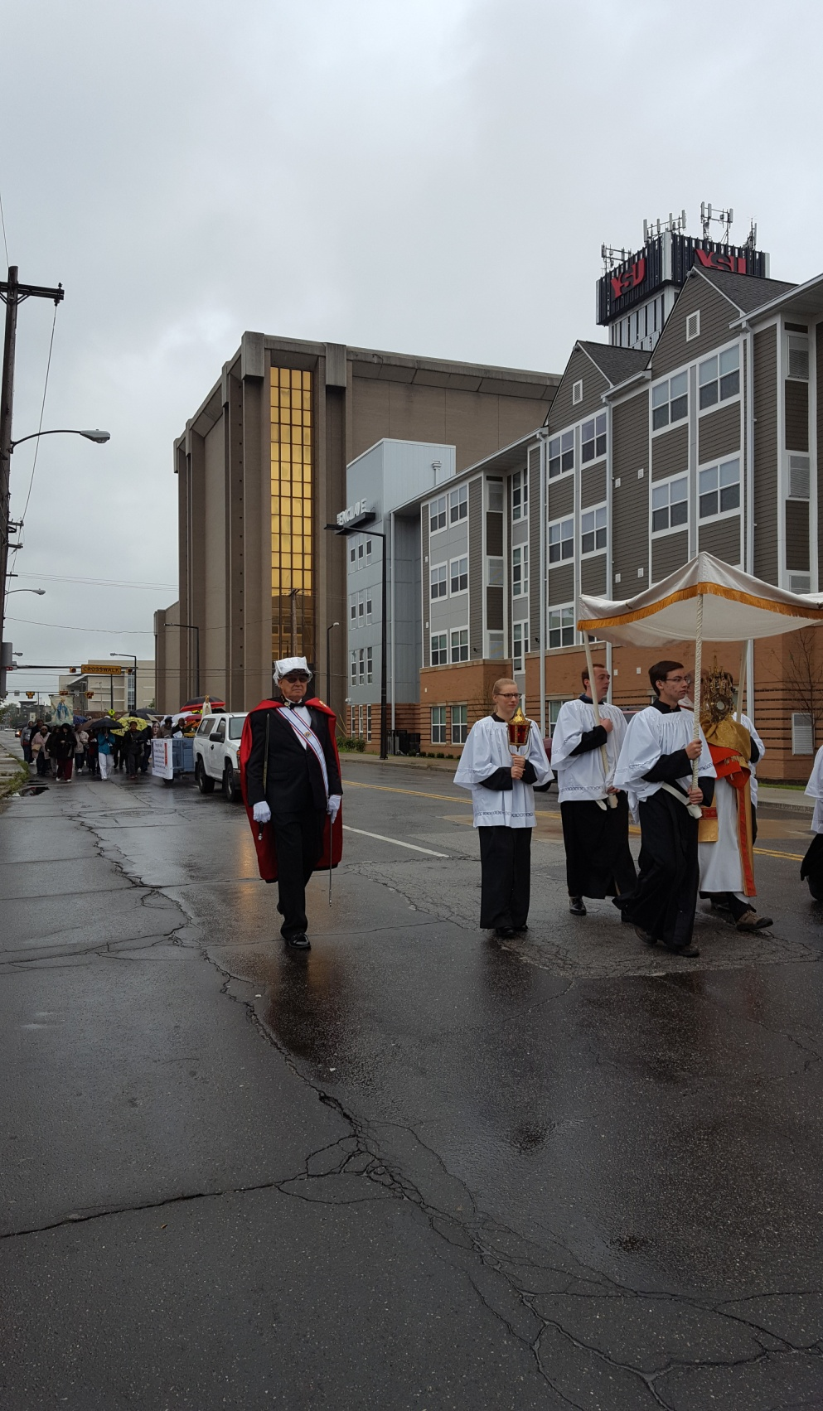

**Participate in the procession either on foot or by vehicle.**

If inclement weather, we shall remain inside the cathedral.

**12:00 Noon Public Recitation of the Rosary**

**at St. Columba Cathedral**

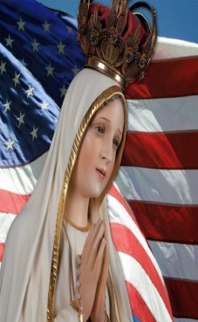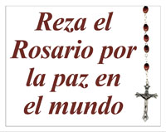

**Praying the Rosary**

**for America…**

As human efforts fail to solve America’s

key problems we turn to God, through

His Holy Mother, asking His urgent help.

**For more information**

**Call or Text**

**Connie (330) 507-3880**

**or**

**Katie (330) 647-3833**