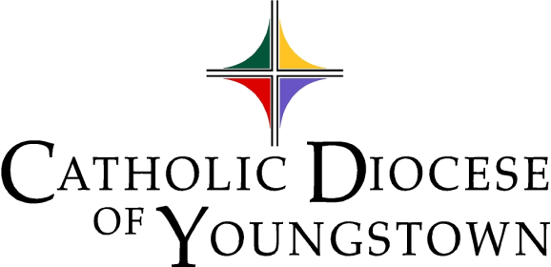

Communiqué
www.doy.org
144 West Wood Street
Youngstown, OH 44503-1081
330-744-8451 fax 330-742-6448

Volume 54 No. 12 November 2022

In November We Remember

At the end of the Liturgical Year, we remember in prayer those who have died. We support each other in our grief while praising God for the promise of eternal life with Jesus Christ.

Quote of the Month
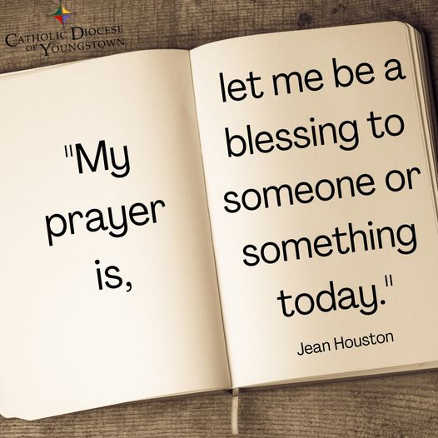
"My prayer is, let me be a blessing to someone or something today."
–Jean Houston
Digital edition available at https://doy.org/communique-november-2022/

Attachments available to download as individual documents in this folder: https://bit.ly/3DaY3L6

Editor’s note: Click on a Table of Contents headline to go directly to that page. If that doesn’t work, hold down the CTRL button while you click. Headlines containing suggested announcements with bulletin/publicity materials are marked with a double asterisk**, and the text is outlined in red. Please see links and attachments for flyers and graphics provided for these events.
Table of Contents
CHANCERY OFFICE 317
OFFICE OF SAFE ENVIRONMENT (Bulletin Materials | Materiales de Boletín) 317
1. Safe Environment Bulletin Announcements (Bulletin Materials | Materiales de Boletín)** 317
2. Safe Environment Policy 318
3. Who needs to be compliant? 318
4. Compliance Requirements 319
5. Updating Information 320
6. Reporting Child/Vulnerable Adult Abuse 320
7. Questions or Concerns 320
LETTERS OF SUITABILITY 321
ARCHDIOCESE FOR THE MILITARY SERVICES COLLECTION (Bulletin Materials) 321
EUCHARISTIC REVIVAL 321
1. Upcoming Eucharistic Revival Events (Bulletin Materials)** 321
ARCHIVES OFFICE 322
Questions about Parish Records? 322
BISHOP BONNAR’S 2023 PILGRIMAGE (Bulletin Materials)** 323
CANONICAL SERVICES 323
TRIBUNAL 323
Tribunal In-Service Available 323
CATHOLIC CHARITIES SERVICES 324
CATHOLIC CHARITIES (Bulletin Materials) 324
Season of Giving** 324
Breakfast with the Bishop Event** 324
Giving Tuesday** 325
Support for Ukraine – Financial Support (Bulletin Materials)** 326
Support for Ukraine – Sponsor Support (Bulletin Materials)** 326
CATHOLIC CHARITIES SERVING PORTAGE AND STARK COUNTIES (Bulletin Materials) 327
Adult Day Services in Louisville is Accepting Participants** 327
CATHOLIC CHARITIES REGIONAL AGENCY (Bulletin Materials) 327
Urgent Need: Catholic Charities Regional Agency** 327
OFFICE OF PEACE AND JUSTICE (Bulletin Materials) 328
Prison Ministry Presents - Kolbe Gathering** 328
DEPARTMENT OF COMMUNICATIONS 329
CATHOLIC EXPONENT 329
MULTIMEDIA (CTNY) (Bulletin Materials) 329
Wineskins ** 329
How to Watch the Mass for Shut-Ins 330
MEDIA RELATIONS 331
OFFICE OF SOCIAL MEDIA 332
1. 2022- 2023 Social Media Profile Report Form 332
2. DOY Social Media Networking Facebook Group for Social Media Contacts 332
3. Social Media Helpful Hint of the Month – Check your settings! 332
CLERGY AND RELIGIOUS SERVICES 333
OFFICE OF CLERGY SERVICES 333
1. Advent Day of Recollection – Save the Date 333
2. New Order of Penance 333
OFFICE OF VOCATIONS (Bulletin Materials) 333
National Vocations Awareness Week 2022 333
Seminarian Pastoral Intern 333
Seminarian Posters and Prayer Cards 334
Vocation Director at Your Parish / School 334
Come and See Weekends (Bulletin Materials)** 334
Seminarian Visits to Your School or Parish 335
“Discovery Days” [Seminary Field Trips] 335
Vocation Intercessions and Bulletin Blurbs (Bulletin Materials)** 335
Vocations Social Media 335
OFFICE OF VOWED RELIGIOUS 336
World Day for Consecrated Life 336
New and Returning Religious 336
Religious Retirement Appeal (Bulletin Materials)** 336
DEVELOPMENT AND STEWARDSHIP OFFICES 337
OFFICE OF THE ANNUAL DIOCESAN APPEAL 337
OFFICE OF DEVELOPMENT AND STEWARDSHIP (Bulletin Materials/Materiales del Boletín) 337
Stewardship Bulletin Thoughts (Bulletin Materials | Materiales de Boletín)** 337
Sign Up for #iGiveCatholic 337
PASTORAL AND EDUCATIONAL SERVICES 338
OFFICE OF FAITH FORMATION AND LAY ECCLESIAL MINISTRY (Bulletin Materials) 338
1. Ministry Day Appreciation 338
2. Ministry with Persons with Disabilities 338
3. LIMEX: There is Still Time (Bulletin Materials)** 339
4. The Catholic Church Needs You (Bulletin Materials)** 339
5. New Library Resources 339
6. Attention Lifelong Learners (Bulletin Materials)** 340
7. Best kept secret: Library 340
8. Advent Retreat: December 1, 2022 340
OFFICE OF PRO-LIFE, MARRIAGE AND FAMILY LIFE (Bulletin Materials) 341
1. Walking with Moms in Need 341
2. INTO LIFE – Love Changes Everything 341
3. Christ the King (Attachment) 341
4. The National March for Life Will Still Take Place in January (Bulletin Materials)** 342
5. National March for Life Related Events 342
6. Marriage Preparation Engaged Couple Retreat Day 342
7. Project Rachel Outreach – November Message for Bulletin/Newsletter (Bulletin Materials)** 343
8. Intercessions for Life and Pro-Life Bulletin Briefs 343
OFFICE OF WORSHIP 344
1. Celebration of Confirmation for Adults 344
2. Parish Liturgical Minister Contact Information Requested 344
3. Lay Leader of Prayer Commission 344
4. Leader of Prayer Formation Series 344
5. New Order of Christian Initiation of Adults 345
6. Liturgical Calendar Advisories for Upcoming Holy Days and Christmas/New Year 345
7. The Light is On for You ~ An Evening of Reconciliation 345
8. New Order of Penance 345
9. Liturgical Directory 346
OFFICE OF YOUTH AND YOUNG ADULT MINISTRY 347
1. Eagle of the Cross 347
2. Confirmation Retreat 347
3. Eucharistic Revival 347
OFFICE OF ECUMENICAL AND INTERRELIGIOUS DIALOGUE 348
1. Catholic Higher Education Symposium on Oct 26 at 6pm 348
2. Catholic–Orthodox Dialogue: Upcoming event via Zoom on Nov 10 at 7pm (Bulletin Materials)** 348
MISCELLANEOUS 349
DIOCESAN CEMETERIES (Bulletin Materials) 349
Chaplet of Divine Mercy, Fridays at 3pm** 349
All Souls Day Masses** 349
PARISH EVENTS (Bulletin Materials) 350
Mahoning County | Cursillo Women's Weekend Jan 12-15, 2023** 350
Mahoning County & Live Streaming | Aid for Ukraine Concert Nov 20 at 3pm at St. Anne (Austintown)** 350
Mahoning County | First Friday Club in November** 351
Mahoning County | First Friday Club in December** 352
Stark County | Catholic Men's Fellowship Nov 5** 352
Stark County | Catholic Man Night Nov 18** 352
IN MEMORIAM: NOVEMBER NECROLOGY 353

CHANCERY OFFICE

OFFICE OF SAFE ENVIRONMENT (Bulletin Materials | Materiales de Boletín)

PARISH BULLETINS/PUBLICITY

Safe Environment Bulletin Announcements (Bulletin Materials | Materiales de Boletín)**

You can also download these files from the November Attachments folder: https://bit.ly/3DaY3L6
The following bulletin announcement regarding education, screening, reporting, and victim assistance, should be included bi-monthly (every two months) in all parish bulletins:
- English Bulletin Insert: PDF
- English Bulletin Insert: Image (PNG)
- Spanish Bulletin Insert: PDF
- Spanish Bulletin Insert: Image (PNG)

CATHOLIC DIOCESE OF YOUNGSTOWN
SAFE ENVIRONMENT POLICY
FOR THE PROTECTION OF CHILDREN AND VULNERABLE ADULTS

EDUCATION & SCREENING

All clergy, religious, seminarians/persons in formation, and employees, as well as any volunteers who work with children, young people, or vulnerable adults, are required to complete a background check and safe environment training. For more information about our safe environment compliance requirements visit: doy.org/safe-environment/.

REPORTING & VICTIM ASSISTANCE

If you or someone you know has been abused or victimized by someone representing the Catholic Church, the Diocese encourages you to come forward and speak out by contacting Civil Authorities and Mr. Dominic Colucy, Victim Assistance Coordinator. Mr. Colucy is available to help. He will listen to your needs and support you. He will help you make a formal complaint.

Contact Information
Confidential Response Line: 330-718-1388
Email: dcolucy@youngstowndiocese.org
By Mail: Catholic Diocese of Youngstown, Attn: Dominic Colucy
144 W. Wood St., Youngstown, OH 44503

Contact information for Civil Authorities can be found at: doy.org/safe-environment/.

DIÓCESIS CATÓLICA DE YOUNGSTOWN
POLÍTICA DE AMBIENTE SEGURO
PARA LA PROTECCIÓN DE NIÑOS Y ADULTOS VULNERABLES

EDUCACIÓN Y DETECCIÓN
Los clérigos, religiosos, seminaristas/personas en formación, y empleados, así como cualquier voluntario que trabaja con niños, jóvenes o adultos vulnerables, están obligados a completar una verificación de antecedentes y capacitación en la política de ambiente seguro. Para más información sobre nuestros requisitos de cumplimiento de ambiente seguro visite doy.org/safe-environment/.

DENUNCIA Y ASISTENCIA LAS VICTIMAS
La Diócesis lo alienta a presentarse y denunciar el caso contactando a las autoridades civiles y/o al Sr. Dominic Colucy, Coordinador de Asistencia a las Víctimas. El Sr. Colucy está disponible para ayudarlo a usted o cualquier otra persona que haya sido abusada o víctima de alguien que representa a la Iglesia Católica. Él lo escuchará y lo apoyará en lo que necesite. Él lo ayudará a redactar una denuncia formal.

Información del contacto
Línea confidencial: 330-718-1388
Email: dcolucy@youngstowndiocese.org

Por correo: Catholic Diocese of Youngstown, Attn: Dominic Colucy

144 W. Wood St., Youngstown, OH 44503

La información para contactar a las Autoridades Civiles puede ser encontrada en: doy.org/safe-environment/.

Safe Environment Policy

Link: Safe Environment Page
Link: Background Check Requirements

Who needs to be compliant?

A. All active clergy, religious, seminarians, and persons in formation are required to be compliant.
B. All employees in parishes, schools, and institutions, including the Diocesan Central Offices, are required to be compliant regardless of their level of contact with children or vulnerable adults.
C. Any volunteer who has unsupervised access to a child or vulnerable adult, or who works directly with a child or vulnerable adult, or who is responsible for a child or vulnerable adult on behalf of the Diocese, must be compliant.

Compliance Requirements

A. VIRTUS Account Creation and VIRTUS Training
- Visit the Safe Environment page on the diocesan website to create an account and complete the online training in either English or Spanish.
- If you completed VIRTUS in a different diocese you can transfer or mirror your account by emailing a request to the VIRTUS online help desk (helpdesk@virtus.org). Please include your full name, email address, original diocese and new diocese, your new parish / school, plus a phone number in case they need to contact you.
- VIRTUS training is valid for five years. An online recertification module is required every five years to maintain compliance.
- Aside from VIRTUS, child/vulnerable adult protection in-service or online courses from other agencies, employers, dioceses, Scouts, etc., are not valid for compliance in the Diocese of Youngstown.

B. Authorization & Verification and Acknowledgement Form (Appendix 9)
  - Visit the Safe Environment page on the diocesan website to review an electronic copy of the Safe Environment Policy.
  - After you have reviewed this policy, print a copy of Appendix 9. Both pages must be completed, and the document requires a witness signature for validity. The witness can be anyone.
  - The original must be submitted to the Compliance Officer at your parish, school, or institution. The Compliance Officer will forward a copy to the diocesan Safe Environment Coordinator.
  - Appendix 9 may not be edited. If any lines of text are removed, crossed off, or altered, the document is not valid for compliance.

- Fingerprinting and Background Checks
  - Visit the Safe Environment page on the diocesan website to review our background check requirements, codes, and instructions, a background check location finder, and a list of criminal offenses that automatically disqualify an applicant from working with children or vulnerable adults.
  - A BCI or BCI/FBI background check is required for compliance. In extraordinary circumstances, the Office of Safe Environment reserves the right to alter background check requirements for individuals, unless the requirements are stipulated by the State of Ohio. This includes the right to require background checks from other background check providers besides the Civilian Identification Office.
  - Background checks are valid for five years and must be renewed to maintain compliance.
  - The Civilian Identification Office must send the BCI and/or FBI background check results directly to the Office of Safe Environment at the Diocese. This needs to be communicated to the person doing the background check: Catholic Diocese of Youngstown, Attn: Office of Safe Environment, 144 West Wood Street, Youngstown, OH 44503
  - If background check results are sent to the wrong location, they are not valid for compliance. Additionally, background checks completed for other agencies, employers, dioceses, public schools, certifications, etc., or in other States, are not valid for compliance in the Diocese of Youngstown.

A person is not compliant until their VIRTUS account notes the dates of completion for all three compliance requirements (VIRTUS Training, Appendix 9, Background Check).

Updating Information

Compliance Officers must submit a Change of Location Form to the Safe Environment Coordinator to add a new person to their Safe Environment Master Report or to request records from other locations. Individuals can be removed/inactivated by emailing the Safe Environment Coordinator. Compliance Officers should monitor the compliance status of individuals at their location via the VIRTUS database.

Reporting Child/Vulnerable Adult Abuse

If you or someone you know has been abused at any time by a priest, deacon, religious, seminarian, person in formation, employee or volunteer of the Diocese of Youngstown, or if you believe that abuse has occurred or is currently occurring, contact civil authorities and also Mr. Dominic Colucy, Safe Environment Coordinator/Victim Assistance Coordinator, (office) 330-744-8451 x293 or (response line) 330-718-1388.

To report a violation of the Safe Environment Policy that does not constitute abuse or suspected abuse contact Mr. Dominic Colucy, Safe Environment Coordinator, (office) 330-744-8451 x293 or (response line) 330-718-1388.

Visit the Safe Environment page on the diocesan website to find our most up-to-date Reporting Requirements and Procedures in English and Spanish.

Questions or Concerns

For more information about the Diocese of Youngstown Safe Environment Policy, contact by mail: 144 W. Wood Street, Youngstown, OH 44503, phone: 330-744-8451 x293; fax: 330-744-5099; or e-mail: dcolucy@youngstowndiocese.org.

LETTERS OF SUITABILITY

Please note that no priest or deacon may exercise ministry within the Diocese of Youngstown without being granted faculties/permission by the bishop. It is the obligation of the pastor of the parish where ministry or speaking engagement will occur (or other responsible person outside a parish setting) to ensure that the visiting cleric has obtained a letter of suitability. Without such a letter, the Diocese, the parish or school and the pastor or president could become legally liable should any wrongdoing occur.

The visiting cleric himself should ask his bishop or religious superior to send a letter of suitability to Bishop Bonnar. Letters of suitability are to be sent from one bishop/superior to another, not directly to a parish, since it is the bishop who is responsible for determining a cleric’s suitability for ministry.

If you have any questions, please contact Msgr. John Zuraw, Vicar General.

ARCHDIOCESE FOR THE MILITARY SERVICES COLLECTION (Bulletin Materials)

Archdiocese for the Military Services, USA collection will be taken the weekend of November 5-6. This triennial collection provides the Gospel, the sacraments and other forms of spiritual support to men and women of the U. S. Armed Forces wherever they serve and to veterans who are in VA medical centers.

Please see bulletin announcements in this month’s Communique attachments at https://bit.ly/3DaY3L6

EUCHARISTIC REVIVAL
PARISH BULLETINS/PUBLICITY

1. Upcoming Eucharistic Revival Events (Bulletin Materials)**
Full-page Flyer
The Diocese of Youngstown March of the Eucharist concludes this month! All are invited to join the regional Eucharistic Revival Mass and Processions in Portage County. Our final celebration will be at:
St. Patrick Parish (Kent) on November 13th at 11:00 am
See https://doy.org/EucharisticRevival/ for the full schedule and more information.
The National Eucharistic Revival is a three-year process sponsored by the U.S. Catholic Bishops to “inspire and prepare the People of God to be formed, healed, converted, united, and sent out to a hurting and hungry world through a renewed encounter with Jesus in the Eucharist – the source and summit of our Catholic faith” (quote taken from the website for the National Eucharistic Revival).
--
More detail:
The first year, which began on June 19, 2022 and continues until June 2023, has been identified as the Year of Diocesan Revival. The Very Rev. John-Michael Lavelle, coordinator of the Eucharistic Revival in the Diocese of Youngstown and the diocese’s Vicar for Missionary Discipleship, says that in the diocesan year, “we will travel to all parts of the diocese, united in the Mass, Eucharistic Processions, and Holy Hours – leading us to a deeper appreciation of the presence of Christ in our lives.”
The second year of the Eucharistic Revival has been identified as the Year of Parish Revival and will run from June 2023 until July 2024. It will include efforts to strengthen Eucharistic devotion and experience at the parish level. Father Lavelle notes that, “In the early days of our diocese, a book was prepared, entitled, The March of the Eucharist, which highlighted all the places of worship in which we celebrated the Eucharist – mainly, our parish Churches. The Eucharistic Revival is an opportunity to discover that the ‘march of the Eucharist’ continues in new ways and that, having experienced the real presence of Christ in the Eucharist, we are called to share him with the world.”
In July 2024, a National Eucharistic Congress will be held in Indianapolis, Indiana, the tenth in the history of the United States, inaugurating the “Year of Going Out on Mission” until Pentecost 2025.

ARCHIVES OFFICE

Questions about Parish Records?

As we strive to preserve our community memory, we welcome questions and suggestions. For instance, if you would like to ask about what to save or dispose of in your parish records, you are welcome to contact Joan Lawson, Archivist, at 330-744-8451 x290, or email jlawson@youngstowndiocese.org.

BISHOP BONNAR’S 2023 PILGRIMAGE (Bulletin Materials)**
PARISH BULLETINS/PUBLICITY
Pilgrimage to Scotland and Ireland: PDF
Pilgrimage to Scotland and Ireland: Image (PNG)
Event details at DOY.org: https://doy.org/events/2023-scotland-pilgrimage/

Make plans to join Bishop David J. Bonnar and parishioners throughout the diocese on a Pilgrimage to Scotland and Ireland as we celebrate the 80th Anniversary of The Diocese of Youngstown.
June 4-14, 2023
Highlights of the trip include visits to: Glasgow, Edinburgh, Stirling, Oban, Belfast, Knock, Galway and Dublin. A special part of the pilgrimage is a visit to the Isle of Iona on the Feast of Saint Columba, where he founded Scotland’s first Christian community.

To receive more information as the trip develops, please email Fr. Lavelle at jlavelle@youngstowndiocese.org.

CANONICAL SERVICES

TRIBUNAL

Tribunal In-Service Available
The Tribunal staff has made available an ongoing, in-service for pastors, associates, deacons, religious, directors of religious education, religious education coordinators and counselors in order to prepare them in facilitating pleas for nullity for persons within the community whose marriages have broken down and who may be seeking a second union recognized by the Church.

The in-service focuses on preparation of case histories, compilation of documents, witnesses and determining of the appropriate grounds of nullity. Covered also are other types of nullity procedures.

Size of the in-service is in small groups of between 8-12 participants and generally runs approximately two hours. The in-service is offered at either the offices of the Tribunal of the Diocese of Youngstown or at a parish in the Canton area. Interested parties, who have not already registered or who need a “refresher,” should call the Tribunal at (330) 744-8451, ext. 252, to have their names placed on the registrant list. You would then be contacted when there are at least eight registrants for a particular location.

CATHOLIC CHARITIES SERVICES

CATHOLIC CHARITIES (Bulletin Materials)

PARISH BULLETINS/PUBLICITY

Season of Giving**
Image attached.
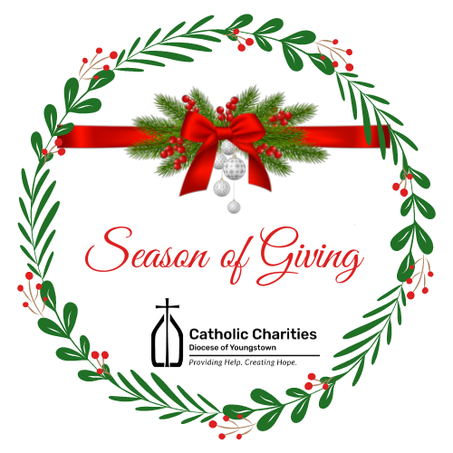
Each year, from November 1 through December 31, Catholic Charities hosts our annual "Season of Giving." It is during this time of Thanksgiving and Christmas blessings that so many of our loyal friends are inspired to get involved and give back to the community. We offer a variety of ways that you too can get involved in this season of giving back to those who need our help the most.
-Pray
-Donate
-Volunteer
-Participate
-Get Social
To get more information on how you can get involved, please visit our website www.ccdoy.org

PARISH BULLETINS/PUBLICITY

Breakfast with the Bishop Event**
Flyer and image attached.
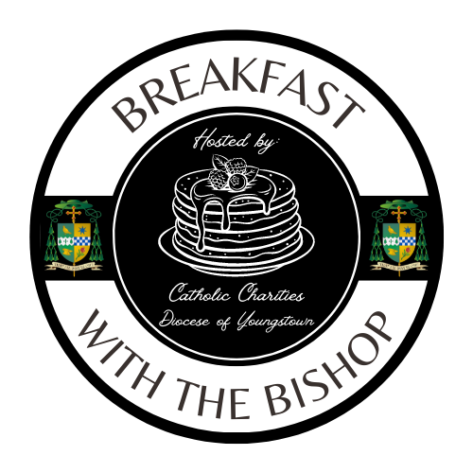
To kick off #GivingTuesday, we are hosting our very first “Breakfast with the Bishop.” This event will take place on Tuesday, November 29; from 8:00 a.m. until 10:00 a.m. at Our Lady of Mt. Carmel Basilica, Youngstown. Guests will have the opportunity to enjoy a hearty breakfast, learn about Catholic Charities, and hear from The Most Reverend, David J. Bonnar, Bishop of Youngstown. All proceeds from this event will support Catholic Charities’ basic needs assistance programs throughout the Diocese of Youngstown. Tickets are on sale now and must be purchased in advance as space is limited.

To reserve your tickets or to make a donation, please visit our website. For parishes or local businesses interested in purchasing AD space in our event program booklet, please contact Jennifer Lucarelli at 330-744-8451, or jlucarelli@youngstowndiocese.org.

www.ccdoy.org

PARISH BULLETINS/PUBLICITY

Giving Tuesday**
Image attached.
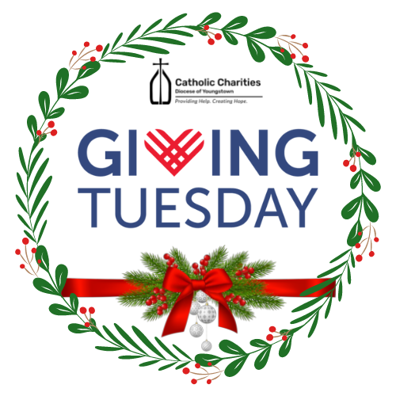
#Giving Tuesday is one of the largest giving days and one of the most successful social media campaigns all over the world! You, too, can participate in this global event. You can make a difference! Visit the Catholic Charities website on TUESDAY, NOVEMBER 29, 2022 and make a gift, and your gift will automatically be DOUBLED thanks to our corporate sponsors! A list of sponsors will be available on our website beginning on November 1, 2022.

Proceeds from #GivingTuesday will help support the many programs and ministries of Catholic Charities in all (6) counties of the Diocese of Youngstown.

www.ccdoy.org

PARISH BULLETINS/PUBLICITY

Support for Ukraine – Financial Support (Bulletin Materials)**
Catholic Charities of the Diocese of Youngstown continues to accept financial contributions to assist the people of Ukraine. 100% of the funds we receive in the Diocese of Youngtown for Ukraine will be divided between the United State Conference of Catholic Bishops’ (USCCB) Subcommittee on Aid to the Church in Eastern Europe and Catholic Relief Services, unless otherwise specified by the donor. Both of these organizations are uniquely suited to help, since they and their partners have been “on the ground” for years doing critical work. Both are intently focused right now on supporting the emergency needs of Ukraine and Ukrainian refugees, with any additional funds (if applicable) supporting ongoing needs in Eastern Europe and globally. Please note that Catholic Charities in the Diocese of Youngstown does not process or keep any of these disaster donations for Ukraine for our local efforts in the collection process. All of the money goes to the people who desperately need it.

PARISH BULLETINS/PUBLICITY

Support for Ukraine – Sponsor Support (Bulletin Materials)**
Uniting for Ukraine is a streamlined process that allows for Ukrainian citizens who have been displaced by Russia’s aggression to apply for humanitarian parole in the United States.
According to the USCCB, this program will need an additional 30,000 to 40,000 American households to register as sponsors in the months to come. If you are interested in becoming a sponsor, learn more about how you may be able to connect with someone in need in order to become their sponsor by viewing the links below.
SPONSORS: https://ukraine.welcome.us/resources
CONNECTIONS: https://ukraine.welcome.us/connect
More Information:
Under Uniting for Ukraine, the U.S. government allows people fleeing the war in Ukraine to seek refuge in the United States on a temporary basis known as humanitarian parole, with the support of a sponsor in the United States. The sponsor will provide financial support to meet the basic needs of someone fleeing Ukraine. They may also provide additional support, such as assistance enrolling in educational or training programs or securing employment.
Sponsors can be U.S. citizens, permanent residents or other lawfully present individuals. This includes individuals on Temporary Protected Status (TPS) and refugees. Groups of sponsors, nonprofits, educational institutions, and employers can also help sponsor people fleeing Ukraine.
So far this year, more than 70,000 Americans have applied to become a sponsor. If you are already connected to a Ukrainian individual or family, please use this link for information on becoming a sponsor.
SPONSORS: https://ukraine.welcome.us/resources
According to the USCCB, this program will need an additional 30,000 to 40,000 American households to register as sponsors in the months to come. If you are interested in becoming a sponsor, but are not currently connected to a Ukrainian individual or family, learn more about how may be able to connect with someone in need in order to become their sponsor by viewing the link below. *The responsibility for making a “connection” will fall upon the Ukrainian beneficiary. It must be their final decision to connect.
CONNECTIONS: https://ukraine.welcome.us/connect

CATHOLIC CHARITIES SERVING PORTAGE AND STARK COUNTIES (Bulletin Materials)

PARISH BULLETINS/PUBLICITY

Adult Day Services in Louisville is Accepting Participants**
The Adult Day Services (ADS) facility operated by Catholic Charities serving Portage and Stark Counties is open and accepting participants on a limited basis. ADS offers a safe and secure environment for older adults in need of supervision or assistance with activities of daily living while family caregivers are at work or attending to other responsibilities. We have implemented strict pandemic related protocols to ensure the health and safety of participants and staff alike. Our well-maintained facility is located on the St. Joseph Senior Living Campus in Louisville, Ohio. For more information about the program, please call 330-875-7979 or send an email to Troy Cochran at troy.cochran@catholiccharitiesps.org

CATHOLIC CHARITIES REGIONAL AGENCY (Bulletin Materials)

PARISH BULLETINS/PUBLICITY

Urgent Need: Catholic Charities Regional Agency**
Catholic Charities Regional Agency (serving Columbiana, Mahoning and Trumbull Counties) is in desperate need of paper products, cleaning supplies and hygiene products. Please contact Wendy at 330.744.3320 for further information. As we enter into the colder months, we are also in need of hats, gloves, and socks.

OFFICE OF PEACE AND JUSTICE (Bulletin Materials)

PARISH BULLETINS/PUBLICITY

Prison Ministry Presents - Kolbe Gathering**

Flyer and image attached.
Kolbe Gathering is a place for the formerly incarcerated and their families to join with parish-based volunteers in spiritual support and fellowship. Embrace spirituality in prayer, music, scripture reading and fellowship, all in a welcoming and warm environment.
St. Maximilian Kolbe is Patron Saint of prisoners and drug addicts. He was martyred at Auschwitz Concentration Camp.
For further information contact William Barber, Coordinator for Prison Ministry, at 330.235.3920.

DEPARTMENT OF COMMUNICATIONS

CATHOLIC EXPONENT

Full Page Flyer
Publication dates and special sections for the Exponent are as follows:
- October 28 (Special Section: Salute to Veterans)
- November 11 (Special Sections: Christmas Gifts / Holiday Catering)
- November 25 (Special Sections: Christmas Recipes / Christmas Gifts)
- December 9 (Special Sections: Christmas Gifts / Nativity Pictures)
- December 23 (Special Section: Christmas Greetings)
The normal deadline for each issue is 12 days before the publication date. We try to get late information into the issue but are sometimes limited by lack of available space.

MULTIMEDIA (CTNY) (Bulletin Materials)
BULLETIN/PUBLICITY

Wineskins **
Wineskins airs every Sunday:
7:30 a.m. on WKBN 570 AM in Youngstown
7:30 a.m. on WRQX 600 AM in Salem
9:30 a.m. and 9:00 p.m. on WILB AM Canton 1060, WILB FM 89.5 Youngstown, WILB FM 94.5 Canton
A new episode of Wineskins airs every Sunday. Listen to Wineskins on the diocesan website at www.doy.org/live/ and click the Wineskins button. Subscribe to our YouTube channel for updates when we post a new episode: https://www.youtube.com/CTNYDOY
November 6, 2022

- Current Issue: Fr. Korda talks with Fr. Scott Kopp about Vocations.
- Saint: Teresa Masczak from St. Michael Parish in Canfield will tell us about Pope St. Leo the Great.
- Interview: Fr. Korda interviews Bishop Laura Barbins from the Evangelical Lutheran Church.
- Music: From the CD “Come, You Who Labor” by Vince Ambrosetti
- Scripture: Fr. Matt Humerickhouse will tell us about the Scriptures for the 32nd Sunday in Ordinary Time.

November 13, 2022
- Current Issue: Fr. John-Michael Lavelle will talk about Addictions.
- Saint: Teresa Masczak from St. Michael Parish in Canfield will tell us about St. Francis X. Cabrini.
- Interview: Fr. Korda continues his interview Bishop Laura Barbins from the Evangelical Lutheran Church.
- Music: From the CD “Come, You Who Labor” by Vince Ambrosetti
- Scripture: Fr. Matt Humerickhouse will tell us about the Scriptures for the 33rd Sunday in Ordinary Time.

November 20, 2022
- Current Issue: Jennifer Lucarelli will update us on Catholic Charities.
- Saint: Miros Masczak from St. Michael Parish in Canfield will tell us about Blessed James Alberione.
- Interview: Fr. Korda concludes his interview Bishop Laura Barbins from the Evangelical Lutheran Church.
- Music: From the CD “Come, You Who Labor” by Vince Ambrosetti
- Scripture: Fr. Matt Humerickhouse will tell us about the Scriptures for Our Lord Jesus Christ, King of the Universe.

November 27, 2022
- Current Issue: Fr. Korda talks with Bill Joyce about the Cursillo Movement.
- Saint: Miros Masczak from St. Michael Parish in Canfield will tell us about St. Andrew the Apostle.
- Interview: Fr. Korda interviews Fr. Michael Balash about The Season of Advent.
- Music: From the CD “Come, You Who Labor” by Vince Ambrosetti
- Scripture: Fr. Matt Humerickhouse will tell us about the Scriptures for the First Sunday of Advent.

How to Watch the Mass for Shut-Ins
The diocese continues to produce the Mass for Shut-Ins. Please share this information according to the availability in your area. The Diocese of Youngstown Mass for Shut-Ins may be viewed the following ways:
Online at doy.org/live/ or Facebook.com/DOYoungstown/ or YouTube.com/CTNYDOY
In Youngstown, Warren, Mahoning Valley on WFMJ TV-21: Sundays at 6 a.m. and on Armstrong Cable Channel 45: Sundays at 8 a.m., noon, 7 p.m., for the time being.
Currently, a technical difficulty was making it unavailable on Spectrum Cable Channel 9, 13, or 14 in the Youngstown-Warren area.
In Stark County on Spectrum Cable in Canton – Channel 989: Sundays at 9:30 a.m., on Massillon Cable Channel 128: Sundays at 9:30 a.m., and on WIVM TV-39: Sundays at 9:30 a.m.
In nursing homes and prisons: The diocese continues to make its televised Mass available in 10 nursing homes and 3 prisons. For more information, contact Bob Gavalier at 330-533-2243.
Any further updates to diocesan cable TV programming will be noted at www.doy.org/live/

MEDIA RELATIONS
- Parishes and other diocesan entities who receive inquiries from the media are asked to consult with Justin Huyck, Director of Communications: (330) 744-8451, ext. 320; jhuyck@youngstowndiocese.org
- Please also kindly inform the Communications Department when your programs, initiatives, and ministries are featured in the news media.
- The Communications Department is available to consult on news releases regarding events and initiatives. Processes will continue to be developed to assist these efforts.

OFFICE OF SOCIAL MEDIA

2022- 2023 Social Media Profile Report Form

Catholic institutions, parishes and schools in the Diocese of Youngstown are asked to complete a 2022-2023 Social Media Profile so that we know what is currently being used around the diocese and to help network those seeking support in various areas.

Click on the link to complete: https://forms.gle/v8cTuJ18cfRQjzoV8

Please note that the contact person listed in the profile will receive period emails from the diocese to support his/her work.

Thank you to the 18 who have already done this!

DOY Social Media Networking Facebook Group for Social Media Contacts

Ongoing networking regarding social media can be found on Facebook in a private group by searching for “DOY Social Media Networking” or click:

https://www.facebook.com/groups/2882358088720802

This is a great place to share resources, ask questions and meet others around the diocese doing social media for their parishes, schools, offices and agencies. You can also share upcoming events that you’d like to invite others to so they can share in social media as well. This is also a key way the Social Media Minister is sharing insights as to avoid overwhelming contacts’ email boxes.

Social Media Helpful Hint of the Month – Check your settings!

When you post items that you want to be shared, for example invitations to events and activities, inspirational memes, Saint of the Day info, or evangelizing posts, make sure your privacy setting is on “Public.” Being public means that anyone who sees it (not just your friends or followers) can share it, comment, and react to it. Facebook now makes it easy to change your privacy setting with each post now (look under your “name” as you are creating the post to see if it says public, friends, custom, etc. Click there to change it. For the most part, the diocesan social media accounts post to Public as just about everything we post is intended to be shared. Any questions, feel free to contact Cindee Case at ccase@youngstowndiocese.org.

CLERGY AND RELIGIOUS SERVICES

OFFICE OF CLERGY SERVICES

1. Advent Day of Recollection – Save the Date

An Advent Day of Recollection will be held on Tuesday, November 29, 2022 beginning at 2:00 p.m. and will conclude with dinner at Our Lady of Mount Carmel Basilica in Youngstown. Rev. Joseph McCraffrey, pastor of Holy Spirit Parish in New Castle will be the presenter. More details will be coming soon. Please mark your calendars and plan to attend.

2. New Order of Penance

Archbishop Jose H. Gomez, USCCB President issued a promulgation decree on June 24, 2022, for the recently confirmed Order of Penance. The new translation may be used beginning on Ash Wednesday, February 22, 2023, and the date for obligatory use has been set for Sunday, April 16, 2023.

Four publishers will produce ritual editions for use in the United States. Some presales began October 1, 2022:
- Catholic Book Publishing Corp: https://catholicbookpublishing.com/product/1639
- Liturgy Training Publications: https://ltp.org/products/details/OPRE/order-of-penance
- Magnificat: https://bookstore.magnificat.net/the-order-of-penance.html
- and Midwest Theological Forum.

OFFICE OF VOCATIONS (Bulletin Materials)

National Vocations Awareness Week 2022

This year, National Vocations Awareness Week is celebrated the week of November 6-12. The Seminarians of the Diocese will be out in our parishes the weekend of October 29-30. This week is a wonderful opportunity to speak about Priesthood, Consecrated Religious Life, Married Life, and Single Life. If you would like more information or if you would like a visit, please contact Fr. Chad Johnson at 330-744-8451 or by email at cjohnson@youngstowndiocese.org.

Diocesan event page: https://doy.org/events/vocations-awareness-week/

Seminarian Pastoral Intern

The following Seminarian has been assigned as a Pastoral Intern for the 2022-2023 Academic Year.

Mr. Travis Seagraves: Our Lady of Peace, Ashtabula

Please remember him, the people of Ashtabula, and all of our seminarians in your prayers.

Seminarian Posters and Prayer Cards

Seminarian Posters, Prayer Cards, and Bookmarks are under development. We hope to have them available in November. Look for them to come out in the near future!

Vocation Director at Your Parish / School

If you have a special youth ministry, parish, retreat, or vocational event, that you would like the Diocesan Vocation Director to attend, please contact him at 330-744-8451 or by email at cjohnson@youngstowndiocese.org

PARISH BULLETINS/PUBLICITY

Come and See Weekends (Bulletin Materials)**
Saint Mary Seminary & Borromeo Seminary are once again offering “Come and See” Weekends. These are opportunities for men who are open to priesthood formation can experience life in the Seminary. The next Come and See Weekend is scheduled for November 18-20, 2022. If you know of anyone interested in this time of prayer, discovery, and discernment, please contact Fr. Chad Johnson at 330-744-8451 or by email at cjohnson@youngstowndiocese.org

Diocesan event page: https://doy.org/events/come-see-seminary-2022/

Image attached

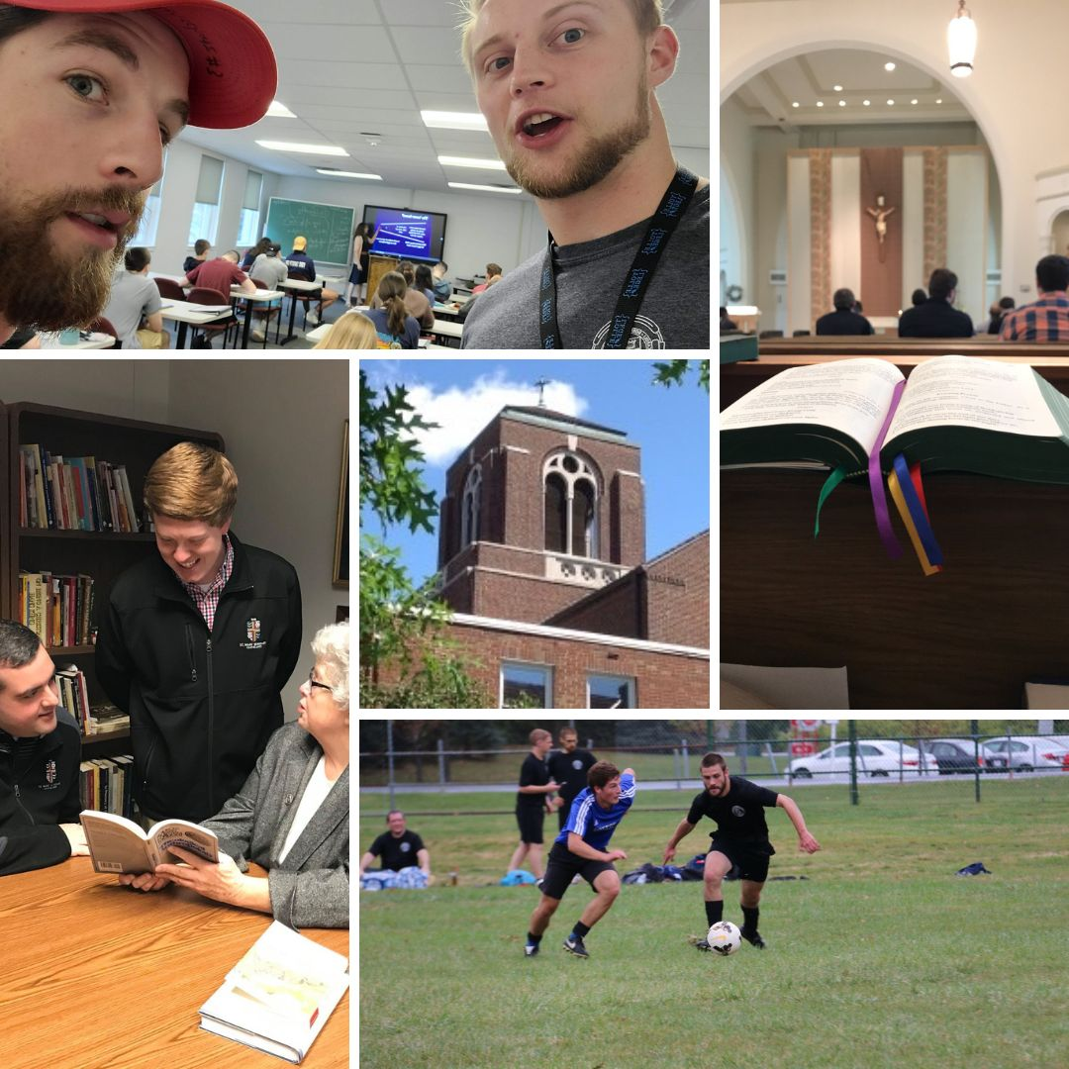

Seminarian Visits to Your School or Parish

Please remember all the seminarians we have currently studying in our diocese. They are all willing and available to come and speak at your parish or school. To schedule, please contact Fr. Chad Johnson at 330-744-8451 or by email at cjohnson@youngstowndiocese.org

“Discovery Days” [Seminary Field Trips]

The Office is in contact with the Vocations Office of the Diocese of Cleveland about scheduling a “Youngstown Discovery Day” for 8th Graders and for High School Juniors & Seniors. More information will be announced as it is made available. In the meantime, consider how and when your school could participate in these events. For more information, please contact Fr. Chad Johnson at 330-744-8451 or by email at cjohnson@youngstowndiocese.org

Vocation Intercessions and Bulletin Blurbs (Bulletin Materials)**
Click the links below or see the Communiqué attachments folder at https://bit.ly/3DaY3L6
for vocation intercessions and bulletin blurbs for the month of November. Please use these in your bulletins and at Mass to help promote vocations to the priesthood and religious life in your parish community and school:
Vocations Intercessions & Bulletin Blurbs: Word Doc
Vocations Intercessions & Bulletin Blurbs: PDF

Vocations Social Media
- Website: www.doy.org/vocations
- Facebook: doyvocations
- Twitter: doy_vocations
- Instagram: doyvocations

OFFICE OF VOWED RELIGIOUS

World Day for Consecrated Life

Bishop David Bonnar will celebrate the annual World Day for Consecrated Life Mass on Sunday, February 5, 2023 at St. Columba Cathedral at 10:30 a.m. Be sure to mark your calendars for this annual diocesan celebration of Consecrated Life. Light refreshments will follow (pending COVID restrictions).

Event page: https://doy.org/events/world-day-consecrated-2022/

New and Returning Religious

This is a reminder for any religious (involved in ministry, student, or retired) who is new, or has recently returned to the Diocese of Youngstown, and has not yet contacted the Office of Vowed Religious, to kindly do so as soon as possible. Please also note that there are some new requirements for our Child Protection Policy. Please call (330) 744-8451, ext. 238 or e-mail sjcandidi@youngstowndiocese.org

PARISH BULLETINS/PUBLICITY

Religious Retirement Appeal (Bulletin Materials)**

Reminder to pastors and religious presenters: The Retirement Fund for Religious Appeal will take place in most parishes November 12 - 13. Some parishes have agreed to hold the Appeal on either November 5-6 or November 19 - 20. In most parishes the collection will be taken the weekend following the Appeal.

Information packets have been sent to pastors and religious presenters. All presenters should have contacted your pastors by now. Kindly do so ASAP if you have not had the opportunity thus far. For further information or materials please contact the Office of Vowed Religious at 330-744-8451, ext. 238. Religious Presenters, please include in your talks that individuals can also donate online by going to the Diocese of Youngstown website home page at doy.org.

Retirement Fund donation page (direct link): https://secure.acceptiva.com/?cst=a08f75

Bulletin editors & social media ministers, please see the Campaign Materials page for images, videos, and web banners: https://retiredreligious.org/materials/

DEVELOPMENT AND STEWARDSHIP OFFICES

OFFICE OF THE ANNUAL DIOCESAN APPEAL
The Diocese has reached 89% of its goal. Father John-Michael Lavelle’s updates regarding the appeal are posted at www.doy.org/appeal/

OFFICE OF DEVELOPMENT AND STEWARDSHIP (Bulletin Materials/Materiales del Boletín)

PARISH BULLETINS/PUBLICITY/BOLETÍN PARROQUIAL

Stewardship Bulletin Thoughts (Bulletin Materials | Materiales de Boletín)**
Please see this website for upcoming Stewardship Bulletin Thoughts in English y Reflexiones del Boletín de Corresponsibilidad en español: https://www.archstl.org/about-stewardship/bulletin-inserts/weekly-bible-reflections
You can also download them as a Word Doc in November’s Communique Attachments folder: https://bit.ly/3DaY3L6

Sign Up for #iGiveCatholic

The Diocese of Youngstown will be participating again in the #iGiveCatholic Giving Day on Tuesday, November 29, 2022. As the point person for the diocese, I am writing to encourage your parish, school or ministry to take advantage of this wonderful opportunity.

Important Note: There is NO cost to participate. The diocese has covered the application fee!

#iGiveCatholic, now in its 8th year, is a proven, dynamic crowdfunding event that offers an excellent opportunity for the Catholic Community to come together to give thanks, give back, and give Catholic! Last year, #iGiveCatholic helped organizations to raise over $16.5 million dollars on this internationally-recognized huge day of philanthropy. Fr. John-Michael Lavelle will be offering guidance, support and training every step of the way!

Registration is simple and will take less than 5 minutes. Please follow the instructions contained in this support article: https://support.givegab.com/en/articles/5436696-how-do-i-register-for-igivecatholic-2022. While registration is open until November 2nd, register ASAP to take advantage of the weekly email series of tasks.

Thank you for your consideration of this fabulous opportunity. Let’s join together to celebrate all that we do, as Catholics, to build His kingdom and invite people to invest in our good work!

#iGiveCatholic downloads (logo, etc): https://www.igivecatholic.org/info/downloads

PASTORAL AND EDUCATIONAL SERVICES

OFFICE OF FAITH FORMATION AND LAY ECCLESIAL MINISTRY (Bulletin Materials)

To download a Word document containing the Faith Formation bulletin announcements, please see the November Communique Attachments folder: https://bit.ly/3DaY3L6

1. Ministry Day Appreciation
Thank you, Bishop Bonnar, for your inspiring welcome and opening prayer for Ministry Day 2022! Thank you, Father Manalo, for the spirited keynote presentation! Thank you to all the Facilitators of the sessions whose areas of expertise expanded commitments to the various ministries! Thank you to Café Augustine for both the morning refreshments and lunches! Thank you to all the participants whose excitement for ministry is contagious! Thank you to the pastors who supported parishioner attendance! We are so grateful to everyone’s contribution to the success of the 2022 Ministry Day!
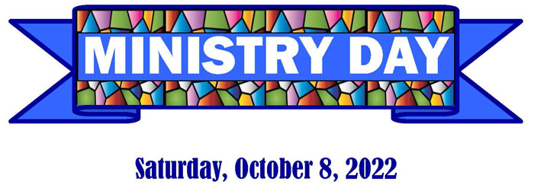

2. Ministry with Persons with Disabilities

The Art of Accompaniment: From Inclusion to Belonging
Thursday, November 17, 2022
9:30 a.m. – 3:30 p.m.
Saint William Parish, Champion

Join the Office of Faith Formation and Lay Ecclesial Ministry and guest facilitator Charleen Katra, the Executive Director of the National Catholic Partnership for Disability for a day of formation. Learn how to transform parishes into places of belonging for all families, and individuals. Open to all in parish leadership, and anyone interested in creating welcoming parishes for All God’s people!

PARISH BULLETINS/PUBLICITY

3. LIMEX: There is Still Time (Bulletin Materials)**
If you are interested in a part time, graduate-level program in theology and spirituality from a Catholic University, Loyola Institute for Ministry Extension Program (LIMEX) may be for you. Please contact Margie Hynes liaison for LIMEX at 330-744-8451 ext. 296 or mhynes@youngstowndiocese.org for more information about a learning group beginning near you.

PARISH BULLETINS/PUBLICITY

4. The Catholic Church Needs You (Bulletin Materials)**

Lay ecclesial ministry is a service within the community of the Church by lay people. Lay Ecclesial Ministers work in the Church and focus on the building of the mission and communion of the Church, which has among its purposes the transformation of the world. These people in your parish are the youth minister, director of faith formation, pastoral associate and director of liturgy.

If you would like more information on Lay Ecclesial Ministry you can talk to your pastor, pastoral associate, or call the Faith Formation and Lay Ecclesial Ministry office at the Youngstown Diocese 330-744-8451 ext. 301 or 296.

5. New Library Resources

The Freedom of Missing Out: Letting Go of Fear and Saying Yes to Life. Michael Rossmann, SJ. Loyola Press, 2022. If you live a life of constant joy, balance, and easy moderation, then this book isn’t for you. But if you are like the rest of us, every day presents a blinding rush of options and opportunities, risks and benefits. And no matter what, you are going to miss out on something that might be better than what you choose. Mix this anxiety with an unhealthy dose of fear in all its various forms, and you have a recipe for a confused, neurotic, and unhappy life. But there is hope for this present-day malady. Shattering the popular conception that we should say yes to everything lest we miss out on something better, Michael Rossmann outlines a practical plan for developing emotional courage, increasing focus, and learning to say no to what depletes us. In turn, we end up with the space and ability to say yes to what energizes us and gives our lives more meaning, vitality, and purpose.

Helping Families Recover from Addiction: Coping, Growing, and Healing through 12-step practices and Ignatian Spirituality. Jean Heaton. Loyola Press, 2020. When addiction enters a home, recovery is necessary for the entire family. The fear, shame, and stigma associated with addiction can prevent families from discussing and addressing the issues that affect everyone who loves the addict. Jean Heaton knows from personal experience that addiction is best responded to when we address the spiritual and familial dimensions of the disease, in addition to the physical aspects.

At Your Side:Prayers for Messy, Delightful, Complicated, Outrageous Everyday Life. Raymond Friel and David Wells. Twenty-Third Publications, 2020. For many of us, prayer tends to be a formal process. But if we want Jesus to be at our side to help us through the ups and downs of daily life, it helps to find other ways to talk to him, even about seemingly ordinary things. This engaging collection of prayers for individuals or groups is deeply rooted in real life and covers a broad range of our human experience. The prayers are often funny, at times poignant, but always inspiring. As the authors say, Sometimes God is going to speak to you through the difficult meeting at work, the woman at the bus stop, or the pregnancy test. It's not all walking on water! Each prayer is accompanied by scripture quotes, thought-provoking insights from Christian authors, and questions to prompt deeper reflection.

PARISH BULLETINS/PUBLICITY

6. Attention Lifelong Learners (Bulletin Materials)**

Adult Faith Formation opportunities for Advent begin November 28, 2022. The courses are, Isaiah: Prophet of Advent facilitated by Joan Lawson and The Infancy Narratives facilitated by William Wainio. Both courses are open to anyone wanting to grow in their faith. These courses are offered online. You don’t need to have prior knowledge to participate. For more information contact Margie Hynes at 330-744-8451 ext. 296 or mhynes@youngstowndiocese.org.

PARISH BULLETINS/PUBLICITY

7. Best kept secret: Library (Bulletin Materials)**

What's the best kept secret in the Youngstown diocese? Our expansive library of materials to enrich your faith. We have books, DVDs and audio books about bereavement support, bible study, devotionals and prayer. Explore our collection online at https://doylib.follettdestiny.com or visit us in person, 225 Elm St., Youngstown, Monday-Friday 8:00 am – 4:00 pm. Contact Margie Hynes for more information 330-744-8451, mhynes@youngstowndiocese.org.

8. Advent Retreat: December 1, 2022

The Annual Advent Retreat for Parish Ministers and their guests will be held on Thursday, December 1, 2022 from 9:30 am – 3:30 pm at Our Lady of Perpetual Help Parish in Aurora. The Office of Faith Formation and Lay Ecclesial Ministry welcomes Father Don King as the retreat facilitator. Registration is required and more information is available by contacting the office.

OFFICE OF PRO-LIFE, MARRIAGE AND FAMILY LIFE (Bulletin Materials)

1. Walking with Moms in Need
In March, Bishop Bonnar wrote to all pastors encouraging the implementation of Walking with Moms in Need in their parishes. This initiative from the USCCB is to help parishes come alongside and accompany pregnant and parenting mothers facing difficulties. Find out more about our local efforts and resources at https://doy.org/walkingwithmomsneo/
The Office of Pro-Life, Marriage and Family Life is piloting Walking with Moms in Need in the Eastern Stark County Region of our diocese and has held information meetings in Mahoning, Stark and Portage Counties. Anyone interested in establishing this important effort in their parish or region may contact Dave Schmidt at dschmidt@youngstowndiocese.org or 330-744-8451 ext. 272.

2. INTO LIFE – Love Changes Everything

A resource that is helpful in implementing Walking with Moms in Need is the INTO LIFE series. INTO LIFE: Love Changes Everything is a 12-part series created by the Sisters of Life and the McGrath Institute for Church Life at the University of Notre Dame. Journey with the Sisters of Life as they explain what it means to walk with a woman who is pregnant and vulnerable. Go to www.intolifeseries.com or contact 330-744-8451 ext. 272 or dschmidt@youngstowndiocese.org.

3. Christ the King (Attachment)
The U.S. Conference of Catholic Bishops’ Committee for Religious Liberty has identified the Solemnity of Christ the King as a fitting moment in the liturgical year to promote the Church’s teaching on religious freedom. The Committee has prepared materials to help educate the faithful about this Solemnity, which the Church celebrates this year on November 20, 2022. These materials include:
Lectionary Notes
A brief background on the Solemnity
Social media graphics
A Novena to Christ the King
All materials are available at www.usccb.org/ChristtheKing. Furthermore, a summary can be found in the attachments folder of this Communique at: https://bit.ly/3DaY3L6 ¡Viva Cristo Rey!

PARISH BULLETINS/PUBLICITY

4. The National March for Life Will Still Take Place in January (Bulletin Materials)**

Ever since the unfortunate 1973 Roe v. Wade decision by the U.S. Supreme Court, those concerned about the right to life of unborn children have gathered annually in Washington DC to March for Life. Fortunately, this past June the Supreme Court overturned Roe v. Wade, but “the work to build a culture of life in the United States of America is far from finished.” Therefore, the March for Life will continue on Friday, January 20, 2023 with the theme “Next Steps: Marching Forward in a Post-Roe America!” For more information go to https://marchforlife.org/.

If you or your parish, school or organization is planning to attend the March for Life in Washington D.C. on Friday, January 20, 2023, please contact Dave Schmidt in the Office of Pro-Life, Marriage and Family Life at 330-744-8451 ext. 272 or dschmidt@youngstowndiocese.org.

5. National March for Life Related Events
The following events will take place before or after the 2023 National March for Life in Washington D.C.:
- The National Prayer Vigil for Life at the Basilica of the National Shrine of the Immaculate Conception in Washington D.C. will begin with an Opening Mass at 5:00 p.m. on Thursday, January 19 and conclude with a Closing Mass at 8:00 a.m.
- The National Pro-Life Summit, sponsored by Students for Life of America, will take place on Saturday, January 21 from 8:00 a.m. until 7:00 p.m. at the Omni Shoreham Hotel in Washington D.C. For more information go to: https://prolifesummit.com/.
- The Cardinal O’Connor Conference on Life will take place on Saturday, January 21from 8:00 a.m. until 4:30 p.m. at Georgetown University in Washington D.C. For more information go to: https://www.oconnorconference.com/.
For more information on the above items, or other related questions or concerns, contact 330-744-8451 ext. 272 or dschmidt@youngstowndiocese.org.

6. Marriage Preparation Engaged Couple Retreat Day
The next diocesan-sponsored one-day marriage preparation retreat day for engaged couples will be held Saturday, November 19 in the social hall at St. Columba Cathedral. Reservations are required. Registration information may be found for the event at www.doy.org/events. You can also visit DOY.org, go to the “Ministries” drop-down menu and click “Pro-Life, Marriage & Family Life.” The schedule of Engaged Couple Retreats for 2023 is forthcoming.

Direct link for registration: https://secure.acceptiva.com/?cst=4479d9

For more information on this, and other opportunities for marriage preparation formation, contact dschmidt@youngstowndiocese.org or 330-744-8451, ext.272.
PARISH BULLETINS/PUBLICITY

7. Project Rachel Outreach – November Message for Bulletin/Newsletter (Bulletin Materials)**
Give Thanks for God’s Mercy! He wants to Forgive and Heal after an abortion experience. For CONFIDENTIAL help text or call Project Rachel of Northeast Ohio at 330-360-0430 or go to https://hopeafterabortionneo.weebly.com/.

8. Intercessions for Life and Pro-Life Bulletin Briefs
Recommended intercessions and bulletin briefs prepared by the U.S. Conference of Catholic Bishops Secretariat for Pro-Life Activities may be found at www.respectlife.org/word-of-life.

OFFICE OF WORSHIP

Celebration of Confirmation for Adults

The Sacrament of Confirmation for Adults will be celebrated on Sunday, November 20, 2022, at 4:00 p.m. in Saint Columba Cathedral. This is a special opportunity for parishioners 18 or older who have not received the sacrament to join with other adults of the diocese. Information and registration/eligibility forms have been mailed to all parishes. Candidates are to be prepared in their parishes for this celebration.

Please contact the Office of Worship with any questions.
Important links:
- Registration Form
- Guidelines for Preparing Practicing Catholic Adults for Confirmation
- Letter to Pastor or Parish Leader and bulletin announcement about arrangements for Confirmation for Practicing Catholic Adults

2. Parish Liturgical Minister Contact Information Requested

Parishes have been asked to update contact information for Church Musicians, Liturgy Committee Chairperson and RCIA Contacts. Please return the Contact Information Sheets to the Office of Worship as soon as possible so that our database can be updated. If a parish did not receive a mailing with contact information sheets, please call the Office of Worship.

3. Lay Leader of Prayer Commission

All Lay Leaders of Prayer will need to receive a new 3-year commission for 2023-2026. It is current policy that a Lay Leader of Prayer be commissioned every three years to serve under the direction of the pastor. The current commission for all Lay Leaders of Prayer will expire this December. Parishes are asked to send in their list requesting a commission for Lay Leaders of Prayer as soon as possible. Certificates will be sent in early December for distribution. Please note only those who have competed the diocesan formation/training sessions may function as a Lay Leader of Prayer. Those current involved in the Lay Leader of Prayer Formation Series will receive their certificate of commission at the conclusion of the sessions in November.

4. Leader of Prayer Formation Series

The Lay Leader of Prayer Formation Series has begun at Immaculate Conception Church in Ravenna. There are 26 participants. Lay Leaders of Prayer are a great assistance when a priest is not available to provide an opportunity and lead prayer for the faithful. Lay Leaders of Prayer often preside at Liturgy of the Word services with or without Holy Communion, Morning and Evening Prayer, Vigil Services for deceased members of the parish, Stations of the Cross and other devotional prayer services. Upon conclusion of the series, they will be commissioned on November 16, 2022.

5. New Order of Christian Initiation of Adults

In anticipation of the new Order of Christian of Adults, the Federation of Diocesan Liturgical Commissions has begun a FREE webinar series on the Order of Christian Initiation of Adults (OCIA). The webinars are offered in both English and Spanish and can be joined live or by viewing the recording.

For a schedule of dates, topics and presenters please visit: https://fdlc.org/ociawebinars/

The webinars are open to all those involved in Initiation Ministry and OCIA Parish Team Members.

6. Liturgical Calendar Advisories for Upcoming Holy Days and Christmas/New Year

~Upcoming Holydays: Tuesday November 1, 2022, the Feast of All Saints and Thursday, December 8, 2022, the Feast of the Immaculate Conception will be normal holy days of obligation this year. The Feast of Our Lady of Guadalupe will be celebrated on Monday, December 12, 2022.

~Sunday, December 25 - Christmas: This year the Nativity of the Lord falls on Saturday (Christmas Eve) and Sunday (Christmas Day) this year. Parishes should plan Mass on Christmas Eve and Christmas Day accordingly.

~Friday, December 30 – Feast of the Holy Family: This year the Feast of the Holy Family will be celebrated on Friday, December 30, 2022.

~Sunday, January 1 - Solemnity of Mary, the Holy Mother of God: The weekend of Saturday (December 31) and Sunday (January 1) will be the Solemnity of Mary, the Holy Mother of God. The Feast of Epiphany will be the weekend of January 7-8, 2023, and the Feast of the Baptism of the Lord will be celebrated on Monday, January 9, 2023.

7. The Light is On for You ~ An Evening of Reconciliation

The Light is On for You ~ An Evening of Reconciliation will return this year and be celebrated on Wednesday, March 8, 2023. Every parish should plan to celebrate the Sacrament of Reconciliation that evening either by scheduling a Lenten Communal Reconciliation Service with neighboring/collaborating parishes or individual reconciliation. The Office of Worship will provide materials in the coming months.

Event page: https://doy.org/events/the-light-is-on-reconciliation/

8. New Order of Penance
Archbishop Jose H. Gomez, USCCB President issued a promulgation decree on June 24, 2022 for the recently confirmed Order of Penance. The new translation may be used beginning on Ash Wednesday, February 22, 2023, and the date for obligatory use has been set for Sunday, April 16, 2023.

9. Liturgical Directory

The Liturgical Directory contains valuable information about Liturgy Committees; liturgical minister formation guidelines; guidelines for the celebration of sacraments; music in liturgical celebrations; and art and architecture directives. The directory can be accessed and downloaded from the diocesan website by clicking on “Worship” under the “Ministries” tab.
DOY Office of Worship: https://doy.org/ministries/worship/
Link to Download Liturgical Directory: https://doy.org/wp-content/uploads/2022/03/Diocese-of-Youngstown-Liturgical-Directory.pdf

OFFICE OF YOUTH AND YOUNG ADULT MINISTRY

Eagle of the Cross
  - Nomination forms will be sent out in January. It’s not too early to start thinking of nominations. Contact Fr. Ryan with any questions: rfurlong@youngstowndiocese.org

Confirmation Retreat
  - Fr. Ryan Furlong and Fr. Chad Johnson are teaming up to create a diocesan confirmation retreat. Please contact them if interested at rfurlong@youngstowndiocese.org or cjohnson@youngstowndiocese.org

Eucharistic Revival
  - All youth and young adults are invited to the Eucharistic Revival Masses. Mass will be followed by a Eucharistic Procession. The November Procession will be November 13 at 11am at St. Patrick Parish in Kent.
  - For a full list of events, see the diocesan Eucharistic Revival page.

OFFICE OF ECUMENICAL AND INTERRELIGIOUS DIALOGUE

1. Catholic Higher Education Symposium on Oct 26 at 6pm

Full Page Flyer
Oct. 26: Facing the Future Together. The Most Rev. David Bonnar, Bishop of the Diocese of Youngstown, and Rabbi David Komerofsky of Temple Israel, Canton, will share their thoughts on challenges facing communities of faith in the 21st century. 6:00-7:30p.m. at Barrette Business and Community Center.
RSVP by October 24 at: facingthefuture.eventbrite.com
Contact: Dr. Chris Seeman at 330.244.4665 or cseeman@walsh.edu
Event page: https://www.walsh.edu/calendar/2022/10/facing-the-future-together.html

PARISH BULLETINS/PUBLICITY

Catholic–Orthodox Dialogue: Upcoming event via Zoom on Nov 10 at 7pm (Bulletin Materials)**

THE SOCIETY OF ST. JOHN CHRYSOSTOM (YOUNGSTOWN - WARREN) CHAPTER PRESENTS “Update on the Progress of The International Orthodox - Catholic Dialogue” by Msgr. Paul McPartlan, S.T.L., D. Phil. who is a member of the Joint International Commission for Theological Dialogue Between the Orthodox Church and the Roman Catholic Church. He also serves as Carl J. Peter Professor of Systematic Theology and Ecumenism at Catholic University of America.

Date: Thursday, November 10, 2022
Time: 7:00-8:20 PM EST

Please contact Thomas Batten (Zoom Host) to sign up to receive a ZOOM INVITATION LINK: thomasbatten2010@gmail.com. You can call with any questions: 330-910-4515.

Event page: https://doy.org/events/zoom-orthodox-catholic-dialogue-nov2022/

Additional Information:
Society of St. John Chrysostom (Youngstown - Warren) Chapter

Books by Msgr. Paul McPartlan:
- The Eucharist Makes the Church: Henri de Lubac and John Zizioulas in dialogue (T&T Clark, 1993)
- Sacrament of Salvation: An Introduction to Eucharistic Theology (T&T Clark, 1995)

MISCELLANEOUS

DIOCESAN CEMETERIES (Bulletin Materials)

BULLETINS/PUBLICITY
Flyer: Divine Mercy Chaplet at Cemeteries
(or see text below)
Event: https://doy.org/events/divine-mercy-chaplet-cemetery/

Chaplet of Divine Mercy, Fridays at 3pm**
Catholic Funeral and Cemetery Services of the Diocese of Youngstown will be offering The Chaplet of Divine Mercy Prayer Service in the chapels of our 4 Cemeteries at 3:00pm every Friday at alternating locations:
First Friday of the month at Calvary Cemetery Chapel in Youngstown.
Second Friday of the month at Resurrection Cemetery Chapel in Austintown.
Third Friday of the month at All Souls Cemetery Chapel in Cortland.
Fourth Friday of the month at Calvary Cemetery Chapel in Massillon.

BULLETINS/PUBLICITY

All Souls Day Masses**

Event: https://doy.org/events/all-souls-day-masses-2022/

Diocesan Cemeteries will remember our deceased loved ones in prayer with All Souls Day Masses at three locations:
All Souls Day Mass at All Souls Cemetery (Cortland) on November 2, at 12:15pm, celebrated by Fr. Cicero. It will be held outside so bring your own chairs.
All Souls Day Mass at Resurrection Cemetery (Austintown) on November 2 at 11:00am, celebrated by Fr. Furlong. It will be held in the chapel.
All Souls Day Mass at Calvary Cemetery (Massillon) on November 2, celebrated by Fr. Cline. It will be held in the chapel, call the office for the time: 330-792-4721.

PARISH EVENTS (Bulletin Materials)

BULLETINS/PUBLICITY

Mahoning County | Cursillo Women's Weekend Jan 12-15, 2023**
The Cursillo Movement of the Youngstown Diocese will be hosting a Women's weekend from January 12 to 15, 2023. The weekend helps you experience your Catholic faith and encourages a spiritual life that is filled with joy and enthusiasm. From Thursday evening through Sunday afternoon, a team of Catholic religious and lay people will share insights on the lay person's role within the church, the meaning of grace and the sacraments, and the importance of supporting one another in our efforts to live a Christian life. Throughout the weekend the participants will pray together, attend daily Mass and have an opportunity to receive the sacrament of reconciliation. To register or for more information, contact Peg Elston at Youngstown4thday@gmail.com

BULLETINS/PUBLICITY

Mahoning County & Live Streaming | Aid for Ukraine Concert Nov 20 at 3pm at St. Anne (Austintown)**

Full Page Flyer

Logo

"Aid for Ukraine" Special Concert at St. Anne Ukrainian Catholic Church Hall

4310 Kirk Road Austintown, Ohio 44511
Sunday, November 20th 3:00 pm
Will be live-streamed for those unable to attend in person.

You are cordially invited to attend this unique concert with beautiful music, refreshments, and display table with religious gifts for sale! Free Admission / Goodwill Offering

All collected donations will be forwarded to Ukraine through the Ukrainian Catholic Diocese of St. Josaphat in Parma*** Thank you for your generosity and your support of Ukraine! Please pray for peace in Ukraine. May our Lord reward you abundantly in this life and the life to come!

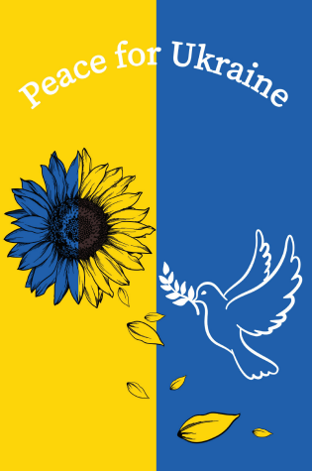
BULLETINS/PUBLICITY

Mahoning County | First Friday Club in November**
John Dear: 11/3 Full Page Flyer

We continue the First Friday Club of Greater Youngstown 2022-23 Speaker Series season with a luncheon on the first Thursday in November! Join us as we welcome Reverend John Dear, Peace Activist and Author, on November 3, 2022. Father Dear will present, “Following the Nonviolent Jesus,” at Avion on the Water Banquet Center, 2177 W. Western Reserve Road in Canfield.

There will be an opportunity for participants’ questions to follow. Luncheon will be served at 11:30 a.m. with the presentation beginning at noon. The cost is $20.00. Call by October 28, 2022, 330-720-4498. Reservations are limited!
Visit our website www.firstfridayclubofgreateryoungstown.org
Integrating the principles of religious faith into our everyday lives and work.

BULLETINS/PUBLICITY

Mahoning County | First Friday Club in December**
Full Page Flyer
The First Friday Club of Greater Youngstown 2022-23 Speaker Series season continues at a special time with dinner on the first Thursday in December! Join us as we welcome John L. Allen Jr. on December 1, 2022. John L. Allen Jr. will present, “Rome is from Mars, America is from Venus,” at Avion on the Water Banquet Center, 2177 W. Western Reserve Road in Canfield.

There will be an opportunity for participants’ questions to follow. Note the special time: dinner will be served at 6:00 p.m. with the presentation beginning afterwards. The cost is $20.00. Call by November 23, 2022, 330-720-4498. Reservations are limited!
Visit our website www.firstfridayclubofgreateryoungstown.org
Integrating the principles of religious faith into our everyday lives and work.
BULLETINS/PUBLICITY

Stark County | Catholic Men's Fellowship Nov 5**

The Catholic Men's Fellowship of the Diocese of Youngstown (CMFDOY) is having a Mini-Retreat on November 5, 2022. There is no fee or registration required for the event.
The event is at St. Joseph Catholic Church in Alliance, Ohio from 8:00 AM - 11:30 AM. Address: 472 E. Broadway St., Alliance, OH 44601
Light refreshments will be served. Fr. David Weikart, Deacon Greg Wood, and Fr. Patrick Manning will be presenting. The theme of the event is "Rekindle the Fire".
Please contact with any questions: Ronn Franczkowski, CMFDOY ronn.franczkowski@sbcglobal.net

BULLETINS/PUBLICITY

Stark County | Catholic Man Night Nov 18**

The Catholic Men's Fellowship of the Diocese of Youngstown (CMFDOY) is having a Catholic Man Night on Friday, November 18, 2022, 6-8:45 PM at Holy Spirit Catholic Church, 2952 Edison St NW, Uniontown, OH 44685; Supper included. Please contact with any questions: Ronn Franczkowski, CMFDOY ronn.franczkowski@sbcglobal.net

IN MEMORIAM: NOVEMBER NECROLOGY

Novak, Rev. George November 2, 1947
Casey, Rt. Rev. Msgr. Maurice November 2, 1947
Aleckna, Rev. Conrad November 3, 1996
Jansen, Rev. Joseph, MSC November 4, 1979
Curran, Rev. Gerald November 4, 2008
Crescentini, Rev. Humbert November 5, 1959
Kowaleski, Rev. Msgr. Edward November 6, 2002
Susko, Rev. Msgr. Martin November 6, 2015
Marceau, Rt. Rev, Msgr. Paul November 10, 1985
Lazur, Rev, Joseph, CPPS November 11, 1984
Maceka, Rev. John T. November 12, 1978
Thome, Rev. Francis, N. November 13, 1958
Loperfido, Rev. Ernest November 13, 2015
Krajdzieski, Rev. Max November 14, 1943
Donnelly, Rev. Thomas C. OP November 15, 1973
McFADDEN, MOST REV. JAMES A. November 16, 1952
Livajusic, Rev. Anthony November 16, 1974
Wieczorek, Reverend Edward November 16, 2019
Mulhearn, Rev. Thomas G. November 17, 1960
McCoy, Rev. Regis, OSB November 17, 1963
Dubois, Deacon Bartley November 17, 2005
Martin, Rev. Joseph November 19, 2002
Buettner, Rev. Herbert, OSB November 20, 1953
Chamberlain, Rev. Robert A. November 20, 1995
Duesman, Brother Paschal, SSP November 20, 2019
Mickler, Rev. Jeffrey, SSP November 20, 2019
Varble, Rev. Edward November 23, 2008
Omlor, Rev. Eugene, CPPS November 24, 1960
Therres, Rev. A.C., OP November 24, 1962
Fasnacht, Rt. Rev. Msgr. Edward November 25, 1968
Krause, Deacon Harold November 29, 2019
Connell, Rev. Michael N., OP November 30, 1957
Nekirk, Deacon Earl November 30, 1990
Kelly, Rev. Msgr. Thomas November 30, 2010

†

