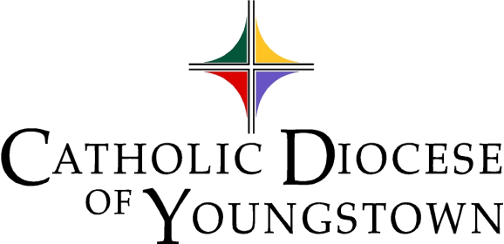

Communiqué
www.doy.org
144 West Wood Street
Youngstown, OH 44503-1081
330-744-8451 fax 330-742-6448

Volume 54 No. 12 December 2022

We Wish You a Blessed Advent

We wait in joyful hope for the Word to be made flesh, for the God of the Universe to awaken our compassion as a vulnerable child, and for all the angels and saints to join in adoration.

Quote of the Month
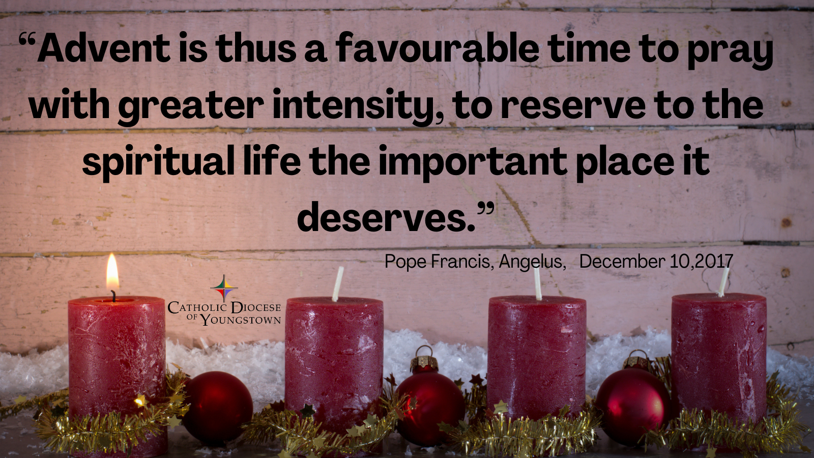
"Advent is thus a favourable time to pray with greater intensity, to reserve to the spiritual life the important place it deserves." –Pope Francis, Angelus, December 10, 2017
Digital edition available at https://doy.org/communique-december-2022/

Attachments available to download as individual documents in this folder: https://bit.ly/dec2022comm

Video: How to Use Communique Attachments Folder https://www.youtube.com/watch?v=7MertrfDN70&t=2s

Editor’s note: Click on a Table of Contents headline to go directly to that page. If that doesn’t work, hold down the CTRL button while you click. Headlines containing suggested announcements with bulletin/publicity materials are marked with a double asterisk**, and the text is outlined in red. Please see links and attachments for flyers and graphics provided for these events.
Table of Contents
CHANCERY OFFICE 358
OFFICE OF SAFE ENVIRONMENT (Bulletin Materials | Materiales de Boletín) 358
1. Safe Environment Bulletin Announcements (Bulletin Materials | Materiales de Boletín)** 358
2. Safe Environment Policy 360
3. Who needs to be compliant? 360
4. Compliance Requirements 360
5. Updating Information 361
6. Reporting Child/Vulnerable Adult Abuse 362
7. Questions or Concerns 362
LETTERS OF SUITABILITY 363
ARCHIVES OFFICE 363
Questions about Parish Records? 363
A Note from the Past for the Present -NEW 363
BISHOP BONNAR’S 2023 PILGRIMAGE (Bulletin Materials)** 364
MINISTERIO HISPANO | HISPANIC MINISTERY (Bulletin Materials | Materiales de Boletín) -NEW 364
Our Lady of Guadalupe Diocesan Celebration | Nuestra Señora de Guadalupe Celebración Diocesana (Bulletin Materials | Materiales de Boletín)** -NEW 364
CANONICAL SERVICES 366
TRIBUNAL 366
Tribunal In-Service Available 366
CATHOLIC CHARITIES SERVICES 367
CATHOLIC CHARITIES (Bulletin Materials) 367
Christmas Gifting** -NEW 367
Breakfast with the Bishop Event** 367
Season of Giving** 368
Giving Tuesday** 369
Support for Ukraine – Financial Support (Bulletin Materials)** 369
Support for Ukraine – Sponsor Support (Bulletin Materials)** 370
CATHOLIC CHARITIES SERVING PORTAGE AND STARK COUNTIES (Bulletin Materials) 371
Adult Day Services in Louisville is Accepting Participants** 371
OFFICE OF PEACE AND JUSTICE (Bulletin Materials) 371
Prison Ministry Presents - Kolbe Gathering** 371
DEPARTMENT OF COMMUNICATIONS 372
CATHOLIC EXPONENT 372
ANNOUNCING THE CATHOLIC ECHO -NEW 372
MULTIMEDIA (CTNY) (Bulletin Materials) -NEW 372
Wineskins ** -NEW 372
How to Watch the Mass for Shut-Ins 373
MEDIA RELATIONS 374
OFFICE OF SOCIAL MEDIA 374
1. Advent Reflections – Sundays, Mondays and Thursdays -NEW 374
2. DOY Social Media Networking Facebook Group for Social Media Contacts 374
3. Social Media Helpful Hint of the Month – Facebook Groups -NEW 375
CLERGY AND RELIGIOUS SERVICES 376
OFFICE OF CLERGY SERVICES 376
1. Advent Day of Recollection – Save the Date 376
2. New Order of Penance 376
OFFICE OF VOCATIONS (Bulletin Materials) 376
Seminarian Pastoral Intern 376
Seminarian Posters and Prayer Cards -NEW 376
Vocation Director at Your Parish / School 377
Come and See the Seminary: February 10-12, 2023 (Bulletin Materials)** -NEW 377
Seminarian Visits to Your School or Parish 377
“Discovery Days” [Seminary Field Trips] -NEW 378
Vocation Intercessions and Bulletin Blurbs (Bulletin Materials)** -NEW 378
Vocations Social Media 378
OFFICE OF VOWED RELIGIOUS 379
World Day for Consecrated Life: February 5, 2023 379
New and Returning Religious 379
Religious Retirement Appeal 379
DEVELOPMENT AND STEWARDSHIP OFFICES 380
OFFICE OF THE ANNUAL DIOCESAN APPEAL 380
OFFICE OF DEVELOPMENT AND STEWARDSHIP (Bulletin Materials/Materiales del Boletín) 380
Stewardship Bulletin Thoughts (Bulletin Materials | Materiales de Boletín)** -NEW 380
Resources for #iGiveCatholic 380
PASTORAL AND EDUCATIONAL SERVICES 381
OFFICE OF FAITH FORMATION AND LAY ECCLESIAL MINISTRY (Bulletin Materials) 381
1. Advent Retreat: December 1, 2022 381
2. New Adult Faith Formation Courses Coming Soon -NEW 381
3. New Library Resources -NEW 381
OFFICE OF PRO-LIFE, MARRIAGE AND FAMILY LIFE (Bulletin Materials) 382
1. Project Rachel Outreach – December Message for Bulletin/Newsletter (Bulletin Materials) -NEW** 382
2. Intercessions for Life and Pro-Life Bulletin Briefs 382
3. National Night of Prayer for Life at the Basilica of Our Lady of Mt. Carmel, Youngstown (Bulletin Materials)** -NEW 382
4. 9 Days for Life – Thursday, January 19 to Friday, January 27, 2023 (Bulletin Materials)** -NEW 382
5. The National March for Life: January 20, 2023 in Washington D.C. 383
6. National March for Life Related Events 383
7. Mass for Life: Sunday, January 22, 2023 at St. Columba Cathedral (Bulletin Materials)** -NEW 383
8. Do You Know Someone Who is Expecting a Child? (Bulletin Materials)** -NEW 384
9. January 23, Day of Prayer for the Legal Protection of Unborn Children -NEW 384
10. Walking with Moms in Need 384
11. INTO LIFE – Love Changes Everything 384
12. Marriage Preparation Engaged Couple Retreat Day 385
13. National Marriage Week: February 7 – 14 -NEW 385
14. Annual White Mass for all Health Professionals Including Mental Health Workers (Bulletin Materials)** -NEW 385
OFFICE OF WORSHIP 386
1. New Order of Penance 386
2. New Order of Christian Initiation of Adults 386
3. Liturgical Calendar Advisories for Upcoming Holy Days and Christmas/New Year 386
4. Sunday of the Word of God -NEW 387
5. The Light is On for You ~ An Evening of Reconciliation 387
6. Liturgical Directory 387
7. Congratulations to New Lay Leaders of Prayer -NEW 387
OFFICE OF YOUTH AND YOUNG ADULT MINISTRY (Bulletin Materials) 388
Eagle of the Cross 388
Confirmation Retreat 388
Spirits and Spirituality – December 1 (Bulletin Materials)** -NEW 388
OFFICE OF ECUMENICAL AND INTERRELIGIOUS DIALOGUE (Bulletin Materials) 389
Advent 2022: Resources for Discussion and Reflection -NEW 389
“The Meeting of Two Bishops: East and West” on December 13 at 6:30pm (Bulletin Materials)** -NEW 389
MISCELLANEOUS 390
DIOCESAN CEMETERIES (Bulletin Materials) -NEW 390
Chaplet of Divine Mercy, Fridays at 3pm** 390
Rosary at Calvary Cemetery (Youngstown)** -NEW 390
Christmas of Remembrance at Diocesan Cemeteries, Dec. 6 at 5pm** -NEW 390
PARISH EVENTS (Bulletin Materials) 391
Mahoning County | Cursillo Women's Weekend Jan 12-15, 2023** 391
Mahoning County | Lessons & Carols at St. Columba (Youngstown) Dec 11 at 6pm** -NEW 391
Mahoning County | First Friday Club in December CANCELED** -NEW 391
Mahoning County | First Friday Club in January** -NEW 392
Mahoning County | The Men of Independence Christmas Show at St Joseph (Youngstown) Dec 9 at 7pm** -NEW 392
Mahoning County & Recorded | Aid for Ukraine Concert Now Available Online** -NEW 393
Stark County | Christmas Bells at St Joseph (Massillon) Dec 11 at 3pm** -NEW 394
Stark County & Live Streamed | Interfaith Thanksgiving Service at St Michael (Canton) on Nov 22 at 7pm -NEW 394
IN MEMORIAM: DECEMBER NECROLOGY 395

CHANCERY OFFICE

OFFICE OF SAFE ENVIRONMENT (Bulletin Materials | Materiales de Boletín)

PARISH BULLETINS/PUBLICITY

Safe Environment Bulletin Announcements (Bulletin Materials | Materiales de Boletín)**

You can also download these files from the November Attachments folder: https://bit.ly/dec2022comm

The following bulletin announcement regarding education, screening, reporting, and victim assistance, should be included bi-monthly (every two months) in all parish bulletins:
- English Bulletin Insert: PDF
- English Bulletin Insert: Image (PNG)
- Spanish Bulletin Insert: PDF
- Spanish Bulletin Insert: Image (PNG)

CATHOLIC DIOCESE OF YOUNGSTOWN
SAFE ENVIRONMENT POLICY
FOR THE PROTECTION OF CHILDREN AND VULNERABLE ADULTS

EDUCATION & SCREENING

All clergy, religious, seminarians/persons in formation, and employees, as well as any volunteers who work with children, young people, or vulnerable adults, are required to complete a background check and safe environment training. For more information about our safe environment compliance requirements visit: doy.org/safe-environment/.

REPORTING & VICTIM ASSISTANCE

If you or someone you know has been abused or victimized by someone representing the Catholic Church, the Diocese encourages you to come forward and speak out by contacting Civil Authorities and Mr. Dominic Colucy, Victim Assistance Coordinator. Mr. Colucy is available to help. He will listen to your needs and support you. He will help you make a formal complaint.

Contact Information
Confidential Response Line: 330-718-1388
Email: dcolucy@youngstowndiocese.org
By Mail: Catholic Diocese of Youngstown, Attn: Dominic Colucy
144 W. Wood St., Youngstown, OH 44503

Contact information for Civil Authorities can be found at: doy.org/safe-environment/.

DIÓCESIS CATÓLICA DE YOUNGSTOWN
POLÍTICA DE AMBIENTE SEGURO
PARA LA PROTECCIÓN DE NIÑOS Y ADULTOS VULNERABLES

EDUCACIÓN Y DETECCIÓN
Los clérigos, religiosos, seminaristas/personas en formación, y empleados, así como cualquier voluntario que trabaja con niños, jóvenes o adultos vulnerables, están obligados a completar una verificación de antecedentes y capacitación en la política de ambiente seguro. Para más información sobre nuestros requisitos de cumplimiento de ambiente seguro visite doy.org/safe-environment/.

DENUNCIA Y ASISTENCIA LAS VICTIMAS
La Diócesis lo alienta a presentarse y denunciar el caso contactando a las autoridades civiles y/o al Sr. Dominic Colucy, Coordinador de Asistencia a las Víctimas. El Sr. Colucy está disponible para ayudarlo a usted o cualquier otra persona que haya sido abusada o víctima de alguien que representa a la Iglesia Católica. Él lo escuchará y lo apoyará en lo que necesite. Él lo ayudará a redactar una denuncia formal.

Información del contacto
Línea confidencial: 330-718-1388
Email: dcolucy@youngstowndiocese.org

Por correo: Catholic Diocese of Youngstown, Attn: Dominic Colucy

144 W. Wood St., Youngstown, OH 44503

La información para contactar a las Autoridades Civiles puede ser encontrada en: doy.org/safe-environment/.

Safe Environment Policy

Link: Safe Environment Page
Link: Background Check Requirements

Who needs to be compliant?

A. All active clergy, religious, seminarians, and persons in formation are required to be compliant.
B. All employees in parishes, schools, and institutions, including the Diocesan Central Offices, are required to be compliant regardless of their level of contact with children or vulnerable adults.
C. Any volunteer who has unsupervised access to a child or vulnerable adult, or who works directly with a child or vulnerable adult, or who is responsible for a child or vulnerable adult on behalf of the Diocese, must be compliant.

Compliance Requirements

A. VIRTUS Account Creation and VIRTUS Training
- Visit the Safe Environment page on the diocesan website to create an account and complete the online training in either English or Spanish.
- If you completed VIRTUS in a different diocese you can transfer or mirror your account by emailing a request to the VIRTUS online help desk (helpdesk@virtus.org). Please include your full name, email address, original diocese and new diocese, your new parish / school, plus a phone number in case they need to contact you.
- VIRTUS training is valid for five years. An online recertification module is required every five years to maintain compliance.
- Aside from VIRTUS, child/vulnerable adult protection in-service or online courses from other agencies, employers, dioceses, Scouts, etc., are not valid for compliance in the Diocese of Youngstown.

B. Authorization & Verification and Acknowledgement Form (Appendix 9)
  - Visit the Safe Environment page on the diocesan website to review an electronic copy of the Safe Environment Policy.
  - After you have reviewed this policy, print a copy of Appendix 9. Both pages must be completed, and the document requires a witness signature for validity. The witness can be anyone.
  - The original must be submitted to the Compliance Officer at your parish, school, or institution. The Compliance Officer will forward a copy to the diocesan Safe Environment Coordinator.
  - Appendix 9 may not be edited. If any lines of text are removed, crossed off, or altered, the document is not valid for compliance.

- Fingerprinting and Background Checks
  - Visit the Safe Environment page on the diocesan website to review our background check requirements, codes, and instructions, a background check location finder, and a list of criminal offenses that automatically disqualify an applicant from working with children or vulnerable adults.
  - A BCI or BCI/FBI background check is required for compliance. In extraordinary circumstances, the Office of Safe Environment reserves the right to alter background check requirements for individuals, unless the requirements are stipulated by the State of Ohio. This includes the right to require background checks from other background check providers besides the Civilian Identification Office.
  - Background checks are valid for five years and must be renewed to maintain compliance.
  - The Civilian Identification Office must send the BCI and/or FBI background check results directly to the Office of Safe Environment at the Diocese. This needs to be communicated to the person doing the background check: Catholic Diocese of Youngstown, Attn: Office of Safe Environment, 144 West Wood Street, Youngstown, OH 44503
  - If background check results are sent to the wrong location, they are not valid for compliance. Additionally, background checks completed for other agencies, employers, dioceses, public schools, certifications, etc., or in other States, are not valid for compliance in the Diocese of Youngstown.

A person is not compliant until their VIRTUS account notes the dates of completion for all three compliance requirements (VIRTUS Training, Appendix 9, Background Check).

Updating Information

Compliance Officers must submit a Change of Location Form to the Safe Environment Coordinator to add a new person to their Safe Environment Master Report or to request records from other locations. Individuals can be removed/inactivated by emailing the Safe Environment Coordinator. Compliance Officers should monitor the compliance status of individuals at their location via the VIRTUS database.

Reporting Child/Vulnerable Adult Abuse

If you or someone you know has been abused at any time by a priest, deacon, religious, seminarian, person in formation, employee or volunteer of the Diocese of Youngstown, or if you believe that abuse has occurred or is currently occurring, contact civil authorities and also Mr. Dominic Colucy, Safe Environment Coordinator/Victim Assistance Coordinator, (office) 330-744-8451 x293 or (response line) 330-718-1388.

To report a violation of the Safe Environment Policy that does not constitute abuse or suspected abuse contact Mr. Dominic Colucy, Safe Environment Coordinator, (office) 330-744-8451 x293 or (response line) 330-718-1388.

Visit the Safe Environment page on the diocesan website to find our most up-to-date Reporting Requirements and Procedures in English and Spanish.

Questions or Concerns

For more information about the Diocese of Youngstown Safe Environment Policy, contact by mail: 144 W. Wood Street, Youngstown, OH 44503, phone: 330-744-8451 x293; fax: 330-744-5099; or e-mail: dcolucy@youngstowndiocese.org.

EUCHARISTIC REVIVAL (Bulletin Materials)

THANK YOU!

Thank you to everyone who participated in our county-wide Eucharistic Processions throughout the Diocese of Youngstown, celebrating the first part of the Diocesan Year of the National Eucharistic Revival. We now enter the second half of the Diocesan Year with opportunities for Eucharistic Adoration and Holy Hours. Beginning this December, we will visit a different county of the diocese each month.

Eucharistic Revival: Adoration and Holy Hour (Bulletin Materials)** -NEW

All are invited to join Bishop Bonnar as the Eucharistic Revival continues! The Holy Hour will begin with a brief understanding of the importance of Eucharistic Adoration, followed by time spent in adoration before the Blessed Sacrament. Our first celebration will be:
Sunday, December 11 at 1:00pm at Little Flower Parish in Canton

Please consider joining us on this joyful Sunday of our Advent journey as we spend time in prayer with our Lord.

In subsequent months, we will visit other parishes throughout the diocese: Saint Christine Parish, Youngstown (January 15); Saint Patrick Parish, Hubbard (February 12); Saint Joan of Arc Parish, Streetsboro (March 19); Corpus Christi Parish, Conneaut (April 16); Saint Jude Parish, Columbiana (May 21). Please make sure to mark your calendar for the Holy Hour in your county.

LETTERS OF SUITABILITY

Please note that no priest or deacon may exercise ministry within the Diocese of Youngstown without being granted faculties/permission by the bishop. It is the obligation of the pastor of the parish where ministry or speaking engagement will occur (or other responsible person outside a parish setting) to ensure that the visiting cleric has obtained a letter of suitability. Without such a letter, the Diocese, the parish or school and the pastor or president could become legally liable should any wrongdoing occur.

The visiting cleric himself should ask his bishop or religious superior to send a letter of suitability to Bishop Bonnar. Letters of suitability are to be sent from one bishop/superior to another, not directly to a parish, since it is the bishop who is responsible for determining a cleric’s suitability for ministry.

If you have any questions, please contact Msgr. John Zuraw, Vicar General.

ARCHIVES OFFICE

Questions about Parish Records?

As we strive to preserve our history, we welcome questions and suggestions. If you would like to ask about what to save or dispose of in your parish records, you are welcome to contact Joan Lawson, Archivist, at 330-744-8451 x290, or email jlawson@youngstowndiocese.org.

A Note from the Past for the Present -NEW

From 1975-1977, the Diocese of Youngstown was in local synod, as we are today in a global synod. Our diocesan archives maintains boxes of records from that synod. In the midst of the synodal process, the diocese published a statement for discussion in preparation for a general assembly. The conclusion of the statement includes words that seem especially appropriate as Advent inspiration today:

“We have presented ourselves as a people of God in Christ called to holiness and ministry. We have described our mission and future directions in terms of being a priestly people striving to build a godly community; a prophetic people, standing for God’s place in our lives; and a servant people building peace on earth by pursuing justice.”

BISHOP BONNAR’S 2023 PILGRIMAGE (Bulletin Materials)**
PARISH BULLETINS/PUBLICITY
Pilgrimage to Scotland and Ireland: PDF
Pilgrimage to Scotland and Ireland: Image (PNG)
Event details at DOY.org: https://doy.org/events/2023-scotland-pilgrimage/

Make plans to join Bishop David J. Bonnar and parishioners throughout the diocese on a Pilgrimage to Scotland and Ireland as we celebrate the 80th Anniversary of The Diocese of Youngstown.
June 4-14, 2023
Highlights of the trip include visits to: Glasgow, Edinburgh, Stirling, Oban, Belfast, Knock, Galway and Dublin. A special part of the pilgrimage is a visit to the Isle of Iona on the Feast of Saint Columba, where he founded Scotland’s first Christian community.

To receive more information as the trip develops, please email Fr. Lavelle at jlavelle@youngstowndiocese.org.

MINISTERIO HISPANO | HISPANIC MINISTERY (Bulletin Materials | Materiales de Boletín)

Our Lady of Guadalupe Diocesan Celebration | Nuestra Señora de Guadalupe Celebración Diocesana (Bulletin Materials | Materiales de Boletín)** -NEW
FULL PAGE FLYER
Diocesan Event Page: https://doy.org/events/fiesta-de-guadalupe-2022/
All are welcome to join Bishop David J. Bonnar in a Diocesan Celebration of Our Lady of Guadalupe on December 12, 2022. 6:00pm Mass at the Cathedral of St. Columba includes mariachi music and presentation of roses to Our Lady. Reception to follow at 7:00pm at Ursuline High School (Youngstown) with food from local Mexican restaurants, dance presentations, and the story of Our Lady's appearance to Juan Diego.
Lunes el 12 de diciembre de 2022 | Monday, December 12, 2022
6:00 pm MISA | MASS
Catedral de San Columba, 154 West Wood Street, Youngstown, OH 44502
Presidirá el Obispo David Bonnar. Habrá música mariachi y presentación de rosas a la Virgen.
Bishop Bonnar will preside. Will include mariachi music and presentation of roses to Our Lady.
7:00-9:00 pm RECEPCIÓN Y CONVIVENCIA CULTURAL | RECEPTION & CULTURAL SHOW
Ursuline High School, 750 Wick Ave., Youngstown, OH 44502
Comida de restaurantes mexicanos locales con presentaciones de danza y el relato de las apariciones de la Virgen a Juan Diego.
Food from local Mexican restaurants with dance presentations and the story of apparitions of Our Lady to Juan Diego.
Questions? Contact Rev. Brian Smith, Diocesan Director of Hispanic Ministry at bsmith@youngstowndiocese.org
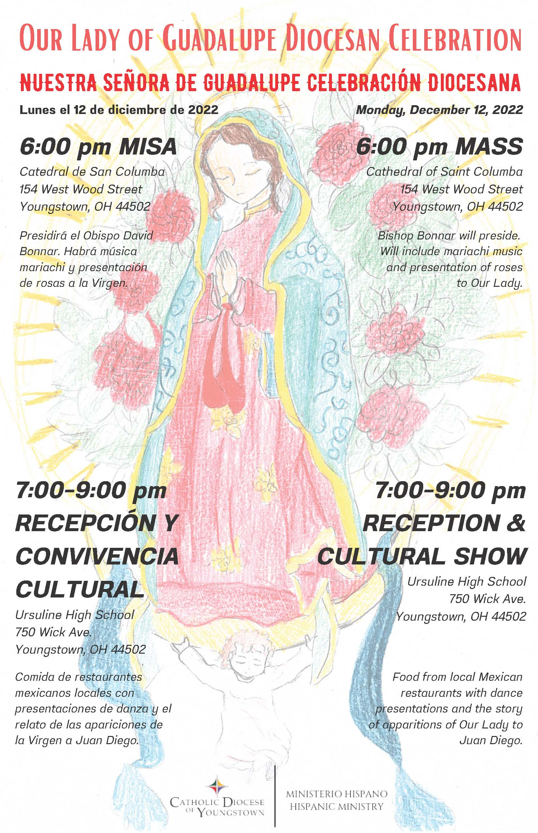

DIOCESAN COMMUNICATIONS COLLECTION (Bulletin Materials)

Diocesan Communications Collection: January 7 & 8, 2023 (Bulletin Materials)** -NEW

FULL PAGE FLYER
Communications Collection Page: https://doy.org/communications-collection/

ANNOUNCEMENT TO PASTORS/PARISH STAFF:
Below are three bulletin announcements that can be used to announce our new “Diocesan Communications Collection” - for December 31/January 1, January 7/8 (the day of the collection) and January 14/15 (after the collection). Thank you to those parishes who were able to add the “Diocesan Communications Collection” (January 7/8) and the “Seminarian Support Collection” (April 29/30) in their regular envelopes. The diocese will provide envelopes to the rest.

Please also include these new collections in your parish online giving selections, and please note the diocesan giving page in each recommended bulletin announcement below. Flyers are also provided in this Communique.

Weekend of December 31/January 1 (or earlier):

Diocesan Communications Collection: Epiphany Weekend
In the Christmas Season, we are also called to share the good news of Jesus who is made known in our faith community. One way we can do this is by supporting the “Diocesan Communications Collection” on January 7 and 8, the Solemnity of the Epiphany. This collection supports the new initiatives of the Diocese of Youngstown's Communications Office, including The Catholic Echo - a new magazine and multimedia website - along with a contemporary social media studio that will help us produce videos, podcasts and more. Your gift will help us to reach out to younger Catholics and help support critical services to the homebound, including the recorded Sunday Mass and radio and television ministry. Thank you for your gift on January 8, or online through your parish’s e-giving, or at doy.org/communications-collection/.

Weekend of January 7/8, 2023:

Diocesan Communications Collection: Epiphany Weekend
On this celebration of Christ's Epiphany, we dare to believe that the light of Christ shines in each one of us. Our new diocesan Communications initiatives will shine a light on the good news of our Catholic community in every county of our diocese, through The Catholic Echo - a new magazine and multimedia website - and a contemporary social media studio that will help us produce videos, podcasts and more. Our diocesan Communications Department also provides necessary publicity and information services to parishes and diocesan offices. Your gift will help us to reach out to younger Catholics and help support critical services to the homebound, including the recorded Sunday Mass and radio and television ministry. Thank you for your gift in today’s second collection, online through your parish’s e-giving, or at doy.org/communications-collection/.

After January 7/8, 2023:

Diocesan Communications Collection: Gratitude
Many thanks to those who already supported this year’s Diocesan Communications Collection on January 7 and 8. Your gift will help us spread the good news of our Catholic community in every county of our diocese, through The Catholic Echo - a new magazine and multimedia website - and a contemporary social media studio that will help us produce videos, podcasts and more. As we celebrate the “Sunday of the Word of God” on January 21 and 22, please pray for our communications ministries, and all who echo God’s word in liturgical, catechesis and service ministries. Please know that your contributions will help us reach out to younger Catholics and help support critical services to the homebound, including the recorded Sunday Mass and radio and television ministry. If you are able, you can still give to our Diocesan Communications Collection online at doy.org/communications-collection/.

CANONICAL SERVICES

TRIBUNAL

Tribunal In-Service Available
The Tribunal staff has made available an ongoing, in-service for pastors, associates, deacons, religious, directors of religious education, religious education coordinators and counselors in order to prepare them in facilitating pleas for nullity for persons within the community whose marriages have broken down and who may be seeking a second union recognized by the Church.

The in-service focuses on preparation of case histories, compilation of documents, witnesses and determining of the appropriate grounds of nullity. Covered also are other types of nullity procedures.

Size of the in-service is in small groups of between 8-12 participants and generally runs approximately two hours. The in-service is offered at either the offices of the Tribunal of the Diocese of Youngstown or at a parish in the Canton area. Interested parties, who have not already registered or who need a “refresher,” should call the Tribunal at (330) 744-8451, ext. 252, to have their names placed on the registrant list. You would then be contacted when there are at least eight registrants for a particular location.

CATHOLIC CHARITIES SERVICES

CATHOLIC CHARITIES (Bulletin Materials)

PARISH BULLETINS/PUBLICITY

Christmas Gifting** -NEW
Flyer and image attached.
Catholic Charities’ Christmas Gifting Project is a great way to support the work of Catholic Charities in the Diocese of Youngstown, while giving a gift that has real meaning. All you have to do is make a donation in any dollar amount, and we will send a personalized, customized greeting card to the recipient(s) of your choice, acknowledging your gift in their honor (but not mentioning the specific dollar amount).

Visit our website www.ccdoy.org for more information and to make your gift online.

Direct link: https://host.nxt.blackbaud.com/donor-form/?svcid=renxt&formId=2708566e-e1c4-4773-a498-5afe2885bdf9&envid=p-dn6FNihuA0GZMWZHGWJvMw&zone=usa

PARISH BULLETINS/PUBLICITY

Breakfast with the Bishop Event**
Flyer and image attached.
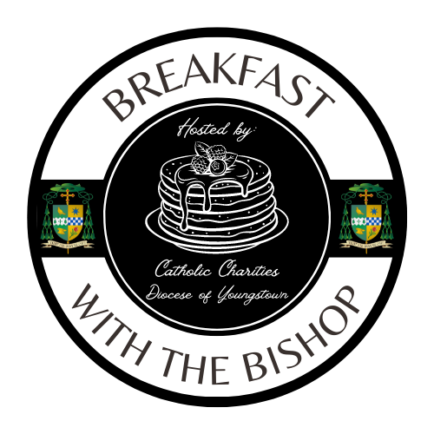
To kick off #GivingTuesday, we are hosting our very first “Breakfast with the Bishop.” This event will take place on Tuesday, November 29; from 8:00 a.m. until 10:00 a.m. at Our Lady of Mt. Carmel Basilica, Youngstown. Guests will have the opportunity to enjoy a hearty breakfast, learn about Catholic Charities, and hear from The Most Reverend, David J. Bonnar, Bishop of Youngstown. All proceeds from this event will support Catholic Charities’ basic needs assistance programs throughout the Diocese of Youngstown. Tickets are on sale now and must be purchased in advance as space is limited.

To reserve your tickets or to make a donation, please visit our website. For parishes or local businesses interested in purchasing AD space in our event program booklet, please contact Jennifer Lucarelli at 330-744-8451, or jlucarelli@youngstowndiocese.org.

www.ccdoy.org

PARISH BULLETINS/PUBLICITY

Season of Giving**
Image attached.
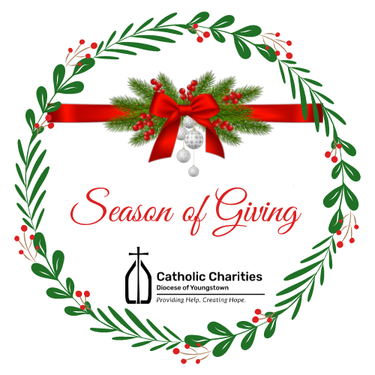
Each year, from November 1 through December 31, Catholic Charities hosts our annual "Season of Giving." It is during this time of Thanksgiving and Christmas blessings that so many of our loyal friends are inspired to get involved and give back to the community. We offer a variety of ways that you too can get involved in this season of giving back to those who need our help the most.
-Pray
-Donate
-Volunteer
-Participate
-Get Social
To get more information on how you can get involved, please visit our website www.ccdoy.org

PARISH BULLETINS/PUBLICITY

Giving Tuesday**
Image attached.
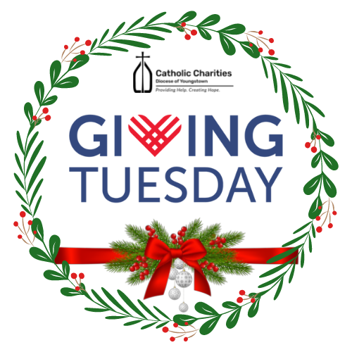
#Giving Tuesday is one of the largest giving days and one of the most successful social media campaigns all over the world! You, too, can participate in this global event. You can make a difference! Visit the Catholic Charities website on TUESDAY, NOVEMBER 29, 2022 and make a gift, and your gift will automatically be DOUBLED thanks to our corporate sponsors! A list of sponsors will be available on our website beginning on November 1, 2022.

Proceeds from #GivingTuesday will help support the many programs and ministries of Catholic Charities in all (6) counties of the Diocese of Youngstown.

www.ccdoy.org

PARISH BULLETINS/PUBLICITY

Support for Ukraine – Financial Support (Bulletin Materials)**
Catholic Charities of the Diocese of Youngstown continues to accept financial contributions to assist the people of Ukraine. 100% of the funds we receive in the Diocese of Youngtown for Ukraine will be divided between the United State Conference of Catholic Bishops’ (USCCB) Subcommittee on Aid to the Church in Eastern Europe and Catholic Relief Services, unless otherwise specified by the donor. Both of these organizations are uniquely suited to help, since they and their partners have been “on the ground” for years doing critical work. Both are intently focused right now on supporting the emergency needs of Ukraine and Ukrainian refugees, with any additional funds (if applicable) supporting ongoing needs in Eastern Europe and globally. Please note that Catholic Charities in the Diocese of Youngstown does not process or keep any of these disaster donations for Ukraine for our local efforts in the collection process. All of the money goes to the people who desperately need it.

PARISH BULLETINS/PUBLICITY

Support for Ukraine – Sponsor Support (Bulletin Materials)**
Uniting for Ukraine is a streamlined process that allows for Ukrainian citizens who have been displaced by Russia’s aggression to apply for humanitarian parole in the United States.
According to the USCCB, this program will need an additional 30,000 to 40,000 American households to register as sponsors in the months to come. If you are interested in becoming a sponsor, learn more about how you may be able to connect with someone in need in order to become their sponsor by viewing the links below.
SPONSORS: https://ukraine.welcome.us/resources
CONNECTIONS: https://ukraine.welcome.us/connect
More Information:
Under Uniting for Ukraine, the U.S. government allows people fleeing the war in Ukraine to seek refuge in the United States on a temporary basis known as humanitarian parole, with the support of a sponsor in the United States. The sponsor will provide financial support to meet the basic needs of someone fleeing Ukraine. They may also provide additional support, such as assistance enrolling in educational or training programs or securing employment.
Sponsors can be U.S. citizens, permanent residents or other lawfully present individuals. This includes individuals on Temporary Protected Status (TPS) and refugees. Groups of sponsors, nonprofits, educational institutions, and employers can also help sponsor people fleeing Ukraine.
So far this year, more than 70,000 Americans have applied to become a sponsor. If you are already connected to a Ukrainian individual or family, please use this link for information on becoming a sponsor.
SPONSORS: https://ukraine.welcome.us/resources
According to the USCCB, this program will need an additional 30,000 to 40,000 American households to register as sponsors in the months to come. If you are interested in becoming a sponsor, but are not currently connected to a Ukrainian individual or family, learn more about how may be able to connect with someone in need in order to become their sponsor by viewing the link below. *The responsibility for making a “connection” will fall upon the Ukrainian beneficiary. It must be their final decision to connect.
CONNECTIONS: https://ukraine.welcome.us/connect

CATHOLIC CHARITIES SERVING PORTAGE AND STARK COUNTIES (Bulletin Materials)

PARISH BULLETINS/PUBLICITY

Adult Day Services in Louisville is Accepting Participants**
The Adult Day Services (ADS) facility operated by Catholic Charities serving Portage and Stark Counties is open and accepting participants on a limited basis. ADS offers a safe and secure environment for older adults in need of supervision or assistance with activities of daily living while family caregivers are at work or attending to other responsibilities. We have implemented strict pandemic related protocols to ensure the health and safety of participants and staff alike. Our well-maintained facility is located on the St. Joseph Senior Living Campus in Louisville, Ohio. For more information about the program, please call 330-875-7979 or send an email to Troy Cochran at troy.cochran@catholiccharitiesps.org

OFFICE OF PEACE AND JUSTICE (Bulletin Materials)

PARISH BULLETINS/PUBLICITY

Prison Ministry Presents - Kolbe Gathering**

Flyer and image attached.
Kolbe Gathering is a place for the formerly incarcerated and their families to join with parish-based volunteers in spiritual support and fellowship. Embrace spirituality in prayer, music, scripture reading and fellowship, all in a welcoming and warm environment.
St. Maximilian Kolbe is Patron Saint of prisoners and drug addicts. He was martyred at Auschwitz Concentration Camp.
For further information contact William Barber, Coordinator for Prison Ministry, at 330.235.3920.

DEPARTMENT OF COMMUNICATIONS

CATHOLIC EXPONENT

Full Page Flyer
Publication dates and special sections for the Exponent are as follows:
- November 25 (Special Sections: Christmas Recipes / Christmas Gifts)
- December 9 (Special Sections: Christmas Gifts / Nativity Pictures)
- December 23 (Special Section: Christmas Greetings)
The normal deadline for each issue is 12 days before the publication date. We try to get late information into the issue but are sometimes limited by lack of available space.

ANNOUNCING THE CATHOLIC ECHO -NEW

The Diocese of Youngstown is pleased to announce a new print product, The Catholic Echo magazine, debuting in spring 2023.

For more information, please see:
- Press Release “Diocese of Youngstown announces The Catholic Echo, a diocesan magazine and multimedia hub, succeeding The Catholic Exponent newspaper”
- Bishop Bonnar’s Message “A New Magazine and More: Adapting to Today’s Needs”

MULTIMEDIA (CTNY) (Bulletin Materials) -NEW
BULLETIN/PUBLICITY

Wineskins (Bulletin Materials)** -NEW
Wineskins airs every Sunday:
7:30 a.m. on WKBN 570 AM in Youngstown
7:30 a.m. on WRQX 600 AM in Salem
9:30 a.m. and 9:00 p.m. on WILB AM Canton 1060, WILB FM 89.5 Youngstown, WILB FM 94.5 Canton
A new episode of Wineskins airs every Sunday. Listen to Wineskins on the diocesan website at www.doy.org/live/ and click the Wineskins button. Subscribe to our YouTube channel for updates when we post a new episode: https://www.youtube.com/CTNYDOY
December 4, 2022
- Current Issue: Fr. Korda talks with Jill Valentic about Catholic Charities.
- Saint: Anthony Huff from St. Angela Merici Parish in Youngstown will tell us about St. Nicholas.
- Interview: Fr. Korda will begin a series on Vatican II this week’s topic is The Liturgy.
- Music: From the CD “Joy to The World” by Daniel Smith.
- Scripture: Fr. Zach Coulter will tell us about the Scriptures for the 2nd Sunday of Advent.

December 11, 2022
- Current Issue: Fr. John-Michael Lavelle will talk about Racism.
- Saint: Anthony Huff from St. Angela Merici Parish in Youngstown will tell us about Our Lady of Guadalupe.
- Interview: Fr. Korda continues a series on Vatican II this week’s topic is Communication.
- Music: From the CD “Joy to The World” by Daniel Smith.
- Scripture: Fr. Zach Coulter will tell us about the Scriptures for the 3rd Sunday of Advent.

December 18, 2022
- Current Issue: Fr. Korda talks with Fr. Brian Smith about Hispanic Ministry.
- Saint: Anthony Huff from St. Angela Merici Parish in Youngstown will tell us about St. Peter Canisius.
- Interview: Fr. Korda continues a series on Vatican II this week’s topic is The Church.
- Music: From the CD “Joy to The World” by Daniel Smith.
- Scripture: Fr. Zach Coulter will tell us about the Scriptures for the 4th Sunday of Advent.

December 25, 2022
- Current Issue: Fr. Korda talks with Nancy Voitus about Catholic Charities.
- Saint: Anthony Huff from St. Angela Merici Parish in Youngstown will tell us about St. Stephen.
- Interview: Fr. Korda continues a series on Vatican II this week’s topic is Ecumenism.
- Music: From the CD “Joy to The World” by Daniel Smith.
- Scripture: Fr. Zach Coulter will tell us about the Scriptures for The Nativity of the Lord, Christmas Day.

How to Watch the Mass for Shut-Ins
The diocese continues to produce the Mass for Shut-Ins. Please share this information according to the availability in your area. The Diocese of Youngstown Mass for Shut-Ins may be viewed the following ways:
Online at doy.org/live/ or Facebook.com/DOYoungstown/ or YouTube.com/CTNYDOY
In Youngstown, Warren, Mahoning Valley on WFMJ TV-21: Sundays at 6 a.m. and on Armstrong Cable Channel 45: Sundays at 8 a.m., noon, 7 p.m., for the time being.
Currently, a technical difficulty was making it unavailable on Spectrum Cable Channel 9, 13, or 14 in the Youngstown-Warren area.
In Stark County on Spectrum Cable in Canton – Channel 989: Sundays at 9:30 a.m., on Massillon Cable Channel 128: Sundays at 9:30 a.m., and on WIVM TV-39: Sundays at 9:30 a.m.
In nursing homes and prisons: The diocese continues to make its televised Mass available in 10 nursing homes and 3 prisons. For more information, contact Bob Gavalier at 330-533-2243.
Any further updates to diocesan cable TV programming will be noted at www.doy.org/live/

MEDIA RELATIONS
- Parishes and other diocesan entities who receive inquiries from the media are asked to consult with Justin Huyck, Director of Communications: (330) 744-8451, ext. 320; jhuyck@youngstowndiocese.org
- Please also kindly inform the Communications Department when your programs, initiatives, and ministries are featured in the news media.
- The Communications Department is available to consult on news releases regarding events and initiatives. Processes will continue to be developed to assist these efforts.

OFFICE OF SOCIAL MEDIA

1. Advent Reflections – Sundays, Mondays and Thursdays -NEW

For this Advent season, beginning on November 27, diocesan social media presents video reflections offered by Catholic leaders from around the diocese posted to Facebook, Twitter and YouTube on Sundays, Mondays and Thursdays at 8:00 a.m. for your personal prayer experience and to share with those in your parish, school, agency and ministry.
Facebook Page: https://www.facebook.com/DOYoungstown

Twitter: https://twitter.com/DOYoungstown

YouTube Channel: https://www.youtube.com/channel/UCKwcSOhoUOePs1qJjTGlgxA

2. DOY Social Media Networking Facebook Group for Social Media Contacts

Ongoing networking regarding social media can be found on Facebook in a private group by searching for “DOY Social Media Networking” or click:

https://www.facebook.com/groups/2882358088720802

This is a great place to share resources, ask questions and meet others around the diocese doing social media for their parishes, schools, offices and agencies. You can also share upcoming events that you’d like to invite others to so they can share in social media as well. This is also a key way the Social Media Minister is sharing insights as to avoid overwhelming contacts email boxes.

3. Social Media Helpful Hint of the Month – Facebook Groups -NEW

If you manage Facebook Groups, you are likely aware of the many changes Meta has been making, including that anyone can see/preview those not listed as Private or Secret, but must request to join to post. (So, double check your Group settings as needed.) The newest change is that ANY member can make themselves Moderators if you enable it from a pop-up notification that looks like it might be a good idea to try, but IGNORE it. Keep only your Group Administrators in control. Or select specific members you know and trust to become Moderators. You can see an image of the pop-up and more information at:
https://www.socialmediatoday.com/news/Facebook-Tests-Option-Which-Enables-Members-to-Make-Themselves-Moderators/636444/?fbclid=IwAR3OnCJCIenij5_fiUmvJzg_1TKhewJd1GJfLm7xnt9388gjvs-dAwfNvLE
If you have any questions, feel free to contact Cindee Case, ccase@youngstowndiocese.org.

CLERGY AND RELIGIOUS SERVICES

OFFICE OF CLERGY SERVICES

1. Advent Day of Recollection – Save the Date

An Advent Day of Recollection will be held on Tuesday, November 29, 2022 beginning at 2:00 p.m. and will conclude with dinner at Our Lady of Mount Carmel Basilica in Youngstown. Rev. Joseph McCraffrey, pastor of Holy Spirit Parish in New Castle will be the presenter. He was ordained in 1987 and in addition to his pastoral assignments he was the first Catholic Chaplain to the Federal Bureau of Investigation in the Pittsburgh office. He remains chaplain to the FBI and is a member of the Advanced Crisis Intervention team. He is also a licensed private pilot and in 2014 he had the opportunity to fly with the Blue Angels and was elected President of the National Association of Priests Pilots in 2019.

2. New Order of Penance

Archbishop Jose H. Gomez, USCCB President issued a promulgation decree on June 24, 2022, for the recently confirmed Order of Penance. The new translation may be used beginning on Ash Wednesday, February 22, 2023, and the date for obligatory use has been set for Sunday, April 16, 2023.

Four publishers will produce ritual editions for use in the United States. Some presales began October 1, 2022:
- Catholic Book Publishing Corp: https://catholicbookpublishing.com/product/1639
- Liturgy Training Publications: https://ltp.org/products/details/OPRE/order-of-penance
- Magnificat: https://bookstore.magnificat.net/the-order-of-penance.html
- and Midwest Theological Forum.

OFFICE OF VOCATIONS (Bulletin Materials)

Seminarian Pastoral Intern

The following Seminarian has been assigned as a Pastoral Intern for the 2022-2023 Academic Year.

Mr. Travis Seagraves: Our Lady of Peace, Ashtabula

Please remember him, the people of Ashtabula, and all of our seminarians in your prayers.

Seminarian Posters and Prayer Cards -NEW

The Seminarian Posters and Prayer Cards are now available! They are being mailed directly to parishes. There are a limited number of extra prayer cards and posters. If you would like any additional cards or posters, please contact Fr. Chad Johnson at 330-744-8451 or cjohnson@youngstowndiocese.org

Vocation Director at Your Parish / School

If you have a special youth ministry, parish, retreat, or vocational event, that you would like the Diocesan Vocation Director to attend, please contact him at 330-744-8451 or by email at cjohnson@youngstowndiocese.org

PARISH BULLETINS/PUBLICITY

Come and See the Seminary: February 10-12, 2023 (Bulletin Materials)** -NEW
Saint Mary Seminary & Borromeo Seminary are once again offering “Come and See” Weekends. These are opportunities for men who are open to priesthood formation can experience life in the Seminary. The next Come and See Weekend is scheduled for February 10-12, 2023. If you know of anyone interested in this time of prayer, discovery, and discernment, please contact Fr. Chad Johnson at 330-744-8451 or by email at cjohnson@youngstowndiocese.org

Diocesan event page: https://doy.org/events/come-see-seminary-feb2023/
Image attached

Seminarian Visits to Your School or Parish

Please remember all the seminarians we have currently studying in our diocese. They are all willing and available to come and speak at your parish or school. To schedule, please contact Fr. Chad Johnson at 330-744-8451 or by email at cjohnson@youngstowndiocese.org

“Discovery Days” [Seminary Field Trips] -NEW

Considered having your school go on a field trip to the Seminary to see what it’s all about? There are many opportunities for 7th/8th grade and High School visits to Saint Mary Seminary & Graduate School of Theology in Cleveland. For more information, please contact Fr. Chad Johnson at 330-744-8451 or by email at cjohnson@youngstowndiocese.org.

Vocation Intercessions and Bulletin Blurbs (Bulletin Materials)** -NEW
Click the links below or see the Communiqué attachments folder at https://bit.ly/dec2022comm
for vocation intercessions and bulletin blurbs for the month of December. Please use these in your bulletins and at Mass to help promote vocations to the priesthood and religious life in your parish community and school:
Vocations Intercessions & Bulletin Blurbs: Word Doc
Vocations Intercessions & Bulletin Blurbs: PDF

Vocations Social Media
- Website: www.doy.org/vocations
- Facebook: doyvocations
- Twitter: doy_vocations
- Instagram: doyvocations

OFFICE OF VOWED RELIGIOUS

World Day for Consecrated Life: February 5, 2023

Bishop David Bonnar will celebrate the annual World Day for Consecrated Life Mass on Sunday, February 5, 2023 at St. Columba Cathedral at 10:30 a.m. Be sure to mark your calendars for this annual diocesan celebration of Consecrated Life. Light refreshments will follow (pending COVID restrictions).

Event page: https://doy.org/events/world-day-consecrated-2022/

New and Returning Religious

This is a reminder for any religious (involved in ministry, student, or retired) who is new, or has recently returned to the Diocese of Youngstown, and has not yet contacted the Office of Vowed Religious, to kindly do so as soon as possible. Please also note that there are some new requirements for our Child Protection Policy. Please call (330) 744-8451, ext. 238 or e-mail sjcandidi@youngstowndiocese.org

Religious Retirement Appeal

Thank you for your generosity on behalf of those who have consecrated their lives in service to God. The Retirement Fund donation page is available year-round.

Retirement Fund donation page (direct link): https://secure.acceptiva.com/?cst=a08f75

DEVELOPMENT AND STEWARDSHIP OFFICES

OFFICE OF THE ANNUAL DIOCESAN APPEAL
The Diocese has reached 90% of its goal. Father John-Michael Lavelle’s updates regarding the appeal are posted at www.doy.org/appeal/

OFFICE OF DEVELOPMENT AND STEWARDSHIP (Bulletin Materials/Materiales del Boletín)

PARISH BULLETINS/PUBLICITY/BOLETÍN PARROQUIAL

Stewardship Bulletin Thoughts (Bulletin Materials | Materiales de Boletín)** -NEW
Please see this website for upcoming Stewardship Bulletin Thoughts in English y Reflexiones del Boletín de Corresponsibilidad en español: https://www.archstl.org/about-stewardship/bulletin-inserts/weekly-bible-reflections
You can also download them as a Word Doc in December’s Communique Attachments folder: https://bit.ly/dec2022comm

Resources for #iGiveCatholic

The Diocese of Youngstown will be participating again in the #iGiveCatholic Giving Day on Tuesday, November 29, 2022.

#iGiveCatholic, now in its 8th year, is a proven, dynamic crowdfunding event that offers an excellent opportunity for the Catholic Community to come together to give thanks, give back, and give Catholic! Last year, #iGiveCatholic helped organizations to raise over $16.5 million dollars on this internationally-recognized huge day of philanthropy. Fr. John-Michael Lavelle has been offering guidance, support and training every step of the way!

#iGiveCatholic downloads (logo, etc): https://www.igivecatholic.org/info/downloads

PASTORAL AND EDUCATIONAL SERVICES

OFFICE OF FAITH FORMATION AND LAY ECCLESIAL MINISTRY (Bulletin Materials)

1. Advent Retreat: December 1, 2022

The Annual Advent Retreat for Parish Ministers and their guests will be held on Thursday, December 1, 2022, from 9:30 am – 3:30 pm at Our Lady of Perpetual Help Parish in Aurora. The Office of Faith Formation and Lay Ecclesial Ministry welcomes Father Don King as the retreat facilitator. Registration is required and more information is available by contacting the office.

2. New Adult Faith Formation Courses Coming Soon -NEW

New adult faith formation courses begin January 23, 2023. Watch the mail and Catechist Cafe for these new learning opportunities and their descriptions. These courses are not just for catechists, everyone is welcome to participate. No prior knowledge of the topic is required. If you have any questions about adult faith formation, please contact Margie Hynes 330-744-8451 ext 296 or mhynes@youngstowndiocese.org.

3. New Library Resources -NEW

Living With Real Presence: Eucharist as an Approach to Life. S. James Meyer. Twenty-Third Publications, 2022. In this transformative new book, best-selling author S. James Meyer introduces us to a whole-life encounter with the living Christ, awakening a fresh awareness that the Eucharist is about life, love, and relationship. Living with Real Presence reminds us that our lives, Christ’s life, and all lives are united in a sacred communion with our Creator and creation. A spiritual journey for personal reflection or small-group discussion, Meyer’s “Eucharistic living” is a timely call for Catholics to engage in the National Eucharistic Revival.
The 7 Joys and Sorrows of Mary: Reflections, Actions, and Prayer. Melanie Rigney. Twenty-Third Publications, 2022. In this meaningful new devotional, readers are invited to walk with Mary, the mother of Jesus, as she encounters deep sorrow and great joy throughout her life. From the Annunciation to the Crucifixion and beyond, Melanie Rigney demonstrates how Mary is a model of strength and perseverance for all believers today. These deeply spiritual reflections, prayers, and writing prompts are powerful guides to help us grow closer to both Mary and her Son, Jesus.
Threshold Bible Study: Music, Hymn, and Canticles. Stephen J. Binz. Twenty-Third Publications, 2022. Why not give your music ministers, cantors, and choir the gift of music in sacred Scripture? Discover how music has played a central role in the life of God’s people, how hymns and songs have been woven into the fabric of their communal living and public worship. Choirs of voices, lyres and harps, strings and pipes, tambourines and dance all resonate in praise, remembering God's wondrous deeds and celebrating the feasts of God's people.

OFFICE OF PRO-LIFE, MARRIAGE AND FAMILY LIFE (Bulletin Materials)

PARISH BULLETINS/PUBLICITY

1. Project Rachel Outreach – December Message for Bulletin/Newsletter (Bulletin Materials) -NEW**
Jesus came for all of us and knows our pain. There is Hope and Healing from abortion. For CONFIDENTIAL help text or call Project Rachel of Northeast Ohio at 330-360-0430 or go to https://hopeafterabortionneo.weebly.com/.

2. Intercessions for Life and Pro-Life Bulletin Briefs
Recommended intercessions and bulletin briefs prepared by the U.S. Conference of Catholic Bishops Secretariat for Pro-Life Activities may be found at www.respectlife.org/word-of-life.

PARISH BULLETINS/PUBLICITY

3. National Night of Prayer for Life at the Basilica of Our Lady of Mt. Carmel, Youngstown (Bulletin Materials)** -NEW

As part of the annual National Night of Prayer for Life on Thursday, December 8, the Basilica of Our Lady of Mt. Carmel at 343 Via Mt. Carmel, Youngstown is hosting a Mass at 7:00 p.m. and Eucharistic Adoration from 8:00 to 10:00 p.m.

PARISH BULLETINS/PUBLICITY

4. 9 Days for Life – Thursday, January 19 to Friday, January 27, 2023 (Bulletin Materials)** -NEW
Full Page Flyer
Diocesan Event Page

Join thousands of Catholics nationwide in the annual Respect Life novena, 9 Days for Life, praying for the protection of human life. Get daily intentions, brief reflections, and more. Sign up at www.9daysforlife.com.

5. The National March for Life: January 20, 2023 in Washington D.C.

Ever since the unfortunate 1973 Roe v. Wade decision by the U.S. Supreme Court, those concerned about the right to life of unborn children have gathered annually in Washington DC to March for Life. Fortunately, this past June the Supreme Court overturned Roe v. Wade, but “the work to build a culture of life in the United States of America is far from finished.” Therefore, the March for Life will continue on Friday, January 20, 2023 with the theme “Next Steps: Marching Forward in a Post-Roe America!” For more information go to https://marchforlife.org/.

If you or your parish, school or organization is planning to attend the March for Life in Washington D.C. on Friday, January 20, 2023, please contact Dave Schmidt in the Office of Pro-Life, Marriage and Family Life at 330-744-8451 ext. 272 or dschmidt@youngstowndiocese.org.

6. National March for Life Related Events
The following events will take place before or after the 2023 National March for Life in Washington D.C.:
  - The National Prayer Vigil for Life at the Basilica of the National Shrine of the Immaculate Conception in Washington D.C. will begin with an Opening Mass at 5:00 p.m. on Thursday, January 19 and conclude with a Closing Mass at 8:00 a.m.
  - The National Pro-Life Summit, sponsored by Students for Life of America, will take place on Saturday, January 21 from 8:00 a.m. until 7:00 p.m. at the Omni Shoreham Hotel in Washington D.C. For more information go to: https://prolifesummit.com/.
  - The Cardinal O’Connor Conference on Life will take place on Saturday, January 21 from 8:00 a.m. until 4:30 p.m. at Georgetown University in Washington D.C. For more information go to: https://www.oconnorconference.com/.
For more information on the above items, or other related questions or concerns, contact 330-744-8451 ext. 272 or dschmidt@youngstowndiocese.org.
PARISH BULLETINS/PUBLICITY

7. Mass for Life: Sunday, January 22, 2023 at St. Columba Cathedral (Bulletin Materials)** -NEW
Full Page Flyer: Word Doc and PDF
Diocesan Event Page: https://doy.org/events/mass-for-life-with-bishop-bonnar-jan2023/

Bishop Bonnar will preside at a Mass for Life on Sunday, January 22, at 4:00 pm at St. Columba Cathedral, Youngstown (154 W. Wood St.). Bishop Bonnar will offer a special Blessing of Children in the Womb to women who are with child, and their families. In addition, there will be a blessing of pilgrims returning from the National March for Life in Washington, D.C. A reception will follow. All are welcome – no reservations needed. For more information contact dschmidt@youngstowndiocese.org or 330-744-8451 ext.272.

PARISH BULLETINS/PUBLICITY

8. Do You Know Someone Who is Expecting a Child? (Bulletin Materials)** -NEW

If you know someone who is expecting a child, invite her and her family to attend the Mass for Life on Sunday, January 22, at 4:00 pm at St. Columba Cathedral, Youngstown (154 W. Wood St.). Bishop Bonnar will offer a special Blessing of Children in the Womb to women who are with child, and their families. The Mass will be followed by a reception. All are welcome – no reservations needed. For more information contact dschmidt@youngstowndiocese.org or 330-744-8451 ext.272.

9. January 23, Day of Prayer for the Legal Protection of Unborn Children -NEW
The General Instruction of the Roman Missal (GIRM), no. 373, designates January 22 as a particular day of prayer and penance, called the "Day of Prayer for the Legal Protection of Unborn Children": "In all the Dioceses of the United States of America, January 22 (or January 23, when January 22 falls on a Sunday) shall be observed as a particular day of prayer for the full restoration of the legal guarantee of the right to life and of penance for violations to the dignity of the human person committed through acts of abortion." Additional information and resources may be found at www.usccb.org/prayer-and-worship/resources/january-22-day-of-prayer-leader-resources.cfm and www.respectlife.org/january-22.

10. Walking with Moms in Need
In March, Bishop Bonnar wrote to all pastors encouraging the implementation of Walking with Moms in Need in their parishes. This initiative from the USCCB is to help parishes come alongside and accompany pregnant and parenting mothers facing difficulties. Find out more about our local efforts and resources at https://doy.org/walkingwithmomsneo/
The Office of Pro-Life, Marriage and Family Life is piloting Walking with Moms in Need in the Eastern Stark County Region of our diocese and has held information meetings in Mahoning, Stark and Portage Counties. Anyone interested in establishing this important effort in their parish or region may contact Dave Schmidt at dschmidt@youngstowndiocese.org or 330-744-8451 ext. 272.

11. INTO LIFE – Love Changes Everything

A resource that is helpful in implementing Walking with Moms in Need is the INTO LIFE series. INTO LIFE: Love Changes Everything is a 12-part series created by the Sisters of Life and the McGrath Institute for Church Life at the University of Notre Dame. Journey with the Sisters of Life as they explain what it means to walk with a woman who is pregnant and vulnerable. Go to www.intolifeseries.com or contact 330-744-8451 ext. 272 or dschmidt@youngstowndiocese.org.

12. Marriage Preparation Engaged Couple Retreat Day

The next diocesan-sponsored one-day marriage preparation retreat day for engaged couples will be held Saturdays, February 4 and March 4 in the social hall at St. Columba Cathedral. Reservations are required. Registration information may be found for the event at www.doy.org/events. You can also visit DOY.org, go to the “Ministries” drop-down menu and click “Pro-Life, Marriage & Family Life.” The schedule of Engaged Couple Retreats for 2023 is forthcoming.

Direct link for registration: https://secure.acceptiva.com/?cst=4479d9

For more information on this, and other opportunities for marriage preparation formation, contact dschmidt@youngstowndiocese.org or 330-744-8451, ext.272.

13. National Marriage Week: February 7 – 14 -NEW
National Marriage Week is February 7-14. Stay tuned for materials from the USCCB’s Secretariat for Laity, Marriage, Family Life and Youth.

RESOURCES:
- ForYourMarriage.org
- NationalMarriageWeek USA
- Toolkit | Family Love: A Vocation and a Path to Holiness
- Bulletin Insert/Poster | English
- Bulletin Insert/Poster | Spanish

PARISH BULLETINS/PUBLICITY

14. Annual White Mass for all Health Professionals Including Mental Health Workers (Bulletin Materials)** -NEW
Diocesan Event Page

The Annual White Mass – celebrating and recognizing the ministry and work of those in the health professions – will be held on Sunday, February 19, 2023 at 10:30 a.m. at the Cathedral of St. Columba located at 154 W. Wood St. in Youngstown. Bishop David J. Bonnar will preside. A reception will follow in the Cathedral Hall. All are welcome. For more information call 330-744-8451 ext.272 or contact dschmidt@youngstowndiocese.org.

OFFICE OF WORSHIP

1. New Order of Penance

Archbishop Jose H. Gomez, USCCB President issued a promulgation decree on June 24, 2022, for the recently confirmed Order of Penance. The new translation may be used beginning on Ash Wednesday, February 22, 2023, and the date for obligatory use has been set for Sunday, April 16, 2023.

Four publishers will produce ritual editions for use in the United States. Some presales began October 1, 2022:
- Catholic Book Publishing Corp: https://catholicbookpublishing.com/product/1639
- Liturgy Training Publications: https://ltp.org/products/details/OPRE/order-of-penance
- Magnificat: https://bookstore.magnificat.net/the-order-of-penance.html
- and Midwest Theological Forum.

2. New Order of Christian Initiation of Adults

In anticipation of the new Order of Christian of Adults, the Federation of Diocesan Liturgical Commissions has begun a FREE webinar series on the Order of Christian Initiation of Adults (OCIA). The webinars are offered in both English and Spanish and can be joined live or by viewing the recording.

For a schedule of dates, topics and presenters please visit: https://fdlc.org/ociawebinars/

The webinars are open to all those involved in Initiation Ministry and OCIA Parish Team Members.

3. Liturgical Calendar Advisories for Upcoming Holy Days and Christmas/New Year

~Upcoming Holydays: Thursday, December 8, 2022, the Feast of the Immaculate Conception will be a normal holy day of obligation this year. The Feast of Our Lady of Guadalupe will be celebrated on Monday, December 12, 2022.

~Sunday, December 25 - Christmas: This year the Nativity of the Lord falls on Saturday (Christmas Eve) and Sunday (Christmas Day) this year. Parishes should plan Mass on Christmas Eve and Christmas Day accordingly.

~Friday, December 30 – Feast of the Holy Family: This year the Feast of the Holy Family will be celebrated on Friday, December 30, 2022.

~Sunday, January 1 - Solemnity of Mary, the Holy Mother of God: The weekend of Saturday (December 31) and Sunday (January 1) will be the Solemnity of Mary, the Holy Mother of God. The Feast of Epiphany will be the weekend of January 7-8, 2023, and the Feast of the Baptism of the Lord will be celebrated on Monday, January 9, 2023.

4. Sunday of the Word of God -NEW

On September 30, 2019, a Motu propio Apostolic Letter “Aperuit illis” issued by Pope Francis established the Third Sunday in Ordinary Time as the “Sunday of the Word of God.” This year, January 21/22, 2023 will be designated as “Sunday of the Word of God” and is to be devoted to the celebration, study, and dissemination of the Word of God. Recalling the importance given by the Second Vatican Council to rediscovering Sacred Scripture for the life of the Church, Pope Francis explains the celebration has “ecumenical value, since the Scriptures point out, for those who listen, the path to authentic and firm unity.” Parishes are invited to find ways to mark this Sunday with a certain solemnity. For more resources:
https://www.usccb.org/committees/divine-worship/sunday-word-god

5. The Light is On for You ~ An Evening of Reconciliation

The Light is On for You ~ An Evening of Reconciliation will return this year and be celebrated on Wednesday, March 8, 2023. Every parish should plan to celebrate the Sacrament of Reconciliation that evening either by scheduling a Lenten Communal Reconciliation Service with neighboring/collaborating parishes or individual reconciliation. The Office of Worship will provide materials in the coming months.

Event page: https://doy.org/events/the-light-is-on-reconciliation/

6. Liturgical Directory

The Liturgical Directory contains valuable information about Liturgy Committees; liturgical minister formation guidelines; guidelines for the celebration of sacraments; music in liturgical celebrations; and art and architecture directives. The directory can be accessed and downloaded from the diocesan website by clicking on “Worship” under the “Ministries” tab.
DOY Office of Worship: https://doy.org/ministries/worship/
Link to Download Liturgical Directory: https://doy.org/wp-content/uploads/2022/03/Diocese-of-Youngstown-Liturgical-Directory.pdf

7. Congratulations to New Lay Leaders of Prayer -NEW
Congratulations to the 25 individuals who completed the Lay Leaders of Prayer Formation series. Please see the press release for the full list of names and parishes.

OFFICE OF YOUTH AND YOUNG ADULT MINISTRY (Bulletin Materials)

1. Eagle of the Cross

Nomination forms will be sent out in January. It’s not too early to start thinking of nominations. Contact Fr. Ryan with any questions: rfurlong@youngstowndiocese.org

2. Confirmation Retreat

Fr. Ryan Furlong and Fr. Chad Johnson are teaming up to create a diocesan confirmation retreat. Please contact them if interested at rfurlong@youngstowndiocese.org or cjohnson@youngstowndiocese.org

PARISH BULLETINS/PUBLICITY

3. Spirits and Spirituality – December 1 (Bulletin Materials)** -NEW

All Young Adults are invited to join St. Michael the Archangel for their next Spirits and Spirituality gathering, Adoration and Appetizers on Thursday, December 1st. They will begin with Adoration at St. Michael's (3430 St. Michael Dr. Canton, OH 44718) in their Chapel at 5:00 pm. Following Adoration, they will have a Christmas Party at Winking Lizard on Fulton Dr.

Image: https://doy.org/wp-content/uploads/2022/11/315215284_3173602302952807_1325179140959063766_n.jpg

Diocesan Event Page: https://doy.org/events/spirits-and-spirituality-adoration-and-appetizers/

4. Christmas Party at St. Thomas the Apostle (Vienna)
St. Thomas the Apostle Parish in Vienna will be having a Christmas decorating party with hot cocoa. All Youth and Young Adults welcome. Contact Fr. Ryan for more details.

Fr. Ryan is working with a diocesan planning council to plan and coordinate diocesan events. Please contact him for more information or ways you can help at rfurlong@youngstowndiocese.org

OFFICE OF ECUMENICAL AND INTERRELIGIOUS DIALOGUE (Bulletin Materials)

Advent 2022: Resources for Discussion and Reflection -NEW
Find weekly Advent readings, reflections, questions and prayers prepared by The Lutheran-Catholic Covenant Commission of the Northeastern Ohio Lutheran Synod of the Evangelical Lutheran Church in America & Roman Catholic Diocese of Youngstown.
Questions? Contact Diocesan Director of Ecumenical and Interreligious Affairs, Rev. Shawn Conoboy, Ph.D. at sconoboy@youngstowndiocese.org
Download Word Document: https://doy.org/wp-content/uploads/2022/11/Ecumenical-2022-Advent-ResourcesforDiscussionandReflection.docx

PARISH BULLETINS/PUBLICITY

“The Meeting of Two Bishops: East and West” on December 13 at 6:30pm (Bulletin Materials)** -NEW

Full page flyer: https://doy.org/wp-content/uploads/2022/11/TwoBishops-Dec2022.pdf
Diocesan event page: https://doy.org/events/the-meeting-of-two-bishops-dec2022/

The Society of St. John Chrysostom Youngstown-Warren Chapter presents:
The Meeting of Two Bishops: East and West
Addressing Contemporary Issues of Mutual Concern to Both East & West

December 13 at 6:30pm

St. Nicholas Greek Orthodox Church
220 N. Walnut St.
Youngstown, OH 44503

Guests: Bishop David Bonnar (Roman Catholic Diocese of Youngstown)
Metropolitan Savas Zembillas (Greek Orthodox Metropolis of Pittsburgh)

For more information:
Fr. Shawn Conoboy, Ph.D. (Diocese of Youngstown)
sconoboy@youngstowndiocese.org

Lori Demiduk, O.F.S. (Society of St. John Chrysostom)
Lori-demiduk@yahoo.com

MISCELLANEOUS

DIOCESAN CEMETERIES (Bulletin Materials) -NEW

BULLETINS/PUBLICITY
Flyer: Divine Mercy Chaplet at Cemeteries
(or see text below)
Event: https://doy.org/events/divine-mercy-chaplet-cemetery/

Chaplet of Divine Mercy, Fridays at 3pm**
Catholic Funeral and Cemetery Services of the Diocese of Youngstown will be offering The Chaplet of Divine Mercy Prayer Service in the chapels of our 4 Cemeteries at 3:00pm every Friday at alternating locations:
First Friday of the month at Calvary Cemetery Chapel in Youngstown.
Second Friday of the month at Resurrection Cemetery Chapel in Austintown.
Third Friday of the month at All Souls Cemetery Chapel in Cortland.
Fourth Friday of the month at Calvary Cemetery Chapel in Massillon.

BULLETINS/PUBLICITY

Rosary at Calvary Cemetery (Youngstown)** -NEW
Join us as we pray the Rosary at Calvary Cemetery in Youngstown on the first Wednesday of the month at 10:00 in the Chapel. We will be led by the Oblate Sisters of the Sacred Heart. All are welcome.
BULLETINS/PUBLICITY

Christmas of Remembrance at Diocesan Cemeteries, Dec. 6 at 5pm** -NEW

Event: https://doy.org/events/christmas-of-remembrance/

We would like to cordially invite you and your family on Tuesday, December 6 from 5-7pm, to attend our Christmas of Remembrance Evening at all 4 of our cemeteries: Calvary in Youngstown, Resurrection in Austintown, All Souls in Cortland and Calvary in Massillon. We will have local choirs with seasonal songs, a prayer service and an opportunity to hang an ornament on the Christmas tree in remembrance of a dearly departed loved one. All are welcome!

PARISH EVENTS (Bulletin Materials)

Send events and news for the Communique to communications@youngstowndiocese.org by the 15th of the month. Next deadline: December 15.

Are you planning a parish music event? Please contact/copy Diocesan Director of Music Ralph Holtzhauser at rholtzhauser@youngstowndiocese.org

BULLETINS/PUBLICITY

Mahoning County | Cursillo Women's Weekend Jan 12-15, 2023**
The Cursillo Movement of the Youngstown Diocese will be hosting a Women's weekend from January 12 to 15, 2023. The weekend helps you experience your Catholic faith and encourages a spiritual life that is filled with joy and enthusiasm. From Thursday evening through Sunday afternoon, a team of Catholic religious and lay people will share insights on the lay person's role within the church, the meaning of grace and the sacraments, and the importance of supporting one another in our efforts to live a Christian life. Throughout the weekend the participants will pray together, attend daily Mass and have an opportunity to receive the sacrament of reconciliation. To register or for more information, contact Peg Elston at Youngstown4thday@gmail.com

BULLETINS/PUBLICITY

Mahoning County | Lessons & Carols at St. Columba (Youngstown) Dec 11 at 6pm** -NEW

Diocesan event page: https://doy.org/events/festival-of-lessons-and-carols/
Full page flyer: https://doy.org/wp-content/uploads/2022/11/Music-Flyer-LessonsandCarols2022.pdf

Festival of Lessons & Carols
December 11th at 6pm

St. Columba Cathedral
159 W Rayen Ave.
Youngstown, OH 44503

The Cathedral will be having the annual Lessons and Carols service with Bishop Bonnar presiding. The music featured will reflect the "O Antiphons" tradition and will feature different instrumentalists and the Cathedral Choir. A reception will follow. This event is free and open to the public. Donations are greatly appreciated.

Mahoning County | Generations of Faith Veterans’ Outreach at St Michael (Canfield) –NEW

6 times a year, the Generations of Faith families participate in our service project bags. Last year we donated birthday cake supplies, Christmas stocking “stuffer” gifts, mid-year school supplies, hygiene products, Easter basket gifts and summer snacks. This year we decided to branch out and support local veterans during November, in honor of Veterans Day.

The attached photo shows off the generosity of our Generations of Faith families. We partnered with Veterans’ Outreach to “fill the cupboard” with food and hygiene products. Over 120 families donated non-perishable food and hygiene supplies in to help local veterans in need. The photo includes Ron and Brian who are two of the volunteers and veterans.

For more information on Veterans’ Outreach, contact Teri Ely, Executive Director at 330-755-5792. Their website is: www.veteransoutreach.org

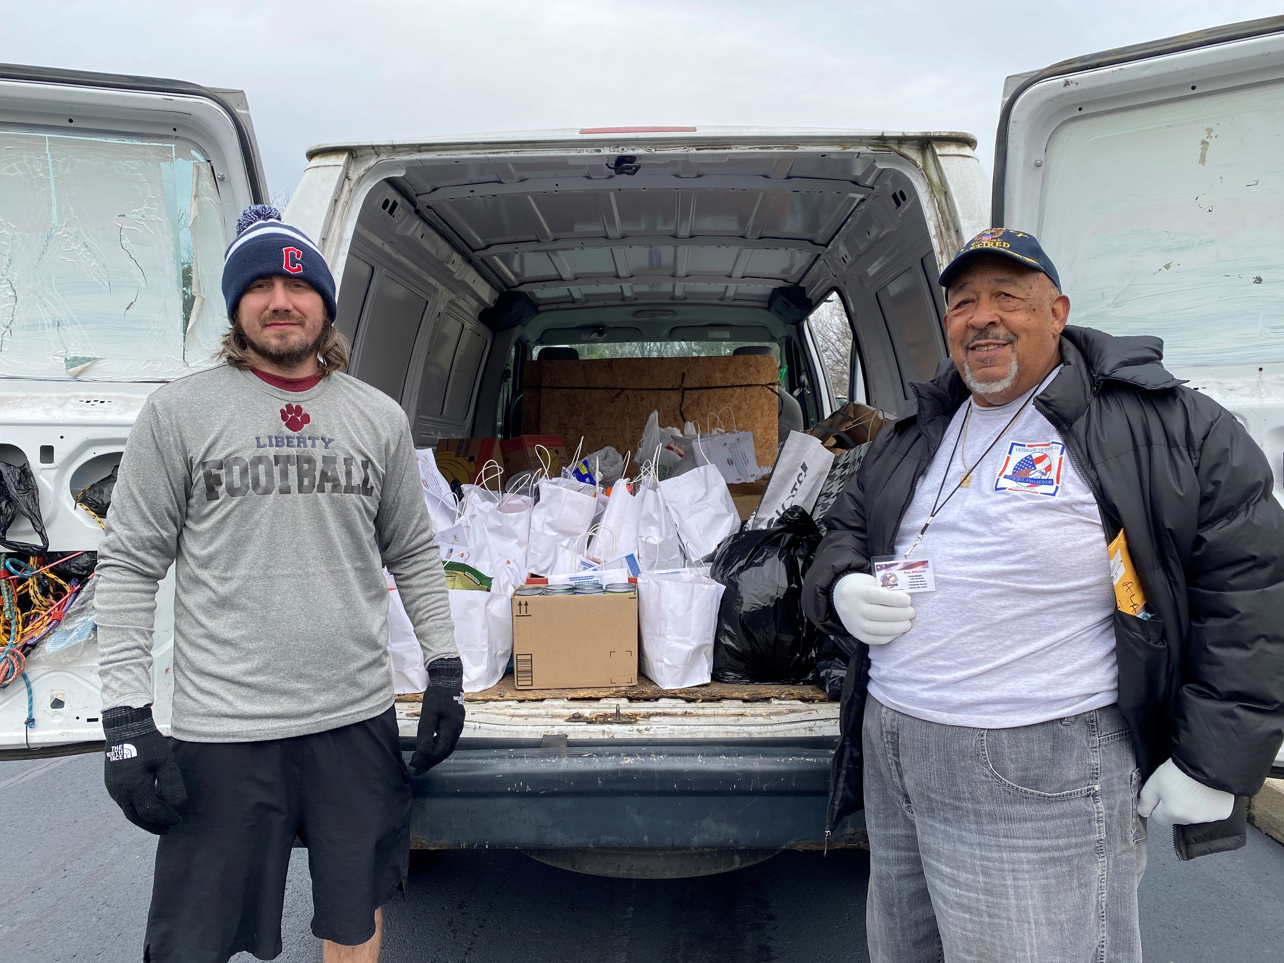

Mahoning County | First Friday Club in December CANCELED** -NEW

The First Friday Club of Greater Youngstown 2022-23 Speaker on December 1, 2022 has been canceled due to illness of the speaker. Please pray for John Allen, Jr., remove any flyers or bulletin announcements, or mark the event as “CANCELED.”

BULLETINS/PUBLICITY

Mahoning County | First Friday Club on January 5, 2023** -NEW

Full page flyer: https://doy.org/wp-content/uploads/2022/11/Dr.-Wilkins-Flyer.pdf

We continue the First Friday Club of Greater Youngstown 2022-23 Speaker Series season with a luncheon on the first Thursday in January! Join us as we welcome Charles E. Wilkins, M.D., expert and pioneer in geriatric medicine, on January 5, 2023. Dr. Wilkins will present “The Baby Boomer Generation a.k.a. the Alzheimer’s Generation” at Avion on the Water Banquet Center, 2177 W. Western Reserve Road in Canfield.

There will be an opportunity for participants’ questions to follow. Luncheon will be served at 11:30 a.m. with the presentation beginning at noon. The cost is $20.00. Call by December 30, 2022, 330-720-4498. Reservations are limited!
Visit our website www.firstfridayclubofgreateryoungstown.org
Integrating the principles of religious faith into our everyday lives and work.

BULLETINS/PUBLICITY

Mahoning County | The Men of Independence Christmas Show at St Joseph (Youngstown) Dec 9 at 7pm** -NEW

Full page flyer: https://doy.org/wp-content/uploads/2022/11/Dec-9_St-Joseph_2022_12_09_MenOfIndependence-1.png

The Men of Independence Christmas Show
December 9th at 7pm

St. Joseph Church
4545 New Road
Youngstown, Ohio 44515

Come and enjoy all-time, favorite sacred selections and old classics. Many quartets will be featured. The Men of Independence are ranked 19th in the world by The Barbershop Harmony Society and are directed by 4 time gold medalist Gary Lewis. This event is free and open to the public. Donations are greatly appreciated.

BULLETINS/PUBLICITY

Mahoning County & Recorded | Aid for Ukraine Concert Now Available Online** -NEW

Logo

"Aid for Ukraine" Special Concert Still Accepting Donations

St. Anne Ukrainian Catholic Church in Austintown, Ohio held a unique concert on Sunday, November 20th that featured Ukrainian choirs, world renowned concert pianist Roman Rudnytsky, and the debut of the barbershop quarter “Tuned Up.”

The recorded concert is now available online at https://vidultra.com/concert
St. Anne’s Church can receive donations by mailing a check or online at http://www.stanneucc.com/donate.html

All collected donations will be forwarded to Ukraine through the Ukrainian Catholic Diocese of St. Josaphat in Parma, Ohio. Thank you for your generosity and your support of Ukraine! Please pray for peace in Ukraine. May our Lord reward you abundantly in this life and the life to come!

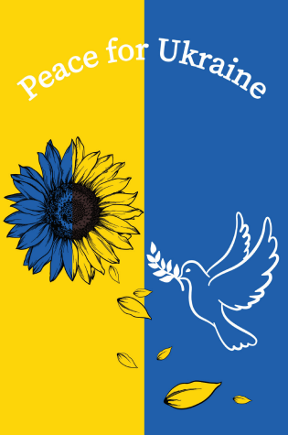

BULLETINS/PUBLICITY

Stark County | Christmas Bells at St Joseph (Massillon) Dec 11 at 3pm** -NEW

Christmas Bells
December 11th at 3pm

St. Joseph Church
322 3rd St SE
Massillon, OH 44646

The Harmony Ringers, a premiere auditioned handbell choir, will give a Christmas concert entitled “Christmas Bells” at St. Joseph Catholic Church on December 11th at 3:00pm. This event is free and open to the public. Donations are greatly appreciated.

Stark County & Live Streamed | Interfaith Thanksgiving Service at St Michael (Canton) on Nov 22 at 7pm -NEW

Interfaith Thanksgiving Service
November 22 at 7pm

Livestream: https://www.stmichaelcanton.org or https://www.facebook.com/stmichaelcanton
St. Michael the Archangel Church
3430 St. Michael Dr. N.W., Canton, OH 44718

St. Michael the Archangel Parish will host the 43rd Annual Stark County Interfaith Thanksgiving Service on Tuesday, November 22, 2022, at 7:00 pm in the Church. The Interfaith service brings together faith communities from around greater Stark County to give thanks to God for the many blessings He has bestowed upon all of us.

Reverend Benson C. Okpara, Ph. D., Pastor of St. Michael the Archangel will deliver a Thanksgiving message. Many Stark County congregations will be represented, including, Jewish, Catholic, Lutheran, Presbyterian, Episcopal, Islamic, Church of Christ, and Unitarian Universalists. The program will also include reflection, scripture, prayer, and music from the various choirs. Each representative will share a message of thanks and gratitude.

We also come together to fundraise for Thanksgiving Baskets Downtown. For more than 30 years, Thanksgiving Baskets Downtown has united faith communities and civic organizations in Canton, Ohio, in an all-volunteer effort to provide families with food at Thanksgiving.

This year we are happy to come together in person at St. Michael the Archangel Parish, 3430 St. Michael Dr. N.W., Canton, OH 44718. There is a live stream option for those that are not able to join us in person. Please visit stmichaelcanton.org or facebook.com/stmichaelcanton to live stream the service.

IN MEMORIAM: DECEMBER NECROLOGY

Shipe, Rev. William December 1, 2004
Coleman, Rev. Dermot December 2, 1974
Lucas, Rev. Joseph R. December 2, 1995
McLaughlin, Rev. William J., OP December 3, 1958
Mastrovich, Deacon George December 4, 2003
Czaja, Rev. Joseph December 5, 2014
Gutman, Rt. Rev. Msgr. Gordon G. December 6, 1998
Klingler, Very Rev. Ronald December 6, 2020
Dempster, Rev. A. Patrick December 7, 1997
Falter, Rev. Clement, CPPS December 8, 1942
Fleckenstein, Rev. Valentine, CPPS December 10, 1961
Pallante, Rev. John J. December 10, 1971
Lyons, Rev. John December 10, 2011
Reis, Rev. Richard December 12, 1998
Herttna, Rev. Matthew M. December 13, 2006
Kennedy, Rev. Bartley J. December 13, 1991
Bobal, Rev. George R. December 14, 1951
Stolarik, Rev. Cyrill M. December 14, 1990
Prokop, Rt. Rev. Msgr. Andrew A. December 15, 1995
Hill, Rev. Paul, MSC December 16, 2002
Keefe, Rev. William J. December 17, 1945
Eischen, Rt. Rev. Msgr. James December 17, 1953
Coleman, Rev. J. Robert December 17, 1986
Crumbley, Rev. Charles December 17, 2016
Heinrich, Rt. Rev. Msgr. Alfred J. December 18, 1964
Coward, Rev. Theodore T. December 18, 1987
Palm, Rev. Francis J. December 19, 1954
Novotny, Rev. Robert J. December 19, 1992
Boeff, Rt. Rev. Msgr. Anthony P. December 20, 1973
Brengartner, Rev. Robert December 21, 1999
Raible, Rev. Joseph, CPPS December 22, 1966
Rapp, Deacon Robert December 23, 2015
Scully, Rev. Austin W. December 25, 1953
Shay, Deacon Thomas December 25, 2010
Smith, Rev. Ernest December 26, 1953
O’Leary, Rev. Patrick December 26, 2010
Landy, Rev. Edgar R., OP December 27, 1947
Bennett, Rev. Joseph R. December 27, 1985
Beil, Deacon David December 27, 2013
Lenz Rt. Rev. Msgr. John H. December 28, 1959
Bardon, Rt. Rev. Msgr. John L. December 29, 1970
Dierker, Rev. Edward J. December 29, 1991
Abi-Nader, Rev. Maron December 29, 1996
Lukehart, Rev. Frederick December 29, 2021
Takacs, Rev. Gabriel, OFM December 30, 1973
Higgins, Rev. Daniel, SP December 30, 1982
Klein, Rev. Albert December 30, 2001
Fitzgerald, Rev. William J. December 31, 1985
Ellis, Rev. William, MSC December 31, 1995

†

