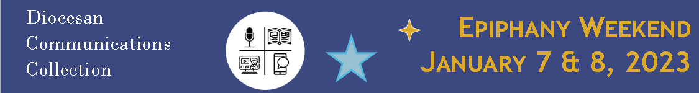
SUGGESTED BULLETIN/ANNOUNCEMENTS:
Weekend of December 31/January 1 (or earlier):
Diocesan Communications Collection: Epiphany Weekend
In the Christmas Season, we are called to share the good news of Jesus who is made known in our faith community. One way we can do this is by supporting the “Diocesan Communications Collection” on January 7 and 8, the Solemnity of the Epiphany. This collection supports the new initiatives of the Diocese of Youngstown’s Communications Office, including The Catholic Echo – a new magazine and multimedia website – along with a contemporary social media studio that will help us produce videos, podcasts and more. Your gift will help us to reach out to younger Catholics and help support critical services to the homebound, including the recorded Sunday Mass and radio and television ministry. Thank you for your gift on January 8, online through your parish’s e-giving, or at doy.org/communications-collection/.

Weekend of January 7/8, 2023:
Diocesan Communications Collection: Epiphany Weekend
On this celebration of Christ’s Epiphany, we dare to believe that the light of Christ shines in each one of us. Our new diocesan Communications initiatives will shine a light on the good news of our Catholic community in every county of our diocese, including through:
- The Catholic Echo – a new magazine and multimedia website – and a contemporary social media studio that will help us produce videos, podcasts and more.
- Our diocesan Communications Department provides publicity and information services to parishes and diocesan offices.
- Reach out to younger Catholics and those who are searching for good news.
- Support critical services to the homebound, including the recorded Sunday Mass and radio and television ministry.
Thank you for your gift in today’s second collection, online through your parish’s e-giving, or at doy.org/communications-collection/.
After January 7/8, 2023:
Diocesan Communications Collection: Gratitude
Many thanks to those who already supported this year’s Diocesan Communications Collection on January 7 and 8. Your gift will help us spread the good news of our Catholic community in every county of our diocese, through The Catholic Echo – a new magazine and multimedia website – and a contemporary social media studio that will help us produce videos, podcasts and more. As we celebrate the “Sunday of the Word of God” on January 21 and 22, please pray for our communications ministries, and all who echo God’s word in liturgical, catechesis and service ministries. Please know that your contributions will help us reach out to younger Catholics and help support critical services to the homebound, including the recorded Sunday Mass and radio and television ministry. If you are able, you can still give to our Diocesan Communications Collection online at doy.org/communications-collection/.

