INTRODUCTORY RITES
WELCOME and BRIEF REMARKS 00:00
REFLECTION ON ADORATION 00:05
EXPOSITION OF THE BLESSED SACRAMENT 00:10
ADORATION
PSALM 63 – My Soul is Thirsting [suggested] 00:20
PSALM PRAYER
Father, you show your almighty power in your mercy and your forgiveness.
Continue to fill us with your abundant gift of love.
Help us to hasten toward the eternal life you promise and come
to share in the joys of the kingdom.
Grant this through our Lord, Jesus Christ, your Son,
who lives and reigns with you and the Holy Spirit, God, forever and ever. Amen.
SCRIPTURE READING – 1 Corinthians 11:23-26 00:28
PSALM 34 – Taste and See [suggested] 00:36
PSALM PRAYER
Almighty and ever-living God, our source of power and inspiration,
give us strength and joy in serving you as followers of Christ,
who lives and reigns with you and the Holy Spirit, God, forever and ever. Amen.
SCRIPTURE READING - Luke 24:28-35 00:44
SONG OF PRAISE 00:50
BENEDICTION 00:55
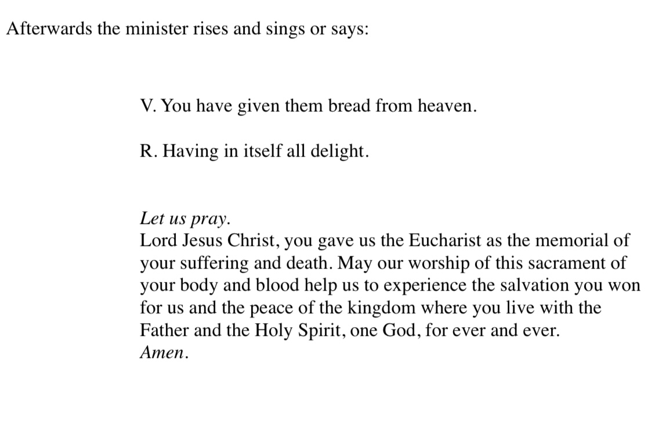

REPOSITION
The Divine Praises
Blessed be God.
Blessed be his Holy Name.
Blessed be Jesus Christ, true God and true man.
Blessed be the name of Jesus.
Blessed be his most Sacred Heart.
Blessed be his most Precious Blood.
Blessed be Jesus in the most Holy Sacrament of the Altar.
Blessed be the Holy Spirit, the Paraclete.
Blessed be the great Mother of God, Mary most holy.
Blessed be her holy and Immaculate Conception.
Blessed be the name of Mary, virgin and mother.
Blessed be Saint Joseph, her most chaste spouse.
Blessed be God in his angels and in his saints.
RECESSIONAL MUSIC

