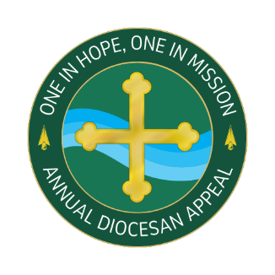

ANNUAL DIOCESAN APPEAL 2024
The Participation of Every Parish Is Vital… and Appreciated!
The success of your parish’s Commitment Weekend is critical for building participation in the 2024 Annual Diocesan Appeal. Parishes with strong In-pew Appeals often see an increase in total dollars raised. More importantly, these parishes boost participation among parishioners and activate a greater number of first-time appeal donors. This means we will be able to help more people in need.
Your leadership support in your parish plays a crucial role in the continued success and growth of the Annual Diocesan Appeal. On behalf of those we serve, thank you for your efforts in the weeks ahead.
Announcement Weekend Parish Resource List
  - Announcement & Commitment Weekend Talking Points
  - Brochures
  - QR Code for pews
  - GiveCentral bulletin information
  - Commitment Weekend bulletin cove
  - Post In-Pew Weekend Talking Points

Announcement Weekend
After the homily at every Mass, the presenter (this may be a lay person or the priest) will begin the in-pew process.
- Ask ushers to distribute the pledge cards or have the pledge already distributed throughout the pews.
- Use the Announcement weekend talking points to ask everyone in the pews to complete their donation.
- Note that anyone completing their donation online does not need to fill out a pledge form.
- WAIT a few minutes after the presenter gives the message to let people go online. (or ask them to complete before the end of the day!)
- Mention that for those who prefer to make their donation by check, may do so by completing the pledge form to submit along with their check.
- It is best to collect any completed forms DURING THE OFFERTORTY and NOT WAIT or ask people to drop them off after Mass.
- Presider THANKS everyone for their participation and their support.
- Ushers/volunteers collect pledge forms and put in a secure place for the office staff to compile and return to the diocese first thing Monday morning.
- Collect all unused pledge envelopes so you will have enough to use at the upcoming Mass.

Commitment Pledge Forms
Three Easy Steps for Processing Annual Diocesan Appeal pledge forms:
- Collect in-pew envelopes during Mass.
- Put the in-pew envelopes in the pre-addressed envelopes.
- Mail the envelopes first thing Monday morning after commitment weekend and throughout the appeal as they are turned in.

Additional Annual Diocesan Appeal Resources
- Parish Resource Sheets:
  - Include bulletin copy, social media posts, and pulpit announcements through Pentecost Sunday.
- Ministry bulletin ministry ads to be used throughout the appeal.

