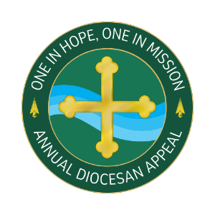

Commitment Weekend
Talking Points for Pastors

- The last weekend (OR LONGER) I spoke about the Annual Diocesan Appeal. I hope you have taken time to consider how you can support this year’s effort which delivers ministries to those seeking to expand their faith and education as well as provides essential ministries throughout our diocese.

AS UPDATES ARE PROVIDED
- I am pleased to tell you that we are % of 2024 Parish Target towards our parish goal of $2024 Parish Target with $Total Raised. If you have not yet made a commitment, I hope you will join me in helping to not only meet but exceed this year’s goal!

- I invite you to use your phone to scan the QR code located in the pews or on the pledge cards or go to DOY.org/Appeal where you’ll be able to make an ongoing monthly gift or a one-time gift. That website again: DOY.org/Appeal.
- Thank you for your support!

